**Assignment 15 Submission**

**Submitted by:** Faraz (#53)

**Part 1: User & Group Permissions**

**Task 1.1: Create Users & Groups**

**Command:**

sudo groupadd network_team

sudo useradd -m -g network_team alice

sudo useradd -m -g network_team bob

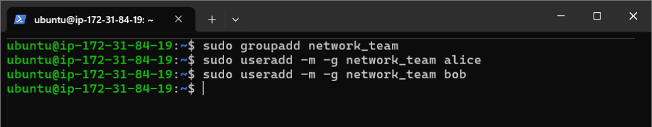

**Explanation**: Created a group network_team and added users alice and bob to it with home directories, then verified group and user creation.

**Task 1.2: Set Directory Permissions**

**Command:**

sudo mkdir /opt/network_data

sudo chown root:network_team /opt/network_data

sudo chmod 770 /opt/network_data

ls -ld /opt/network_data

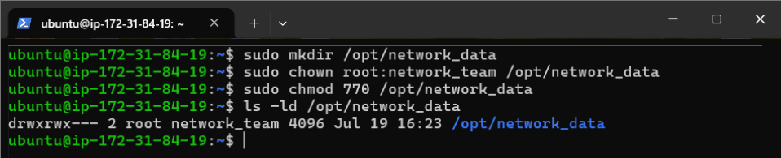

**Explanation**: Created a shared directory /opt/network_data, set its group to network_team, granted group read/write/execute permissions, and verified with ls.

**Part 2: Network Tools & Real-Time Checks**

**Task 2.1: Check Connectivity to google.com**

**Command:**

ping -c 4 google.com

traceroute google.com

mtr --report google.com

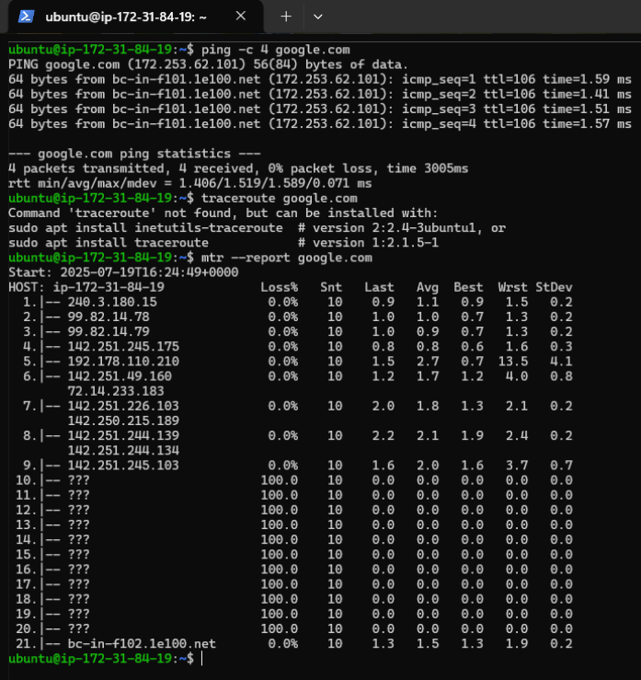

**Explanation**: Tested connectivity to google.com using ping for latency, traceroute for routing, and mtr for detailed network diagnostics.

**Task 2.2: Check Open Ports & Listening Services**

**Command:**

sudo ss -tulwn

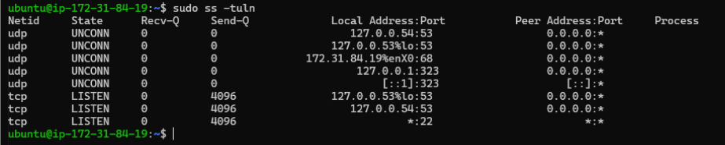

**Explanation**: Listed TCP and UDP listening ports and services using  ss to check open ports on the system.

**Task 2.3: Test Remote Port Connectivity**

**Command:**

telnet google.com 443

nc -zv google.com 443

**Explanation**: Checked if port 443 (HTTPS) on google.com is open using telnet and nc to verify remote connectivity.

**Task 2.4: Check Network Interfaces**

**Command:**

ifconfig

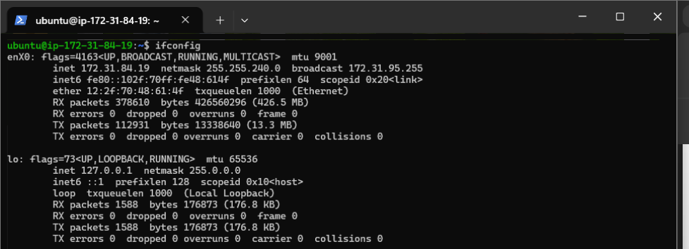

**Explanation**: Displayed network interface details, including IP addresses and status, using ifconfig

**Task 2.5: DNS Lookup**

**Command:**

dig google.com

**Explanation**: Queried DNS for google.com’s IP addresses using nslookup and dig to verify name resolution.

**Task 2.6: Download Test File**

**Command:**

wget https://example.com/testfile.txt

curl -O <https://example.com/testfile.txt>

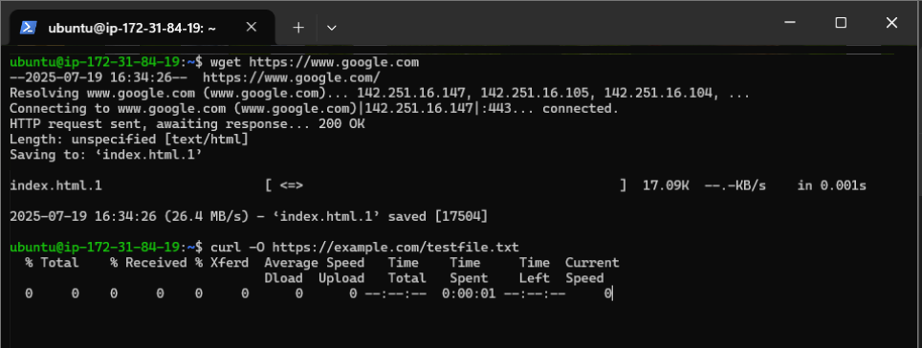

**Explanation**: Downloaded a test file from a URL using wget and curl to verify network download capabilities.

**Task 2.7: Monitor Bandwidth in Real Time**

**Command:**

sudo iftop -i enX0

**Explanation**: Monitored real-time bandwidth usage on the enX0 interface using iftop  for network performance analysis.

**Part 3: Compression & Decompression**

**Task 3.1: Archive Directory**

**Command:**

tar cvf network_data.tar /opt/network_data

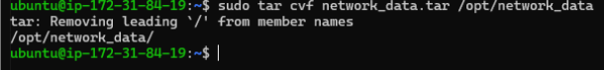**Explanation**: Created a .tar archive of the /opt/network_data directory, listing files being archived.

**Task 3.2: Compress Archive**

**Command:**

gzip network_data.tar



**Explanation**: Compressed the network_data.tar file into network_data.tar.gz using gzip.

**Task 3.3: Decompress**

**Command:**

gunzip network_data.tar.gz



**Explanation**: Decompressed network_data.tar.gz back to network_data.tar using gunzip.

**Task 3.4: Use bzip2 Compression**

**Command:**

bzip2 network_data.tar

bunzip2 network_data.tar.bz2

**Explanation**: Compressed network_data.tar into network_data.tar.bz2 using bzip2, then decompressed it back to network_data.tar using bunzip2.

**Part 4: Text Processing with grep & awk**

**Task 4.1: Search for "error" in Log Files**

**Command:**

grep "error" /var/log/syslog

**Explanation**: Searched for lines containing “error” in /var/log/syslog to identify error messages.

**Task 4.2: Count Errors**

**Command:**

grep -c "error" /var/log/syslog

**Explanation**: Counted the number of lines with “error” in /var/log/syslog to quantify errors.

**Task 4.3: Extract Specific Fields**

**Command:**

grep "error" /var/log/syslog | awk '{print $1, $2, $3, $5}'

**Explanation**: Extracted the date, time, host, and source fields from lines with “error” in /var/log/syslog using grep and awk.

**Task 4.4: Filter and Summarize**

**Command:**

grep "error" /var/log/syslog | awk '{print $5}' | sort | uniq -c | sort -nr

**Explanation**: Summarized unique error sources from /var/log/syslog by extracting the source field, counting occurrences, and sorting by frequency.