**Assignment – 17**

1. **Practical Example 1**

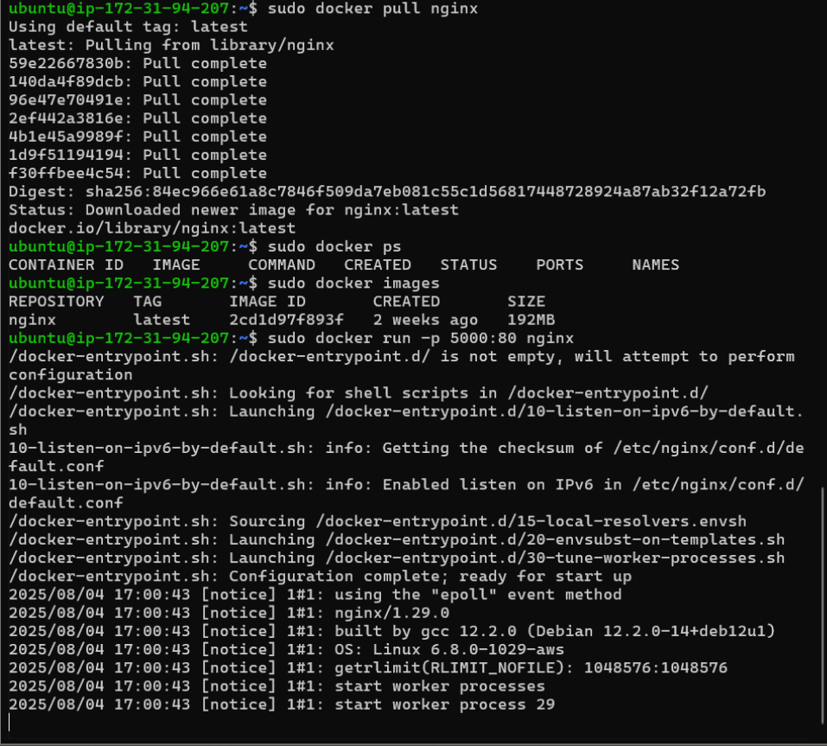

1. **Example2_FlaskApplication**

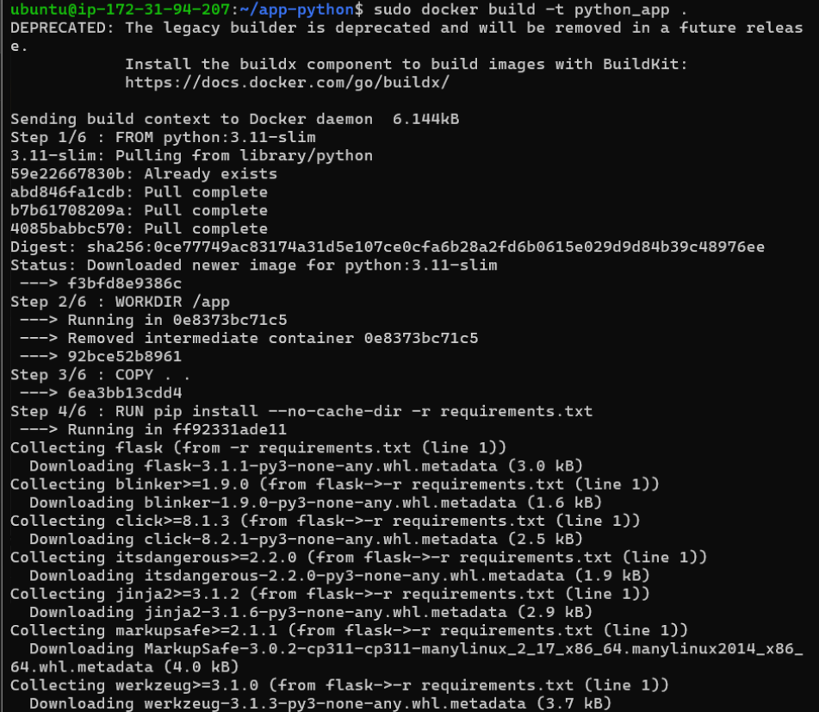

1. **NodeJS app in Docker**



