**Assignment – 18**

* Cloning the todo-list app

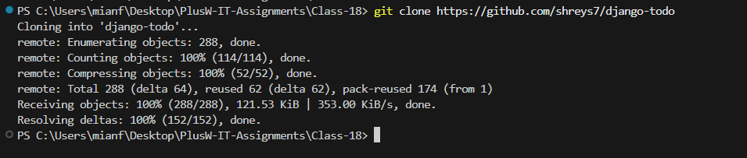

* Setting up the project locally

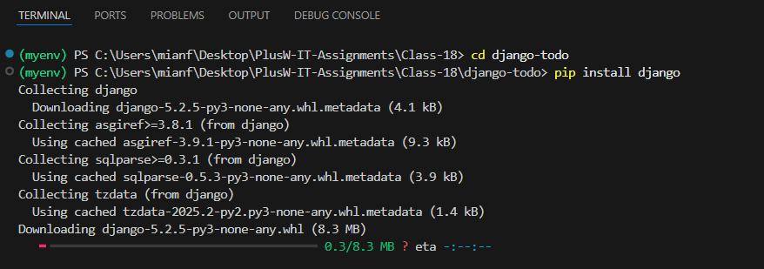

* Doing **migrations**

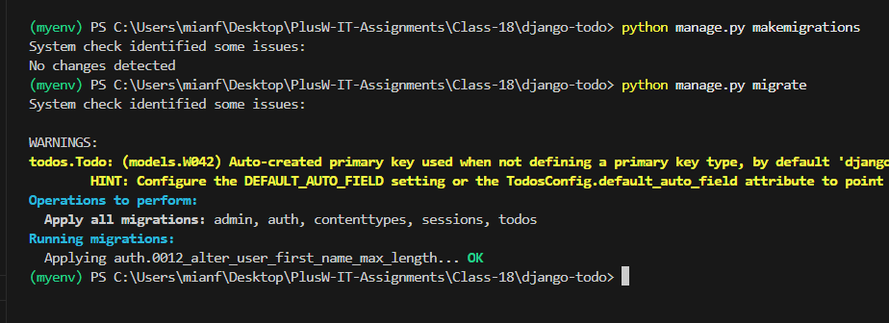

* Testing app **locally**

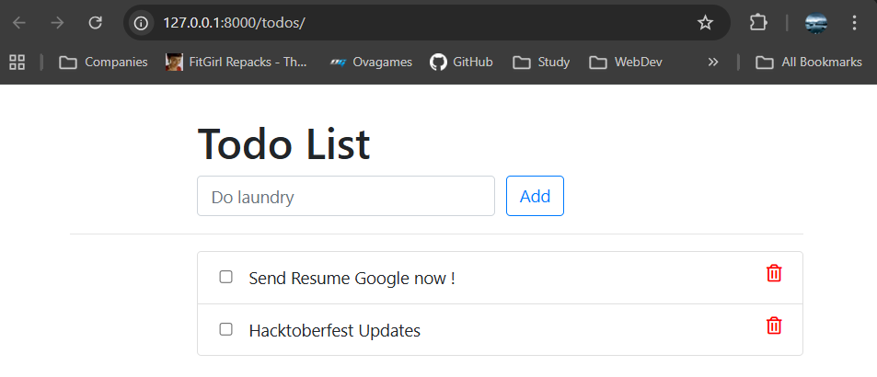

* Setting up **Instance** and cloning repository

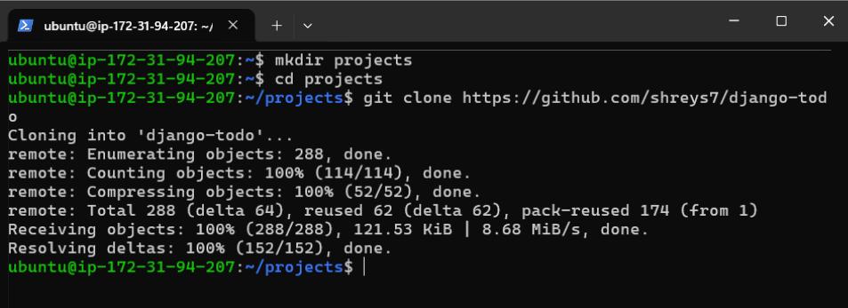

* Doing migrations and running app on **Instance**

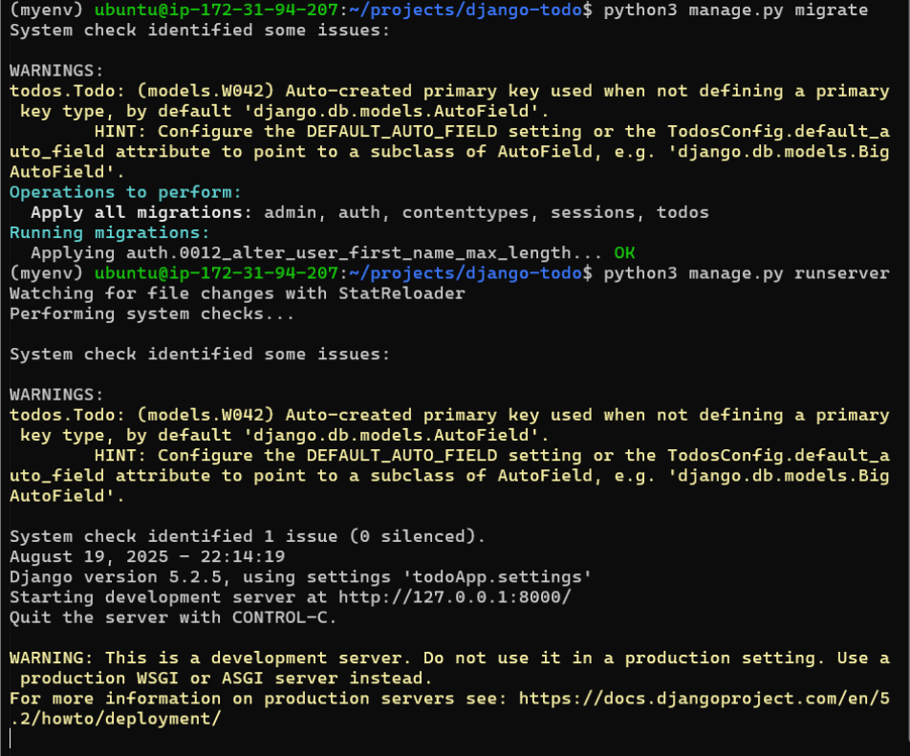

* Adding **Inbound rule** for port **8001**.

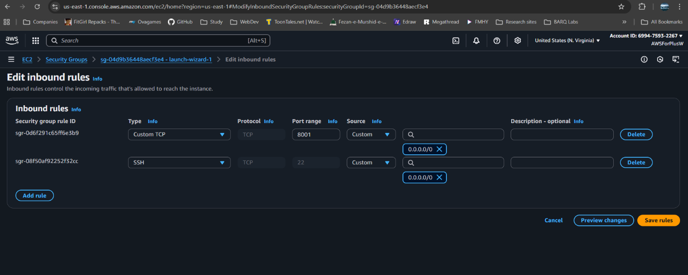

* Updating **ALLOWED_HOSTS** in settings.py

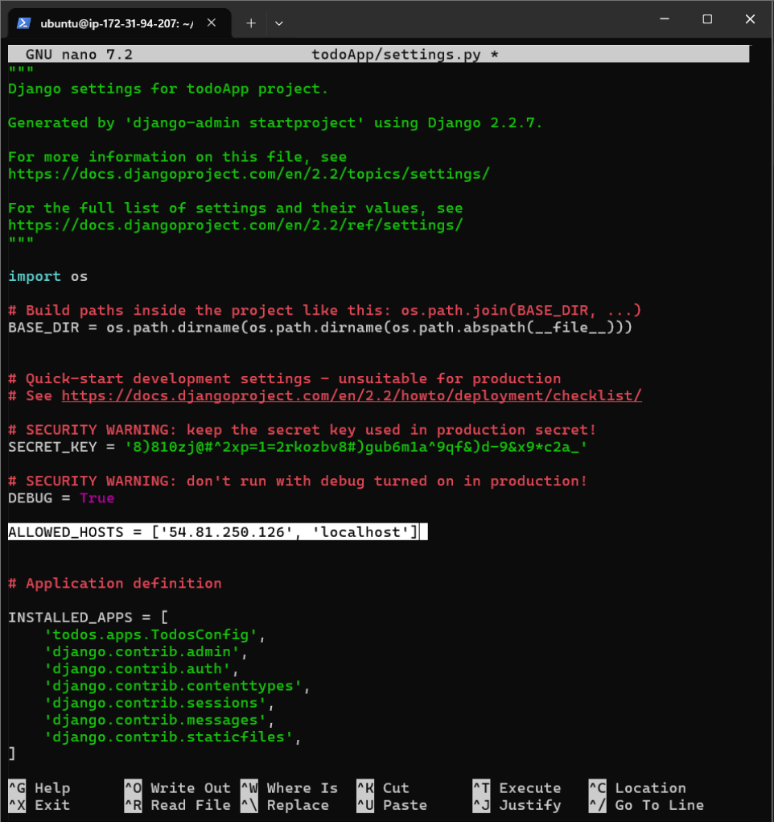

* Running app and testing it using **Instance’s IP address**

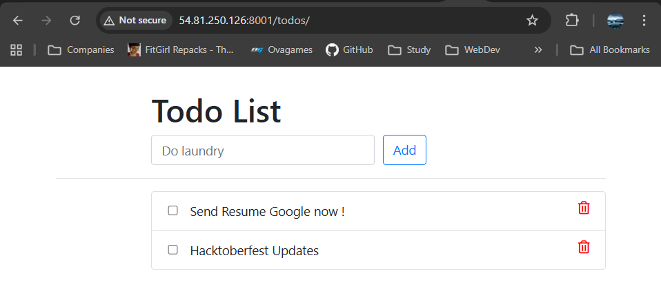

* Setting up **Dockerfile**

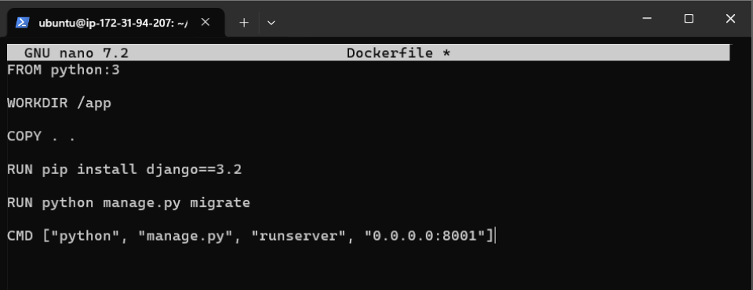

* **Building** the app on **Docker**

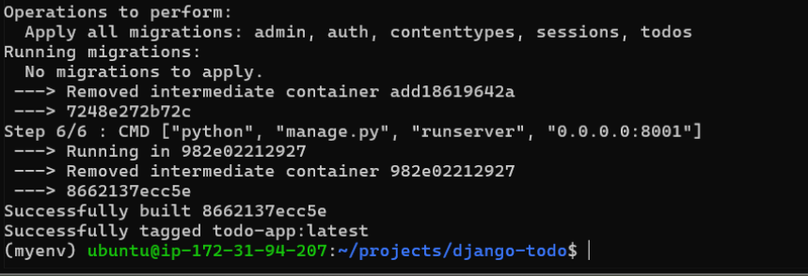

* **Running** the app using **Docker** and **testing** it.

