**Assignment-19**

* Install **yaml**

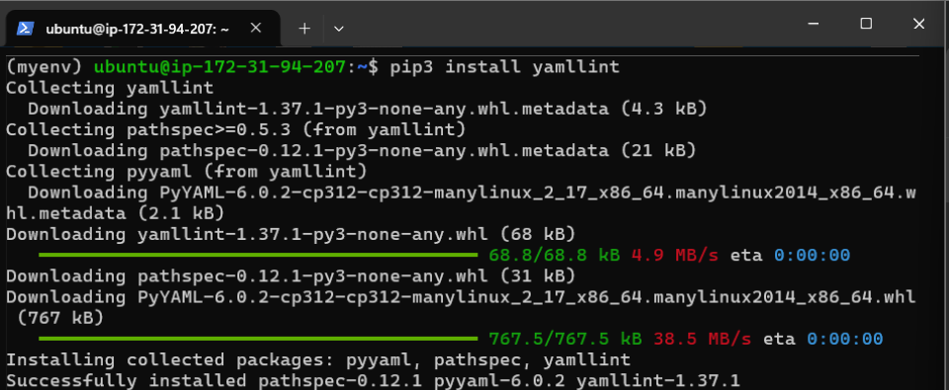

* Make a directory for ansible and make **inventory.ini** file

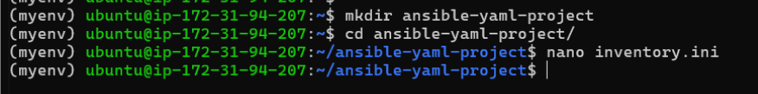

* Open **inventory.ini**

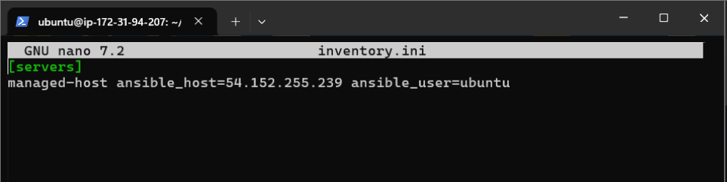

* Make **config.yml**

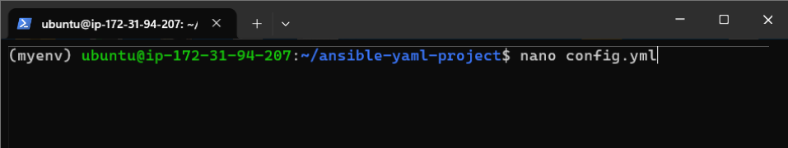

* Open **config.yml**

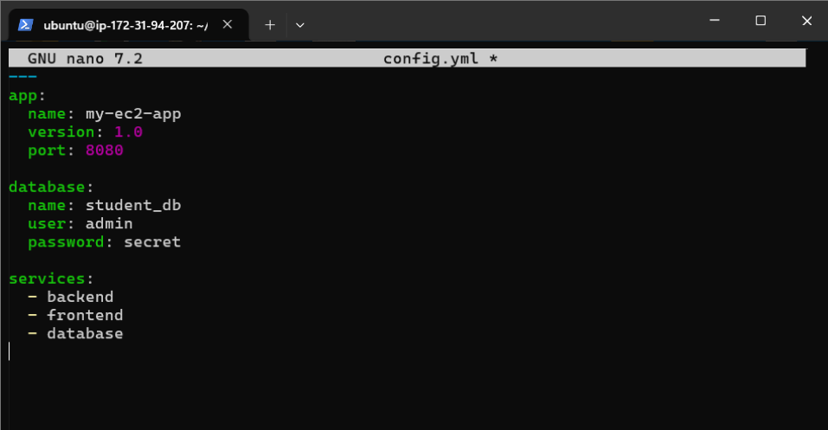

* Validate **config.yml**

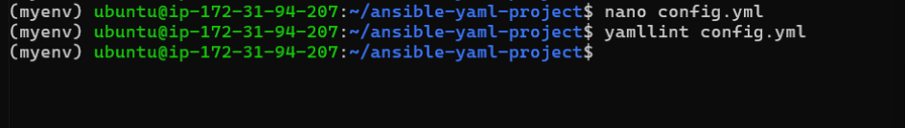

* Make **docker-compose.yml**

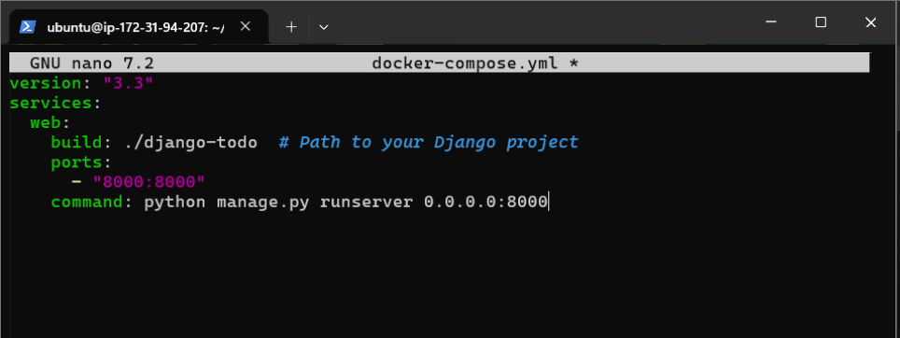

* Run **docker-compose**

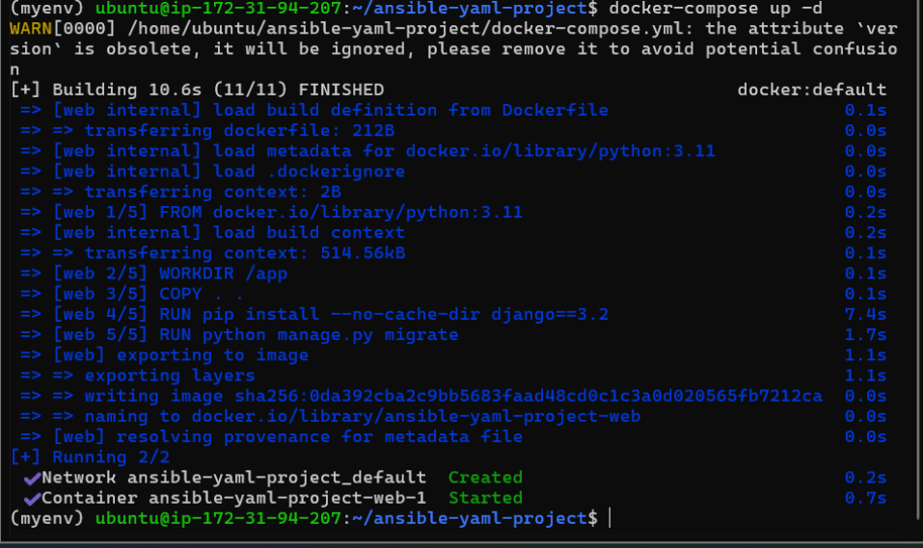

* Make **install_docker.yml** to automate the docker installation

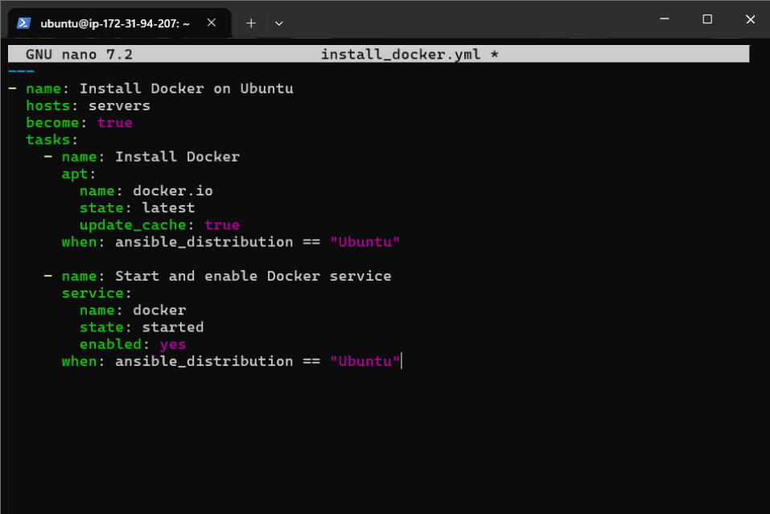

* Running it with **ansible-playbook**

