**Assignment-22**

* Initialize **git**

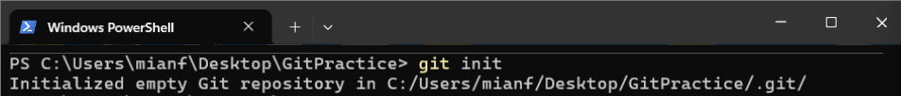

* **Create** files and **add** them to repository and **commit**

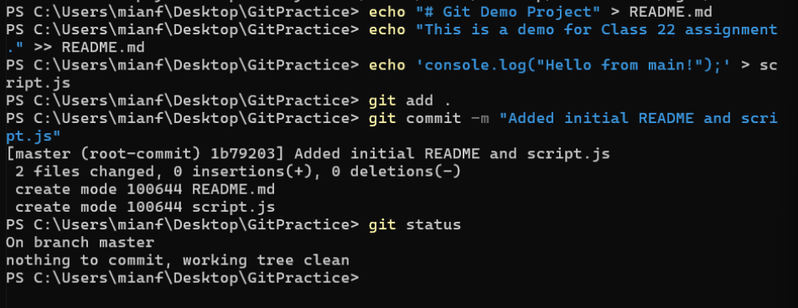

* **Create** new **branches** and add different version of a file into them, then **stage** them

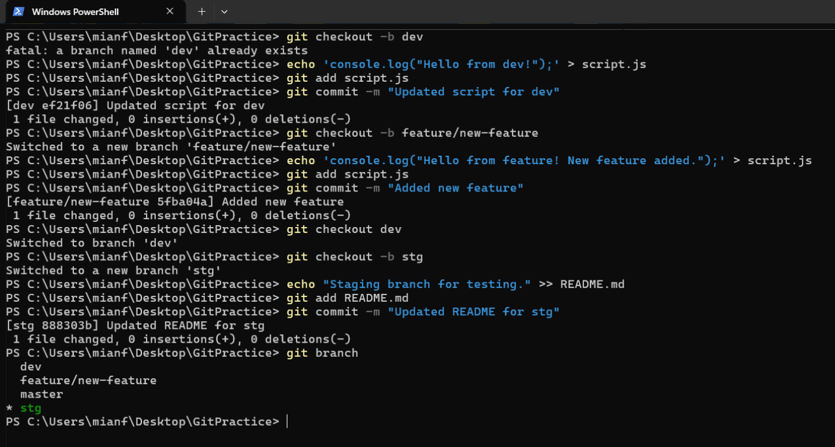

* **Push** them on GitHub

