**Assignment – 23**

Deploy a Django Application:

**{IP Address of the Instance is maintained using AWS Elastic IP}**  
  
1 – Setup “**gunicorn.service”:**

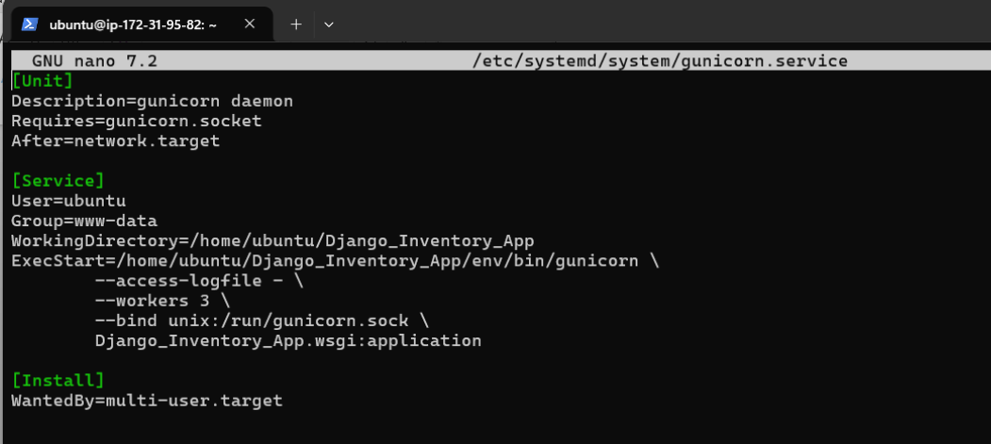

2 – Setup **“gunicorn.socket”:**

3 – Enable and start “**gunicorn.socket**” and Reload “**Daemon” :**



4 – Setup “**Sites-available”** file of Nginx:

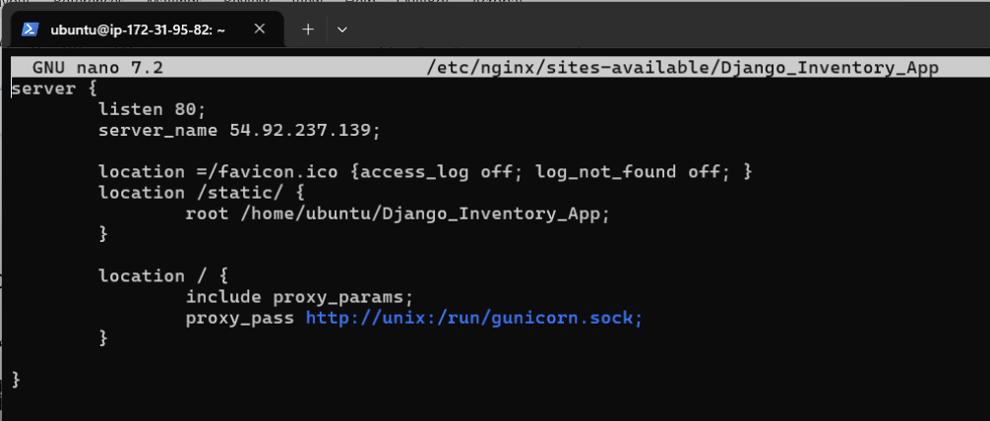

5 – Restart Nginx using “**sudo systemctl restart nginx**” and see results (Visit <http://54.92.237.139/login/>) and type Username: employee_user

Password: greatpakistan

To see employee’s accessible inventory page (can only add items in inventory but cannot remove):



