**Assignment-24**

* Sign in to jira app on slack and connect project

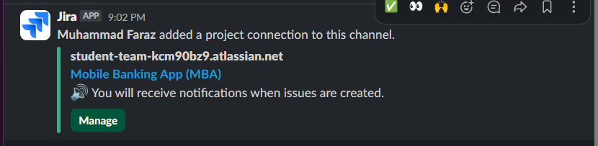

* Create a task

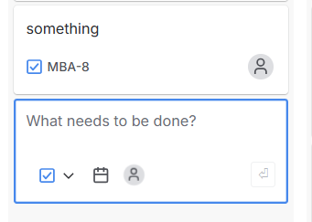

* Got notification

