**Assignment-25**

1. **Create an IAM user and then login into AWS with IAM user**

* Sign-In as Root User and go to **IAM** services and click on **Users** tab and then **create user**

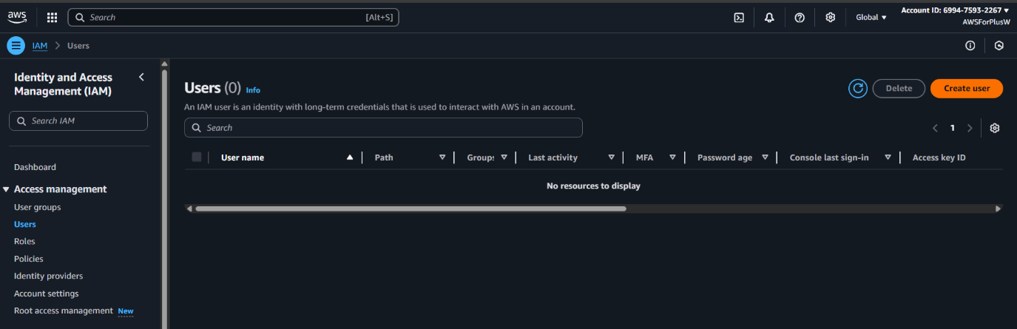

* Specify user’s name

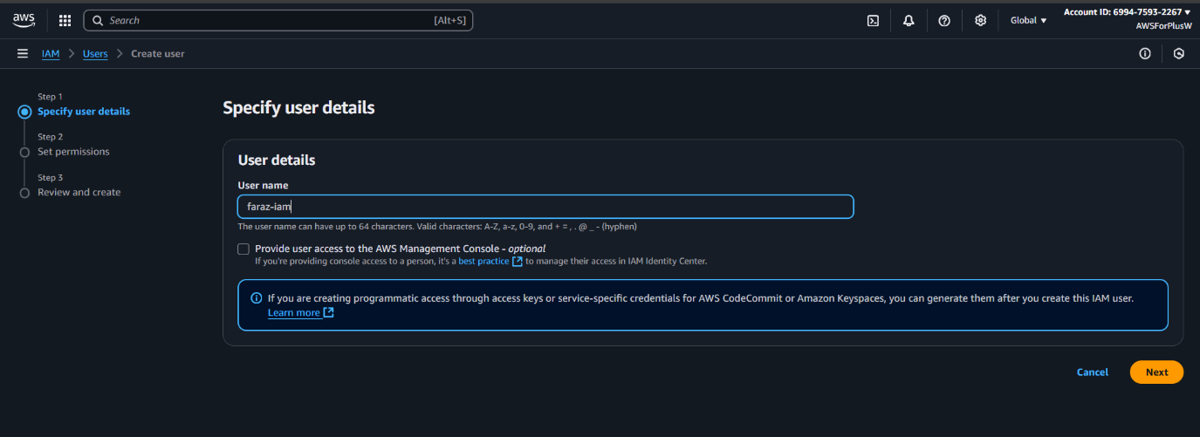

* Create a user group or give permissions individually. I created a group named as **fullaccess** and provided **EC2FullAccess** and **S3FullAccess**

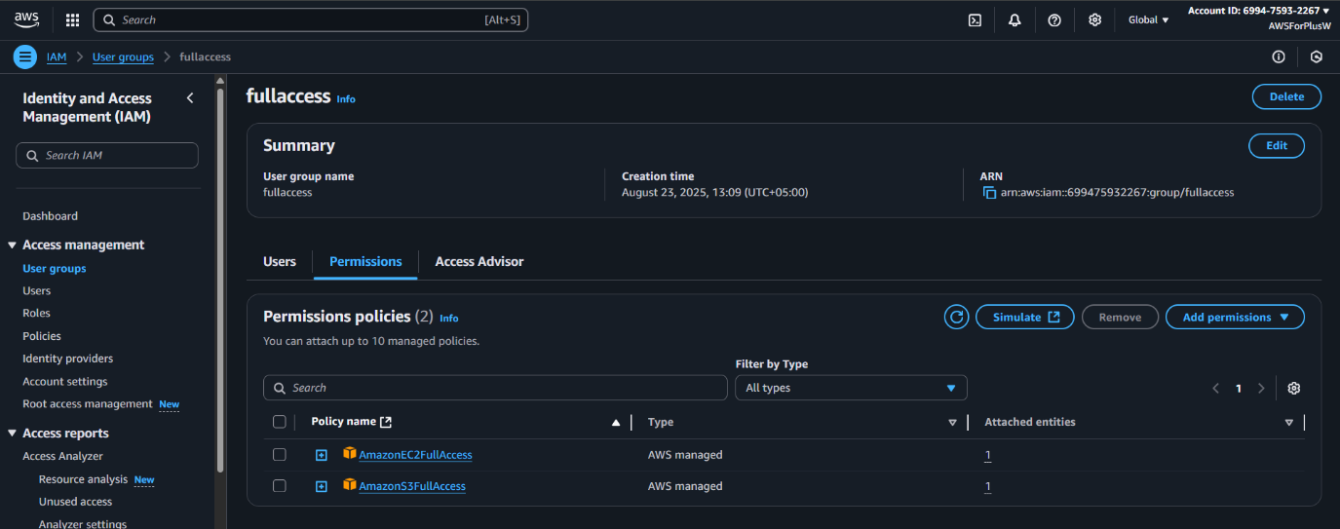

* Then go to **Credentials** section of that IAM user, and give a password/autogenerate password in **Console sign-in**

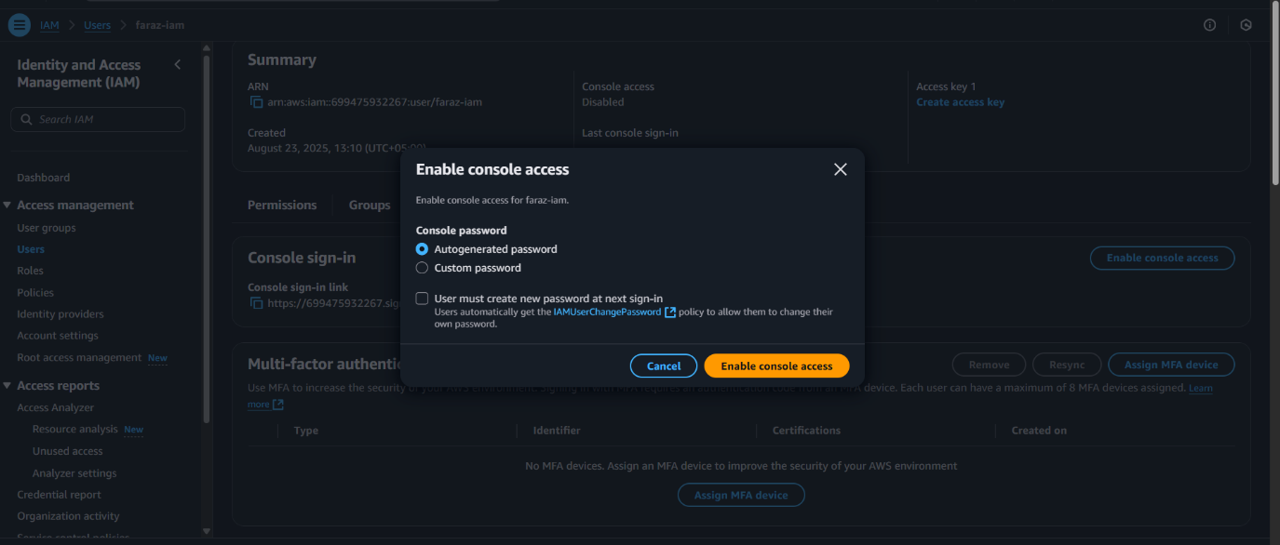

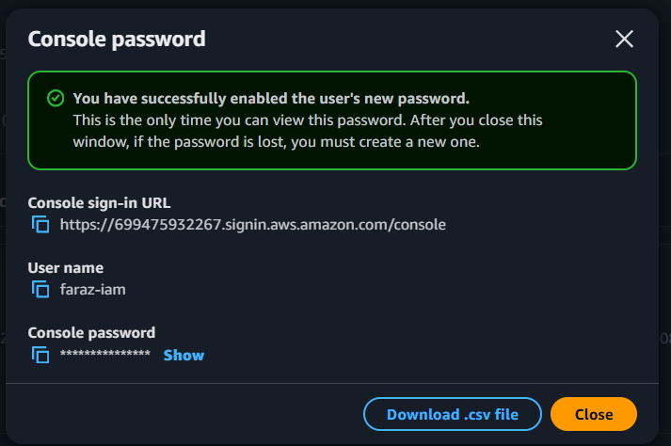

* Logout of root user and sign in as **IAM user**

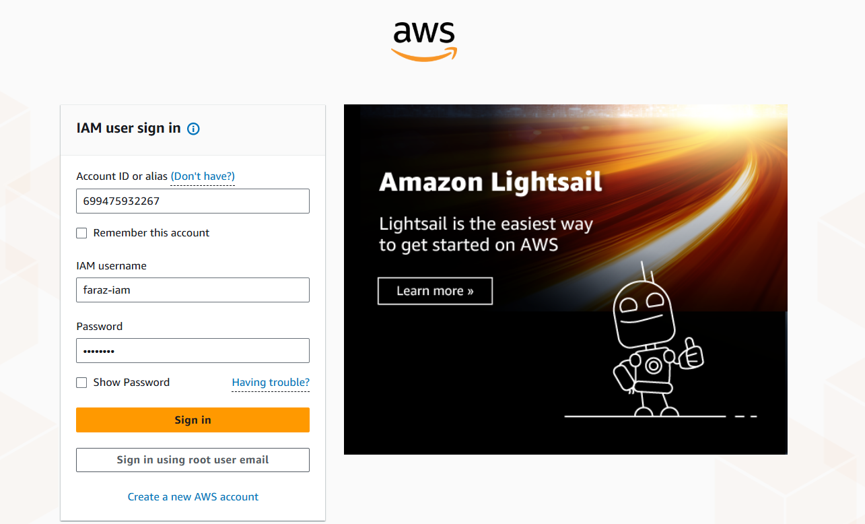

* **Access Denied** for services like **Security Lake**

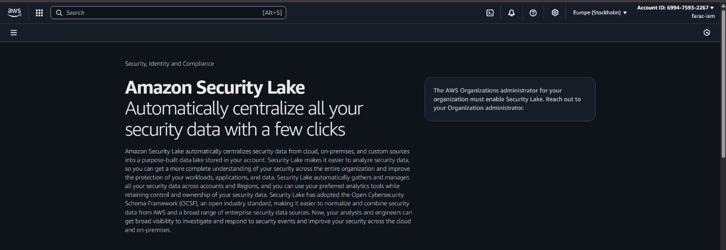

* **Access Granted** for **EC2**

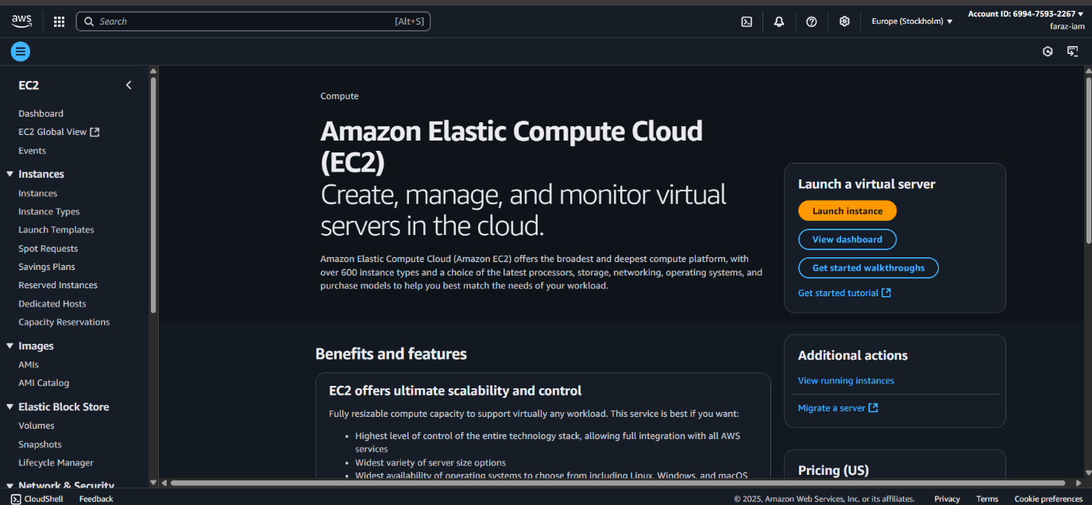

1. **Create a simple static website and deploy on S3 bucket**

* Go to **Amazon S3** and click on **Create Bucket**

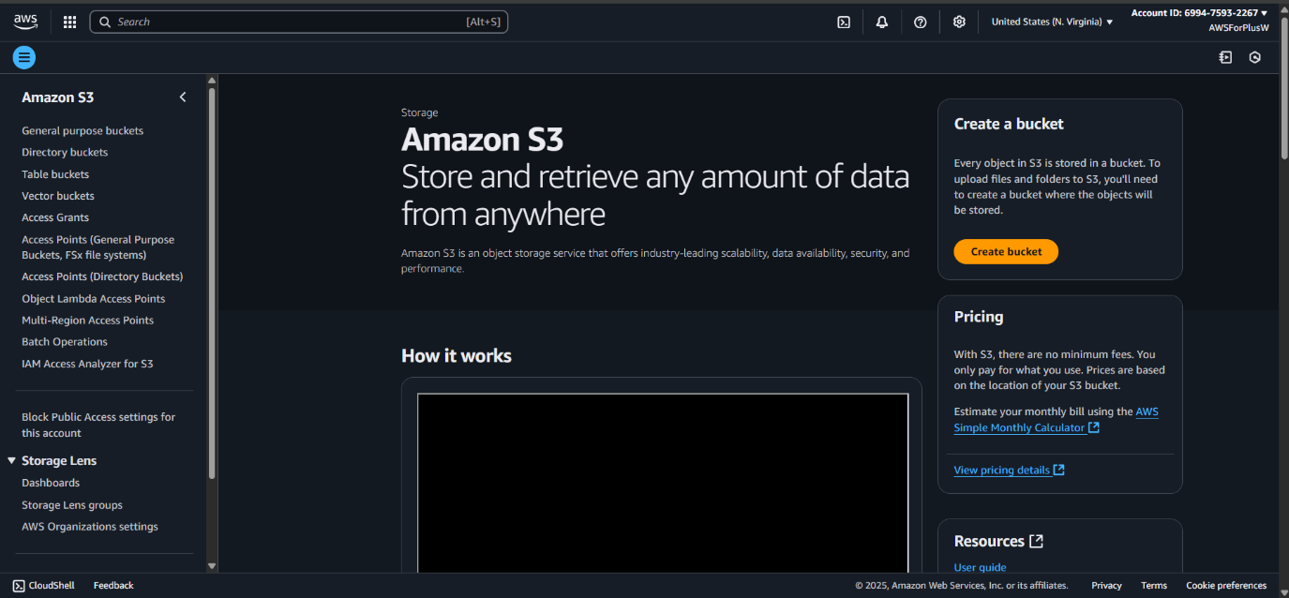

* Give bucket a name

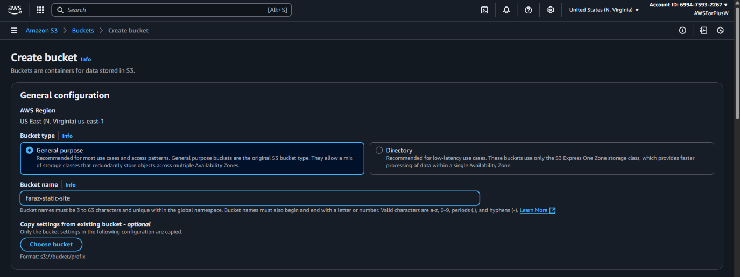

* **UnCheck** all the public access blockers

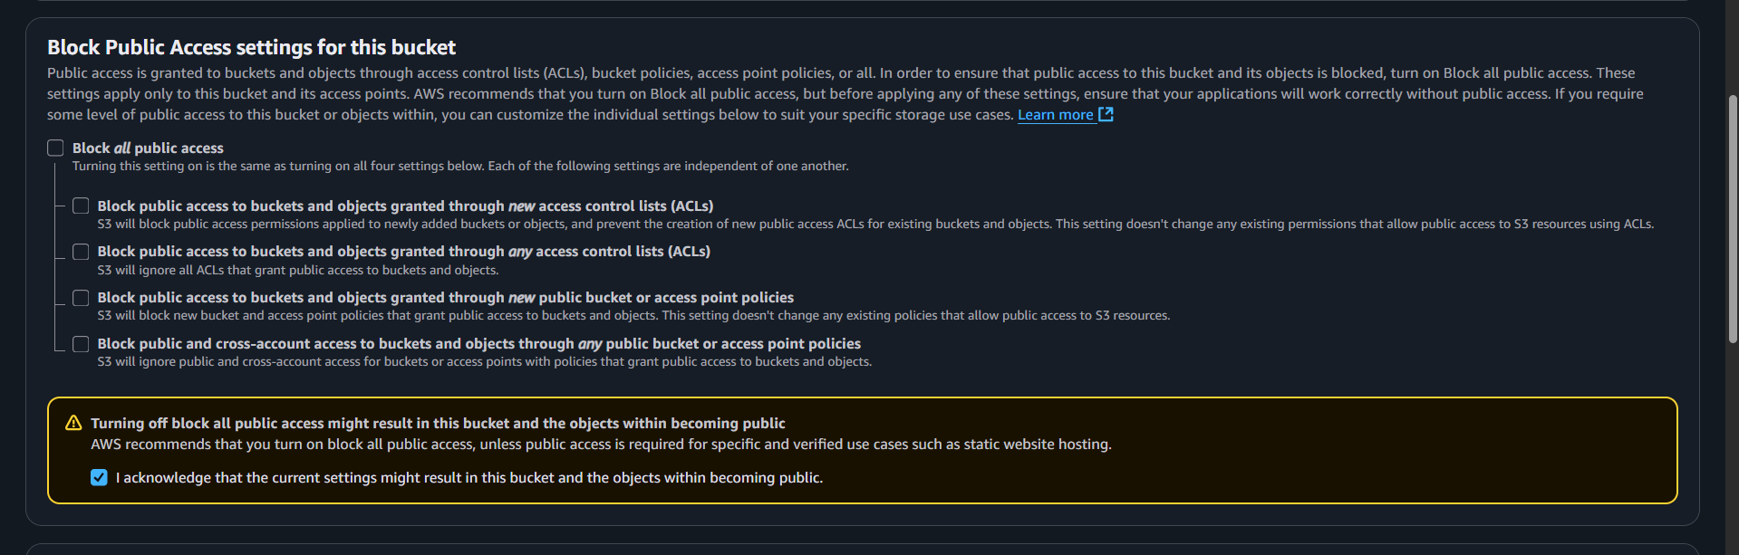

* **Upload** the file you want to host

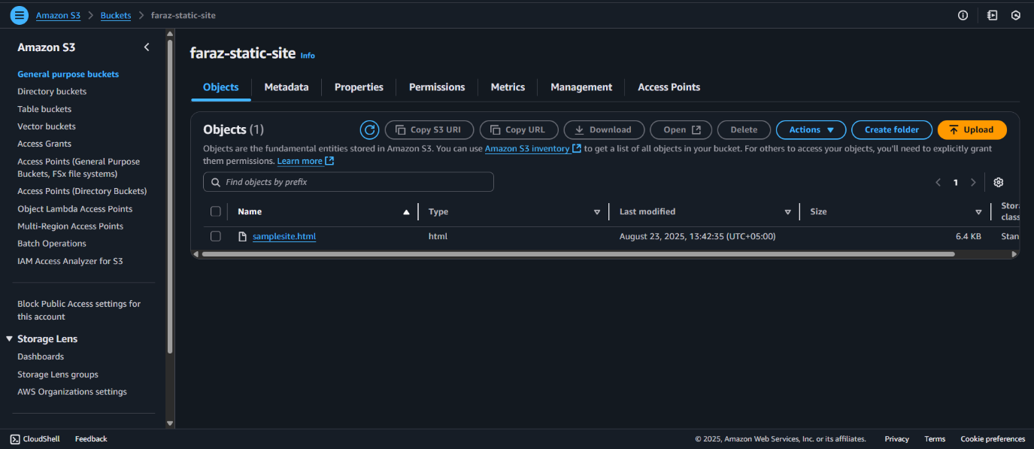

* Click on your uploaded file and from **properties** tab, you must copy the **Object URL**

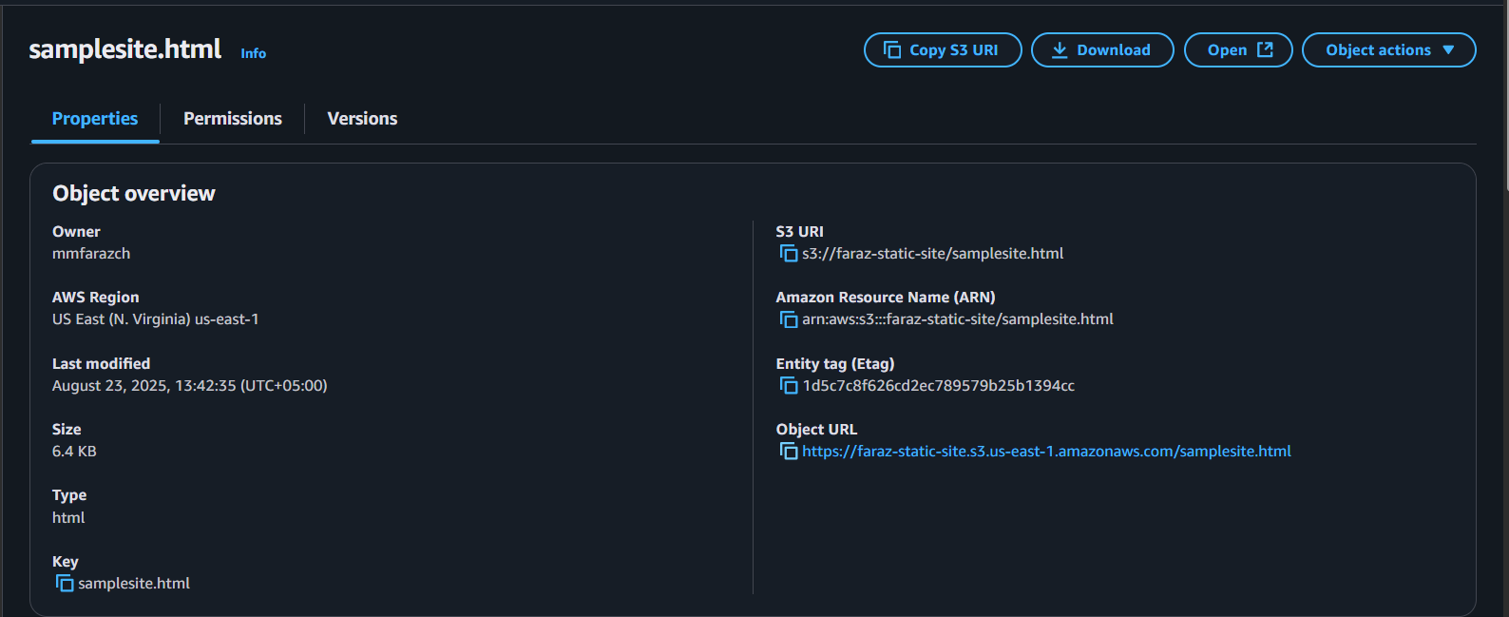

* Go to **Permissions** tab of your bucket and edit **Bucket Policy**

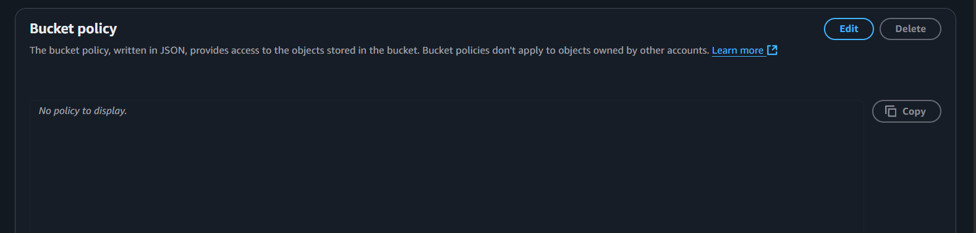

* Visit [WebsiteAccessPermissions docs](https://docs.aws.amazon.com/AmazonS3/latest/userguide/WebsiteAccessPermissionsReqd.html) to get the JSON script of the public access policy.

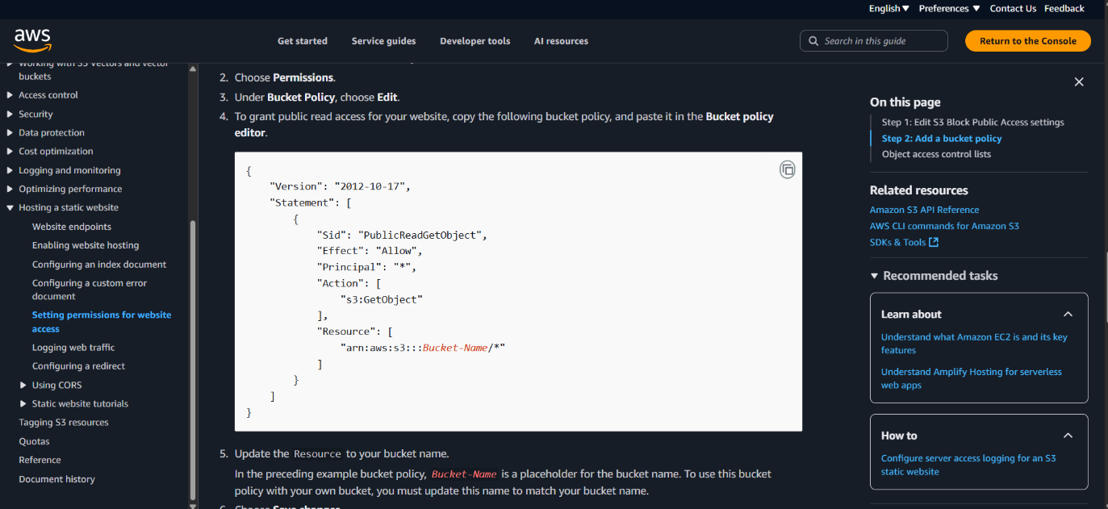

* Copy that script and paste in the **Bucket Policy** and replace the ***Bucket-Name*** with your bucket name, I’ve replaced it with **faraz-static-site** which is my bucket’s name. Then save changes.

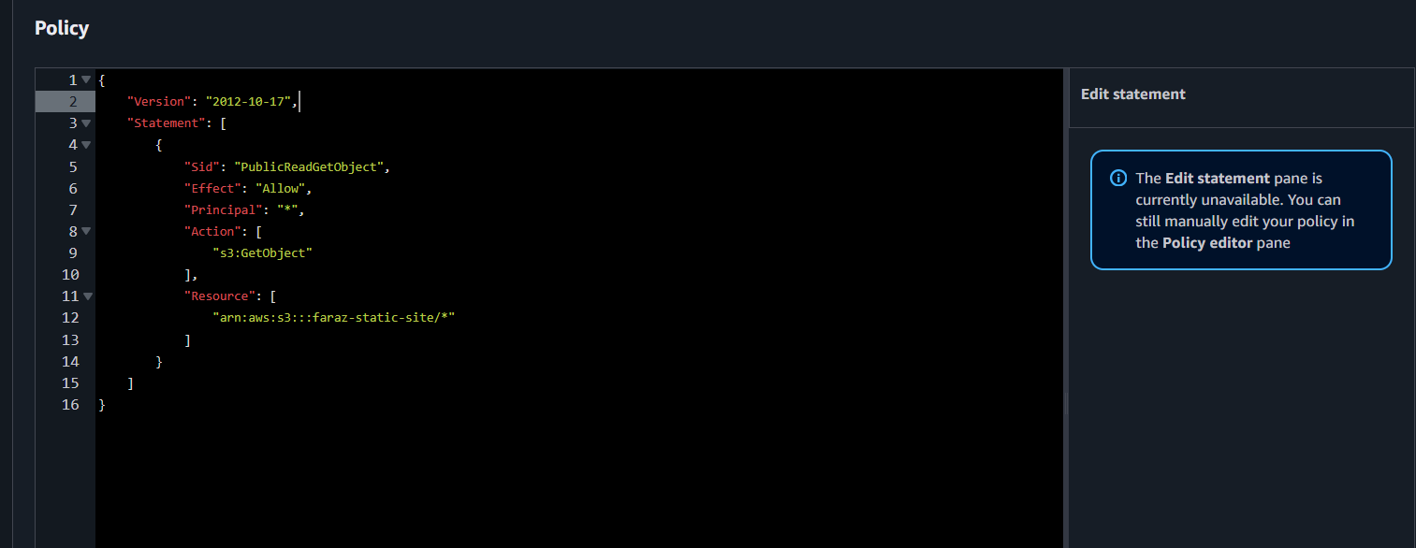

* Open new tab on your browser and paste the **Object URL** and press enter, you’ll be able to see your static website.

