ONPG Bead Reactor, Enzyme Kinetics and Internal Diffusion
Faraz Rahimi | David B. Thiessen | Bernard J. Van Wie
Voiland School of Chemical Engineering & Bioengineering • Washington State University
Pullman, WA 99164-6515
Simulation: https://farazrahimi95-collab.github.io/labs/onpg/
Worksheet revised October 2026
Student name(s): _______________________________________ Date: ____________________
For all questions, report numerical values with units and cite simulation tables or graphs when supporting your answers.

Educational Purpose
Through this virtual experiment, students examine β-galactosidase-catalyzed ONPG hydrolysis, compare two immobilized-enzyme bead sizes, and use free-enzyme reaction-rate data to investigate Michaelis–Menten kinetics.

Student Learning Objectives
• Use calibrated absorbance readings at 415 nm to determine ONP concentration. ONP absorbs strongly at this wavelength.
• Compare ONP production for 2.8 mm and 4.6 mm beads prepared with the same total reactor enzyme charge.
• Determine initial reaction rate from the slope of an ONP concentration–time curve.
• Use the six supplied free-enzyme initial rates and one 39.8 mM simulated assay to interpret a Michaelis–Menten response.
• Explain how bead diameter and internal substrate availability influence the internal effectiveness factor, ηᵢ.

System and Measurement
β-Galactosidase catalyzes the hydrolysis shown below. The yellow product ONP is measured using absorbance at 415 nm (ABS₄₁₅).
ONPG + | H₂O | β-galactosidase  ⟶ | ONP + | D-galactose
o-nitrophenyl-β-D-  galactopyranoside | water | enzyme catalyst | o-nitrophenol  (yellow product) | galactose
Blanking sets the baseline to zero by subtracting background absorbance from the cuvette and solution before measuring ONP.
$${\text{ABS}}_{415} = 3.43 × C_{ONP}$$
$$C_{ONP} = \frac{{\text{ABS}}_{\text{415}}}{3.43}$$
The supplied experimental ONP calibration is shown in Fig. 4 (R² = 0.9982). Use the rounded slope of 3.43 mM⁻¹ in this worksheet and the virtual simulation.

Before Operating the Simulation
The recirculating apparatus is shown in Fig. 1. The two laboratory bead sizes are shown in Fig. 2.
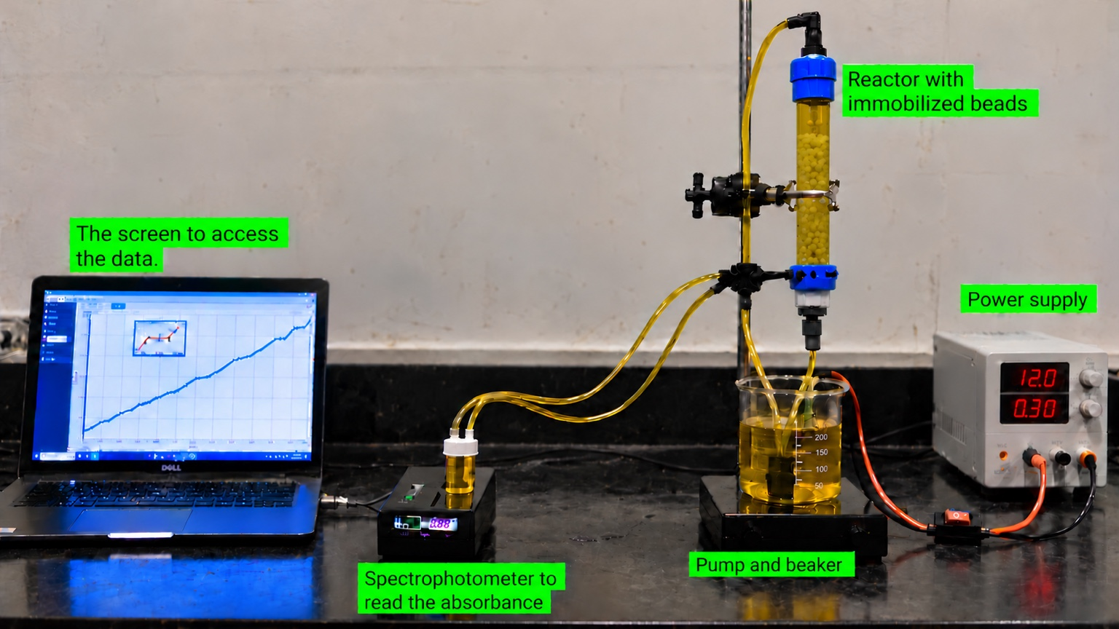
Fig. 1 Recirculating immobilized-enzyme apparatus used to motivate the Stages 1–3 simulation.
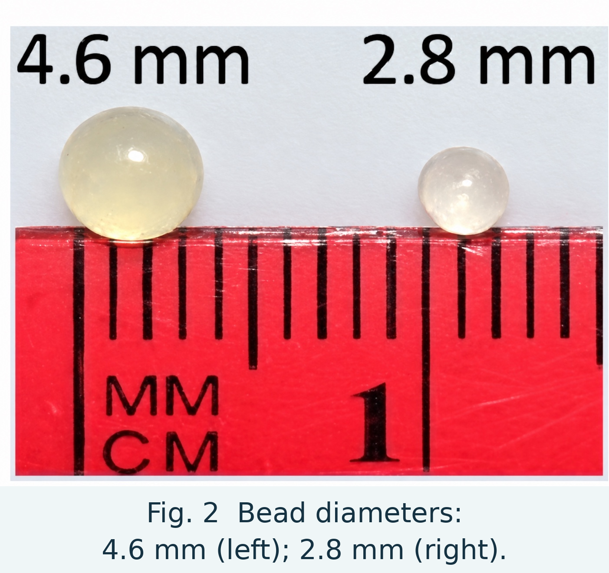

Click the “About” button at the top of the ONPG simulation. The pump recirculates liquid from the reservoir through a fluidized bed of beads containing immobilized β-galactosidase, past the in-line spectrophotometer, and back to the reservoir.
Stages 1 and 2 use the same initial ONPG concentration and total enzyme charge; bead diameter is the intended comparison variable.

System and Measurement: Blanking and Calibration
Before each run, the experimentalist obtains a baseline absorbance for the clear ONPG-containing liquid and zeroes the spectrophotometer. This subtracts background absorption so the remaining 415 nm signal is attributed to ONP formation.
Before measuring ONP, blank the spectrophotometer using a clear liquid reference. The reference cuvette at left is not empty. The seven Stage 4 assay cuvettes have equal enzyme amounts but different initial ONPG concentrations; their yellow color represents ONP formation during the scan.
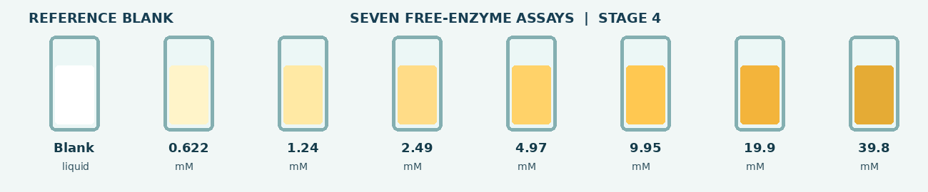
Fig. 3 Clear reference blank (left) and seven Stage 4 ONPG assay cuvettes (right). Stronger yellow represents greater ONP formation.

Experimental ONP Calibration Curve
The eight measured ONP calibration points and the zero-intercept fitted line are shown in Fig. 4. The horizontal axis is ONP concentration [mM]; the vertical axis is dimensionless absorbance at 415 nm. The fitted slope is 3.4337 mM⁻¹ (R² = 0.9982). Use 3.43 mM⁻¹ for calculations.

Fig. 4 Experimental ONP calibration data (zero-intercept fit: 3.4337 mM⁻¹, R² = 0.9982). Use 3.43 mM⁻¹ for calculations.
$$C_{ONP} = \frac{{\text{ABS}}_{\text{415}}}{3.43}$$

Predictions Before Experiment 1
1. Before running the simulation, which bead size do you expect to produce ONP faster, the 2.8 mm or 4.6 mm bead? Give reasons for your prediction.

2. Before running the simulation, sketch $C_{ONP}$ versus time for both bead sizes on Fig. 5.

Fig. 5 Prediction axes for 2.8 mm and 4.6 mm beads. Label both curves.
3. What are the reasons you sketch this the way you did?

Experiment 1: Compare the Two Bead Sizes (Stages 1–3)
Purpose: Compare $C_{ONP}$ vs. time for 2.8 mm and 4.6 mm beads.

Procedure
1. Open Stage 1 (2.8 mm beads). Click “Set autosampler · six sample times.”
2. Click “Start 340-min run (1-minute playback).” The simulated 340-minute experiment runs in 60 seconds, recording ONP concentration at 0, 28, 85, 170, 255 and 340 equivalent lab minutes. Observe the smooth full-conversion curve.
3. Continue to Stage 2 (4.6 mm beads). Set the same six-time autosampler and run its 60-second simulation.
4. Open Stage 3 to compare the two saved runs. No new reactor run is performed in Stage 3.

Experiment 1: Paired Results and Performance
Record the six ONP concentrations from Stages 1 and 2 at the matching times below. Stage 3 displays the same six samples and both complete conversion responses.
Equivalent lab time [min] | ONP concentration [mM]  2.8 mm beads | ONP concentration [mM]  4.6 mm beads
0 | 0 | 0
28
85
170
255
340
4. At the same time points, which bead size produced the higher ONP concentration? Cite one pair of values from the table, e.g., at 170 min.

Bead-Size Comparison and Internal Mass Transfer
Use the Stage 3 comparison screen and record the summary values.
Bead diameter [mm] | Initial rate [mM/min] | Final conversion [%] | Internal effectiveness factor, ηᵢ [–]
2.8
4.6
5. Which bead preparation reacted faster? Support your conclusion with the displayed initial rates and final conversions.

Experiment 1: Internal Concentration and Effectiveness
The internal effectiveness factor, ηᵢ, is the integrated whole-bead reaction rate divided by the rate expected if the entire bead were at its surface ONPG concentration. A smaller ηᵢ indicates stronger internal diffusion limitations.
Smaller beads have more external area per total bead volume, allowing beads to see a higher concentration overall. ONPG is consumed in the outer region of a bead; if diffusion cannot replenish it quickly enough, the inner region receives little ONPG which reduced the reaction rate in the interior.
6. Which bead has the larger decrease in ONPG concentration with dimensionless radius, i.e., from the bead surface to the bead center?

7. What is happening to ONPG inside the larger bead compared to the smaller bead? Look at $r/R$ = 0.6. Hints:
What is the concentration of the ONPG for the larger bead at $r/R$ = 0.6 compared to the smaller bead?

If the concentration in one case is higher what happens to the reaction rate inside the bead at the same $r/R$? Consider mass action effects where larger concentrations mean more frequent molecular collisions.

If ONPG concentration is very low below $r/R$ = 0.6 what happens to the reaction rate there?

How is that difference reflected in $η_{i}$?

8. Return to your prediction before Experiment 1. What would you keep or revise after comparing the two runs?

Experiment 2: Free-Enzyme Kinetics (Stage 4)
Purpose: compare seven ONPG concentrations with equal enzyme amount, solution volume, pH and temperature. Six initial rates are supplied laboratory values, and the 39.8 mM virtual assay follows the stated Michaelis–Menten reference model.

Why the Slope Is Used
Each trace plots ONP concentration vs. time. During the first few seconds, the response is treated as approximately linear. The slope of each line is the initial reaction rate.
$$v_{0} = \frac{ΔC_ONP}{Δt}$$
The seven slopes become seven points on the rate-versus-initial-ONPG-concentration plot in Stage 5.

Procedure
1. Open Stage 4 and click “Load seven cuvettes.”
2. Click “Blank spectrophotometer.” The background reading is subtracted and the baseline becomes zero before further color change due to yellow-colored ONP formation.
3. Click “Start 4.5-s scan.” Seven ONP-concentration-versus-time traces appear together.
4. Click “Show initial rates” and enter the seven values below.
Initial ONPG, C_ONPG,0 [mM] | Initial rate, v₀ [mM/s]
0.622
1.24
2.49
4.97
9.95
19.9
39.8
9. Compare the slopes at 0.622 and 4.97 mM, and then at 19.9 and 39.8 mM ONPG. Explain why the rate increases more slowly as substrate becomes abundant.

Experiment 2: Michaelis–Menten Analysis (Stage 5)
10. Predict the shape of initial rate v₀ versus initial ONPG concentration C_ONPG,0 from 0 to 40 mM. Sketch your prediction on Fig. 6 and explain the expected saturation.

Fig. 6 Prediction and initial-rate plot (0–40 mM). Use a dashed predicted curve and plot all seven Stage 4 virtual-lab rates.

11. Plot the seven Stage 4 rates on Fig. 6, then build the Stage 5 rate curve. Compare the data with your predicted shape.

The 39.8 mM trace in Stages 4 and 5 is a simulated Michaelis–Menten extension, not an additional laboratory measurement. The reference uses Kₘ = 2.00 mM and Vₘₐₓ = 0.002510 mM/s, anchored to the supplied 19.9 mM rate. The model assumes no substrate inhibition.
$$v₀ = \frac{Vₘₐₓ C_ONPG,0}{Kₘ + C_ONPG,0}$$

Experiment 2: Interpretation of Kinetics
12. Using Fig. 6 and Stage 5, describe how v₀ changes with initial ONPG concentration.

At low ONPG concentrations, why is v₀ approximately proportional to C_ONPG,0?

At high ONPG concentrations, enzyme active sites become nearly saturated. Explain why adding more ONPG produces very little additional rate increase.

13. Calculate Vₘₐₓ/2 using the Stage 5 reference and locate the corresponding C_ONPG,0 on the rate curve. How does this concentration compare with Kₘ?

Experiment 3: Bead-Diameter Design (Stage 6)
Purpose: Adjust bead diameter and compare 0.6 mm and 0.3 mm against the internal effectiveness factor target η_{i} ≥ 0.95.

Procedure
1. In Stage 6, use the slider or exact-diameter field to set 0.6 mm. Click “Calculate,” then save the result.
2. Set the diameter to 0.3 mm, calculate, and save its result. You may also explore other diameters using the slider or exact-value field and save any additional results. These extra trials are optional.
3. Record the internal effectiveness factors and the surface and center ONPG concentrations for both diameters. Identify which one meets η_{i} ≥ 0.95.
4. Compare the two saved surface-to-center ONPG concentration profiles.
Result | Diameter [mm] | ηᵢ [–] | Surface ONPG [mM] | Center ONPG [mM]
Large laboratory bead | 4.6 | 0.2885
Small laboratory bead | 2.8 | 0.4890
Assigned 0.6 mm design | 0.6
Assigned 0.3 mm design | 0.3
14. For the assigned diameter with η_{i} ≥ 0.95, what is true about its ONPG concentration profile?

What does that say about diffusion vs. reaction rate for these conditions? Think about the driving force for diffusion, a concentration gradient, and the driving force for reaction, a specific concentration in the M-M equation.

15. Which of the two assigned bead diameters (0.6 mm or 0.3 mm) satisfies η_{i} ≥ 0.95? Use both ONPG concentration profiles and the internal effectiveness factors to support your answer.

16. Would there be any detriments to choosing a very small bead diameter?

17. Why should we immobilize the enzyme at all if the fastest rate is when we have no beads at all, just the enzyme in solution.

Homework Problems
Complete these problems after using the simulation. Show the equations, values, units and reasoning used in your answers. Use the six supplied laboratory rates for regression; do not treat the additional 39.8 mM model-based assay as an independent measurement.
Submission note: Clearly label each answer and include units. Attach extra calculation space if needed.

Homework 1: ONP Measurement and Reaction Rates
Question 1. Verify the absorbance calibration and estimate early reaction rates using your bead-run records.
a. Select one nonzero equivalent laboratory time recorded for both bead sizes (for example, 170 min). Use the ONP concentrations in your Stage 3 paired-results table and the supplied calibration relationship to calculate the corresponding blank-corrected ${\text{ABS}}_{415}$ reading for each bead size. Show the equation, substitutions, and units for $C_{ONP}$, and explain how these results follow from the calibration equation.

b. Using ONP concentrations at 0 and 28 equivalent lab minutes, calculate the first-interval average rate for each bead size in mM/min. Explain why this two-point average differs from the initial rate obtained by fitting the complete 0–60 min reactor response.

$$v_{early} ≈ \frac{C_{ONP}(28 min) - C_{ONP}(0 min)}{28 min}$$

Homework 2: ONPG Kinetics — Short Mathematical Analysis
Question 2. For free β-galactosidase, ONPG is the substrate and ONP is the measured product. Use the initial-rate equation below (not a full mechanism derivation).
$$v₀ = \frac{Vₘₐₓ C_ONPG,0}{Kₘ + C_ONPG,0}$$
a. In one sentence each, define Vₘₐₓ and Kₘ. State their units (mM/s and mM).
b. Take the reciprocal of the ONPG equation and identify the slope m and intercept b of a plot of 1/v₀ against 1/C_ONPG,0.
$$\frac{1}{v₀} = \frac{Kₘ}{Vₘₐₓ} × \frac{1}{C_ONPG,0} + \frac{1}{Vₘₐₓ}$$
c. Write two short expressions for calculating Vₘₐₓ and Kₘ from the reciprocal-plot slope and intercept.
$$Vₘₐₓ = \frac{1}{b} Kₘ = \frac{m}{b}$$
Calculations and interpretation:

Question 3. Using only the six supplied laboratory initial rates (0.622–19.9 mM), plot 1/v₀ versus 1/C_ONPG,0 on Fig. 7 and fit a straight line. Calculate Vₘₐₓ and Kₘ from the fitted slope and intercept. The additional 39.8 mM virtual rate is excluded from this experimental fit.
Slope [s]: ___________________ Intercept [s/mM]: ___________________

Fig. 7 Reciprocal plot for the six supplied ONPG laboratory rates. Draw a best-fit line.
Calculated $v_{max}$ [mM/s]: _______________ $K_{m}$ [mM]: _______________

The six-rate reciprocal regression need not match the Stage 5 reference (Kₘ = 2.00 mM, Vₘₐₓ = 0.002510 mM/s), which is anchored to the 19.9 mM supplied rate rather than globally fitted. Reciprocal fitting also changes the weighting of experimental errors.
Write the slope and intercept of your line and show how they give Vₘₐₓ and Kₘ. Briefly explain why the reciprocal fit differs from the Stage 5 reference.

Question 4. Compare the rates at 9.95, 19.9 and 39.8 mM ONPG. The 39.8 mM value is model-generated. Explain why additional substrate produces only a small increase in rate near saturation.

