ONPG Bead Reactor  VIRTUAL LABORATORY WORKSHEET | β-GAL  KINETICS +  MASS TRANSFER
Name(s) | Course / section | Date
Student learning objectives
• Compare ONP production by 2.8 mm and 4.6 mm beads prepared with the same enzyme charge.
• Relate bead diameter, external area per bead volume, radial ONPG profiles, and internal effectiveness.
• Use six free-enzyme assays to recognize a Michaelis–Menten initial-rate response and interpret Km and Vmax.
• Select a bead diameter that meets an internal-effectiveness design target and support the choice with a concentration profile.
System and measurement
Colorless ONPG circulates through β-galactosidase immobilized in spherical beads. Yellow ONP forms and is measured at 415 nm.  The simulation converts A415 to ONP automatically using A415 = 3.5804[ONP in mM]. | 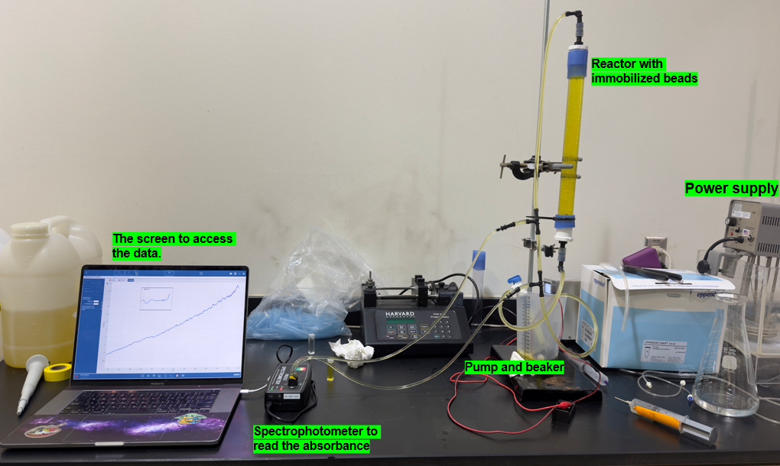  Laboratory reactor used to ground the virtual apparatus
Before opening Stage 1
Two independent 30 mL bead preparations each contain the same 8 mL enzyme charge. One preparation contains 2.8 mm beads and the other contains 4.6 mm beads. Both runs begin with 0.83 mM ONPG.
B1. On the axes below, sketch your predicted ONP-versus-time response for both bead sizes and label both curves. Briefly state the reasoning for your prediction.
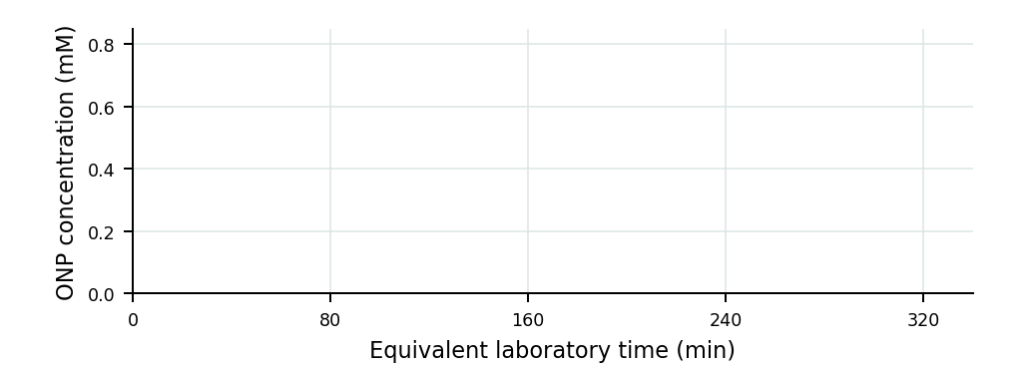

EXPERIMENT 1 · STAGES 1 AND 2
Measure ONP formation for both bead sizes
Purpose: Collect matched automatic readings for two bead preparations that differ only in diameter.

Each simulation lasts 120 s and represents 340 min of laboratory reaction time. Before starting, set the spectrophotometer to record the zero baseline and then one reading every 10 simulation seconds.
Stage 1 · 2.8 mm beads
1. Open Stage 1 and confirm 2.8 mm beads, the same enzyme charge, and 0.83 mM initial ONPG.
2. Click Set automatic readings · every 10 s. Confirm that the table records the 0 s baseline with A415 = 0.000 and ONP = 0.000 mM.
3. Click Start 2-minute simulation. The spectrophotometer will continue automatically every 10 s through 120 s.
4. When all 13 readings are saved, click Continue to Stage 2.
Stage 2 · 4.6 mm beads
1. Confirm that only the bead diameter changed to 4.6 mm.
2. Set the same automatic 10 s sequence, confirm the zero baseline, and click Start 2-minute simulation.
3. When all 13 readings are saved, click Continue to Stage 3.
Record the paired automatic results
Open Stage 3 and copy its paired table below. Simulation time is the accelerated on-screen clock; equivalent laboratory time is the time represented from the supplied experiment.
Simulation  time (s) | Equivalent lab  time (min) | 2.8 mm  A415 | 2.8 mm ONP  (mM) | 2.8 mm ONPG left  (mM) | 4.6 mm  A415 | 4.6 mm ONP  (mM) | 4.6 mm ONPG left  (mM)
0 | 0 | 0.000 | 0.000 | 0.830 | 0.000 | 0.000 | 0.830
10 | 28
20 | 57
30 | 85
40 | 113
50 | 142
60 | 170
70 | 198
80 | 227
90 | 255
100 | 283
110 | 312
120 | 340
B2. At the same simulation time, which run generally produced more ONP? Cite one pair of readings from the table.

EXPERIMENT 1 · STAGE 3
Connect bead diameter with mass transfer
Purpose: Compare the two saved experiments; no new reactor run is performed on this page.

Use the comparison screen
1. Open Stage 3. Do not start another experiment.
2. Inspect Your two automatic sample series and the paired results table generated from Stages 1 and 2.
3. Inspect the two Modeled radial ONPG profiles, then record the summary results.
Bead diameter | Initial rate  (mM/min) | t50  (min) | t80  (min) | Final conversion  (%) | Internal ηi
2.8 mm
4.6 mm
B3. Which bead preparation reacted faster? Support your answer with both an initial-rate value and one time-based result.
Geometry after the observation
For spherical beads with equal total bead volume, calculate total external area per total bead volume:
Aₜₒₜₐₗ / Vₜₒₜₐₗ = 6 / d
Diameter, d | Calculation | A total / V total (mm⁻¹)
2.8 mm | 6 / 2.8
4.6 mm | 6 / 4.6
B4. How does the area-to-volume comparison agree or disagree with the measured ONP response? Cite one performance value.
Internal concentration after the profiles
Internal effectiveness compares the actual whole-bead rate with the rate if the entire bead were at its surface ONPG concentration.
B5. Which bead has the larger center-to-surface ONPG decrease? Explain how that observation is reflected in the two ηi values.
B6. Return to your Page 1 prediction. What did the experimental and model evidence support, and what—if anything—would you revise?

EXPERIMENT 2 · STAGE 4
Run the six-cuvette kinetic scan
Purpose: Observe how initial substrate concentration changes the early rate of a free enzyme reaction.

Beads are absent. Every cuvette contains the same free-enzyme amount, solution volume, pH, and temperature. Only initial ONPG concentration changes. Before blanking, the display shows A415 = 0.056 from background absorbance by the cuvette and reaction mixture; blanking subtracts this background and establishes A415 = 0.000.
Predict before collecting data
K1. Sketch your predicted initial rate, v0, versus initial ONPG concentration. Briefly explain the shape you predicted.
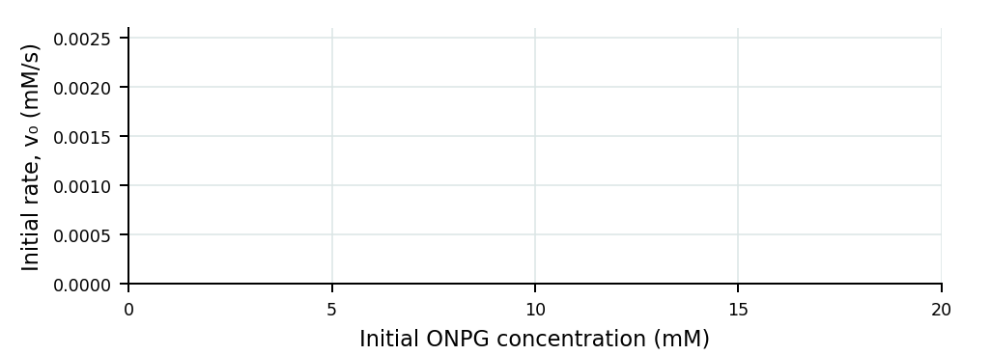
Run the virtual experiment
1. Open Stage 4, observe the A415 = 0.056 background reading, and click Load six cuvettes.
2. Click Blank spectrophotometer. Confirm that the background reading changes from 0.056 to 0.000.
3. Click Start 4.5-s scan. Observe all six ONP-time traces on the same graph.
4. Click Show initial rates and transfer the results below.
Initial ONPG  (mM) | Initial rate, v0  (mM/s) | ONP at 4.5 s  (mM) | A415 at 4.5 s
0.622
1.244
2.488
4.975
9.95
19.9
K2. Which ONP-time line is steepest? Report its initial ONPG concentration and rate, then state what that slope represents physically.

EXPERIMENT 2 · STAGES 4 AND 5
Interpret the Michaelis–Menten response
Purpose: Use the six measured slopes to decide how substrate concentration affects enzyme rate.

Compare equal concentration changes
For each substrate doubling, calculate the rate factor as v0 at the higher concentration divided by v0 at the lower concentration.
K3. Calculate the rate factor for 1.24 → 2.49 mM ONPG and for 9.95 → 19.9 mM ONPG.
Low-concentration factor = __________ High-concentration factor = __________
K4. Did doubling ONPG have the same effect in both concentration ranges? Support your answer with the two factors.
Build the rate curve
1. Open Stage 5 and click Build kinetics plot.
2. Inspect the measured v0 points and the fitted Michaelis–Menten curve.
3. Use the graph to complete K5 and K6. Click Show half-maximum guide only after making your own estimate.
v₀ = Vmax[S]₀ / (Km + [S]₀)
K5. Describe the shape of v0 versus initial ONPG. Is the response linear over the full range? Cite two results from the graph or table.
K6. Find the half-maximum point on the Michaelis–Menten graph. Calculate one-half of Vmax = 0.00226 mM/s. Locate this rate on the vertical axis, follow it across to the fitted curve, and then read the corresponding initial ONPG concentration from the horizontal axis.
Vmax ÷ 2 = __________ mM/s → Initial ONPG = __________ mM

MODEL DESIGN · STAGE 6
Select a bead diameter using internal effectiveness
Purpose: Change diameter—not ηi—to find the largest tested bead that meets the stated utilization target.

This is a model investigation, not a timed reactor run. Initial ONPG and enzyme kinetics remain fixed. The 2.8 and 4.6 mm rows are laboratory-tested bead sizes; smaller sizes are model predictions.
Design action
1. Open Stage 6. Use the diameter slider or the − / + controls.
2. Near the target boundary, decrease diameter in 0.1 mm increments and click Save this result after each trial.
3. Continue until you have saved one result immediately below ηi = 0.95 and the largest diameter at or above ηi = 0.95.
4. Copy the final two Design table rows below. Their profiles will appear together on the simulation graph.
Result | Diameter  (mm) | Internal ηi | Surface ONPG  (mM) | Center ONPG  (mM)
Large laboratory bead | 4.6 | 0.29
Small laboratory bead | 2.8 | 0.45
Closest tested result below 0.95
Largest tested diameter at/above 0.95
D1. What is the largest tested bead diameter that meets ηi ≥ 0.95? Report the ηi values on both sides of the pass/fail boundary.
D2. Which bead diameter would you select? Explain how the two surface-to-center ONPG profiles support your selection.
Class activity submission check
□ Thirteen automatic readings saved for each bead size  □ Stage 3 paired comparison and A/V calculations complete  □ Original predictions remain visible | □ Six kinetic rates recorded  □ Half-maximum point recorded  □ Passing and failing bead designs saved

HOMEWORK
Apply the kinetic relationships
Purpose: Use the saved Stage 4 and Stage 5 results; show units and brief reasoning.

Michaelis–Menten equation: v₀ = Vmax[S]₀ / (Km + [S]₀)
H1. Using your K6 result, explain in words what Km means for this enzyme–substrate system.
H2. What does Vmax represent? State the experimental condition required for the rate to approach Vmax.
H3. At high ONPG concentration, what limits the reaction rate? Use the high-concentration portion of the Stage 5 graph as evidence.
The fractional Michaelis–Menten occupancy term is:
Fractional occupancy = [S]₀ / (Km + [S]₀)
H4. Using Km = 2.00 mM, calculate the fractional occupancy at 0.62 mM and 19.9 mM ONPG. Report each result as a fraction or percent.
H5. Use your H4 values and the shape of the Stage 5 curve to explain why equal increases in ONPG produce diminishing increases in rate at high substrate concentration.
Submission reminder
Keep predictions unchanged, cite simulation values in explanations, and label all numerical answers with units where applicable.

