ONPG Bead Reactor, Enzyme Kinetics and Internal Diffusion
Faraz Rahimi | David B. Thiessen | Bernard J. Van Wie
Voiland School of Chemical Engineering & Bioengineering • Washington State University
Pullman, WA 99164-6515
Simulation: https://farazrahimi95-collab.github.io/labs/onpg/
Worksheet revised October 2026
Student name(s): _______________________________________ Date: ____________________
For all questions, report numerical values with units and cite simulation tables or graphs when supporting your answers.

Educational Purpose
Through this virtual experiment, students examine β-galactosidase-catalyzed ONPG hydrolysis, compare two immobilized-enzyme bead sizes, and use free-enzyme reaction-rate data to investigate Michaelis–Menten kinetics.

Student Learning Objectives
• Use calibrated absorbance readings at 415 nm to determine ONP concentration. ONP absorbs strongly at this wavelength.
• Compare ONP production for 2.8 mm and 4.6 mm beads prepared with the same total reactor enzyme charge.
• Determine initial reaction rate from the slope of an ONP concentration–time curve.
• Use the six supplied free-enzyme initial rates and one 39.8 mM simulated assay to interpret a Michaelis–Menten response.
• Explain how bead diameter and internal substrate availability influence the internal effectiveness factor, η_{i}.

System and Measurement
β-Galactosidase catalyzes the hydrolysis shown below. The yellow product ONP is measured using absorbance at 415 nm (ABS₄₁₅).
ONPG + | H₂O | β-galactosidase  ⟶ | ONP + | D-galactose
o-nitrophenyl-β-D-  galactopyranoside | water | enzyme catalyst | o-nitrophenol  (yellow product) | galactose
Blanking sets the baseline to zero by subtracting background absorbance from the cuvette and solution before measuring ONP.
$${\text{ABS}}_{\text{415}} = 3.43 × C_{ONP}$$
$$C_{ONP} = \frac{{\text{ABS}}_{\text{415}}}{3.43}$$
The experimental ONP calibration is shown in Fig. 4. Use the calibration slope of 3.43 mM⁻¹ throughout this worksheet and the simulation.

Before Operating the Simulation
The recirculating apparatus is shown in Fig. 1. The two laboratory bead sizes are shown in Fig. 2.
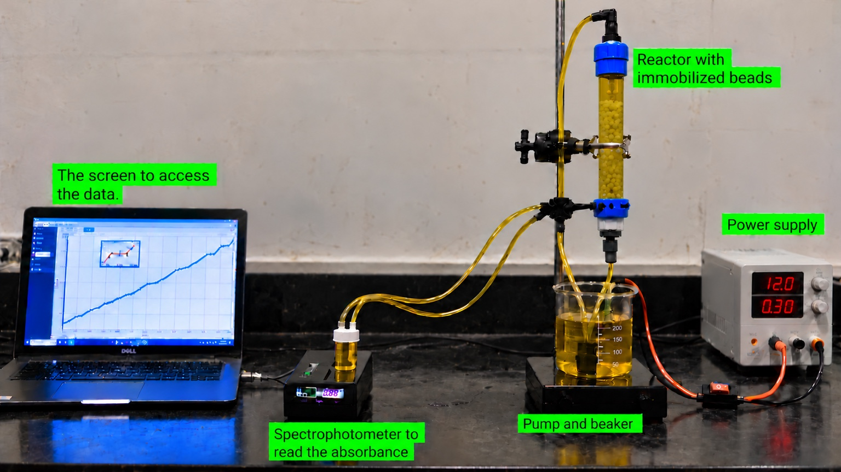
Fig. 1 Recirculating immobilized-enzyme apparatus used to motivate the Stages 4–6 simulation.
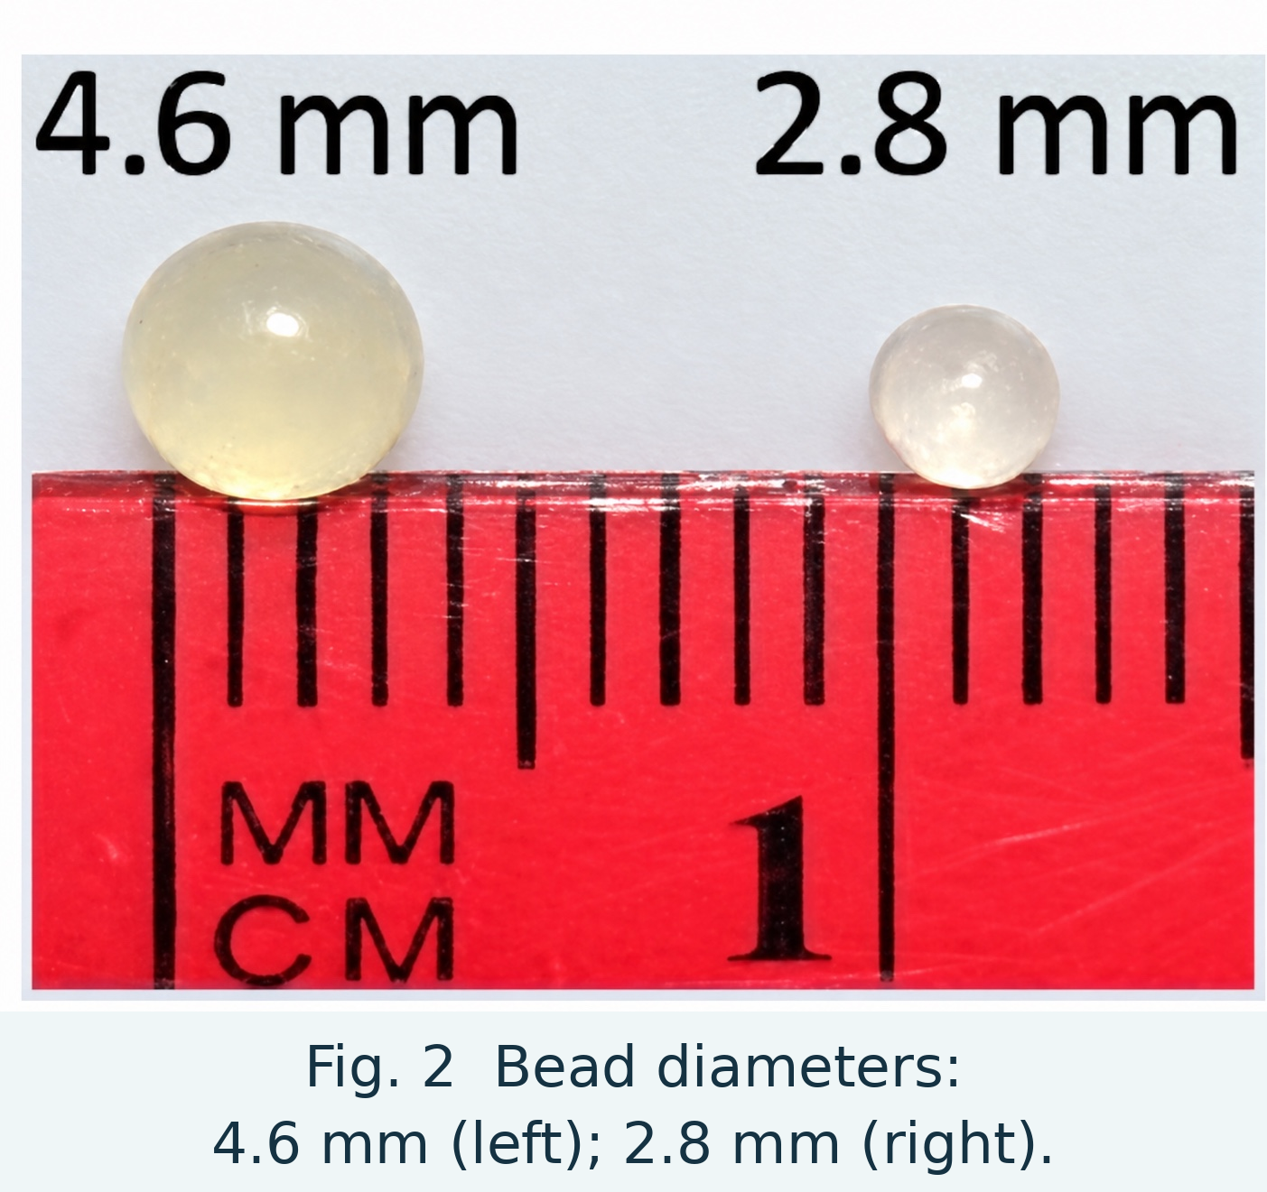

Click the “About” button at the top of the ONPG simulation. The pump recirculates liquid from the reservoir through a fluidized bed of beads containing immobilized β-galactosidase, past the in-line spectrophotometer, and back to the reservoir.
Stages 4 and 5 use the same initial ONPG concentration and total enzyme charge; bead diameter is the intended comparison variable.

System and Measurement: Blanking and Calibration
Before each run, the experimentalist obtains a baseline absorbance for the clear ONPG-containing liquid and zeroes the spectrophotometer. This subtracts background absorption so the remaining 415 nm signal is attributed to ONP formation.
Before measuring ONP, blank the spectrophotometer using a clear liquid reference. The reference cuvette at left is not empty. The seven Stage 1 assay cuvettes have equal enzyme amounts but different initial ONPG concentrations; their yellow color represents ONP formation during the scan.
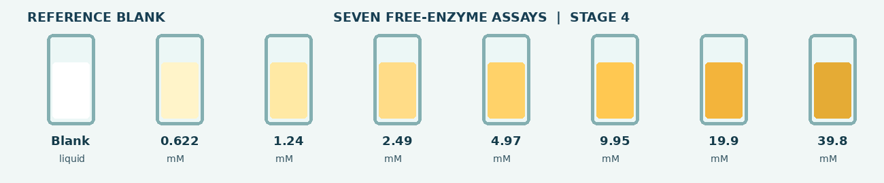
Fig. 3 Clear reference blank (left) and seven Stage 1 ONPG assay cuvettes (right). Stronger yellow represents greater ONP formation.

Experimental ONP Calibration Curve
Figure 4 shows eight experimental ONP calibration points and the fitted line. The horizontal axis is ONP concentration [mM] and the vertical axis is absorbance at 415 nm. Use 3.43 mM⁻¹ as the calibration slope.

Fig. 4 Experimental ONP calibration data.
$$C_{ONP} = \frac{{\text{ABS}}_{\text{415}}}{3.43}$$

Experiment 1: Free-Enzyme Kinetics (Stage 1)
Purpose: compare seven ONPG concentrations with equal enzyme amount, solution volume, pH and temperature. Six initial rates are supplied laboratory values, and the 39.8 mM virtual assay follows the stated Michaelis–Menten reference model.

Why the Slope Is Used
Each trace plots ONP concentration vs. time. During the first few seconds, the response is treated as approximately linear. The slope of each line is the initial reaction rate.
$$v_{0} = \frac{ΔC_{ONP}}{Δt}$$
The seven initial rates appear together in Stage 2, including the one explicitly simulated 39.8 mM assay.

Procedure
1. Open Stage 1 and click “Load seven cuvettes.”
2. Click “Blank spectrophotometer.” The background reading is subtracted, and the baseline becomes zero before further color change due to yellow-colored ONP formation.
3. Click “Start 4.5-s scan.” Seven ONP-concentration-versus-time traces appear together.
4. Click “Show initial rates” and enter the seven values below.
Initial ONPG concentration, C_{ONPG,0} [mM] | Initial rate, v₀ [mM/s]
0.622
1.24
2.49
4.97
9.95
19.9
39.8
1. Compare the slopes at 0.622 and 4.97 mM, and then at 19.9 and 39.8 mM ONPG. Explain why the rate increases more slowly as substrate becomes abundant.

When this stage is complete, click “Continue to Stage 2” at the bottom of the simulation.

Experiment 1: Michaelis–Menten Analysis (Stage 2)

Procedure
1. After completing Stage 1, click “Continue to Stage 2” at the bottom of the simulation.
2. Before building the plot, complete the prediction in Question 2 on Fig. 5. Then click “Build kinetics plot” in the simulation.
3. Click “Show half-maximum guide” in the simulation and use the displayed curve to answer Questions 3–4.

Fig. 5. Initial-rate prediction graph (0–40 mM ONPG). Sketch your expected curve.
2. Predict the shape of initial rate v₀ versus initial ONPG concentration C_{ONPG,0} from 0 to 40 mM. Sketch your prediction on Fig. 5 and explain the expected trends.

Stage 2 Questions: Interpretation of Kinetics
3. After clicking “Build kinetics plot” in Stage 2 of the simulation, compare the displayed curve with your prediction in Fig. 5. Does the simulation agree with your prediction? Based on the simulation curve, describe how v₀ changes with initial ONPG concentration.

At low ONPG concentrations, why is v₀ approximately proportional to C_{ONPG,0}?
Hint: Think about molecular collision frequency with higher concentrations.

At high ONPG concentrations, enzyme active sites become nearly saturated. Explain why adding more ONPG produces very little additional rate increase.

4. Calculate V_{max}/2 using the Stage 2 curve and locate the corresponding C_{ONPG,0} from the rate curve. How does this concentration compare with K_{m}?

When this stage is complete, click “Continue to Stage 3” at the bottom of the simulation.

Experiment 2: Bead-Diameter Design (Stage 3)
Purpose: Adjust bead diameter and compare 0.6 mm and 0.3 mm against the internal effectiveness factor target η_{i} ≥ 0.95.

Procedure
1. In Stage 3, use the slider or write the exact diameter in the box to set 4.6, 2.8, 0.6, and 0.3 mm. Click “Save result” for each one.
2. Record the internal effectiveness factors and the surface and center ONPG concentrations for both diameters. Identify which one meets $η_{i}$≥ 0.95.
3. Compare the four saved surface-to-center ONPG concentration profiles.

Result | Diameter [mm] | $$η_{i}$$ | Surface ONPG  [mM] | Center ONPG  [mM]
Large laboratory bead | 4.6 | 0.2885
Small laboratory bead | 2.8 | 0.4890
Assigned 0.6 mm bead | 0.6
Assigned 0.3 mm bead | 0.3

5. For the assigned diameter, which has $η_{i}$≥ 0.95? What is true about the ONPG concentration profile?

What happens to the ONPG reactant concentration profile with the largest 4.6mm and smallest 0.3 mm beads?

6. Would there be any detriments to choosing a very small bead diameter?

7. Why should we immobilize the enzyme at all if the fastest rate is when we have no beads at all, just the enzyme in solution.

When this stage is complete, click “Continue to Stage 4” at the bottom of the simulation.

Experiment 3: Compare the Two Bead Sizes (Stages 4–6)
Purpose: Compare $C_{ONP}$ vs. time for 2.8 mm and 4.6 mm beads.

Procedure
1. In Stage 4 (2.8 mm beads), click “Set autosampler · six sample times.” This captures the initial reading at 0 min and schedules five more readings.
2. Click “Start 340-min run (10 sec playback).” The simulated 340-minute experiment runs in 10 sec, recording ONP concentration at 0, 28, 85, 170, 255, and 340 equivalent lab minutes. Observe the smooth full-conversion curve.
3. Click “Continue to Stage 5” in the simulation. For the 4.6 mm beads, click “Set autosampler · six sample times,” then “Start 340-min run (10 sec playback).” The same six equivalent laboratory times are recorded.
4. Click “Continue to Stage 6” in the simulation to compare the six readings and complete ONP concentration–time curves for both bead sizes. No additional reactor run is performed in Stage 6.
After reading the complete procedure above, answer prediction Questions 9–11 below before starting the simulation in Stage 4. Then perform Stages 4–6 and answer the remaining comparison questions.

Predictions Before the Reactor Runs
8. Before running the simulation, which bead size do you expect to produce ONP faster, the 2.8 mm or 4.6 mm bead? Give reasons for your prediction.

9. Before running the simulation, sketch $C_{ONP}$ versus time for both 2.8 and 4.6 bead sizes on Fig. 6.

Fig. 6 Prediction for 2.8 mm and 4.6 mm beads. Label both curves.
10. What are the reasons you sketched this the way you did?

Paired Results and Performance
Record the six ONP concentrations from Stages 4 and 5 at the matching times below. Stage 6 displays the same six samples and both complete conversion responses.
Equivalent lab time [min] | ONP concentration [mM]  2.8 mm beads | ONP concentration [mM]  4.6 mm beads
0 | 0 | 0
28
85
170
255
340
11. At the same time points, which bead size produced the higher ONP concentration? Cite one pair of values from the table, e.g., at 170 min.

Bead-Size Comparison and Internal Mass Transfer
Use the Stage 6 comparison screen and record the summary values.
Bead diameter [mm] | Initial rate [mM/min] | Final conversion [%] | Internal effectiveness factor $η_{i}$[–]
2.8
4.6
Note: For both bead sizes the reactor has the same total amount of enzyme.
12. Or the full diced bed reactions shown in stages 4 and five where bead size leads to a faster conversion of ONPG to colored ONP?

Internal Concentration and Effectiveness
The internal effectiveness factor, η_{i}, is the integrated whole-bead reaction rate divided by the rate expected if the entire bead were at its surface ONPG concentration. A smaller η_{i} indicates stronger internal diffusion limitations.
Smaller beads have more external area per total bead volume, allowing beads to see a higher concentration overall. ONPG is consumed in the outer region of a bead; if diffusion cannot replenish it quickly enough, the inner region receives little ONPG, which reduces the reaction rate in the interior.
13. Which bead has the greater percentage decrease in ONPG concentration from its surface to its center? For each bead, calculate 100 × (C_{s} − C_{c}) / C_{s}, where C_{s} and C_{c} are the surface and center ONPG concentrations, respectively.

14. What is happening to ONPG inside the larger bead compared to the smaller bead? Look at $r/R$ = 0.6. Hints:
What is the concentration of the ONPG for the larger bead at $r/R$ = 0.6 compared to the smaller bead?

If the concentration in one case is higher what happens to the reaction rate inside the bead at the same $r/R$? Consider mass action effects where larger concentrations mean more frequent molecular collisions.

If ONPG concentration is very low below $r/R$ = 0.6 what happens to the reaction rate there?

How is that difference reflected in $η_{i}$?

15. Return to your prediction before Experiment 3. What would you keep or revise after comparing the two runs?

Homework Questions
Complete these problems after using the simulation. Show the equations, values, units and reasoning used in your answers. Use all seven Stage 1 initial rates in the kinetics and reciprocal-plot questions.
Submission note: Clearly label each answer and include units. Attach extra calculation space if needed.
Question 1. For free β-galactosidase, ONPG is the substrate, and ONP is the measured product. Use the initial-rate equation below (not a full mechanism derivation).
$$v_{0} = \frac{V_{max} C_{ONPG,0}}{K_{m} + C_{ONPG,0}}$$
a. Define V_{max} (mM/s) and K_{m} (mM), including their physical meaning.
b. Take the reciprocal of the ONPG equation and identify the slope m and intercept b of a plot of 1/v₀ against 1/C_{ONPG,0}.
$$\frac{1}{v_{0}} = \frac{K_{m}}{V_{max}} × \frac{1}{C_{ONPG,0}} + \frac{1}{V_{max}}$$
$$y=(m×x)+b$$
c. Write two short expressions for calculating V_{max} and K_{m} from the reciprocal-plot slope and intercept.
$$V_{max} = \frac{1}{b}; K_{m} = \frac{m}{b}$$
Calculations and interpretation:

Question 2. Using all seven Stage 1 initial rates (0.622–39.8 mM), plot 1/v₀ versus 1/C_{ONPG,0} on Fig. 7 and fit a straight line. Calculate V_{max} and K_{m} from the fitted slope and intercept.
Slope, m [s]: __________________ Intercept, b [s/mM]: __________________

Fig. 7. Reciprocal plot for all seven Stage 1 initial rates.
Calculated V_{max} [mM/s]: ______________ K_{m} [mM]: ______________
Question 3. Compare the rates at 9.95, 19.9 and 39.8 mM ONPG. The 39.8 mM value is model-generated. Explain why additional substrate produces only a small increase in rate near saturation.

