Developed by
Faraz Rahimi • David B. Thiessen • Bernard J. Van Wie
Name(s): __________________________________________ Date: __________________
Educational Purpose
This digital experiment will guide students to examine heat loss from a hot cylindrical vessel through a steel wall and insulation, followed by convection and radiation from the outer surface.
Student Learning Objectives
- Identify the heat-flow path and types of heat losses to the ambient air.
- Distinguish series from parallel mechanisms.
- Explain how convection coefficient and surface emissivity affect the two outer-surface heat-loss effects.
- Explain how insulation thickness changes thermal resistance, total heat loss, and outer-surface temperature.
- Use simulation data and governing equations to calculate heat rates, thermal resistances, and temperature changes.
- Determine the minimum selectable insulation thickness that satisfies the outer-surface safety limit.
Before Starting the Digital Experiment
This reaction vessel must maintain a constant internal temperature. Insulation is supplied around the steel vessel to reduce heat loss and keep the outer surface safe for people nearby.
Model assumptions: the inner steel wall is fixed at 800 °C; inside film resistance is neglected. Insulation conductivity is constant at 0.080 W/(m·K). Air and radiative surroundings are both at 25 °C.
$$Vessel Properties: D_{i} = 1.00 m; steel thickness = 0.025 m; L = 6.00 m; k_{steel} = 45\frac{W}{m·K};$$
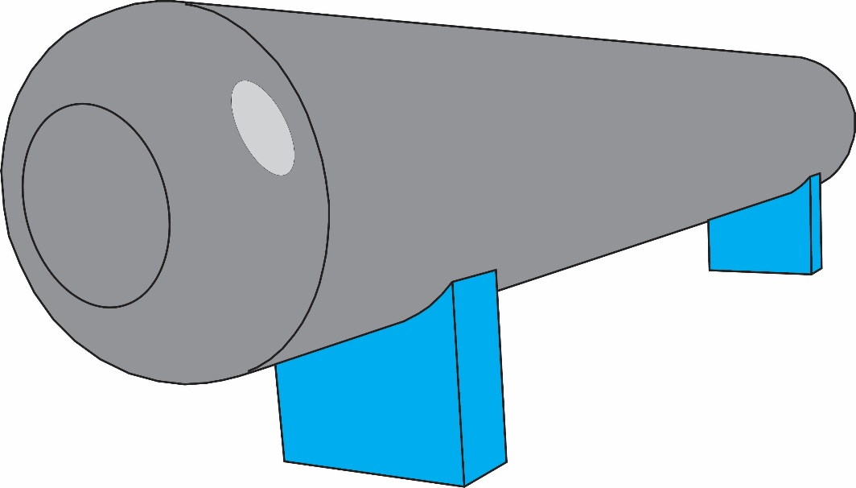
$$T_{Air,∞} = 25 °C$$

Prediction
How do you think heat will travel from the hot reactor interior to the surrounding air?

How will increasing insulation thickness change total heat loss and outer-surface temperature? Explain why.

Convective Heat Transfer
What is convective heat transfer, and why does it occur?

What can be done to increase convection?

Radiative Heat Transfer
What is radiative heat transfer, and why does it occur?

What is emissivity, and how does it affect radiative heat transfer?

How can the emissivity of a surface be changed?

Experiment 1: Parallel Convection and Radiation heat transfer (Case A, Trials 1–3)
Purpose: isolate each heat transfer path to the surroundings, then activate both paths together.
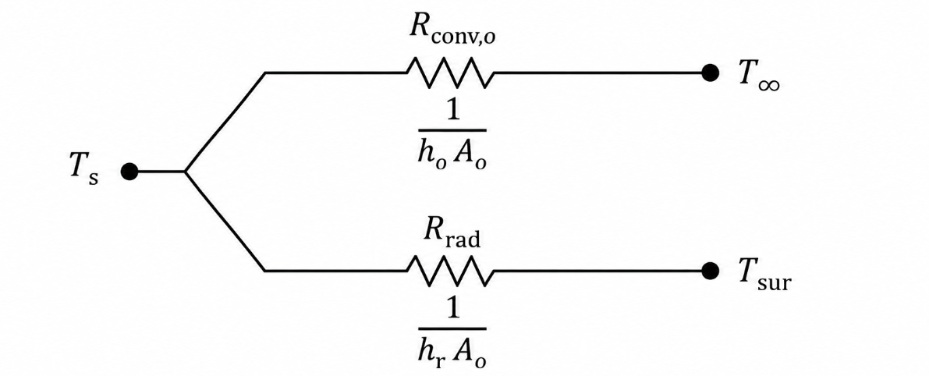
Thermal-network focus for 1–3: convection and radiation branch from the same outer-surface node and therefore act in parallel.
Note: convection transfers heat to the surrounding air, while radiation transfers heat to surrounding surfaces. The zero values of ε and h are idealized limiting cases.
Procedure:
- Click “Parallel paths”. Fixed settings: $T_{in}$ = 800 °C, insulation thickness $t_{ins}$= 0.100 m, $k_{ins}$ = 0.080 W/(m·K).
- For Trial 1, set ε = 0.00 and h = 8 W/(m²·K). Click “Run and record trial” and copy the outputs.
- For Trial 2, change ε to 0.85 and h to 0 W/(m²·K). Click “Run and record trial” and copy the outputs.
- For Trial 3, use ε = 0.85 and h = 8 W/(m²·K). Click “Run and record trial” and copy the outputs.
Table 1. Experimental data for parallel surface paths
Trials | $$ε$$ | $$h$$[W/m²·K] | $$T_{s}$$[°C] | $${\dot{Q}}_{conv} \\ [kW]$$ | $${\dot{Q}}_{rad} \\ [kW]$$ | $${\dot{Q}}_{total} \\ [kW]$$
1 | 0.00 | 8
2 | 0.85 | 0
3 | 0.85 | 8
Questions After Experiment 1
Use the relationships below. Here, h is the convection coefficient, ε is emissivity, A_{o} is the insulated outside area, T_{s} is the outer-surface temperature, and T∞ is the ambient temperature. Use kelvin in the radiation equation.
$${\dot{Q}}_{conv}=hA_{o}\left(T_{s}-T_{∞}\right)$$
$${\dot{Q}}_{rad}=εσA_{o}\left(T_{s,K}^{4}-T_{∞,K}^{4}\right)$$
$${\dot{Q}}_{total}={\dot{Q}}_{conv}+{\dot{Q}}_{rad}$$
- Which run isolates convection and which run isolates radiation?

- In Trial 3, which parallel heat-transfer mechanism contributes more to the total heat loss?

- Why can the trial 1 and 2 heat rates not simply be added to predict trial 3?

- Why do you see a shiny surface (smaller emissivity) on the process vessels?

- Across Trials 1–3, the total heat-loss rates are nearly the same, but the outer-surface temperatures differ. Why can the surface temperature change appreciably while the total heat loss changes only slightly?

Experiment 2: Series Conduction Through Steel and Insulation (Case A, Trials 4–6)
Purpose: Observe how adding insulation resistance changes heat loss and outer-surface temperature.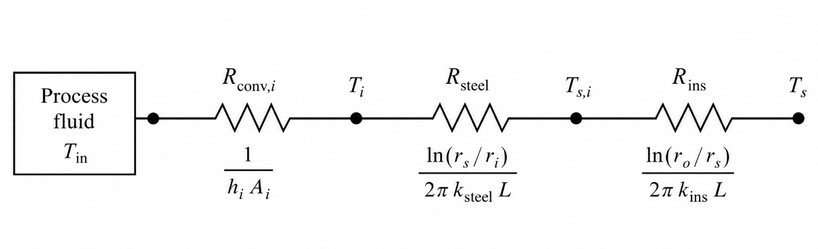
Thermal-network focus for Trials 4–6: process → steel wall → insulation → outer surface is a series conduction path. The inside-film resistance shown in the schematic is neglected in this simulation.
Procedure
- Click “Continue to series conduction”. Fixed settings: $T_{in}$ = 800 °C, $k_{ins}$ = 0.080 W/(m·K), h = 8 W/(m²·K), ε = 0.85.
- Run trial 4 with t = 0.000 m and record all outputs.
- Run trial 5 with t = 0.100 m. Change only the insulation thickness and record all outputs.
- Run trial 6 with t = 0.150 m. Again, change only the insulation thickness and record all outputs.
- Check that trials 4–6 use identical values for every input except insulation thickness.
Table 2. Experimental data for insulation thickness
$$Trials$$ | $$t_{ins} \\ [m]$$ | $$T_{s} \\ [°C]$$ | $${\dot{Q}}_{cond} \\ [kW]$$ | $${\dot{Q}}_{conv} \\ [kW]$$ | $${\dot{Q}}_{rad} \\ [kW]$$ | $${\dot{Q}}_{total} \\ [kW]$$
4 | 0.000
5 | 0.100
6 | 0.150
Questions After Experiment 2
Use the relationships below. The radii r_{i}, r_{s}, and r_{o} are the vessel inner radius, bare-steel outer radius, and insulated outer radius; L is the vessel length; k is the thermal conductivity; and R is the cylindrical thermal resistance.
$$R_{steel}=\frac{ln\left(r_{s}/r_{i}\right)}{2πLk_{steel}}$$
$$R_{ins}=\frac{ln\left(r_{o}/r_{s}\right)}{2πLk_{ins}}$$
$${\dot{Q}}_{cond}=\frac{T_{in}-T_{s}}{R_{steel}+R_{ins}}$$
- Describe the changes in T_{s} and ${\dot{Q}}_{total}$ from trial 4 to 5 to 6.

- Why are the steel-wall and insulation resistances in series rather than in parallel?

- Does the additional 0.050 m of insulation from trial 5 to 6 appear to have the same effect as the first 0.100 m from trial 4 to 5?

Experiment 3: Outer-Surface Safety Limit (Case B, Trials 7–8)
Purpose: find the minimum selectable insulation thickness to keep the touchable outer surface at or below 60 °C.
ASTM International. (2020). ASTM C1055-20: Standard guide for heated system surface conditions that produce contact burn injuries. ASTM International. https://doi.org/10.1520/C1055-20
Procedure
Click “Continue to safety limit”
- Confirm the fixed settings: T_{in} = 800 °C, k_{ins} = 0.080 W/(m·K), h = 8 W/(m²·K), ε = 0.85.
- Use insulation-thickness increments of 0.005 m. Increase t until the first setting with T_{s} ≤ 60 °C is found.
- Click “Record current trial” to save that first passing setting as trial 7, including both surface-path heat rates.
- Reduce $t_{ins}$ by exactly 0.005 m ; the display updates automatically. Click “Record current trial” to save this immediately thinner setting as trial 8.
- Mark each run Pass or Fail by comparing the recorded outer-surface temperature with 60 °C.
Table 3. Experimental data for the surface-safety search
$$Trials$$ | $$t_{ins} \\ [m]$$ | $$T_{s} \\ [°C]$$ | $${\dot{Q}}_{conv} \\ [kW]$$ | $${\dot{Q}}_{rad} \\ [kW]$$ | ${\dot{Q}}_{total}$ $$[kW]$$ | $$Pass/Fail$$
7
first pass
8
one step lower
Questions After Experiment 3
$$outer-surface safety limit = 60 °C.$$
Use T_{s} ≤ 60 °C for the safety decision. T_{s} is the touchable outer-surface temperature
$$T_{s}≤{60}^{∘}C \text{and} {t_{ins}}_{8}={t_{ins}}_{7}-0.005 m$$
9. Why is the outer-surface temperature, rather than the process temperature, used for the touch-safety decision?

10. Why must the setting immediately below trial 7 be tested before trial 7 can be called the minimum selectable safe thickness?

11. At trial 7, which outer-surface mechanism contributes more heat loss? How might that affect the safe thickness if h or ε changed?

Homework Problems
Use the experimental results recorded in Tables 1–3. Show the equation, substitution, units, and final answer for each calculation. Use watts in thermal-resistance calculations and kelvin in the radiation equation.
Homework 1: Convection and Radiation in Parallel
Question 1. Calculate the isolated convection and radiation heat losses.
For Trials 1–3, use the fixed insulation thickness of 0.100 m. First calculate the insulated outer radius and outer-surface area:
$$r_{o}=r_{s}+t_{ins} \text{and} A_{o}=2πr_{o}L$$

Using the outer-surface temperature recorded for Trial 1, calculate the convection heat loss:
$${\dot{Q}}_{conv, trial 1}=hA_{o}\left(T_{s, trial 1}-T_{∞}\right)$$

Using the outer-surface temperature recorded for Trial 2, calculate the radiation heat loss:
$${\dot{Q}}_{rad, trial 2}=εσA_{o}\left(T_{s, trial 2,K}^{4}-T_{∞,K}^{4}\right)$$

Report both heat rates in kilowatts. Compare each calculated value with the corresponding output in Table 1 and state whether it agrees within normal rounding.
Homework 2: Complete Thermal Network and Insulation Performance
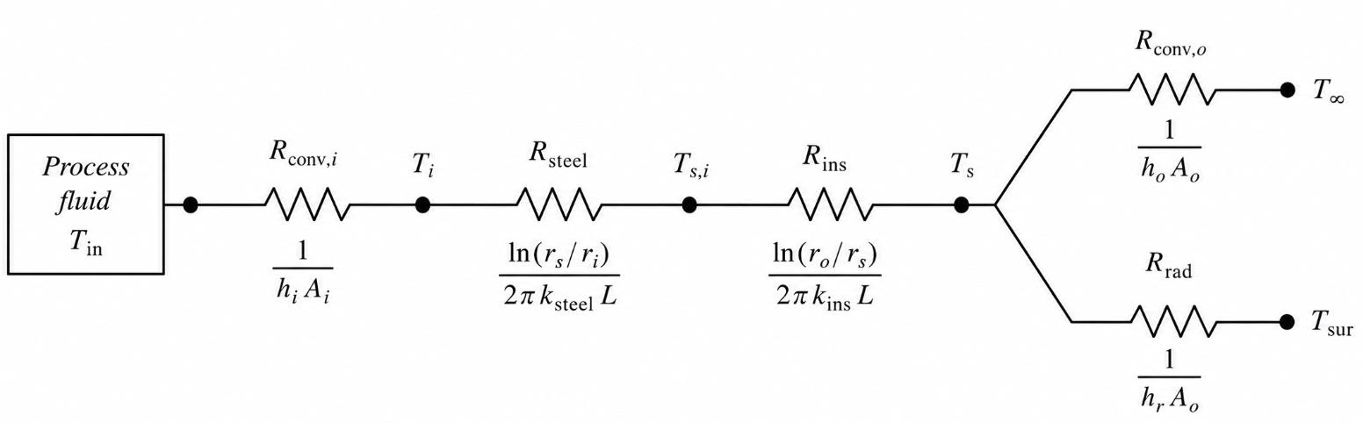
Figure 1. Thermal network for the complete vessel system. The inside-film resistance is neglected; the specified temperature is applied at the inner steel wall.
Question 2. Analyze the complete vessel system shown in Figure 1. Use the Trial 3 results. Heat passes through the steel wall and insulation in series and then leaves the outer surface by convection and radiation in parallel.
1. Use the insulated outer radius calculated in Question 1. Calculate the steel-wall and insulation resistances:
$$R_{steel}=\frac{ln\left(r_{s}/r_{i}\right)}{2πLk_{steel}}$$

$$R_{ins, trial 3}=\frac{ln\left(r_{o, trial 3}/r_{s}\right)}{2πLk_{ins}}$$

2. Calculate the total heat-transfer rate leaving the outer surface:
$${\dot{Q}}_{total, trial 3}={\dot{Q}}_{conv, trial 3}+{\dot{Q}}_{rad, trial 3}$$

3. Convert the total heat-transfer rate from kilowatts to watts. Then calculate the steel–insulation interface temperature and the predicted outer-surface temperature:
$$T_{interface}=T_{in}-{\dot{Q}}_{total, trial 3}R_{steel}$$

$$T_{s, predicted}=T_{interface}-{\dot{Q}}_{total, trial 3}R_{ins, trial 3}$$

4. Compare the predicted outer-surface temperature with the Trial 3 simulation result. In one or two sentences, explain why the heat rate through the steel and insulation must equal the combined convection and radiation heat rates at steady state.

Homework 3: Outer-Surface Safety
Question 3. Confirm the minimum selectable safe thickness. Use the surface-safety requirement and the required relationship between Trials 7 and 8:
$$T_{s}≤{60}^{∘}C \text{and} t_{ins, trial 8}=t_{ins, trial 7}-0.005 m$$

For Trials 7 and 8, report the insulation thickness and outer-surface temperature, classify each trial as Pass or Fail, and confirm that the Trial 8 thickness is exactly 0.005 m below the Trial 7 thickness. Explain briefly why these results show that Trial 7 is the minimum safe thickness selectable using 0.005 m increments.

