Assignment: Software Development Life Cycle Models in Software Engineering
Subject: Software Engineering

1. Introduction
Software Engineering is defined by IEEE [1] as the application of a systematic, disciplined and measurable approach to the development, operation and maintenance of software. In simple words, it is the application of engineering principles to produce reliable, good-quality software within time and budget. Unlike writing a small program for personal use, software engineering deals with large products that are built by teams, used by many people, and changed over many years. For this reason it needs planning, a clear process, careful testing and proper documentation.
The Software Development Life Cycle (SDLC) is a structured sequence of phases that guides how software is built from the first idea until it is retired. The usual phases are [2]:
- Requirement analysis: collecting and documenting what the users and the customer need.
- Design: planning the architecture, modules, interfaces and database of the system.
- Implementation: writing the program code according to the design.
- Testing: finding and fixing defects and checking that the software meets the requirements.
- Deployment: releasing the software to the users.
- Maintenance: correcting errors and adding improvements after the release.
Different SDLC models arrange and repeat these phases in different ways. Some models complete every phase once in a fixed order, while others repeat the phases many times and build the product in parts or versions. Because projects differ in size, risk, budget, time and in how clear the requirements are, no single model is best for all of them. Choosing the right model is therefore an important early decision of every project. Six commonly known SDLC models are:
- Waterfall Model
- V-Model
- Prototyping Model
- Spiral Model
- Iterative Model
- Incremental Model

2. Models in Software Engineering
This section explains each of the six models in turn. For every model, it describes what the model is and in which situation it is suitable. The Iterative Model and the Incremental Model are the two main topics of this assignment, so they are discussed last and in the most detail. Three diagrams are given to make the V-Model, the Iterative Model and the Incremental Model easier to understand.

2.1 Waterfall Model
i. What it is and in which situation it is suitable
[3] states that the Waterfall Model is a sequential model that divides software development into pre-defined phases, where each phase must be completed before the next one begins and there is no overlap between the phases. The same source [3] adds that the model was introduced by Winston Royce in 1970.
The six phases are requirement gathering, design, construction (coding), testing, deployment and maintenance. The output of one phase becomes the input of the next, so the work flows downwards like a waterfall and returning to an earlier phase is difficult. Because the customer sees the working software only at the end, any misunderstanding of the requirements is discovered very late and can be expensive to correct.
[3] lists the main advantages of the model: each phase has to be completed before the next one starts, it works well for small projects with clear requirements, quality assurance testing is done before each phase is completed, and detailed documentation is prepared at every stage. The same source [3] also lists disadvantages: errors can be fixed only within the same phase, the model is not desirable for complex projects with frequently changing requirements, the testing phase comes late, documentation takes a lot of time, and valuable customer feedback cannot be included during development.
According to [3], the Waterfall Model can be used in the following situations:
- When the requirements are clear and do not change frequently.
- When the application is small and simple and the project duration is short.
- When the environment, technology and tools are stable.
- When trained resources are available for every phase.
Example: A small payroll or billing system for a company whose rules are fixed by law is a typical example, because all the requirements are known from the beginning and are unlikely to change.

2.2 V-Model
i. What it is and in which situation it is suitable
Rook [4], in his 1986 paper on controlling software projects, presented the V-model lifecycle as a guideline for software development.
The V-Model is an extension of the Waterfall Model. Its name comes from the V-shaped diagram in Figure 1: the left side covers the development stages (requirements, system design, architecture design, module design and coding) and the right side covers the matching testing levels. Every development stage is paired with a testing level, and the test planning for that level starts early. The left side is called verification (are we building the product right?) and the right side is called validation (are we building the right product?).
The pairs are as follows. Requirement analysis is checked by acceptance testing, which confirms that the software meets the needs of the user. System design is checked by system testing, which tests the complete system. Architecture design is checked by integration testing, which tests how the modules work together. Module design is checked by unit testing, which tests each small module on its own. The main benefits of the model are early test planning, easy management and clear deliverables for every phase. Its main limitations are that it is rigid, no working software is available until late in the project, and changes in the requirements are costly.
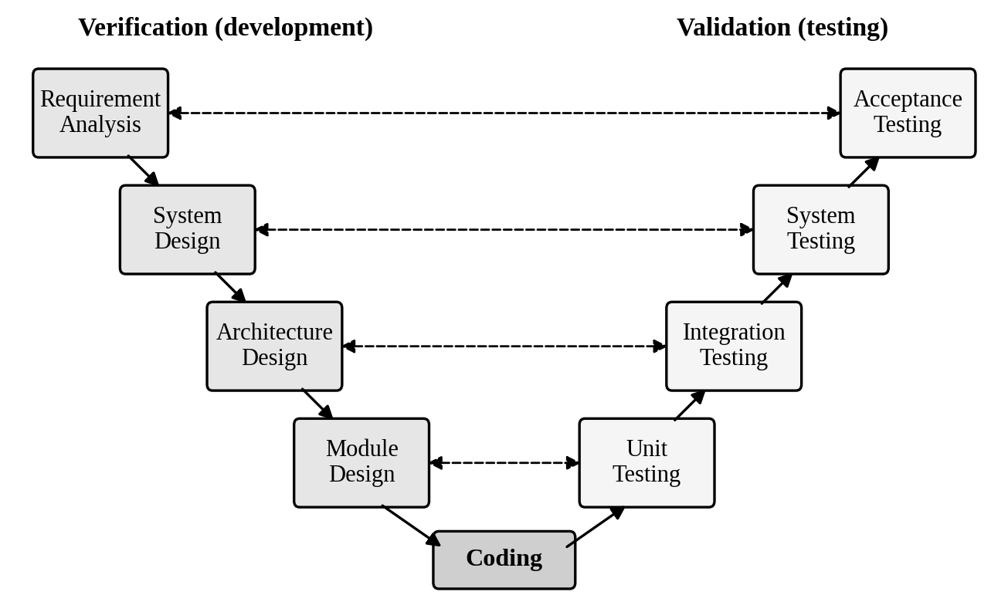
Figure 1: V-Model
The V-Model is suitable in the following situations:
- When the requirements are well defined, clear and fixed from the start.
- When quality and testing are critical, for example in medical, defence or government systems.
- When the technology is stable and not expected to change during the project.
- It is not suitable when requirements change frequently, because the model is rigid.
Example: Embedded software for medical devices or the control software of an aircraft are typical examples, because every function must be tested against its requirement and failure can be dangerous.

2.3 Prototyping Model
i. What it is and in which situation it is suitable
[5] states that the Prototyping Model is a way of developing software in which an early version, or prototype, of the product is created and shared with users for feedback. The same source [5] explains that the system is partially implemented before or during the analysis phase, so the customers can see the product early in the life cycle.
The model has six phases, starting from requirements gathering and quick design and ending with implementing the final product and maintenance. The prototype is built, shown to the users, and reworked until they accept it; it then guides the development of the final system.
[5] describes four types of prototyping, including rapid throwaway prototyping and evolutionary prototyping. In throwaway prototyping the prototype is thrown away once the requirements are understood, while in evolutionary prototyping the prototype is improved step by step until it becomes the final system. The same source [5] says that prototyping can bridge the gap between technical and non-technical stakeholders by giving them something tangible to look at, and it lists high cost in time and money as a disadvantage. Another limitation is that users may think the prototype is the finished product and expect it to be delivered quickly.
According to [5], the Prototyping Model should be used in the following situations:
- When the requirements of the product are not clearly understood or are unstable, or are changing quickly.
- When developing user interfaces, high-technology software-intensive systems, and systems with complex algorithms and interfaces.
- When the technical feasibility of the product has to be demonstrated.
Example: A mobile application or website whose screens are first shown to the client as mock-ups, before the real coding starts, is a typical example.

2.4 Spiral Model
i. What it is and in which situation it is suitable
Boehm [6] states that the major distinguishing feature of the Spiral Model is that it creates a risk-driven approach to the software process, rather than a primarily document-driven or code-driven process. Boehm [6] further states that the model incorporates many of the strengths of other models and resolves many of their difficulties, and he illustrates it with the TRW Software Productivity Project as an example.
In this model the project passes through repeated loops of a spiral. Each loop usually has four steps: setting the objectives, identifying and resolving risks (often with a prototype), developing and testing the next version, and planning the next loop. The product grows with every loop, and the project can be stopped or changed when risks become too high.
The main advantages of the model are that risks are found and reduced early, changes can be accepted in later loops, and the customer reviews the product at the end of every loop. Its limitations are that it is complex to manage, it can be costly, and its success depends on people who are skilled in risk analysis. For these reasons it is usually not worth using for small projects with low risk.
The Spiral Model is suitable in the following situations:
- When the project is large, costly and carries high technical or business risk.
- When the requirements are complex or unclear and are expected to change.
- When regular customer review and risk analysis are needed at every stage.
- When the organisation has people who are skilled in risk analysis, because the model depends on it.
Example: A large banking or defence system that uses new technology and has serious technical and financial risks is a typical example.

2.5 Iterative Model
i. What it is and in which situation it is suitable
Larman et al. [7] states that iterative and incremental development is not a modern idea, because its use goes back to the mid-1950s, and that the different practices shared one common theme: avoiding a single-pass, sequential, document-driven, gated-step approach.
In the Iterative Model, the software is developed through repeated cycles called iterations. A first version containing only the basic requirements is built quickly. It is then tested and evaluated, and the feedback is used to improve the requirements, design and code in the next iteration. This continues until the complete product is obtained. Every iteration passes through planning, analysis and design, implementation, testing and evaluation, as shown in Figure 2.
The main advantages of the model are that a working version is available early, defects and risks are found in small cycles, and the feedback of the users shapes the final product. Its limitations are that it needs good planning and management, and that the project can exceed its time and budget if the number of iterations is not controlled. If the overall architecture is not planned properly at the start, later iterations may also require expensive rework.
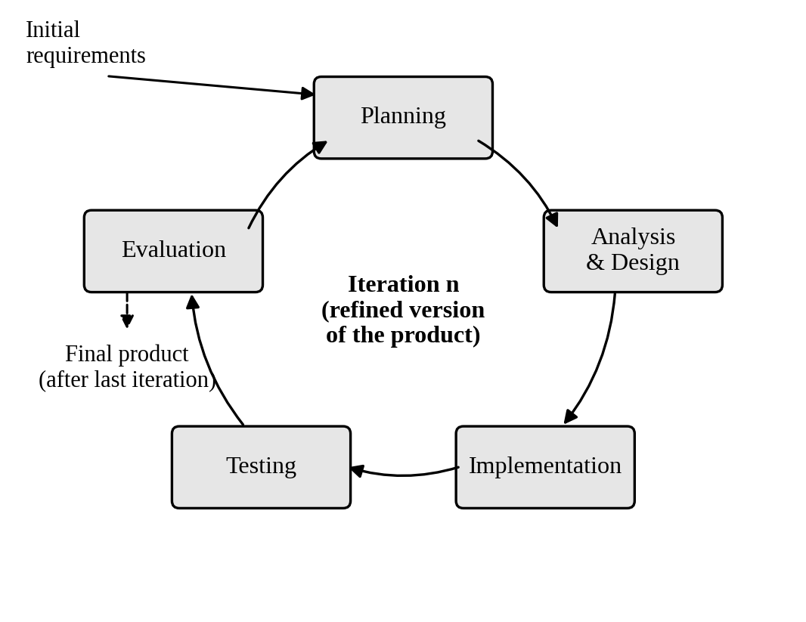
Figure 2: Iterative Model
The Iterative Model is suitable in the following situations:
- When the requirements are unclear, incomplete or likely to change during development.
- When the project is large or risky and the risky parts must be tried and verified early.
- When the customer or users are available to give regular feedback.
- When new technology or an unfamiliar problem domain is involved and the team needs to learn as it builds.
Example: A university management system whose first version covers only student registration, and is then improved cycle by cycle with the feedback of teachers and office staff, is a typical example.

2.6 Incremental Model
i. What it is and in which situation it is suitable
[8] states that the Incremental Process Model is a method of software development in which the system is built step by step, and that the software is developed and delivered in small, manageable pieces where each piece adds new features to the previous version. The same source [8] explains that each increment goes through the requirement, design, implementation and testing phases until the complete system is obtained.
In other words, the full requirements are divided into several modules (increments). The first increment usually contains the core functionality and is delivered to the user early. Later increments add further features on top of it, as shown in Figure 3. Testing each module separately improves the quality and reliability of the product [8].
The main advantages of the model are early delivery of useful software, easier testing and debugging of small parts, and lower risk because a problem affects only one increment. Its limitations are that the whole system must be planned well at the start so that the increments fit together, and the integration of increments can become difficult. The total cost may also be higher than in a single-pass approach.
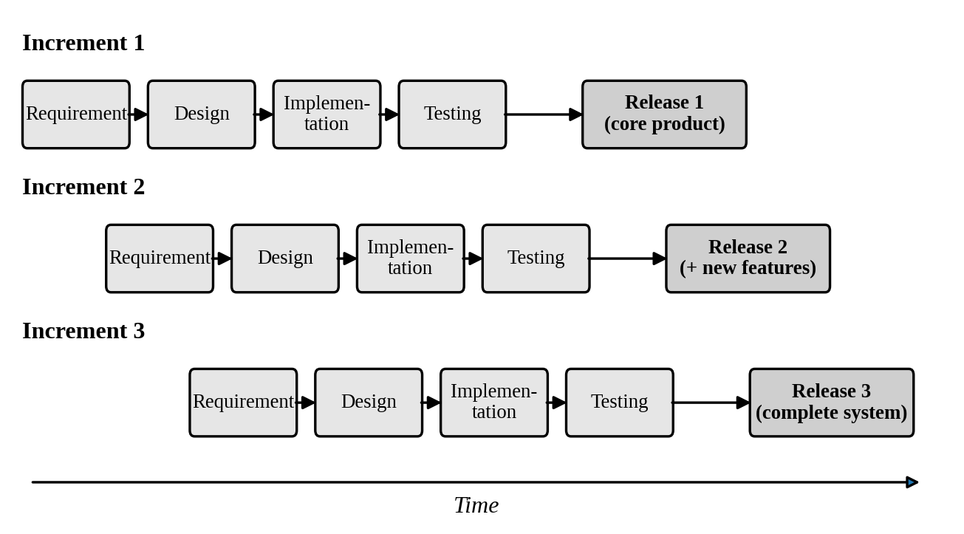
Figure 3: Incremental Model
The Incremental Model is suitable in the following situations:
- When the main requirements are well understood in advance and can be divided into modules.
- When the customer needs an early working version of the product, even if it is partial.
- When the development team is small at the start and staff can be added for later increments.
- When a skilled and experienced team is available, because [8] notes that managing increments and integrating them well requires a competent team.
Example: An online shopping system is a typical example: the first increment gives product listing and ordering, the second adds online payment, and the third adds customer reviews and delivery tracking.
Summary of Section 2: The Waterfall and V-Models follow a fixed sequence and work best when the requirements are stable. The Prototyping Model reduces the uncertainty of requirements by showing early versions to the users, and the Spiral Model adds risk analysis to every loop. The Iterative Model improves the whole product again and again, while the Incremental Model builds it in working parts. These last two models are compared with the other four in the next section.

3. Comparison Table
The six models are compared on the following parameters. Development Approach means how the work is organised and repeated; Requirements Handling means how much of the requirements must be known at the start; Delivery Style means what the customer receives and when; Risk Handling means how early and how well risks are found and reduced; and Flexibility to Change means how easily changes can be accepted during development.
Table 1: Comparison of SDLC Models
Model | Development Approach | Requirements Handling | Delivery Style | Risk Handling | Flexibility to Change
Waterfall Model | Linear; each phase is done once, in a fixed order. | Must be complete and fixed before development starts. | Single delivery at the end of the project. | Low; problems are found late, during testing. | Very low; going back to an earlier phase is costly.
V-Model | Linear and V-shaped; every development phase has a matching test level. | Must be clear and fixed upfront. | Single delivery after all test levels are passed. | Moderate; test planning starts early, so defects are found sooner. | Low; changes are hard once the project has started.
Prototyping Model | A prototype is built, shown to users and reworked. | Unclear or unstable; discovered through the prototype. | Early prototype first; final system after approval. | Moderate; requirement and interface risks are reduced early. | High; user feedback can change the product easily.
Spiral Model | Repeated loops, each with objectives, risk analysis, development and planning. | Evolve and become clearer with every loop. | A new version at the end of each loop. | Very high; risk analysis is the core of the model. | High; each loop can change the plan.
Iterative Model | Whole system is built in repeated cycles; each cycle refines the full product. | Can start with incomplete requirements; refined in every cycle. | Rough version first, improved with each iteration. | High; risky parts are revisited early through feedback. | High; changes are welcome after each iteration.
Incremental Model | System is split into modules; each is built completely and added. | Main requirements are mostly known upfront and divided into increments. | Working part of the product is delivered in every increment. | Moderate; risk is spread over small, separately tested increments. | Medium; later increments can change, but the core design is fixed early.

4. Conclusion
Table 1 shows that the six models differ mainly in how much they depend on fixed requirements and how early they deal with risk. The Waterfall and V-Models are sequential and suit stable, well-defined requirements, with the V-Model adding a test level to every stage. The Prototyping, Spiral and Iterative Models handle unclear requirements and risk better through feedback and repetition. The Incremental Model delivers working modules early for well-planned systems. Hence, no single model is the best; the choice depends on requirement stability, project risk and delivery needs.

5. References
[1] IEEE, "IEEE Standard Glossary of Software Engineering Terminology," IEEE Std 610.12-1990, 1990.
[2] R. S. Pressman and B. R. Maxim, Software Engineering: A Practitioner's Approach, 8th ed. New York, NY, USA: McGraw-Hill Education, 2015.
[3] Guru99, "What is Waterfall Model in SDLC? Advantages and Disadvantages," Online article (Software Engineering tutorials), Guru99, 2026, vol. N/A.
[4] https://doi.org/10.1049/sej.1986.0003, last accessed 2nd November 2026.
[5] GeeksforGeeks, "Prototyping Model – Software Engineering," Online article (Software Engineering tutorials), GeeksforGeeks, 2025, vol. N/A.
[6] https://doi.org/10.1109/2.59, last accessed 2nd November 2026.
[7] https://doi.org/10.1109/MC.2003.1204375, last accessed 2nd November 2026.
[8] GeeksforGeeks, "Incremental Process Model – Software Engineering," Online article (Software Engineering tutorials), GeeksforGeeks, 2025, vol. N/A.

