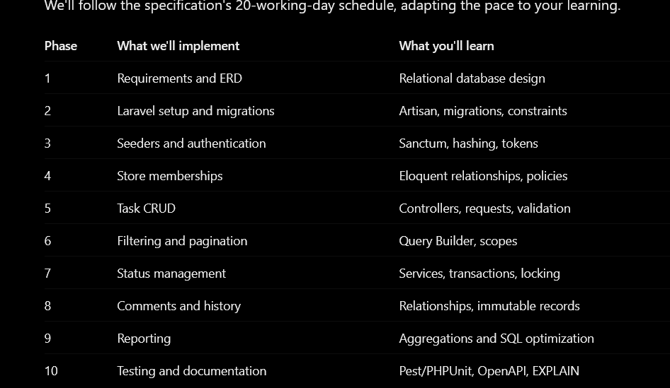

Our first task will be designing these six tables:
- users
- stores
- store_memberships
- tasks
- task_comments
- task_events



