|  |
| --- |
| Connecting to Exosite using LuvitRED |
|  |

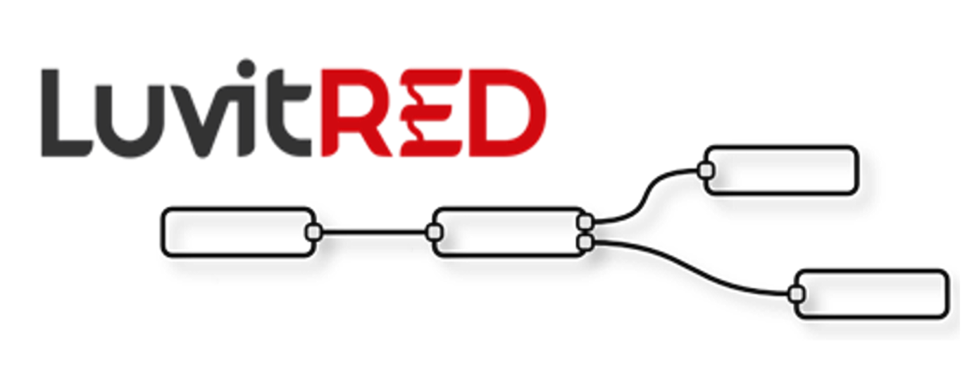

**Franco Arboleda**

**12-Apr-16**

Table of Contents

1 Introduction 3

2 Using the RS232 interface from the front panel. 5

2.1 Modifying the configuration under the Advanced Editor. 9

2.1.1 Verifying if firewall hole is opened by LuvitRED 9

2.1.2 Inactivity timeout on the TCP node. 10

3 Using the USB ports for storage. 11

3.1 Writing data to the mass storage device. 11

3.2 Reading data from the mass storage device. 14

4 Configuring the I/O interfaces. 16

4.1 Digital outputs 17

4.2 Digital inputs 20

4.3 Analog inputs 23

4.3.1 Monitoring the Digital output using a GPIO query node 26

5 One Wire interface 28

6 Double SIM usage 32

# Introduction

This document covers the configuration of the telematics card using LuvitRED.

# Using the RS232 interface from the front panel.

Go to the "Plugin" tab and then to the sub-tab called "Serial and GPS settings" or "LuvitRED" (the name "LuvitRED" is used from version 2.3.0 onwards):

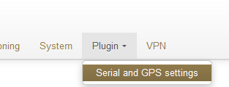

Figure 5: Plugin tab, Serial and GPS settings.

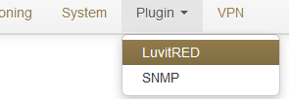

Figure 6: Plugin tab, LuvitRED.

**NOTE:** Do not focus on the SNMP (Simple Network Management Protocol) sub-tab. This tab is not going to be used on this document.