|  |
| --- |
| Connecting to Exosite using LuvitRED |
|  |

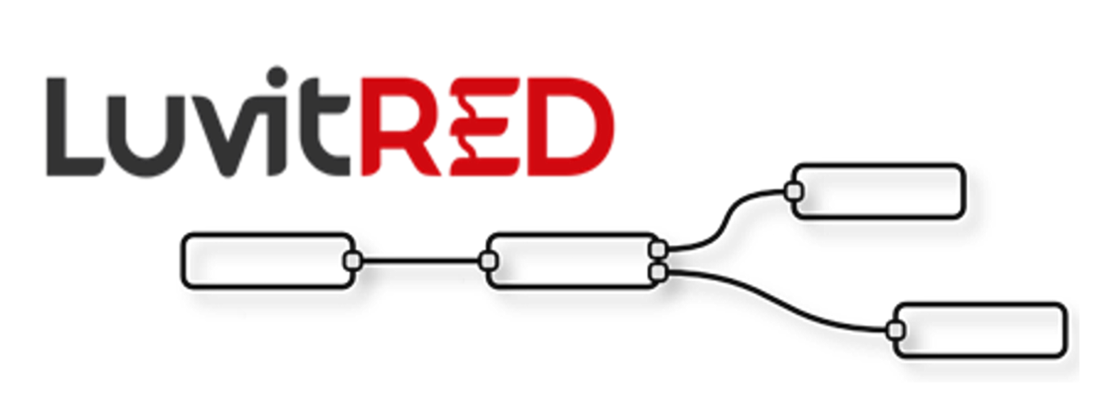

**Franco Arboleda**

**20-Apr-16**

Table of Contents

1 Introduction 3

2 Configuring the Exosite platform. 4

2.1 Creating a new generic device 4

2.2 Creating data items. 6

3 LuvitRED configuration. 8

3.1 Sending data to the Exosite platform. 9

3.2 Receiving data from the Exosite platform. 16

# Introduction

This document explains how to send and receive data to and from Exosite using LuvitRED.

This document was written using CloudGate firmware version and LuvitRED version . Although older versions of firmware and LuvitRED might work in the same way, we strongly recommend to upgrade to the above mentioned versions or newer in order to ensure the same results.

For this explanation we are using a free account on the Exosite platform (<https://portals.exosite.com>).

# Configuring the Exosite platform.

## Creating a new generic device

1. Start by logging into your Exosite account.
2. On the left hand side click on Devices:

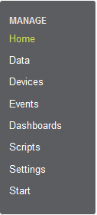

Figure : Exosite: Devices.

1. Click on + Add Device:



Figure : Exosite: Add Device.

1. Select the option to create a generic device then click on Continue:

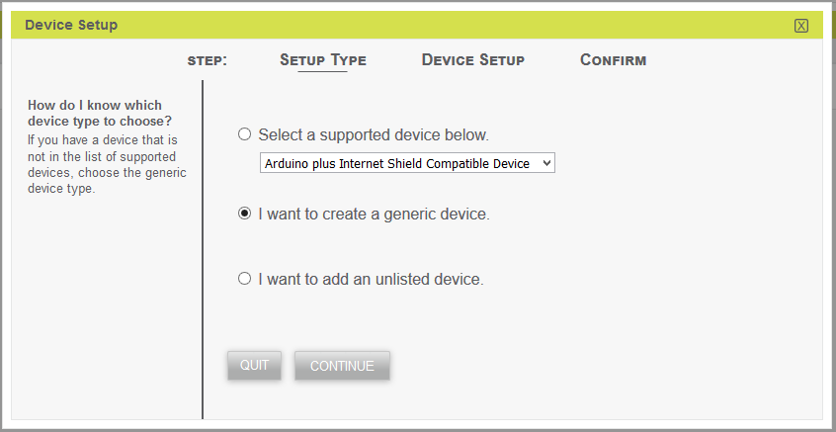

Figure : Exosite: New generic device.

1. Select the Timezone and write the device location then click on Continue:

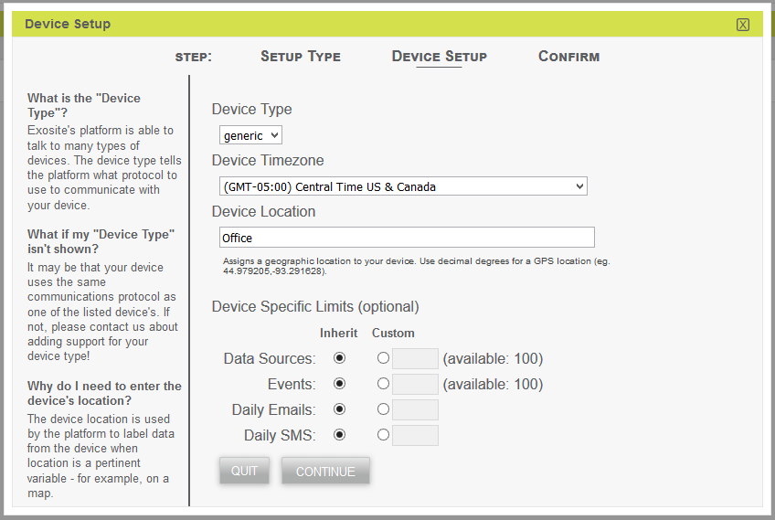

Figure : Exosite: Device setup 1.

1. Finally, set the device name and click on Submit:

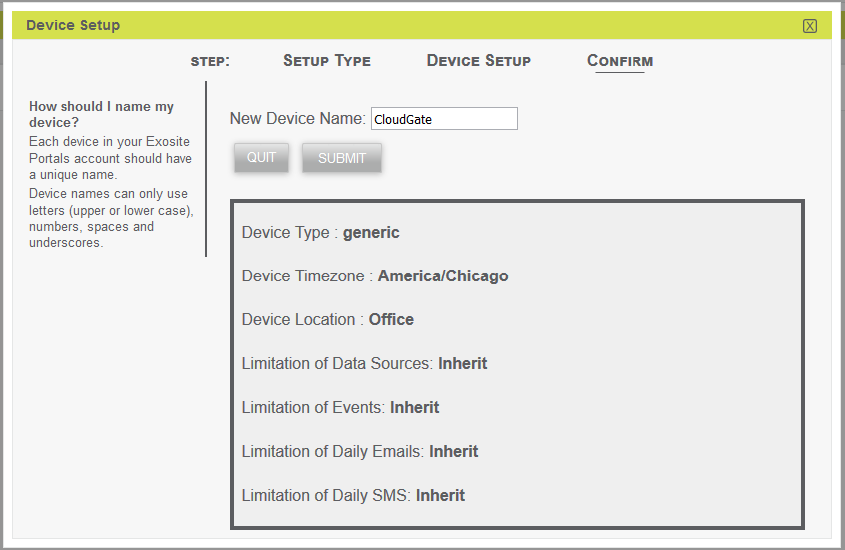

Figure : Exosite: Device setup 2.

1. A new device is created:



Figure : Exosite: Device created.

1. Click on the newly created device and take note of the CIK number created:

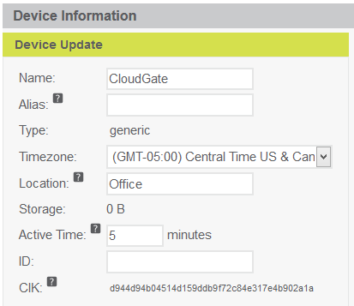

Figure : Exosite: Device's CIK number.

## Creating data items.

1. Click on the new device created on section 2.1
2. Once inside the device’s configuration click on + Add Data:

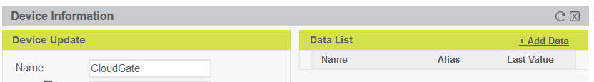

Figure : Exosite: Add Data.

1. Provide a Source Name, Source Format (integer), Unit (if needed) and Alias (very important) to the new data item and click on Submit:

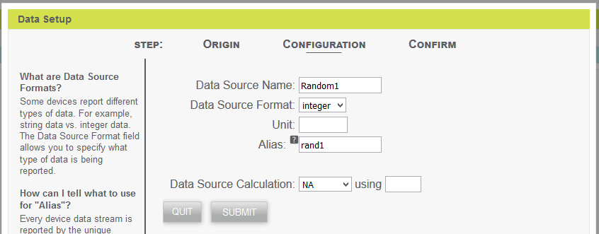

Figure : Exosite: Data setup.

1. Create two more data items, one called Random2 (Format: float, Alias: rand2) and Command (Format: integer, Alias: command) by following the previous 2 steps.
2. The final result should be a list of three data items on our device:

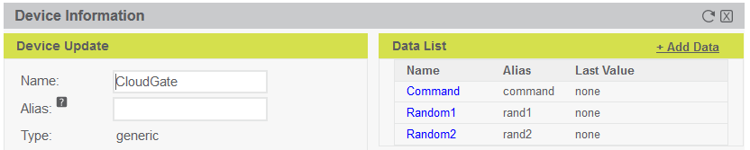

Figure : Exosite: Device's data items.

# LuvitRED configuration.

Go to the web interface of the CloudGate and then to the "Plugin" tab and sub-tab called "LuvitRED"

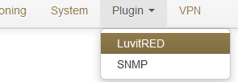

Figure : Plugin tab, LuvitRED.

**NOTE:** Do not focus on the SNMP (Simple Network Management Protocol) sub-tab. This tab is not going to be used on this document.

Under the “Advanced Editor” of LuvitRED, there are two nodes that are related to Exosite (See Figure 12):

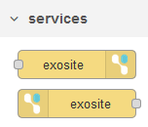

Figure : Exosite nodes.

## Sending data to the Exosite platform.

1. Drag and drop an exosite out node:



Figure : Exosite out node.

1. Configure the exosite out node in the following way:

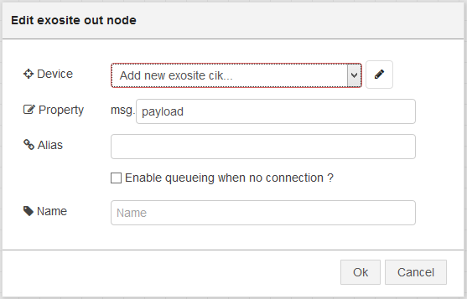

Figure : Default Exosite out node.

* 1. Add a **new** Device by clicking on the pencil icon and configure it for the CIK noted on the previous section, make sure the “Use https ?” checkbox is selected and the “Name” is changed. Click on “Add”:

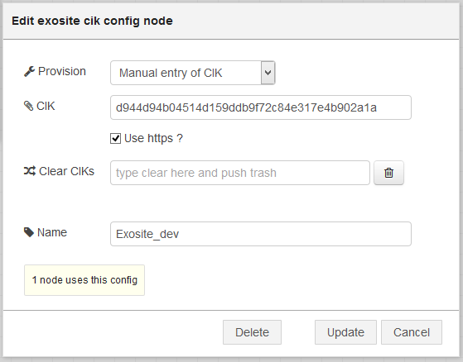

Figure : Adding Device's CIK.

* 1. On the node configuration write the Alias of the first data item we created for the device (rand1) and change the name of the node. Click on “OK” when finished:

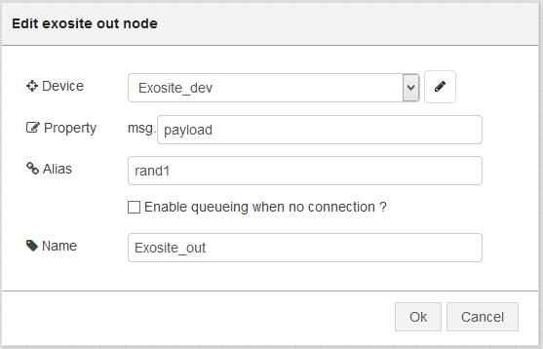

Figure : Final node configuration.

This node is now configured to send data to the Random1 data item on our server. Now we need to actually send data.

1. Drag and drop an inject node and configure it so that it outputs a random integer (0-100) every 10 seconds (give the node a name):

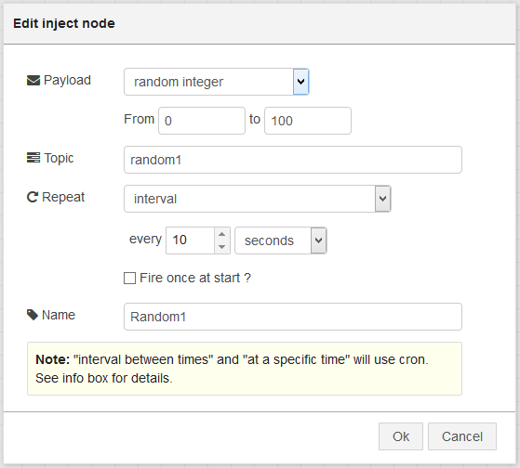

Figure : Inject node configuration.

1. Let’s connect the nodes together in the following way:



Figure : Final Configuration.

1. Click on “Deploy”

If we now go back to our device on the Exosite platform, we should be able to see that the Random1 data item is being updated with the values that our CloudGate is sending:

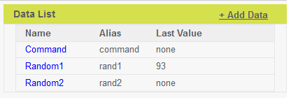

Figure : Exosite: Random1 data item updated.

Sending data for the second data item (Random2) is as simple as copying the current configuration and changing the following:

1. Alias on the exosite out node:

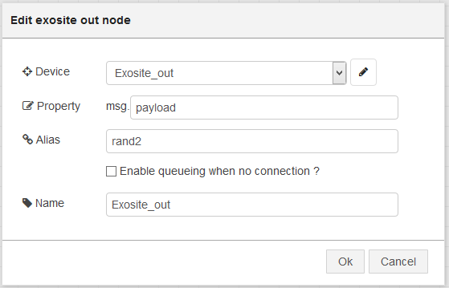

Figure : Changing the Alias on the second Exosite out node.

1. The type of data on the inject node from “random integer” to “random number” (keeping in mind that the Random2 data item is a **float**):

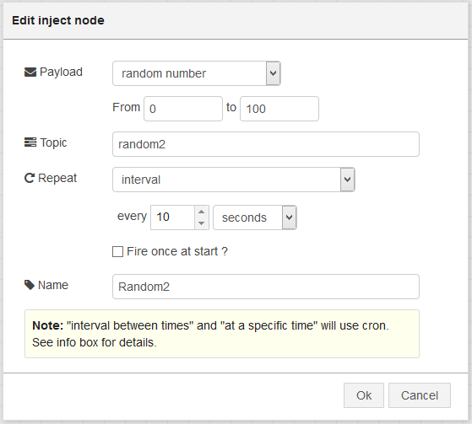

Figure : Changing the type of data on the inject node.

1. We are also changing the node names in order to keep a visual difference between both. The final configuration should look like this after Deploying it:

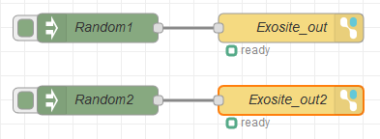

Figure : Two data items to Exosite.

If we now go back to the device on the Exosite platform, we should see that the second data item called Random2 is also being updated:

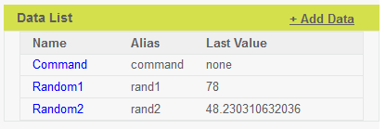

Figure : Exosite: Random1 and Random2 updated.

Of course, this is simple because we are working with a reduced amount of data items, but if we need to post data for a hundred data items, this solution is not the best. The Exosite out node can send information for multiple data items as long as this information is provided to the node as a table in which case the keys of the table need to be the alias of the data item we want to update (See Figure 24):

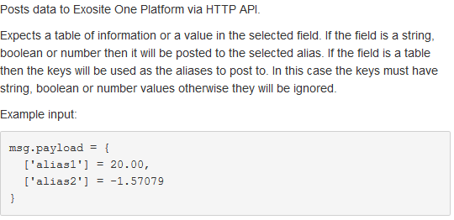

Figure : Information tab of the Exosite out node.

Let’s adapt the configuration we already have so that we can post data for both data items using one single exosite out node:

1. Let’s delete the exosite out node called “Exosite_out2” shown on Figure 22.
2. Open the renaining exosite out node and delete the Alias (Remember: the Alias is now going to be provided as the key of the table):

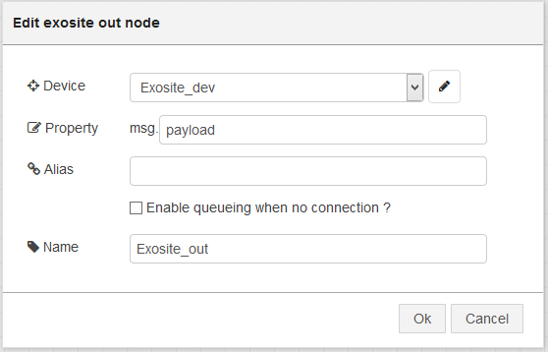

Figure : exosite out node with no Alias.

1. Now, lets open both inject nodes and change their topics to rand1 and rand2 accordingly:

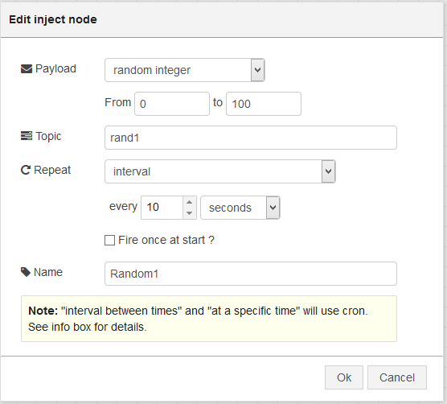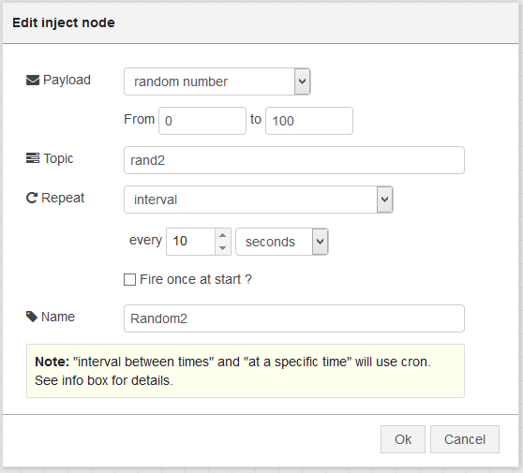

Figure : Random1 and Random2 inject nodes with new topics.

**NOTE:** The idea behind doing this is that now we can use a combine node to combine the messages coming from both nodes into one message and using their topics as keys.

1. Drag and drop a combine node and configure it the following way:

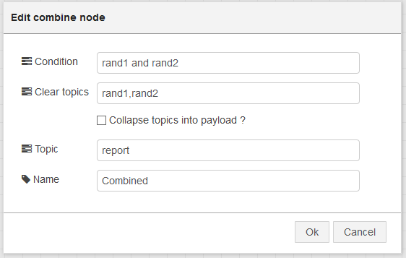

Figure : Combine node.

**NOTE:** This configuration does the following:

* The condition is to wait for both ran1 and rand 2 topics to arrive.
* After they arrive, you clear the topics, so that the node waits for two new values to come.
* It changes the final topic to “report”

1. Drag and drop a debug node (This is just to show the format of the data after the combine node under the debug tab).
2. Let’s connect the nodes together in the following way and click on “Deploy”:

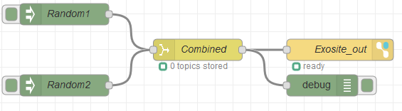

Figure : Configuration using combine and one exosite out node.

On the debug tab, we should be able to see the table created by the combine node containing both rand1 and rand2 values:

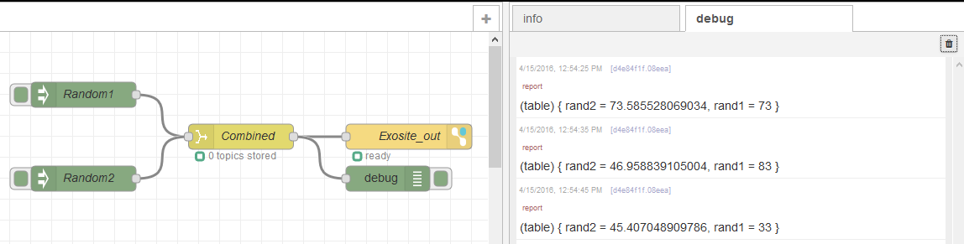

Figure : Table of data shown under debug tab.

On the Exosite platform we should see the values being updated:

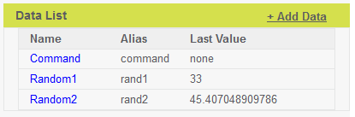

Figure : Exosite: Values updated.

## Receiving data from the Exosite platform.

We have been successful in sending data from our device to the Exosite platform, but how about sending data from the Exosite platform to the device? We are going to use the third data item called **Command** for this.

1. Drag and drop an exosite in node:



Figure : Exosite in node.

1. Configure the exosite in node in the following way:

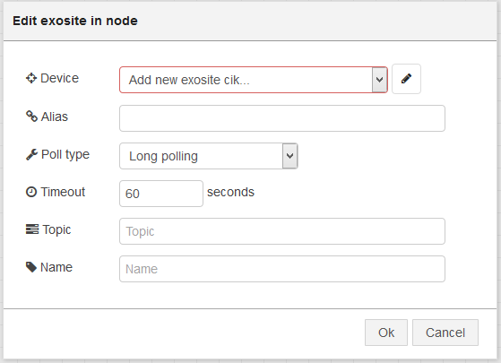

Figure : Default Exosite in node.

* 1. Select the already configured Exosite Device. If no device is already configured, please follow the steps explained on section 3.1. Change the Alias to **command** and change the name of the node:

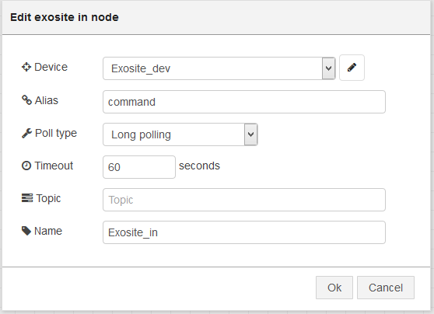

Figure : Exosite in node configuration.

1. Drag and drop a debug node and connect both nodes as shown on :



Figure 34: Final configuration.

1. Click on “Deploy”

Now, let’s push some data from the Exosite platform:

1. Click on the **Command** data item.
2. On the right hand side there is a Write Data section. Enter a number (e.g. 1000) and then click on Update:

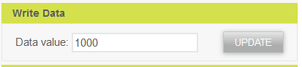

Figure 35: Exosite: Entering data to the Command data item.

The new data should be shown on the Debug tab in LuvitRED:

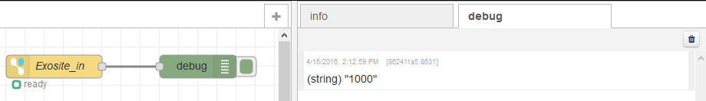

Figure 36: Data coming from Exosite.