|  |
| --- |
| Connecting to ThingWorx using LuvitRED |
|  |

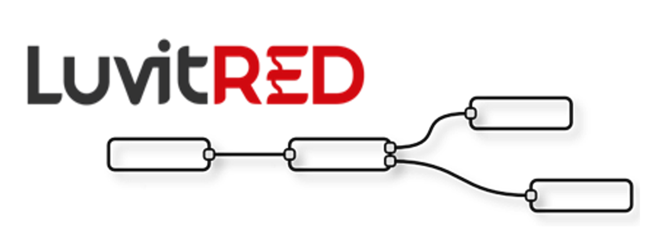

**Franco Arboleda**

**1-Jun-16**

Table of Contents

1 Introduction 3

2 Configuring the ThingWorx platform. 4

3 LuvitRED configuration. 6

3.1 Sending data to the ThingWorx platform. 7

3.2 Receiving data from the Thingworx platform. 15

# Introduction

This document explains how to send and receive data to and from the ThingWorx platform using LuvitRED.

This document was written using CloudGate’s firmware version 2.62.0 and LuvitRED version 2.7.5. Although older versions of firmware and LuvitRED might work in the same way, we strongly recommend to upgrade to the above mentioned versions or newer in order to ensure the same results.

For this explanation we are using a developer account on the ThingWorx platform (<http://www.thingworx.com/developer>).

# Configuring the ThingWorx platform.

When creating a new account on the Thingworx platform a new application key is automatically created under the Security section:

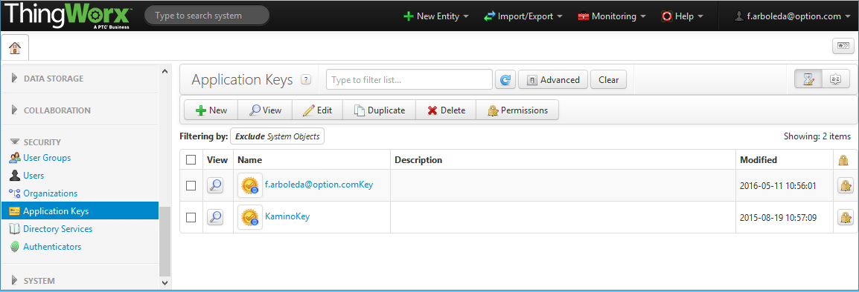

Figure 1: ThingWorx: Account application key created.

We are going to create a new application key.

1. Click on the “New” button:

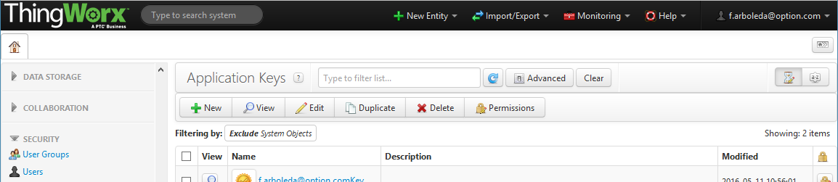

Figure 2: ThingWorx: New application key.

1. Type a name for the new key (e.g myappkey), select a User Name Reference and then click on “Save”:

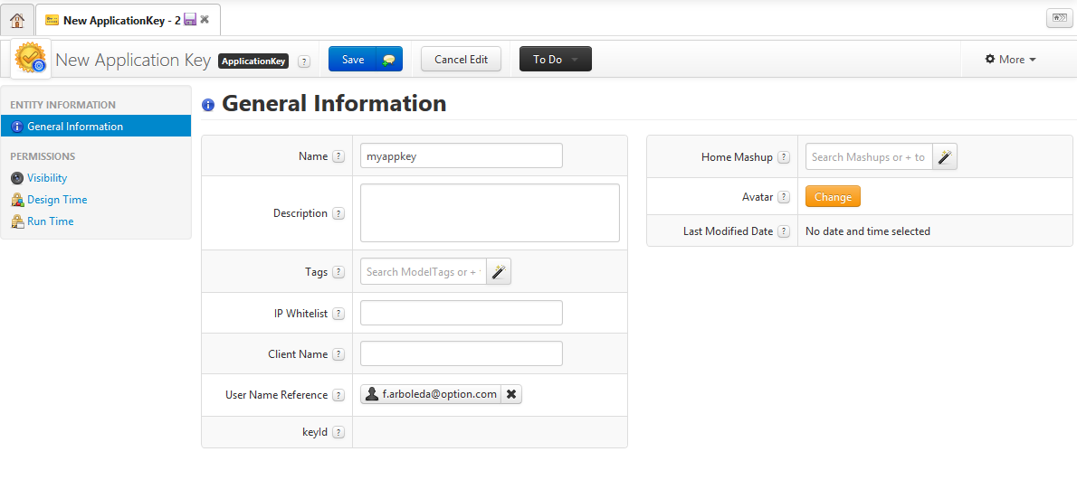

Figure 3: ThingWorx: Application key configuration.

1. After saving the new key, take note of the “keyId” created:

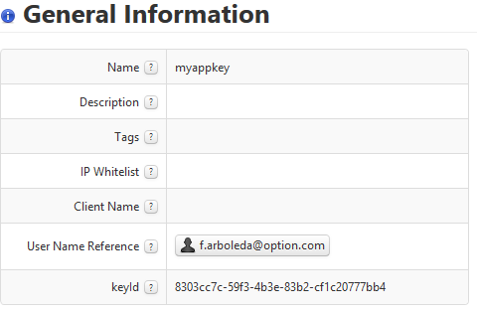

Figure 4: ThingWorx: New keyId.

We are going to create a new Thing under the Modeling section.

1. Click on the “New” button:

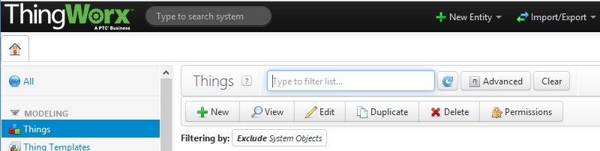

Figure 5: ThingWorx: New Thing.

1. Type a name for the new thing (e.g CloudGate), select “RemoteThing” as a Thing Template and then click on “Save”:

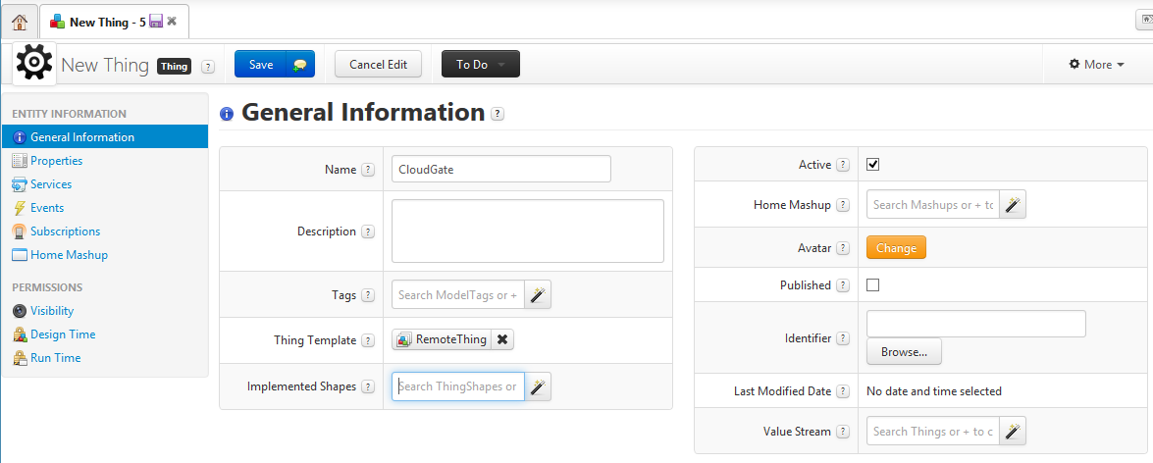

Figure 6: ThingWorx: New thing configuration.

# LuvitRED configuration.

Go to the web interface of the CloudGate and then to the "Plugin" tab and sub-tab called "LuvitRED"

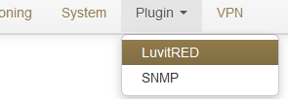

Figure 7: Plugin tab, LuvitRED.

**NOTE:** Do not focus on the SNMP (Simple Network Management Protocol) sub-tab. This tab is not going to be used on this document.

Under the “Advanced Editor” of LuvitRED, there are five nodes that are related to ThingWorx (See Figure 8):

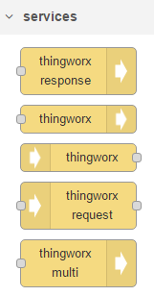

Figure 8: thingworx nodes.

## Sending data to the ThingWorx platform.

1. Drag and drop a thingworx out node:



Figure 9: thingworx out node.

1. Configure the thingworx out node in the following way:

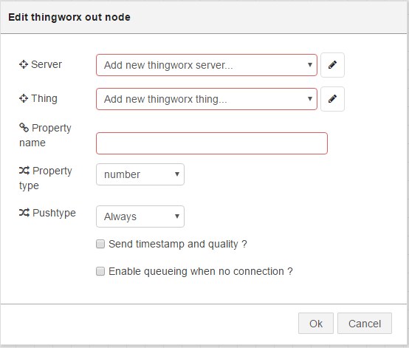

Figure 10: Default thingworx out node.

* 1. Add a **new** Server configuration by clicking on the pencil icon and configure it with the server address (Server), the port for the server (80 for http – Use https if the server supports it), Enter the keyID (Application key) noted on the previous section. Change the “Name” of the configuration node and click on “Add”:

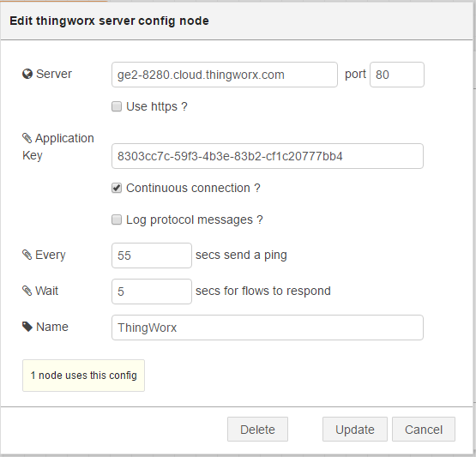

Figure 11: Adding server configuration and application key.

* 1. Add a **new** Thing by clicking on the pencil icon and configure it with the “Thing” name created on the ThingWorx platform (***CloudGate***). Click on “Add” when finished:

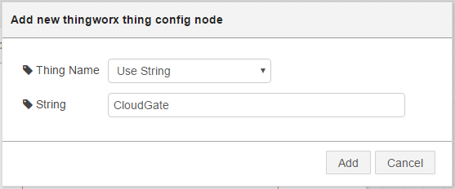

Figure 12: Thing configuration.

* 1. On the node configuration write a “Property name” that represents the type of data that will be send to ThingWorx (e.g **rand_num1**) and select the “Property type” (e.g **number**). Click on “OK” when finished:

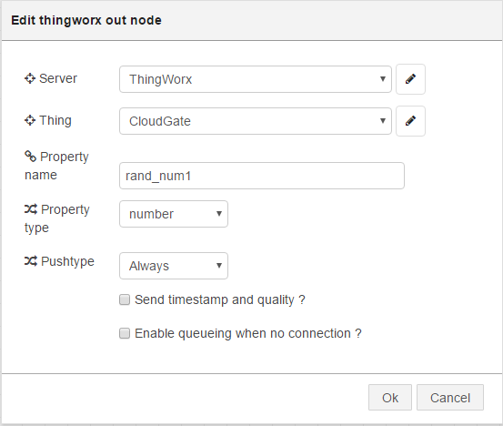

Figure 13: Final node configuration.

This node is now configured to send one property called ***rand_num1***. Now we need to actually send data.

1. Drag and drop an inject node and configure it so that it outputs a random integer (0-100) every 10 seconds (give the node a name):

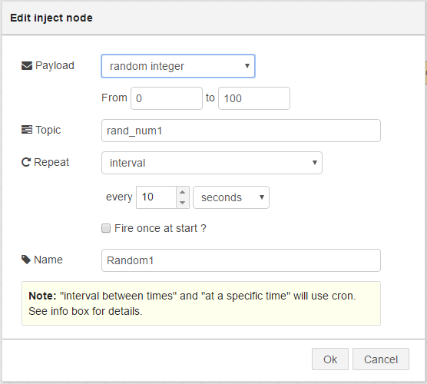

Figure 14: Inject node configuration.

1. Let’s connect the nodes together in the following way:



Figure 15: Final Configuration.

1. Click on “Deploy”

Under our device’s properties on the ThingWorx platform, we should go to Manage Bindings:

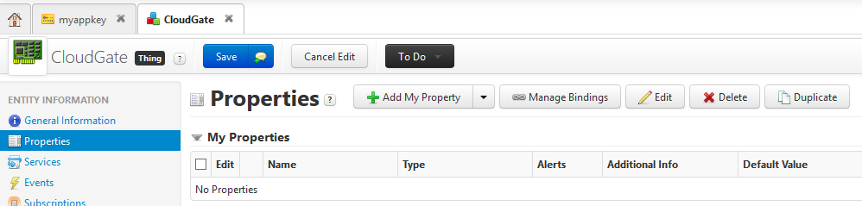

Figure 16: ThingWorx: Manage Bindings.

Under the remote section, we should now be able to see our new property called ***rand_num1***. We need to drag and drop that new, remote property to the right hand side, right to the “Drag HERE to create new properties” message and then click on “Done”:

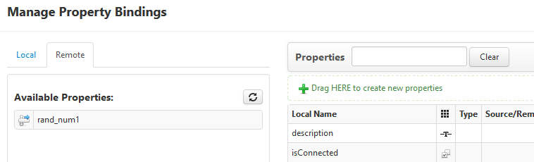

Figure 17: ThingWorx: rand_num1 property under the bindings

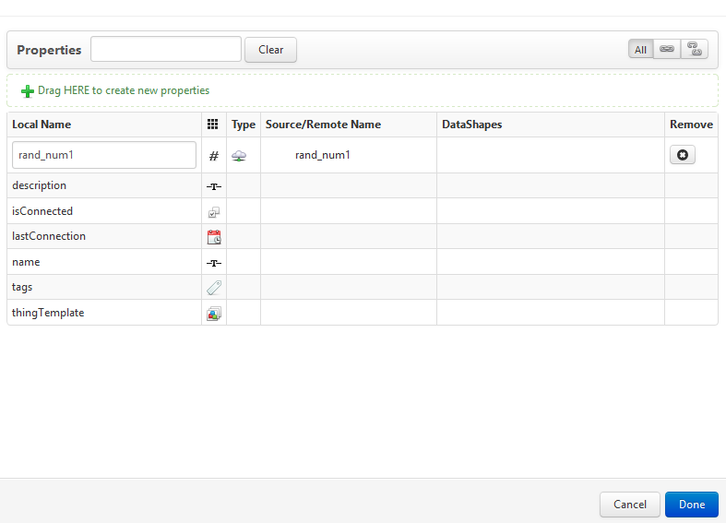

Figure 18: ThingWorx: New property created.

Click on “Save” under the Thing configuration:

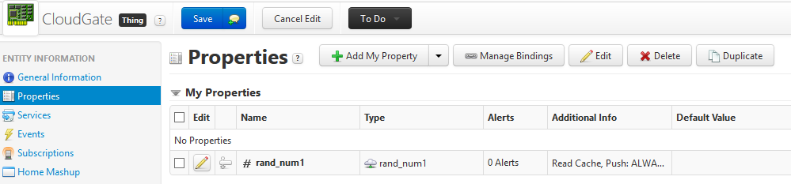

Figure 19: ThingWorx: Thing showing new Property.

We should now be able to see the new values coming by clicking on the Refresh button right on the Value column:

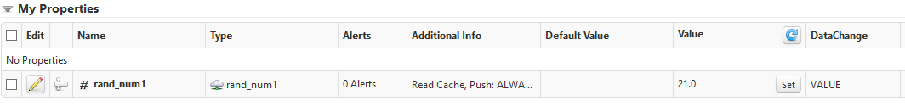

Figure 20: ThingWorx: rand_num1 value updated.

Multiple properties can be added by replicating the above steps we used to add ***rand_num1***, but this is only a good solution for a reduced amount of properties. If we need to post data for a hundred properties, this solution is not the best. The ThingWorx out node **cannot** send information for multiple properties, but there is another ThingWorx node called “thingworx multi out” that can do this as long as this information is provided to the node as a table in which case each key of the table need to be the name of the property we want to update (See Figure 21):

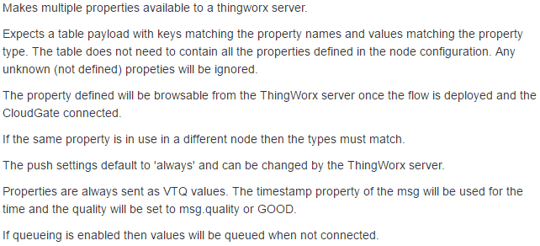

Figure 21: Information tab of the thingworx multi out node.



Figure 22: thingworx multi out node.

Let’s adapt the configuration we already have so that we can post data for multiple properties using one single Thingworx multi out node:

1. Drag and drop a thingworx multi out node Configure the thingworx out node in the following way:

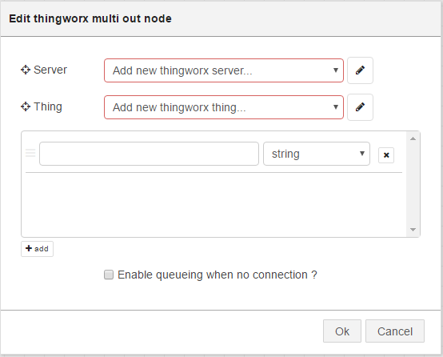

Figure 23: Default thingworx multi out node.

1. Select the already configured thingworx “Server” and “Thing”. If no “Server” and “Thing” are already configured, please follow the steps explained on section 3.1. Add two properties on the list of properties, with the following property names: ***rand_num1*** and ***rand_num2*** (both numbers) by clicking on the “+ add” button. Click on “OK”:

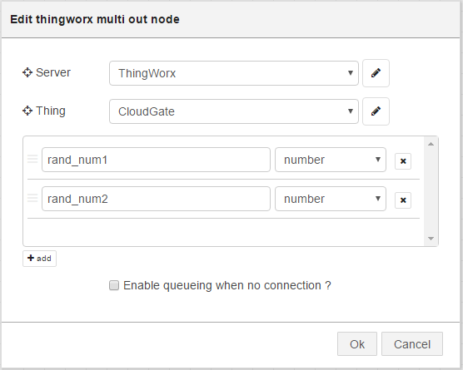

Figure 24: thingworx multi out node configured.

1. Delete the old thingworx out node as it is no longer needed.
2. Now, lets drag and drop a second inject node and configure it as follows:

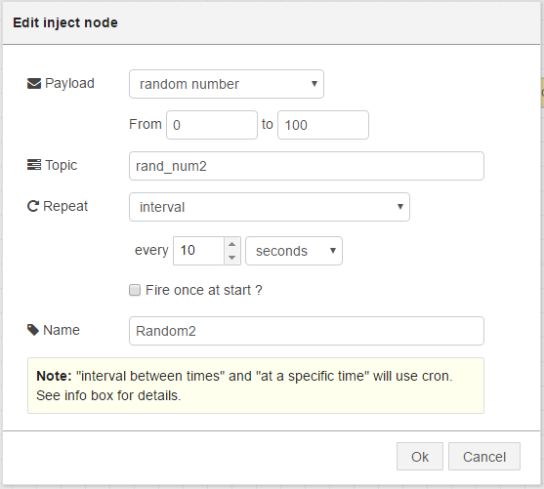

Figure 25: Random2 inject node (random number).

**NOTE:** We can now use a combine node to combine the messages coming from both nodes into one message and using their topics as keys.

1. Drag and drop a combine node and configure it the following way:

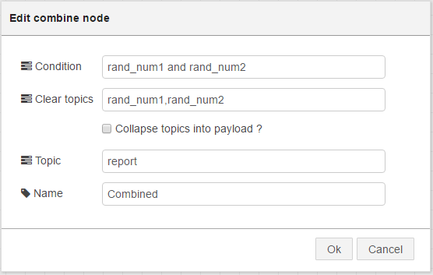

Figure 26: Combine node.

**NOTE:** This configuration does the following:

* The condition is to wait for both random1 and random2 topics to arrive.
* After they arrive, clear the topics, so that the node waits for two new values to come.
* It changes the final topic to “report”

1. Drag and drop a debug node (This is just to show the format of the data after the combine node).
2. Let’s connect the nodes together in the following way and click on “Deploy”:

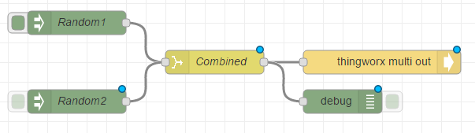

Figure 27: Configuration using combine and one thingworx multi out node.

On the debug node, we should be able to see the table created by the combine node containing both random1 and random2 values:

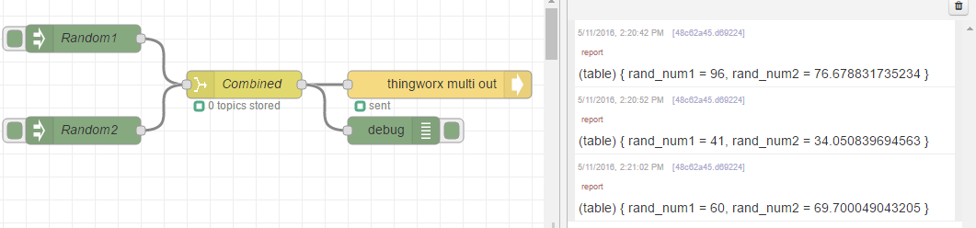

Figure 28: Table of data shown under debug tab.

On the ThingWorx platform, under the thing bindings, we should see new properties listed. We can now follow the same steps explained on section 3.1 to create the new properties under the Thing:

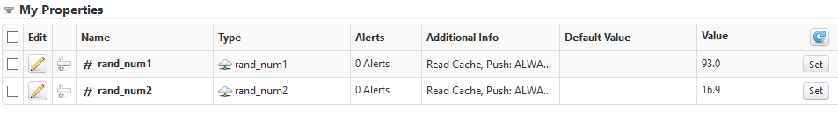

Figure 29: ThingWorx: New properties created and values updated.

## Receiving data from the Thingworx platform.

We have been successful in sending data from our device to the ThingWorx platform, but how about receiving values back from the ThingWorx platform on our device? We are going to use a third property for this.

1. Drag and drop an thingworx in node:



Figure 30: thingworx in node.

1. Configure the thingworx in node in the following way:

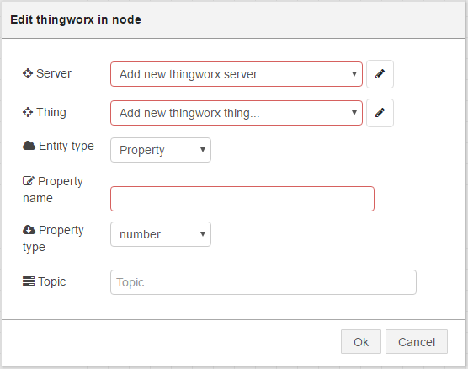

Figure 31: Default thingworx in node.

* 1. Select the already configured thingworx “Server” and “Thing”. If no “Server” and “Thing” are already configured, please follow the steps explained on section 3.1. Add a property name (e.g ***command***). Click on “OK”:

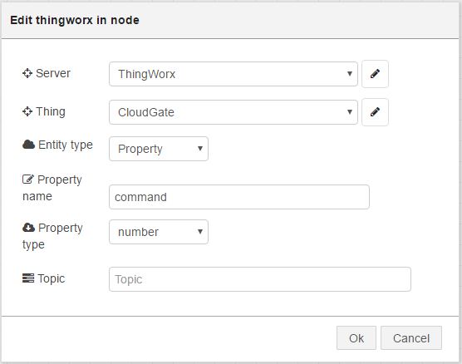

Figure 32: thingworx in node configuration.

1. Drag and drop a debug node and connect both nodes as shown below:

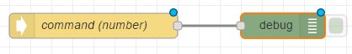

Figure 33: Final configuration.

1. Click on “Deploy”

Now, let’s push some data from the ThingWorx platform:

On the ThingWorx platform, under the thing bindings, we should see a new property called ***command*** listed. We can now follow the same steps explained on section 3.1 to create the new properties under the Thing:

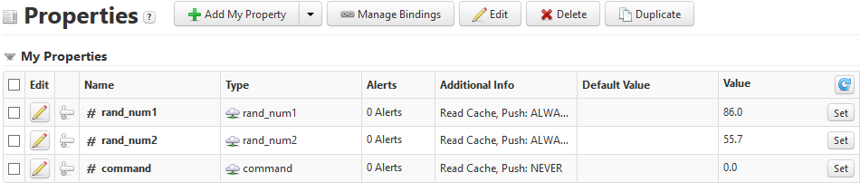

1. Click on the **Set** button to change the value of the property and enter a number (e.g. 1000) and then click on Set:

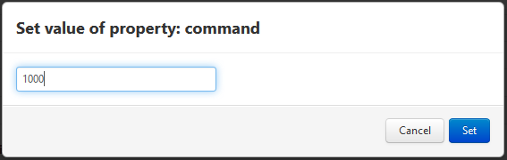

Figure : ThingWorx: Entering data to the Command property.

The new data should be shown on the Debug tab in LuvitRED:

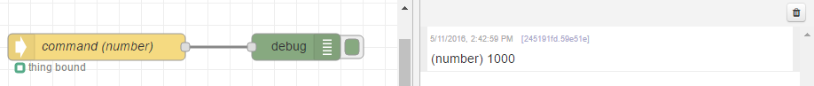

Figure : Data coming from ThingWorx.