|  |
| --- |
| Connecting to ThingWorx using LuvitRED |
|  |

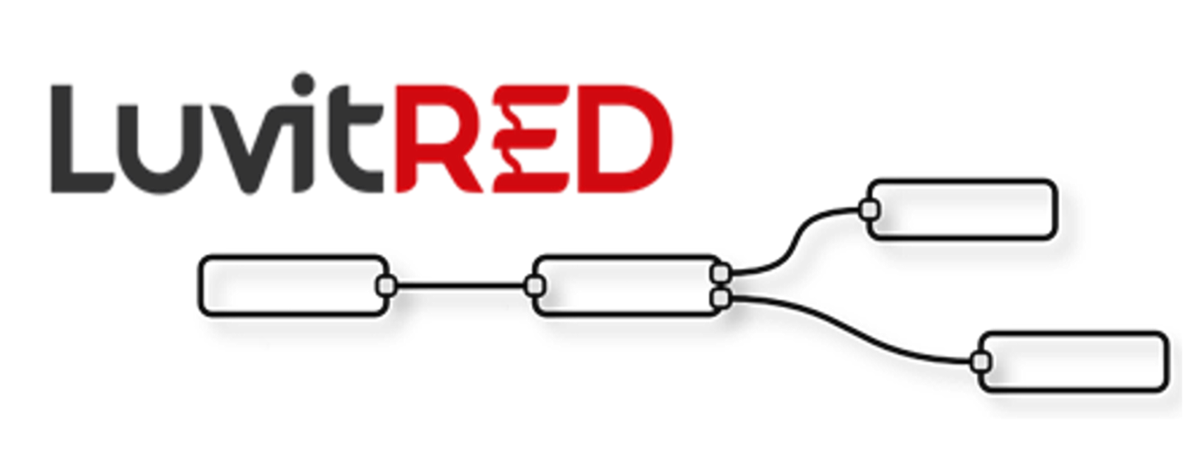

**Franco Arboleda**

**12-Apr-16**

Table of Contents

1 Introduction 3

2 Using the RS232 interface from the front panel. 4

# Introduction

This document covers the configuration of the telematics card using LuvitRED.

# Using the RS232 interface from the front panel.

Go to the "Plugin" tab and then to the sub-tab called "Serial and GPS settings" or "LuvitRED" (the name "LuvitRED" is used from version 2.3.0 onwards):

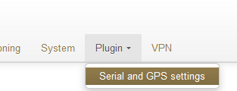

Figure : Plugin tab, Serial and GPS settings.

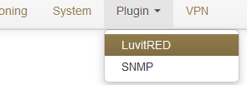

Figure : Plugin tab, LuvitRED.

**NOTE:** Do not focus on the SNMP (Simple Network Management Protocol) sub-tab. This tab is not going to be used on this document.