|  |
| --- |
| Industrial Serial Card on LuvitRED |
|  |

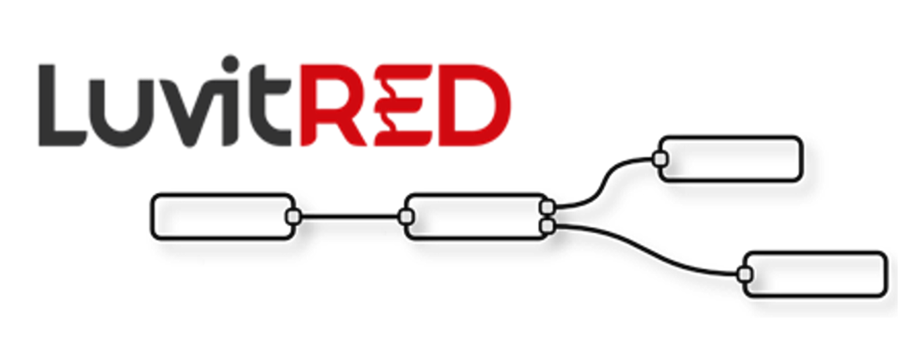

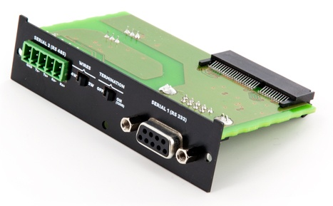

**Franco Arboleda**

**29-Jul-15**

Table of Contents

1 Introduction 3

2 Basic interface - Configuring the RS232 interface. 4

3 Modifying the configuration under the Advanced Editor. 8

3.1 Serial interface from RS232 to RS485 8

3.2 Verifying if firewall hole by LuvitRED 9

3.3 Inactivity timeout on the TCP node. 10

4 Advanced Editor - Both RS232 and RS485 at the same time. 11

# Introduction

This document covers the configuration of the industrial serial card using LuvitRED.

The industrial serial card (CG1102-11920) is shown on Figure 1 below:

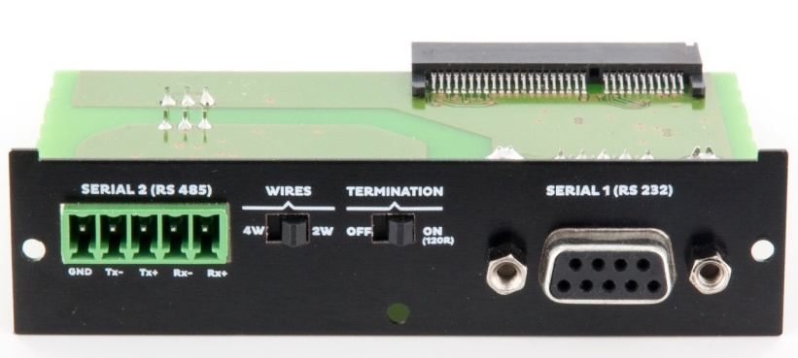

Figure : Industrial Serial Card

* The **RS232** interface is shown on the system as **/dev/ttySP0**
* The **RS485** interface is shown on the system as **/dev/ttySP4**
* The **RS485** interface also has two switchable items that need to be set correctly on the plate:
  + The first item is the amount of wires to use: 4W or 2W.
  + The second item is the termination: OFF or ON.

# Basic interface - Configuring the RS232 interface.

Go to the "Plugin" tab, under it one will find a sub-tab called "Serial and GPS settings" or "LuvitRED" (The name depends on the LuvitRED version being used):

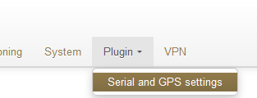

Figure : Plugin tab, Serial and GPS settings.

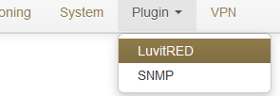

Figure : Plugin tab, LuvitRED.

Without any configuration, the basic interface looks as follows:

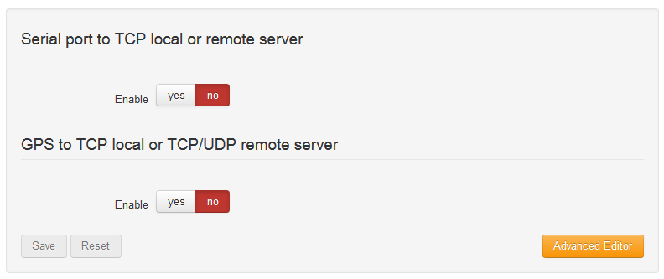

Figure : Basic interface.

For the industrial serial card we are going to focus on the section called "Serial port to TCP local or remote server". This section allows the configuration of one single serial port, the RS232 (**/dev/ttySP0** by default), to be accessible remotely via a local TCP server running on the CloudGate (See Figure 5) or a remote TCP server, running at another location (See Figure 6).

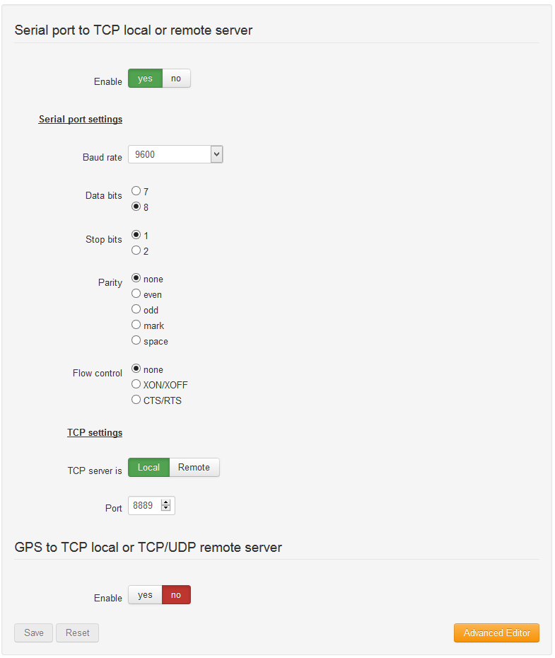

Figure : Serial to local TCP server.

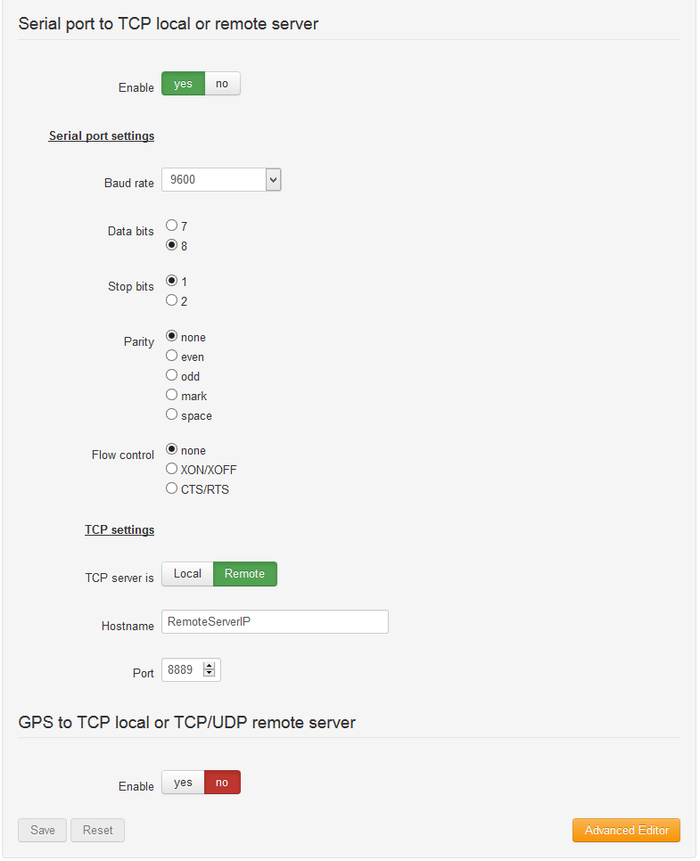

Figure : Serial to Remote TCP server.

On both configurations, one can find the configuration of the serial interface (***Serial port settings****)*:

* Baud rate
* Data bits
* Stops bits
* Parity
* Flow control

These settings need to match the setting of the device connected to the serial interface.

On Figure 5, the CloudGate is running a local TCP server that will listen for incoming connections and forward them to the serial port. The Port number of the TCP server is, by default, **8889**, but it can be changed by the customer at any moment.

If access from the WAN interface (internet) is needed, an appropriate firewall rule needs to be in place to allow the connection to the port:

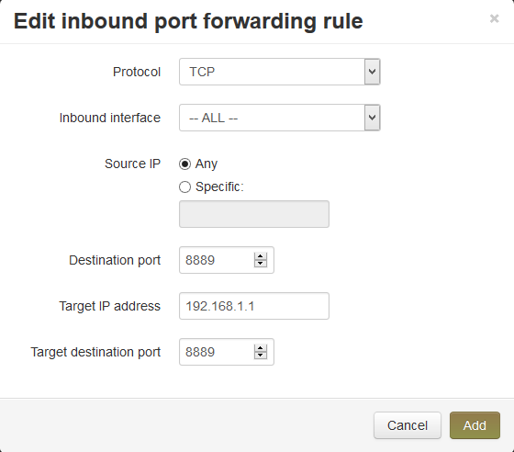

Figure : Inbound port forwarding rule.

**NOTE:** Recent versions of LuvitRED already open a firewall hole to allow remote access from the WAN interface. This can be verified only under the advanced editor, not on the basic interface (see section 3.2).

In Figure 6, the CloudGate will connect to a remote TCP server running on the specified port and send all the information that arrives from the device connected to the serial interface.

# Modifying the configuration under the Advanced Editor.

After configuring the serial port under the basic interface, one can go to the Advance Editor and edit the configuration. The configuration made on the basic interface will be reflected under the Advanced editor in the following way:

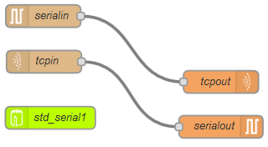

Figure : Same configuration under Advanced editor.

## Serial interface from RS232 to RS485

Double click on the ***serialin*** node:

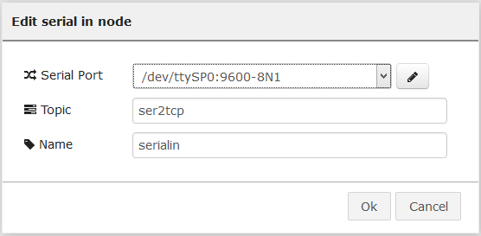

Figure : Serial node general configuration.

One can access the serial interface configuration by clicking on the pencil icon:

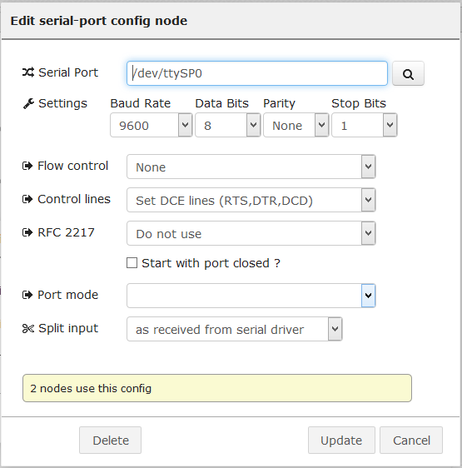

Figure : Serial interface configuration.

Clicking on the magnifying glass will give access to the interface selection:

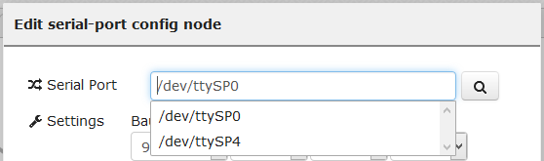

Figure : Interface selection.

Selecting the ***/dev/ttySP4*** interface will modify the configuration to work with the RS485 interface instead of the RS232 interface.

Click on Update, then on OK and then on Deploy (at the top right corner).

## Verifying if firewall hole by LuvitRED

Double click on the ***tcpin*** node:

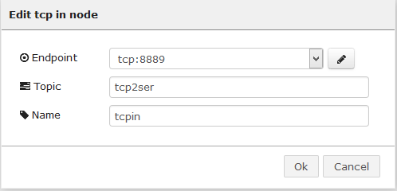

Figure : Tcpin node general configuration.

One can access the "Endpoint" configuration by clicking on the pencil icon:

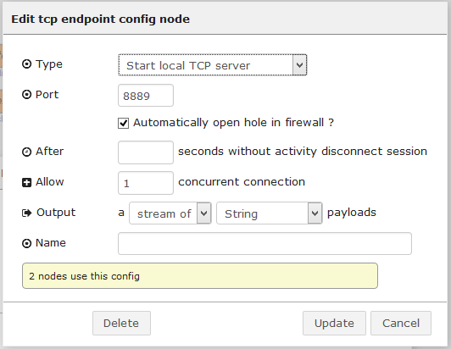

Figure : Endpoint configuration.

Check if the configuration item called "Automatically open a hole in firewall?" is checked or modify it according to the needs of the configuration.

## Inactivity timeout on the TCP node.

Open the "Endpoint" configuration as explained on section 3.2. Once there, add a timeout, in seconds (30 on the example below), on the "After ___ seconds without activity disconnect session" configuration item so that it closes any open connection that is not generating traffic:

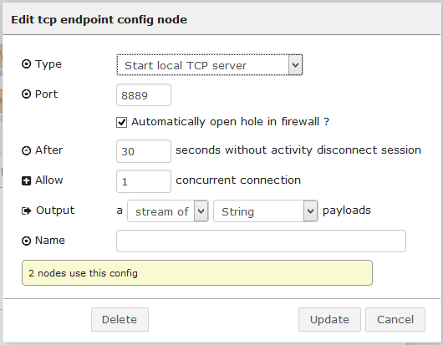

Figure : Adding connection timeout.

# Advanced Editor - Both RS232 and RS485 at the same time.

To reduce deployment time, let's start from the configuration created using the basic interface of LuvitRED for the RS232 interface:



Figure : Basic configuration (RS232).

Click on the green ***std_serial1*** node and delete the node by using the delete key on the keyboard and then click on Deploy:

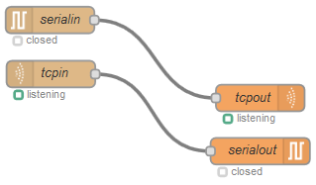

Figure : RS232 configuration without link to basic interface.

Select all nodes using the mouse pointer and then copy the node using CTRL+C and paste them again using CTRL+V into the Editor section of LuvitRED:

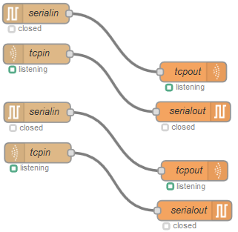

Figure : Copy and Paste the flow.

Let's modify the name of the new nodes in order to avoid problems when editing them. To do that simply double click on the node to rename and change the configuration item called "Name":

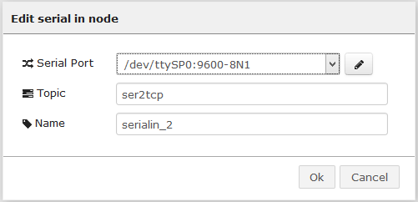

Figure : Renaming the tcpin node.

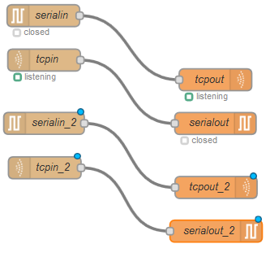

Figure : Renamed nodes.

Double click on the ***serialin_2*** node to edit the node and select "Add new serial-port", then click on the pencil icon:

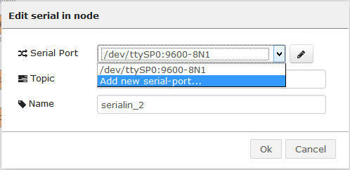

Figure : Adding a new serial port.

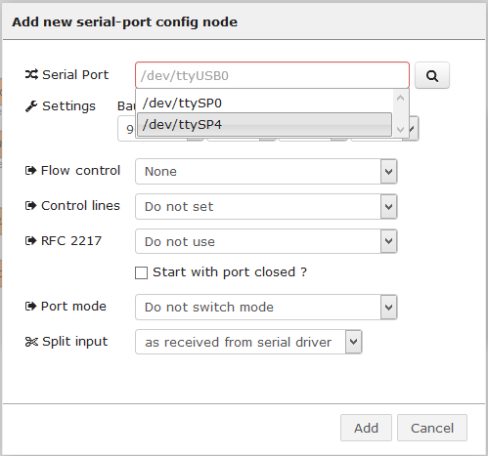

Figure : Adding the RS485 port.

Edit the RS485 according to your needs, then click on "Add" and then "OK".

Open the ***serialout_2*** node and select the newly created configuration for the RS485 interface:

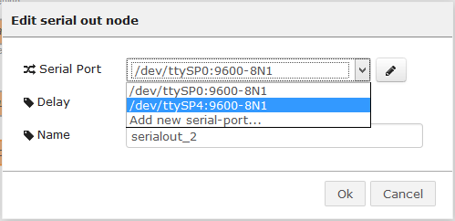

Figure : Select the configuration for the RS485 interface.

Click on "OK".

Open ***tcpin_2*** and select "Add a new tcp endpoint", then click on the pencil icon:

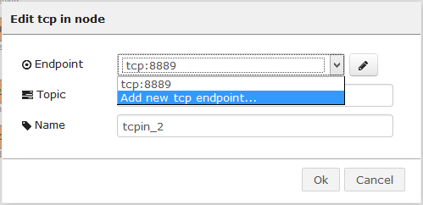

Figure : Adding a new tcp endpoint.

Click on "OK".

Start a local TCP server, but on the port, make sure a different port number than the one used on the RS232 configuration is selected:

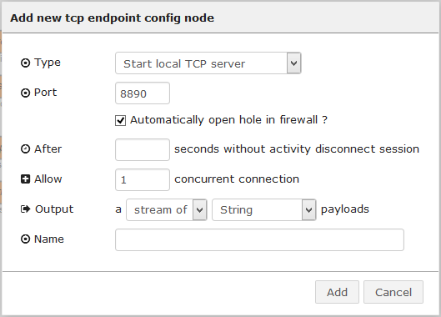

Figure : Local TCP server on port 8890.

Click on "Add" and then "OK".

Open the ***tcpout_2*** node and select the newly created TCP endpoint running on port 8890:

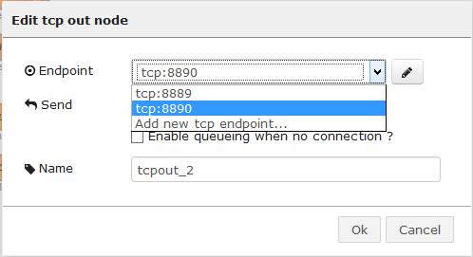

Figure : Select the new endpoint.

Press "OK" and Deploy the configuration.

When looking at the "Configuration nodes" list one should see that four configuration nodes are available and that each of those are used by two nodes:

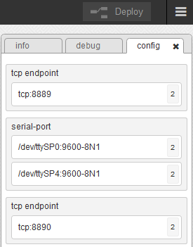

Figure : Configuration nodes view.

If the configuration was done correctly, access to the serial ports should be granted on TCP port 8889 for RS232 and TCP port 8890 for RS485.