|  |
| --- |
| CloudGate as a mini-PC replacement |
|  |

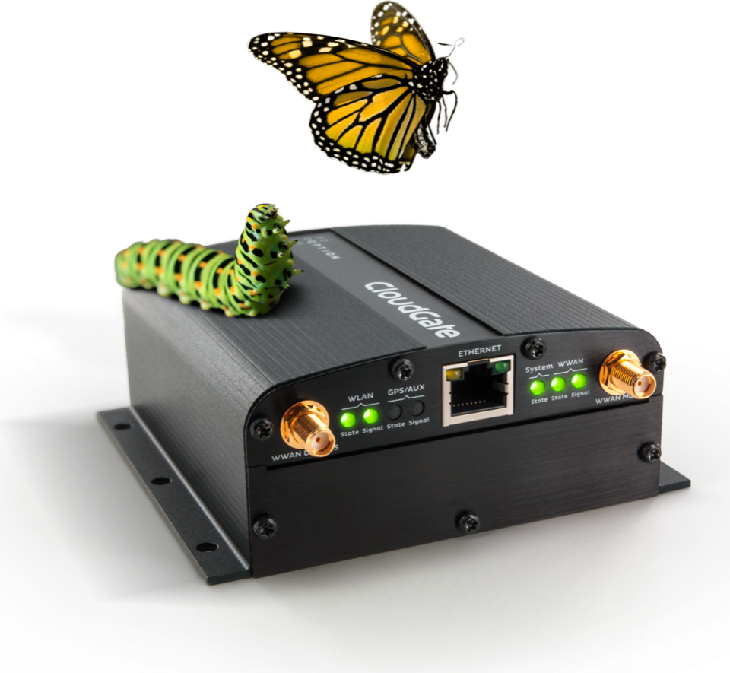

**Franco Arboleda**

**12-Aug-15**

Table of Contents

1 Introduction 3

2 Example of CloudGate acting as a mini-PC replacement 4

# Introduction

The Option CloudGate is, in most cases, used as a simple 3G/LTE internet gateway to provide connectivity to other devices such as mini-PCs and other kind of networking devices. This is the most basic usage that one can give to the CloudGate.

The idea behind this document is to illustrate how can the CloudGate be used as a replacement for mini-PCs currently in charge of doing some preprocessing before sending the data through the gateway onto the internet.

The CloudGate itself is a mini-PC, a Linux based mini-PC, that has the following specifications for memory and CPU (Extracted from the datasheet of the CloudGate 3G Americas):

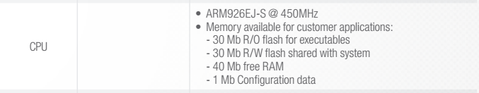

Figure : CPU and Memory specifications for CloudGate 3G/LTE.

Using the SDK (Software Developer Kit) of the CloudGate, it is possible to create/port the same software that is used in any other mini-PC and place it into the CloudGate. This capability allows the user to basically concentrate both mini-PC and gateway pieces of a solution on a single piece of hardware hence reducing points of failure and costs of deployment.

The ability of using the already existing expansion cards or the HDK (Hardware Developer Kit) to create custom expansion cards for the CloudGate, makes it possible to add any required interface that is not provided by the default CloudGate configuration.

# Example of CloudGate acting as a mini-PC replacement

In a setup in which one has multiple wireless sensors talking to a centralized mini-PC that is charge of processing the values from the wireless sensors, take a decision based on those values and send the information to a server using a gateway (See Figure 2)

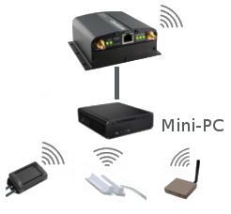

Figure : Original configuration using mini-PC.

The mini-PC part of the setup can be replaced by the CloudGate itself using a wireless expansion card and adding the software that is in charge of processing the data using the SDK (See Figure 3).

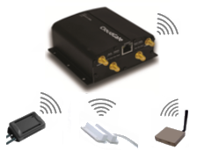

Figure : New setup replacing the mini-PC with the CloudGate.