**CMC Guidance for Updating Booked Opportunities to Create Better Project Records**

Starting in January 2014, the North American marketing systems group is beginning to create records in the Projects object in Salesforce from records in Opportunities that are in Stage 6 – Contracted/Booked/Won. The current criteria for which opportunities will become projects include:

* Information coming into Salesforce from Oracle (Account, Booked Amount, and Booked Date)
* Gross AECOM Contract Revenue greater than 10,000
* Description in the Project Description field

The key to creating project records that will have value to CMC people looking to include something in a proposal will be the description entered into the Project Description field.

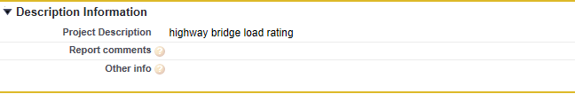

CMC people involved in proposal development generally have access to enough information to create a really good description. And these are the same people that are always hoping to find good descriptions in the system.