**GNG Procedure for requesting a B&P number when the lead geography is EMEA or APAC and the lead department is not on Oracle.**

**Note:** this procedure is to be used only for opportunities that are led by a department in EMEA or APAC that is not yet on Oracle. B&P charge numbers for most EMEA and APAC-led opportunities should be issued by the lead geography’s Oracle system and used by Americas staff.

1. Make sure the North America department has been added to the opportunity (in this example, it has not yet been added.

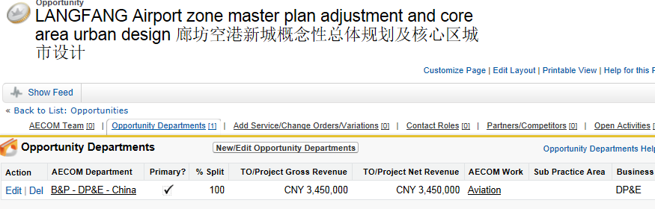

1. In the left panel of any Salesforce screen, click **Create New** and then **Select Go/No Go Conversation**:

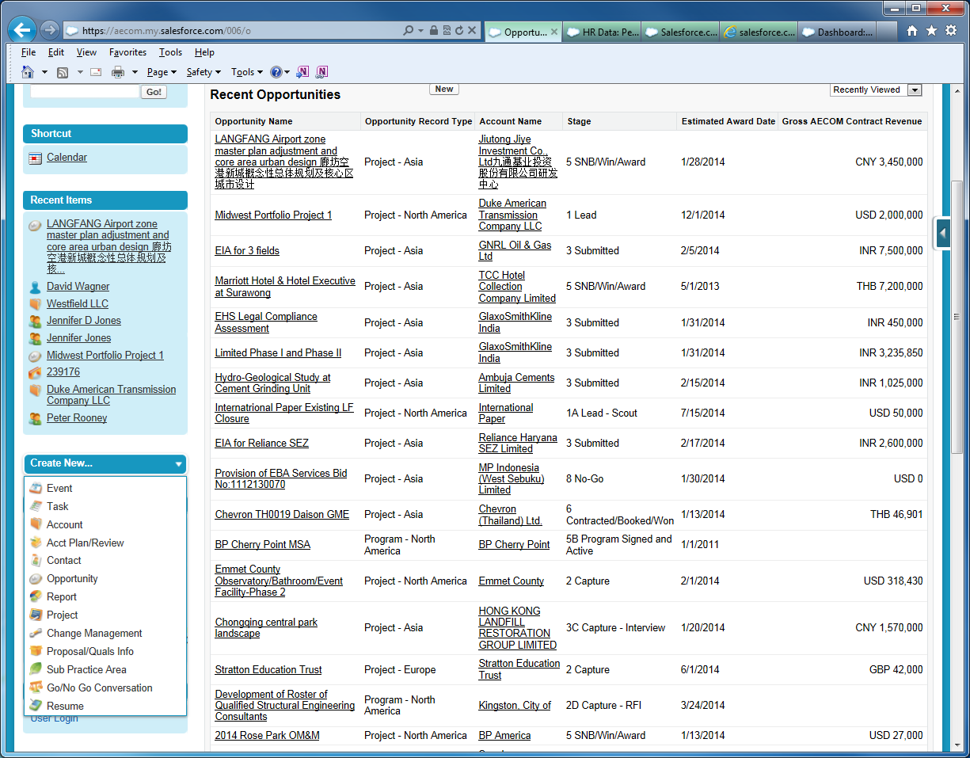

1. In the Opportunity field, select the name of the opportunity led by the other geography, then continue as usual.