Set up

Customize

Salesforce CRM Content

Content Types

Define content types

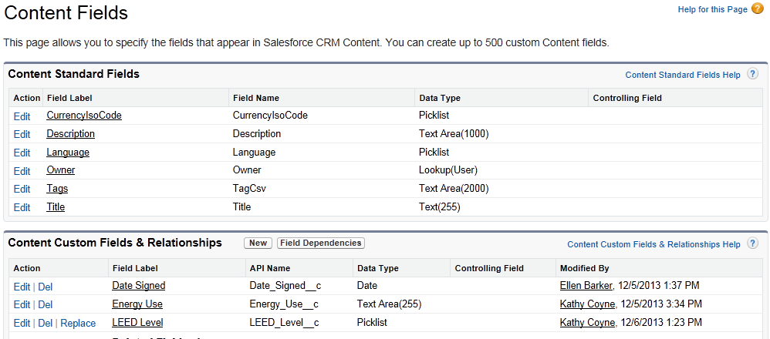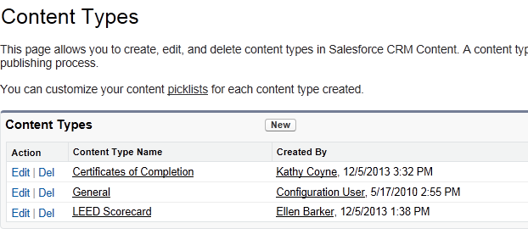

Create fields

The General content type includes standard fields

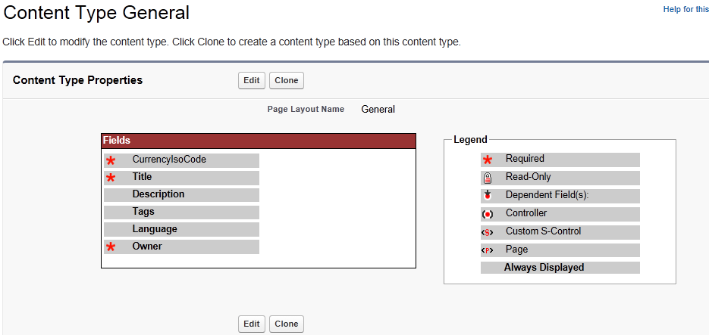

When you go to Libraries and pick a library, click on Content Types to define the content types used in the library

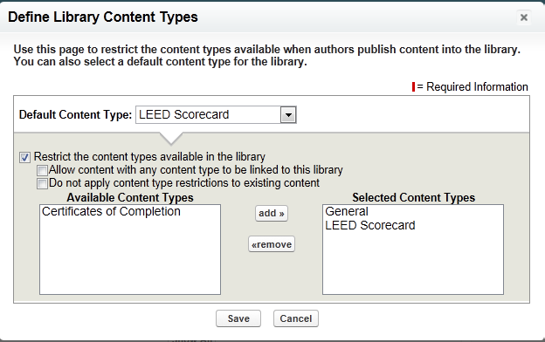

If you don’t want to have to include the General content type in all of your libraries, include the fields you want in the content types you create.

Title, Description, and Tags and from the General content type, but included in the LEED Scorecard content type.

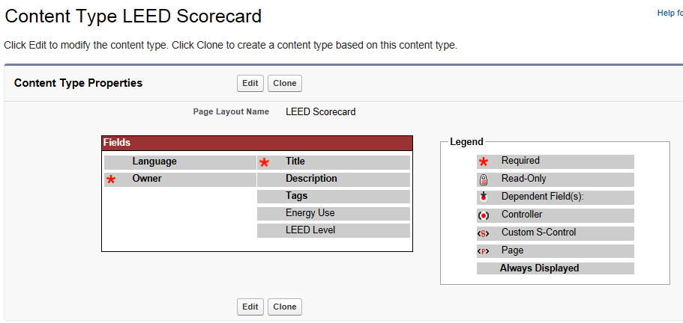

When you contribute content to publish to a library, once you select the shared library you want to publish it to, you will see the fields you added to the content type.

