**Salesforce Integration in APIC**

July 2013

Introduce a new section called “Salesforce Opportunity Details” on Project Setup workbook

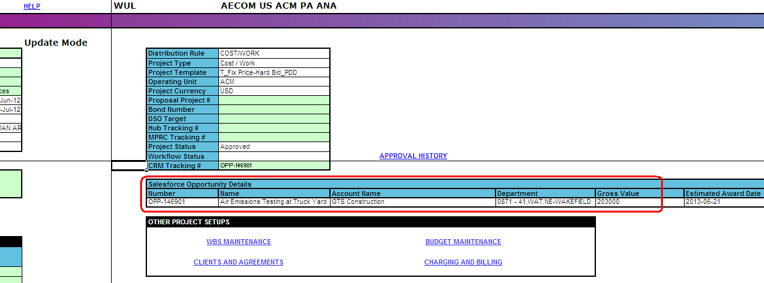

During project creation, PM can select the “CRM Tracking #” in the Quick Entry page

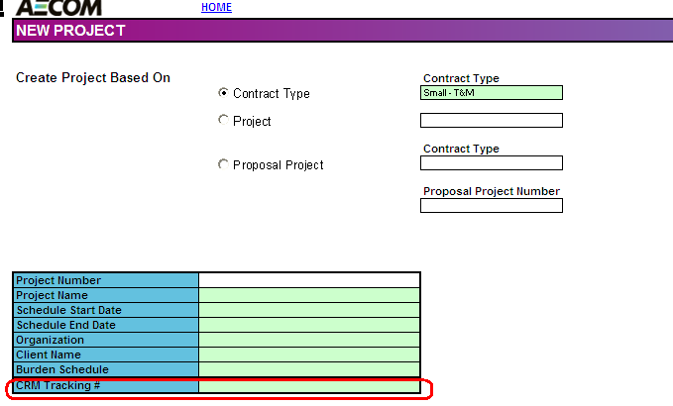

Or add it after project has been created.

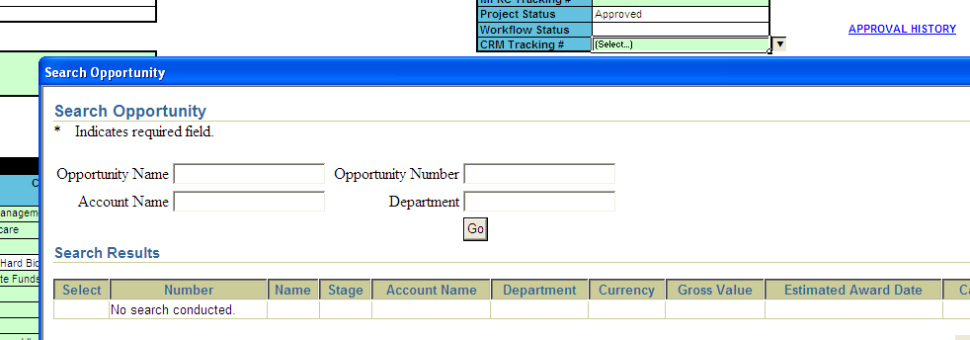

CRM = Client Relationship Management

CRM Tracking # used to be a text field but is now a dropdown lookup list.

The search opportunity page should show all opportunities on stages 2 through 5, and 6 if opportunity is not tied to a project yet. If an opportunity is selected in APIC but not yet synced to Salesforce, the opportunity will be on the list to be eligible for selection in APIC. So potentially, an opportunity is tied to two projects. In the event that an opportunity is tied to two projects, upon workflow completion, Oracle data will be deleted in Salesforce and it will go to the latest sync project. In APIC, both projects will show the same CRM Tracking #.

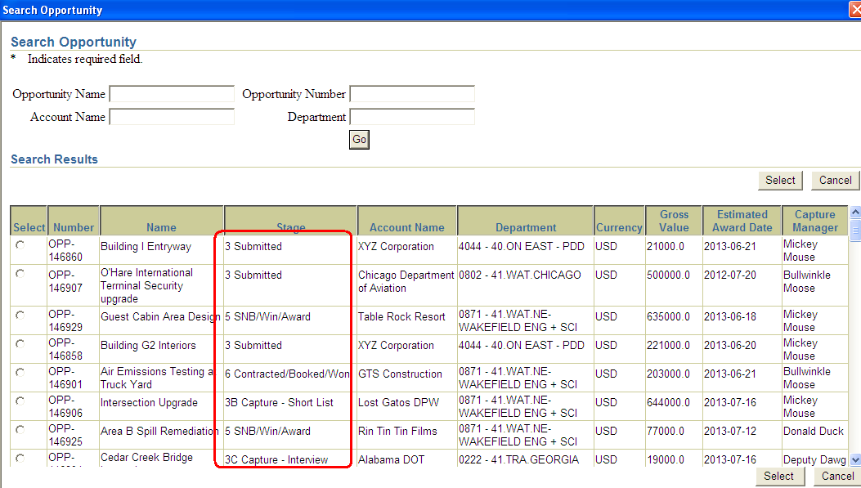

After selecting an opportunity, the other data elements on “Salesforce Opportunity Details” will be brought in/displayed.

Adding the CRM Tracking # will not trigger a project status change. The next time the project goes through and completes workflow, APIC will send data back to Salesforce via web services. It is done by a concurrent program in Oracle.

The concurrent program will send back Oracle data to Salesforce and sets the opportunity stage to “6”. If there is any issue with this processing, an email will be sent to APIC support and Salesforce support. The support analyst in Salesforce will manually update this data there if there’s anything wrong with this processing.

If successfully, the “sync date” on “Salesforce Opportunity Details” section is populated.

Concurrent program is launched under PM user ??? But should be by system administrator? This is always in Running mode.

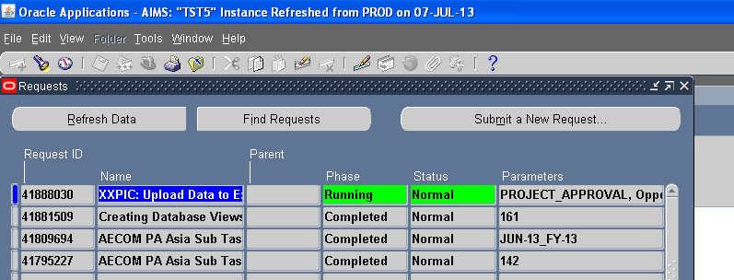

XXPIC: Upload Data to External Applications

Salesforce login (test):

<https://test.salesforce.com/>

[sureshp@projectp.com](mailto:sureshp@projectp.com)

oracle12

Search by opportunity number

If sync process was successful the “Oracle Read-only Data:” is populated for this opportunity.

Oracle Read-only Data: fields

Oracle account : Oracle customer name

Oracle booked amount: total baselined funding

Oracle booked date: max funding allocation date

Oracle completion: project trans completion date

Oracle NSR: APIC NSR formula

Oracle PM Employee ID: HR employee number

Oracle Primary Department: Project owning org name

Oracle Project Name:

Oracle project number:

Oracle start date: Project trans start date

If “win date” and “book date” (in “Date fields”) are blank in Salesforce, then this process will also populate them with the “Oracle Booked Date”.

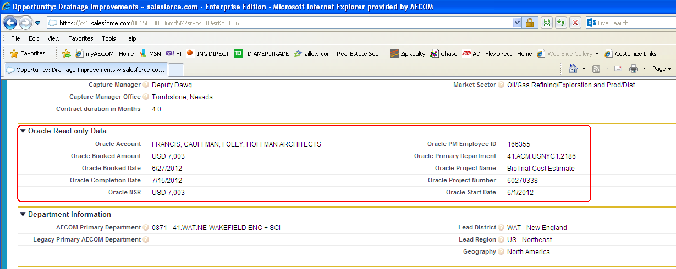

As long as an opportunity is not synced to Salesforce, then CRM# can be deleted in APIC.