Rock paper Scissors Lizard Spock with a strategy based game

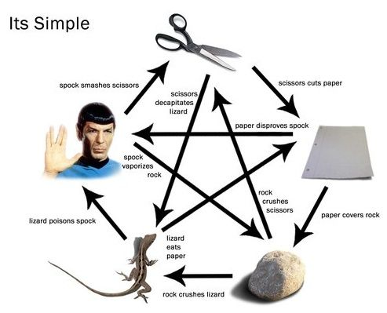

Both Player has 5 pawns with some behaviors:

1. Rock
   1. Strong against Lizard, Scissors
   2. Weak Against Spock, Paper
   3. Attack: 50
   4. Health: 100
2. Paper
   1. Strong against Rock, Scissors
   2. Weak Against Spock, Paper
   3. Attack:
   4. Health: 100
3. Scissors
   1. Strong against Paper, Scissors
   2. Weak Against Spock, Rock
   3. Attack:
   4. Health: 100
4. Spock
   1. Strong against Rock, Scissors
   2. Weak Against Lizard, Paper
   3. Attack:
   4. Health: 100
5. Lizard
   1. Weak against Rock, Scissors
   2. Strong Against Spock, Paper
   3. Attack:
   4. Health: 100

The concept of health adds complication to the game idea as the player won’t be able to use a pawn if it dies but that’s not the only twist. At the beginning of the game both the players will be asked to choose the pawns.

If the idea complicates one then think of it like a Pokémon game with fire, grass, water, electric, ghost, poison …. Type Pokémon. Here we have only 5 different one pawns.

**GUI:**

Boxes will have the pawn type and their health. Once the Health of a pawn depletes to zero the box disappears.

Classes:

Player 1 and Player 2 (Similar)

Class for each pawn

Pawns

R = rock

P = paper

S = Scissors

O = Spock

L = Lizard

* + **R**:
    - **-> R = 10**
    - **-> P = 5**
    - **-> S = 20**
    - **-> O = 5**
    - **-> L = 20**
  + **P**:
    - **-> R = 20**
    - **-> P = 10**
    - **-> S = 5**
    - **-> O = 20**
    - **-> L = 5**
  + **S**:
    - **-> R = 10**
    - **-> P = 5**
    - **-> S = 20**
    - **-> O = 5**
    - **-> L = 20**
  + **O**:
    - **-> R = 10**
    - **-> P = 5**
    - **-> S = 20**
    - **-> O = 5**
    - **-> L = 20**
  + **L**:
    - **-> R = 10**
    - **-> P = 5**
    - **-> S = 20**
    - **-> O = 5**
    - **-> L = 20**