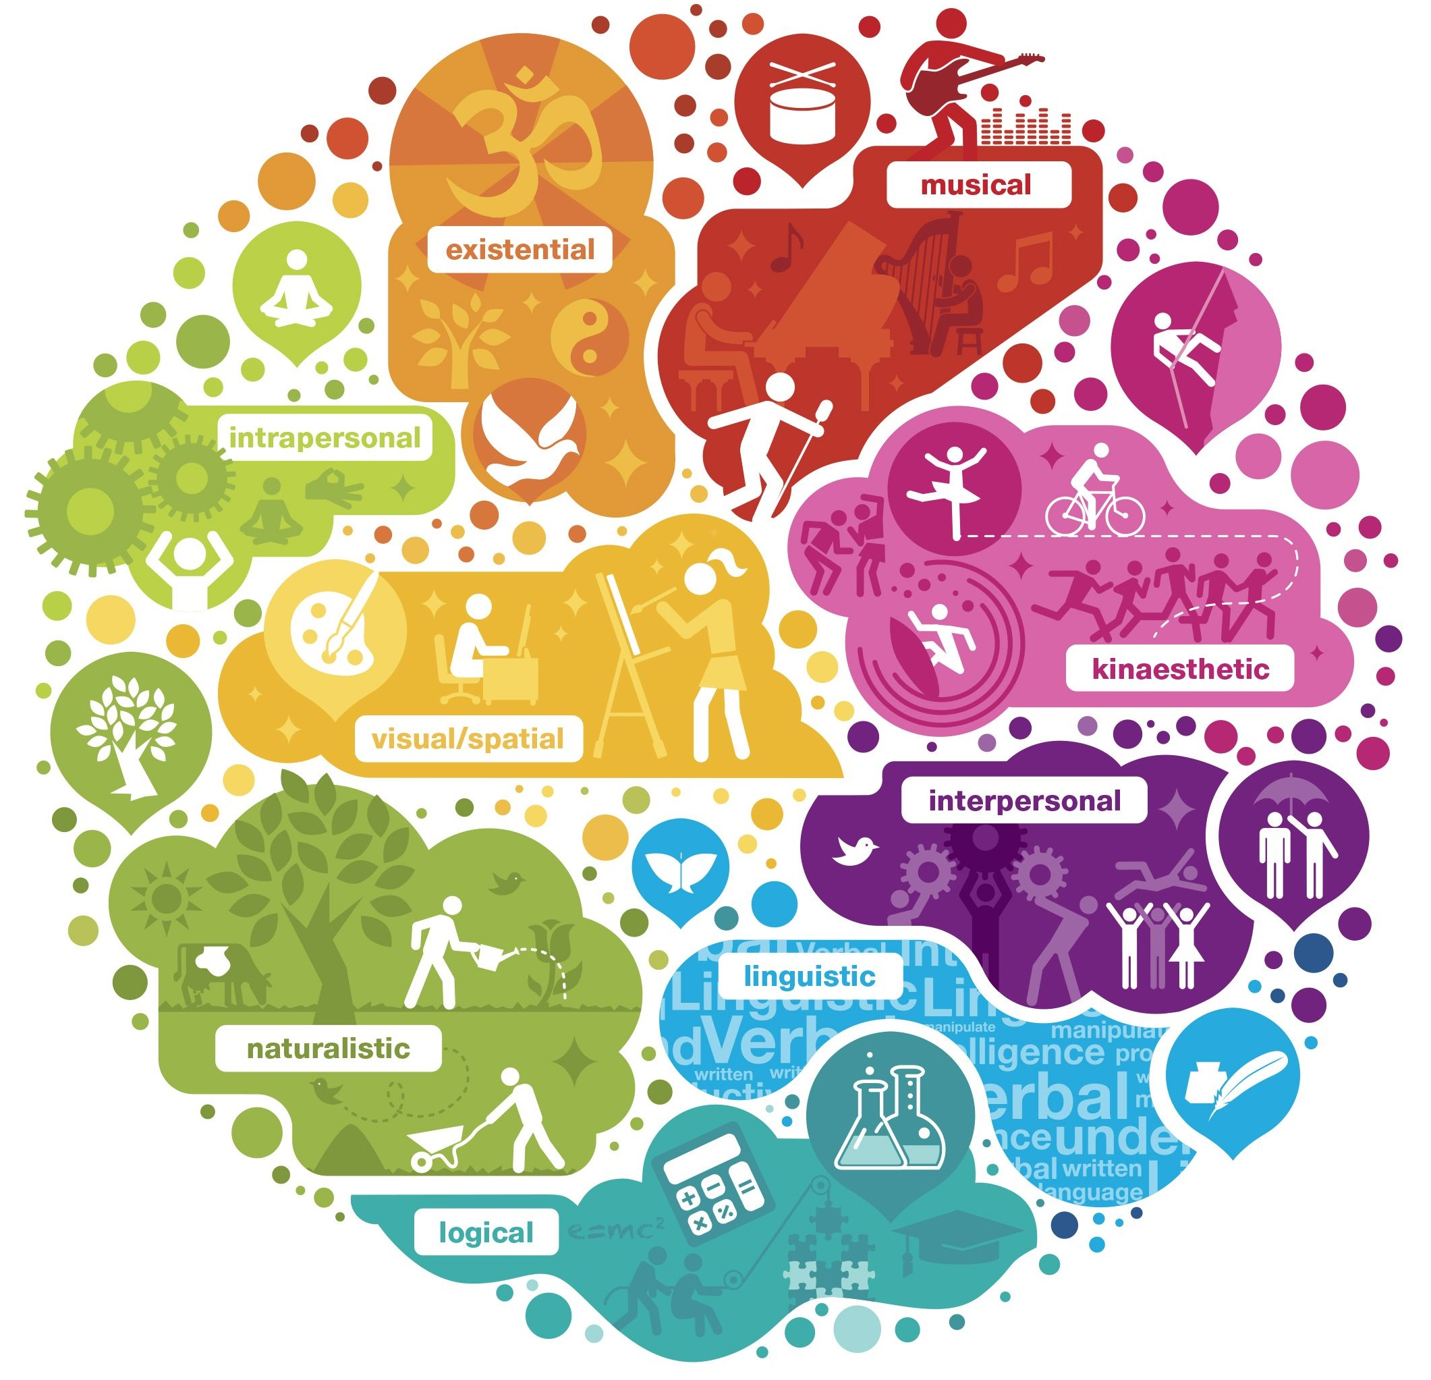logical #3EACA9

linguistic #28A9DD

musical #BD352B

naturalist #99B44C

spatial #E9B739

interpersonal #72247E

intrapersonal #BAD04B

existential #E1993A

bodily #D765A7