**Majyhain, Average Height of Male and Female by Country 2022, Kaggle Dataset, February 02, 2022.”**

**About Dataset**

**Context**

This dataset is about Average Height of Male and Female by Country 2022. It has in it the height of both genders (male and female) in metric feet and centimeter. Also has column stating the country names and a column for ranking.

**Content**

The dataset contains six columns:

* Rank
* Country Name
* Male height in Cm
* Female height in Cm
* Male height in Ft
* Female height in Ft

References:

The Data is collected from the following sites:

<https://ourworldindata.org/>

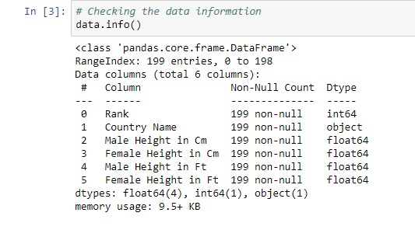

The Image above shows the general information of the dataset, showing that we have 199 entries (rows) and 6 total columns. The data types are shown and we have no missing data on the dataset.

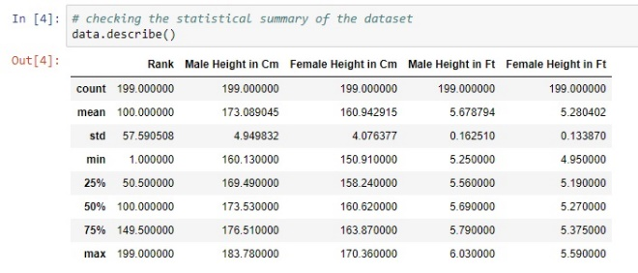

The table above shows the statistical summary of the dataset stating the count, mean, standard deviation, min and the max of each numerical columns.

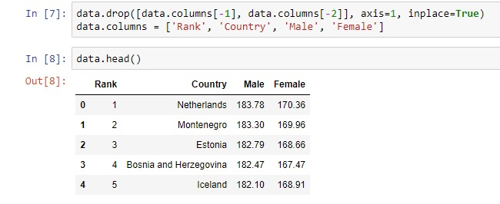

The height are being represented in feet and cm, since they both represent the same information, the height in cm is being dropped and kept the measures in feet. The columns names are being replaced with Male and Female for each of the gender heights columns.

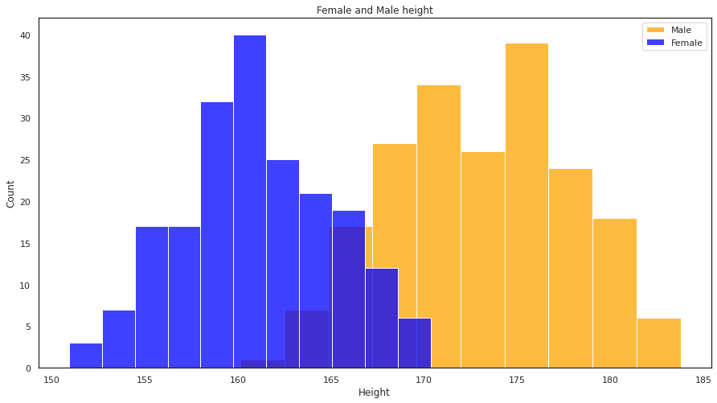

The figure above shows the histogram marge plot of both the male and female distribution height, so there is mild change in ratio, but in acceptable level (the ratio ranges from 30.45 to 30.51)

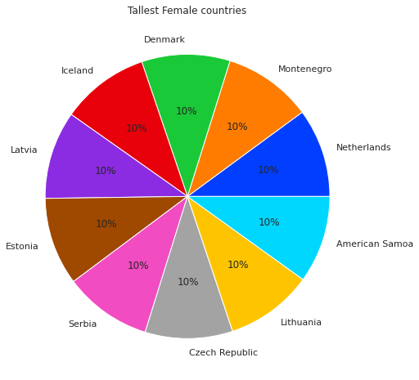

The figure above shows the pie chart plot of the top 10 tallest female countries ranging from Netherlands down to American samoa. The figure below shows the bar chart representation of it.

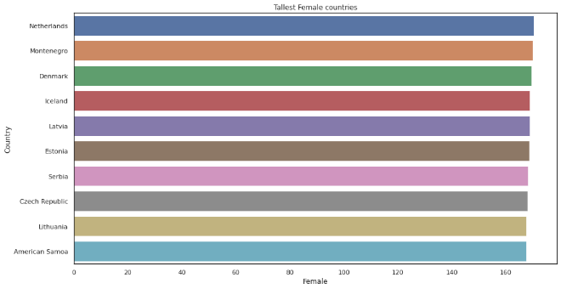

The figure below shows the pie chart plot of the top 10 tallest male countries ranging from Netherlands down to Slovenia. The bar chart representation is shown below as well.

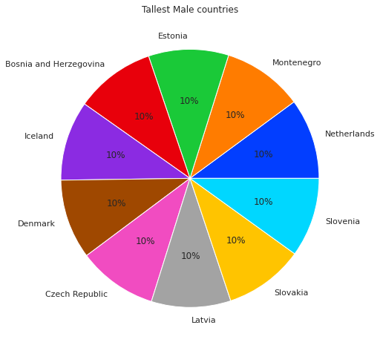

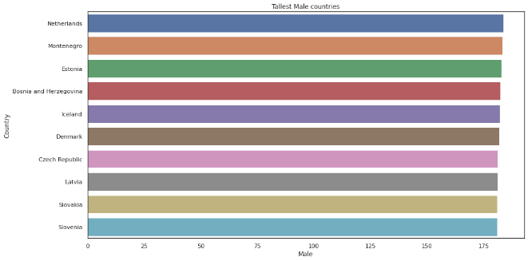

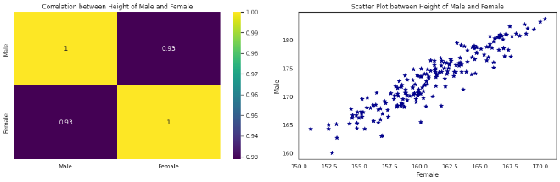

The figure above shows both the correlation and scattered plot representation of the both the male and female height.no surprise, there is exceedingly high correlation between height of male and female. Hence, the country with high average male height is likely to have high mean female’s height.

In conclusion, Netherlands and Montenegro are the two countries with the tallest average height of both Male and Female, Timor-Leste is the country with the shortest average height of Male and Guatemala is the country with the shortest average height of Female. Timor-Leste is the country with the shortest average height of Male and Guatemala is the country with the shortest average height of Female and the Shortest countries are mostly from Asia and South Asia.