**Earthquake prediction using Python**

**Phase -4**

**Training the model:**

**Exploratory Data Analysis:**

EDA is an approach to analyzing the data using visual techniques. It is used to discover trends, and patterns, or to check assumptions with the help of statistical summaries and graphical representations.

Code:

plt.figure(figsize=(10, 5))

x = df.groupby('year').mean()['Depth']

x.plot.bar()

plt.show()

Output: 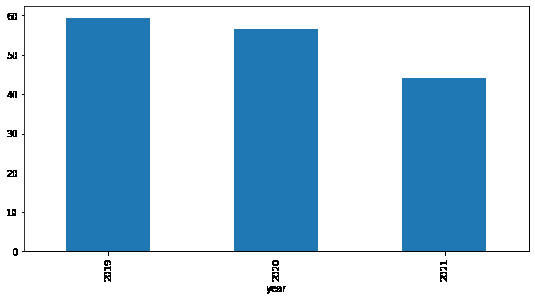

The depth from which earthquakes are starting is reducing with every passing year.

**Monthly Analysis:**

Code :

plt.figure(figsize=(10, 5))

sb.lineplot(data=df,

x='month',

y='Magnitude')

plt.show()

Output:

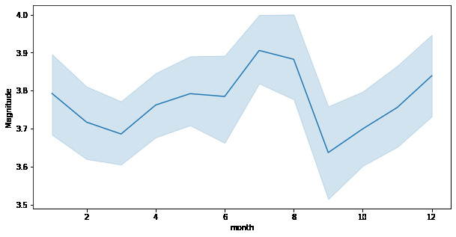

Here we can observe that the changes of an earthquake with higher magnitude are more observed during the season of monsoon.

**Distribution Graph:**

Code:

plt.subplots(figsize=(15, 5))

plt.subplot(1, 2, 1)

sb.distplot(df['Depth'])

plt.subplot(1, 2, 2)

sb.boxplot(df['Depth'])

plt.show()

Output:

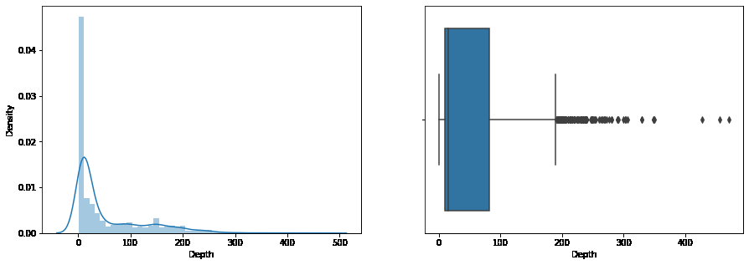

From the distribution graph, it is visible that there are some outliers that can be confirmed by using the boxplot. But the main point to observe here is that the distribution of the depth at which the earthquake rises is left-skewed.

**Normal Distribution:**

Code:

plt.subplots(figsize=(15, 5))

plt.subplot(1, 2, 1)

sb.distplot(df['Magnitude'])

plt.subplot(1, 2, 2)

sb.boxplot(df['Magnitude'])

plt.show()

Output:

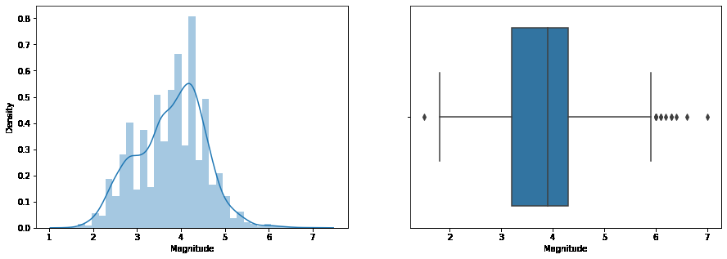

**Scatterplot:**

Code:

plt.figure(figsize=(10, 8))

sb.scatterplot(data=df,

x='Latitude',

y='Longitude',

hue='Magnitude')

plt.show()

Output:

