

Software Quality & Testing

**Assignment on Selenium (Final Term)**

Submitted By

|  |  |
| --- | --- |
| Name | ID |
| **Idrak, Muntakim Islam** | 17-35784-3 |
| **Shanto, Shadhin Islam** | 18-37660-1 |
| **Imran, Fardin Ahsan** | 17-33846-1 |
| **Sumaiya, Farjana Yeasmin** | 17-34115-1 |

Under the supervision of

**Abhijit Bhowmik**

Senior Assistant professor & Special Assistant

Office of Student Affairs

Department of Computer Science

Faculty of Science and Technology

American International University Bangladesh

Summer Semester 2019-2020

# **Installing Selenium**

We have installed Selenium for 2 different language. These are *C#* and *JavaScript.* We have included both installations’ screenshots.

## **For JavaScript**

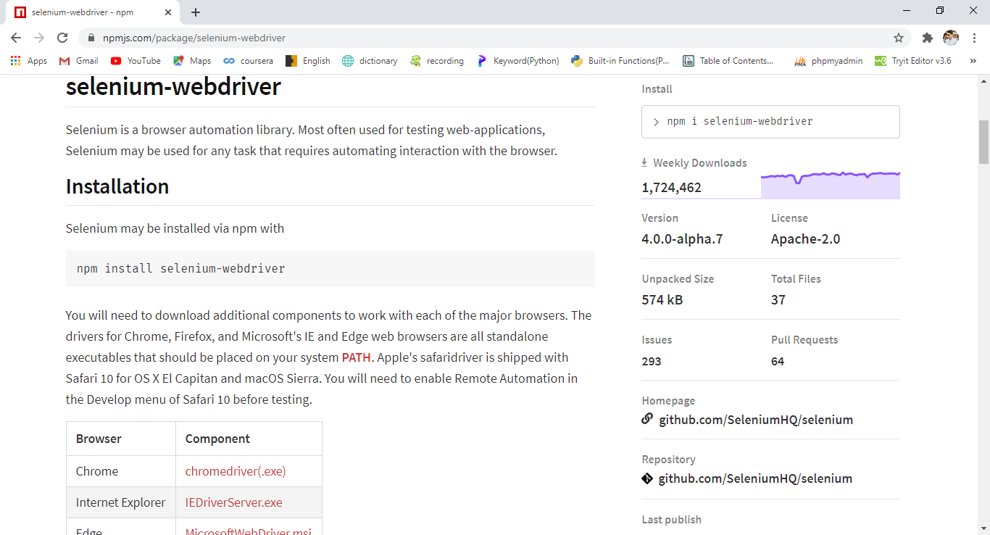

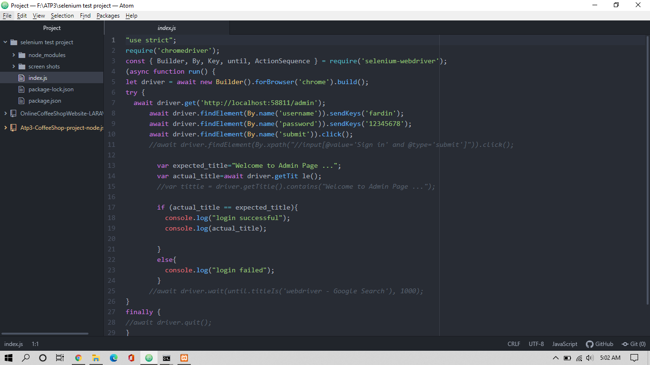

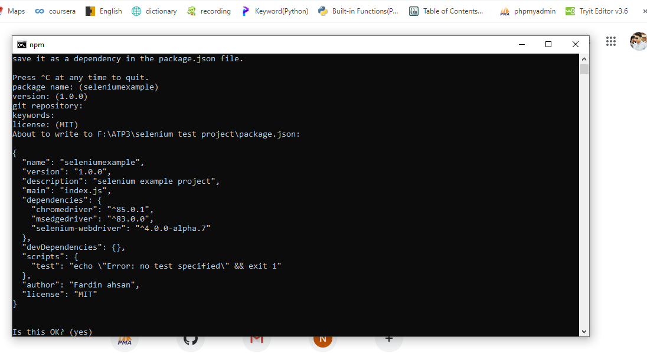

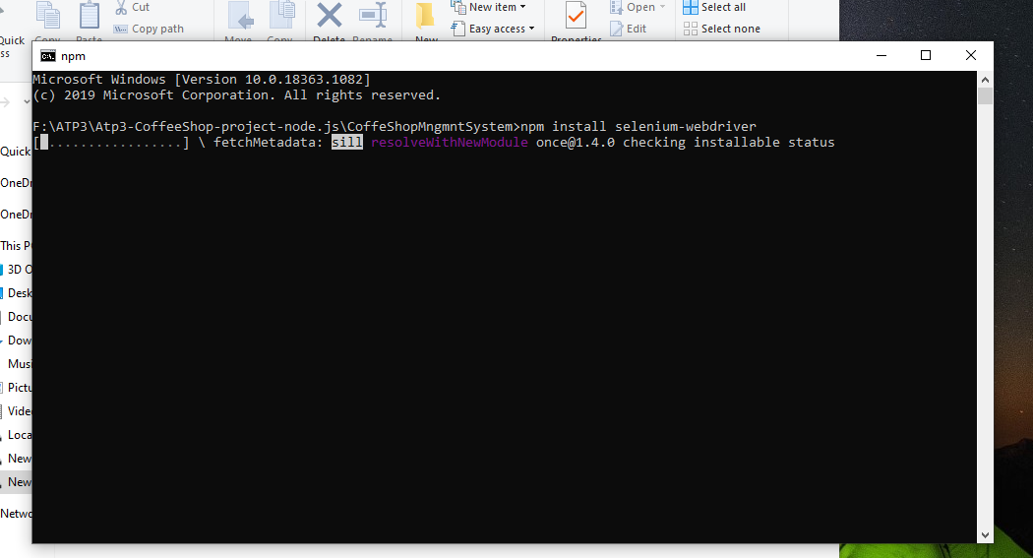

## **For C#**

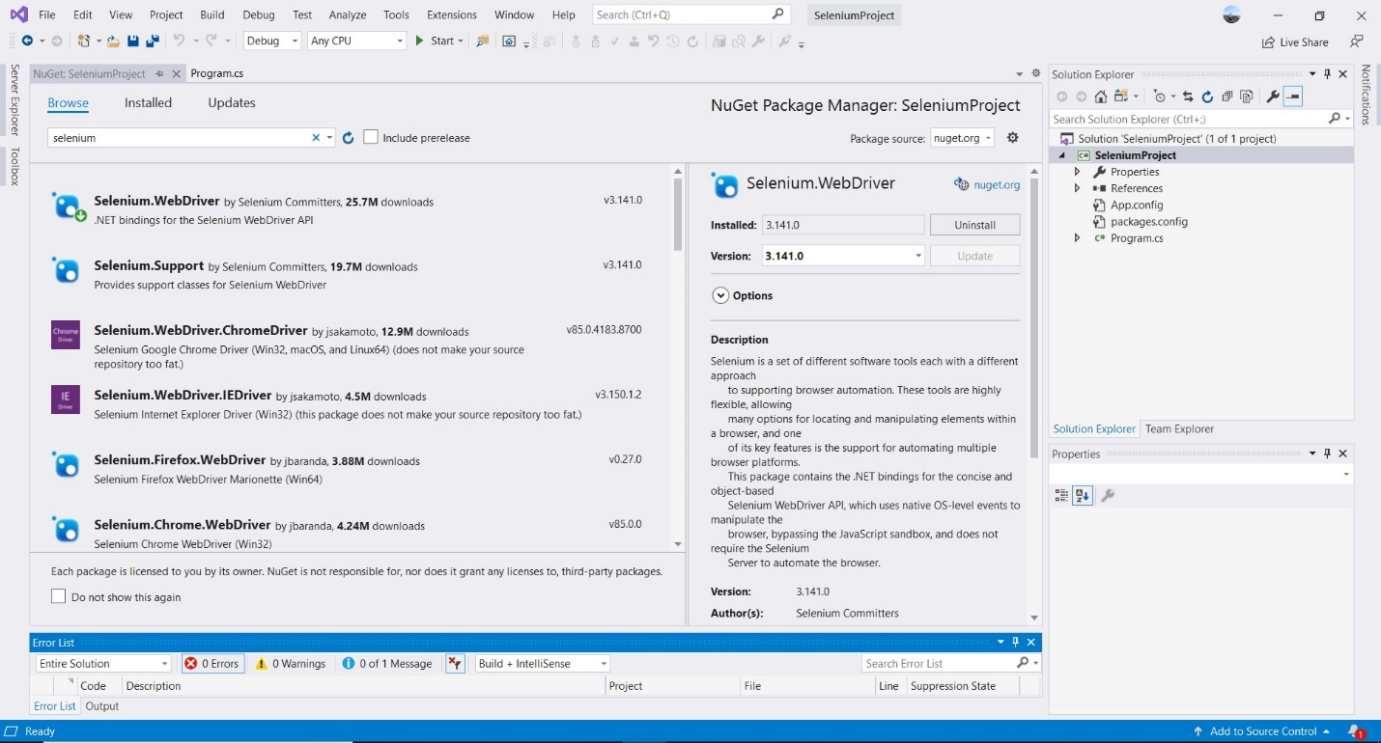

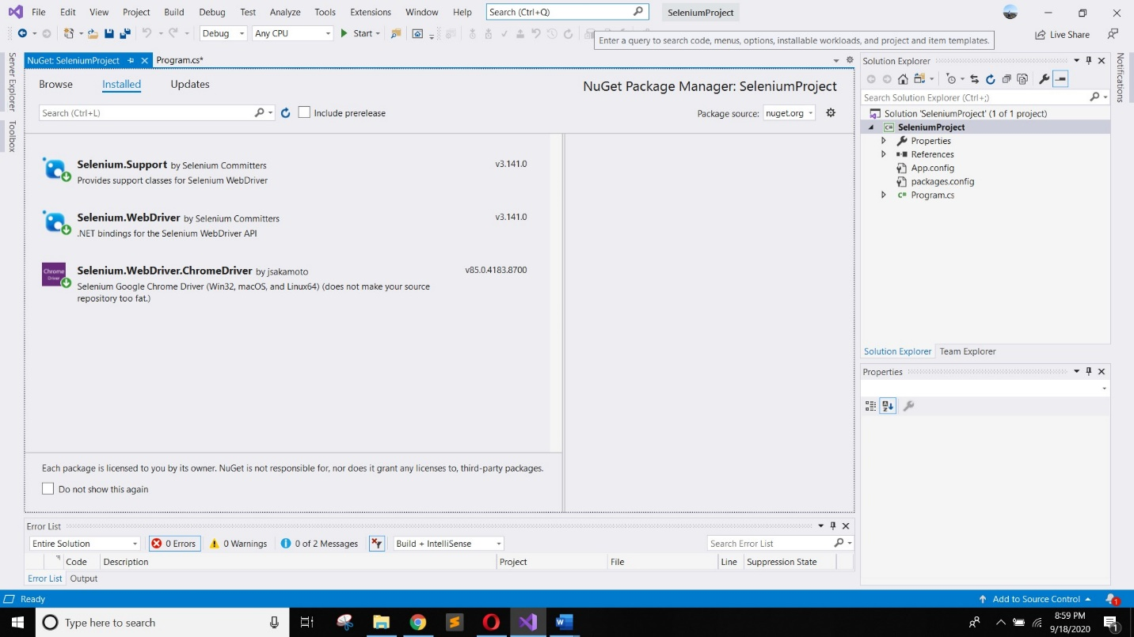



# **Benefits of Automated Testing and Specialty of Selenium**

Automation testing is a Software testing technique to test and compare the actual outcome with the expected outcome. This can be achieved by writing test scripts or using any automation testing tool. Test automation is used to automate repetitive tasks and other testing tasks which are difficult to perform manually.

Some benefits of automated testing are listed below.

1. **Faster Feedback**

Automated testing comes as a relief for validation during various phases of a software project. This improves communication among coders, designers, and Product Owners, and allows potential glitches to be immediately rectified. Automated testing assures higher efficiency of the development team.

1. **Accelerated Results**

Owing to the quick implementation of automated testing, plenty of time is saved even for intricate and enormous systems. This allows for the testing to be carried out repeatedly, delivering faster results each time with lesser effort and time.

1. **Reduced Business Expenses**

It comes as no surprise that while the initial investment may be on the higher side, automated testing saves companies many a penny. This is predominantly due to the sharp drop in the amount of time required to run tests. It contributes to a higher quality of work, thereby decreasing the necessity for fixing glitches after release and reduces project costs.

1. **Testing Efficiency Improvement**

Testing takes up a significant portion of the overall application development lifecycle. This goes to show that even the slightest improvement of the overall efficiency can make an enormous difference to the overall timeframe of the project. Although the setup time takes longer initially, automated tests eventually take up significantly lesser amounts of time. They can be run virtually unattended, leaving the results to be monitored towards the end of the process.

1. **Higher Overall Test Coverage**

Through the implementation of automated tests, more tests can be executed pertaining to an application. This leads to a higher coverage that in a manual testing approach, would imply a massive team limited heavily with their amount of time. An increased test coverage leads to testing more features and higher quality applications.

1. **Reusability of Automated Tests**

Due to the repetitive nature of test automation test cases, in addition to the relatively easy configuration of their setup, software developers have the opportunity to assess program reaction. Automated test cases are reusable and can hence be utilized through different approaches.

1. **Earlier Detection of Defects**

The documentation of software defects becomes considerably easier for the testing teams. This helps increase the overall development speed while ensuring correct functionality across areas. The earlier a defect is identified, the more cost-effective it is to fix the glitch.

1. **Thoroughness in Testing**

Testers tend to have different testing approaches, and their focus areas could vary due to their exposure and expertise. With the inclusion of automation, there is a guaranteed focus on all areas of testing, thereby assuring best possible quality.

1. **Faster Time-to-Market**

Test Automation greatly helps reduce the time-to-market of an application by allowing constant execution of test cases. Once automated, the test library execution is faster and runs longer than manual testing.

1. **Information Security**

The effectiveness of testing will be largely dependent on the quality of the test data you use. Manually creating quality test data takes time, and as a result, testing is often performed on copies of live databases. Automation solutions can help with creating, manipulating, and protecting your test database, allowing you to re-use your data time and again. The time and cost savings in this area are potentially huge.

Some Specialties of Selenium are given below.

1. Language and Framework Support
2. Open Source Availability
3. Multi-Browser Support
4. Support Across Various Operating Systems
5. Ease of Implementation
6. Reusability and Integrations

# **Demo Project and Code snippet**

We have tested 2 websites using different languages. At first we tested our local project and another was on web server.

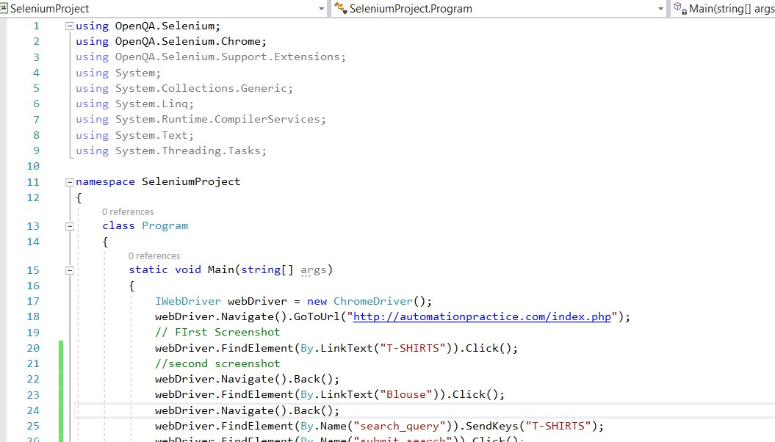



# **Results**

