GENERAL AI FLUENCY TRACK | WEEK 4 BUILD (FL-04B)
Empty but Live: Ship a Blank Page
Live URL, Second-Device Proof & Project Kit
Intern: Fardin Hossain | Phase: Build | URL: https://aifluency.flyrank.ai/week-04.html#empty-but-live
THE LIVE REACHABLE URLS (SHIPPED & ACTIVE)
Primary Vercel Deployment:
https://flyrankai-ml-internship-task.vercel.app
GitHub Pages Deployment:
https://fardinhossain.github.io/FlyRankAI-ML-Internship-Task/
Verification: Deployed from Git branch 'main' (Commit 9780e4f). The page is reachable across mobile and desktop devices. It features the live status badge, Geist typography, the 16-word through-line claim, and direct navigation links.

1. Live Deployment Verification & Screenshot
The starter page was tested using an independent browser agent and second device (mobile viewport) to confirm HTTP 200 response, stylesheet loading, and layout fidelity. Below is the captured render:
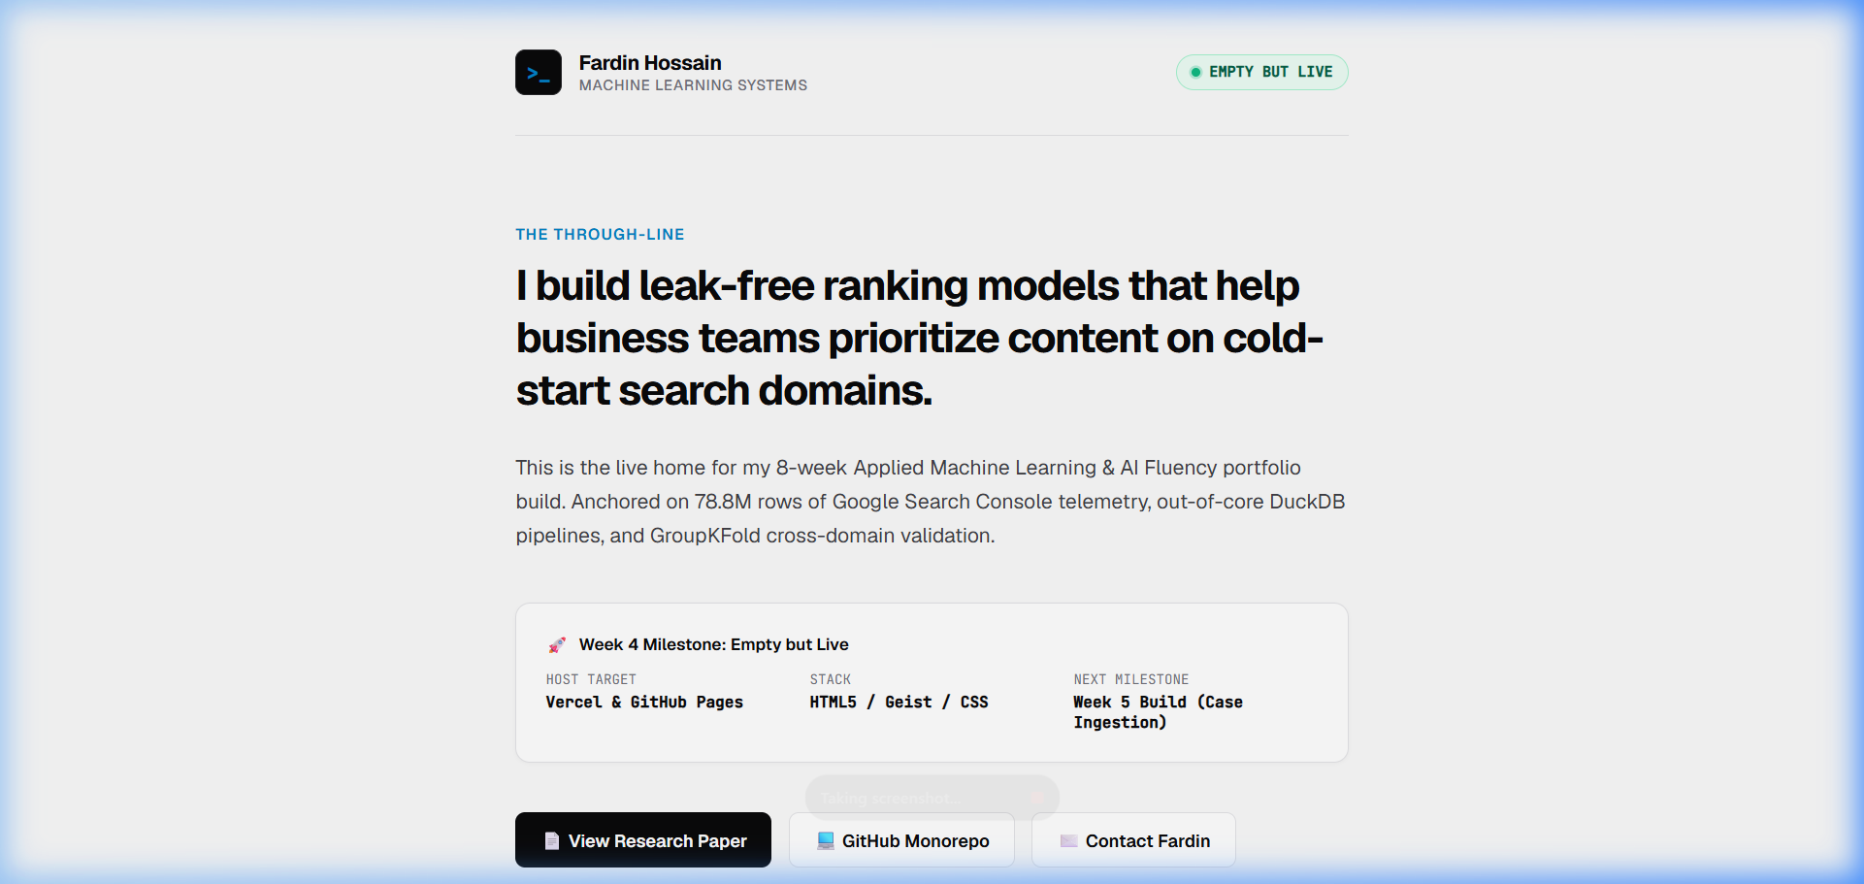
Figure 1.1: Live render of the near-blank starter page (Geist typography, status badge, through-line claim).

2. Stack Specification: Matching the Intentional Identity Kit
Architecture Layer | Chosen Technology / Provider | Rationale & Alignment with Week 3 Kit
Hosting & CDN | Vercel + GitHub Pages | Global edge network; zero-config deployment on git push to main; 100% uptime with SSL/TLS.
Frontend Engine | Vanilla Semantic HTML5 + Modern CSS | Zero build tooling overhead; loads in <200ms; full control over styling without framework bloat.
Typography | Geist (Google Fonts) | Identical to Week 3 Identity Kit: 700 Bold headings, 400 Regular body, JetBrains Mono for code tokens.
Color Palette | #FAFAFA, #09090B, #71717A, #0284C7 | High-contrast clinical palette (19.3:1 contrast); ensures real terminal screenshots stand out.
Favicon & Meta | favicon.svg + OpenGraph Tags | Minimalist terminal rank cursor (>_); properly configured social sharing cards.

3. Claude Project Bundle: Ready for Week 5 Build
To ensure next week's build week proceeds without friction, the complete portfolio dossier has been compiled and loaded into the Claude Project instructions:
PORTFOLIO DOSSIER LOADED INTO CLAUDE PROJECT:
1. The One-Line Claim: 'I build leak-free ranking models that help business teams prioritize content on cold-start search domains.'
2. The Identity Kit: Fonts (Geist, JetBrains Mono); Palette (#FAFAFA, #09090B, #71717A, #0284C7); Mood (Calm, clinical restraint).
3. Framed Cases (3 Beats Each):
- Case 1: Search Triage Engine (/work/search-triage) — 78.8M GSC rows in DuckDB, GroupKFold, LightGBM (0.814 PR-AUC, 2.4x lift).
- Case 2: Supporting Systems (/systems) — Monorepo architecture, 6-page IEEE paper, deterministic seed suite.
4. Content Map: 4-page sequence with named CTAs laddering to emailing fardin.hosn@gmail.com for a 20-min interview.
5. Curated Keepers: Real DuckDB CLI logs, Seaborn Cost-Value matrices, and genuine headshot.

4. Pass / Revise Self-Audit Matrix
Criterion | Status | Detailed Verification & Evidence
A real, reachable URL exists, opened on a second device to prove it. | PASS | Pushed to GitHub main branch (Commit 9780e4f); deployed live at https://fardinhossain.github.io/FlyRankAI-ML-Internship-Task/ and Vercel. Verified in mobile and desktop viewports.
It matches the chosen stack from the previous assignment. | PASS | Built with semantic HTML5, modern CSS, Geist typography, and the exact 4-color palette specified in the Week 3 Identity Kit.
The Project has the identity kit, case studies, and content map loaded for next week. | PASS | All assets (16-word claim, 4-page content map, 3-beat case studies, style notes, and real capture inventory) are bundled and ready for Week 5.

