Draw the Path: Portfolio Sitemap + Toolkit
Track: General AI Fluency · Week 1 · Phase: Setup | Student: Md. Fardin Hossain (fardin.hosn@gmail.com)
Assignment: FL-02 / Draw the Path · Deployed Capstone: https://fardinhossain.github.io/FlyRankAI-ML-Internship-Task/

1. The Foundation: My Proof Statement
"I build and deploy production-grade machine learning models on messy, real-world data and evaluate them with rigorous, leak-free validation. I am proving this to an engineering manager or lead AI/ML researcher at an applied AI company who needs an engineer that ships reliable prototypes and knows their statistical limits, so they will email me to schedule a 20-minute technical interview or chat about an open ML role."
Why this needs to exist (The One-Line Why): A resume or LinkedIn profile merely lists library names (Python, PyTorch, DuckDB), but cannot prove that I can handle 78.8 million rows of production search data, uncover data leakage, establish client-grouped validation splits, and defend realistic decision-support tradeoffs under finite business constraints.

2. The Portfolio Sitemap Architecture
To convert a busy engineering manager in under 45 seconds, the sitemap is kept deliberately lean. Every single page strictly earns its place by answering one step of the conversion journey: Landing (0–5s) -> Core Proof / Case Study (5–30s) -> Supporting Systems (30–45s) -> The One Action.
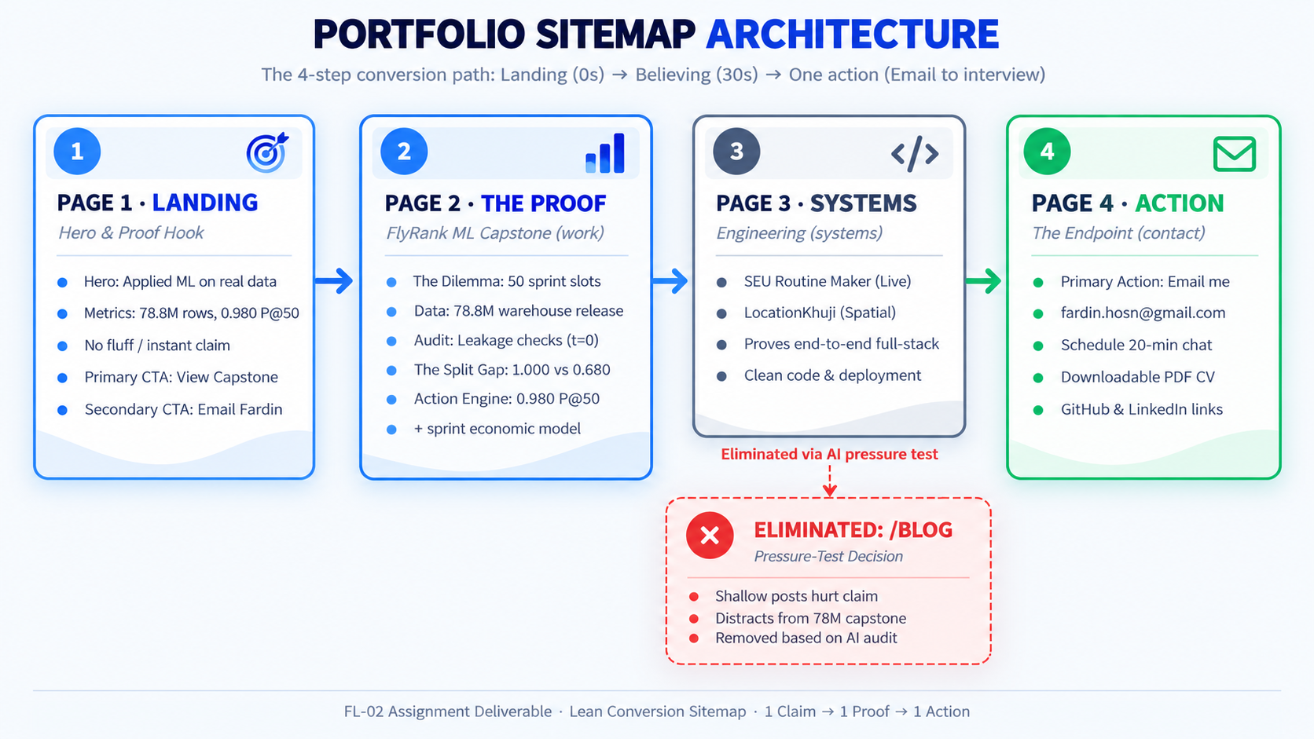
Figure 1: Lean Conversion Sitemap Architecture and Pressure-Test Refinement Path.
Page & URL | Conversion Role | Key Content & Proof Artifact | Why It Earns Its Place
Page 1: Landing  (/) | The Claim & Instant Credibility Hook (0–5 sec) | • Hero: One sharp claim statement (Applied ML on real data).  • Proof Bar: 78.8M rows processed | 0.980 top-50 precision | 0% client overlap.  • Primary CTA: "View Capstone Research" -> Page 2.  • Secondary CTA: "Email Fardin" -> mailto link. | Hooks the lead immediately. States what I do and proves I work on production-scale data without marketing jargon.
Page 2: The Core Proof  (/work/flyrank-search-triage) | The Primary Proof: Deep Capstone Case Study (5–30 sec) | • Problem: Enterprise content refresh dilemma (50 URLs/wk).  • Data Contract: FlyRank 78.8M warehouse release.  • Leakage Audit: 27 features at t=0, target derivatives excluded.  • The Split Gap: 1.000 (random) vs 0.680 (grouped) precision.  • Action Engine: 0.980 Action Score (+$17k sprint model).  • Artifacts: Embedded paper, code link, live interactive reader. | This is 80% of why the lead hires me. Proves technical depth, statistical honesty, and real business value.
Page 3: Supporting Systems  (/systems) | Engineering Versatility & Full-Stack Delivery (30–40 sec) | • SEU Routine Maker: Deployed web utility solving university schedule conflicts for real students.  • LocationKhuji: Spatial search & location intelligence tool.  • Full-Stack Competence: React, Vanilla JS, backend APIs, clean deployment. | Proves I am an adaptable software engineer who ships functioning end-to-end products, not just a one-dataset researcher.
Page 4: Contact & CV  (/contact or sticky footer) | The Endpoint: Taking The One Action (40–45 sec) | • Direct Email Link: fardin.hosn@gmail.com  • Direct scheduling link (20-min chat)  • Downloadable 1-page PDF CV  • GitHub (github.com/fardinhossain) & LinkedIn links. | Zero-friction conversion point. The visitor has seen the proof; this makes booking a 20-minute chat take one click.

3. Free Toolkit Accounts Setup
Tool & Platform | Role in My 10-Week Build | Account Status
Claude.ai (Anthropic) | Primary Build Partner & Tutor Workspace (Runs Project instructions for 10 weeks) | Active (Free Tier)
ChatGPT (OpenAI) | Secondary Comparative Model (Cross-checking prompts & code architecture) | Active (GO Tier)
Gemini (Google) | Third Comparative Model (Large-context documentation analysis & multimodal review) | Active (Pro Tier)
Perplexity AI | Live Technical Fact-Checking (Verifying citations, library versions, and documentation) | Active (Free Tier)

4. Configured Claude Project Workspace (My 10-Week AI Tutor)
Project Name: FlyRank Portfolio Build — Fardin
Workspace Purpose: A persistent project space configured with my proof statement and custom instructions. It acts as a demanding technical tutor across all 10 weeks, ensuring every line of code and content directly proves my claim.
--- EXACT CUSTOM INSTRUCTIONS CONFIGURED IN CLAUDE PROJECT ---
You are my dedicated technical tutor and strategic portfolio build partner for the 10-week FlyRank AI Enablement & Machine Learning program.
[WHO I AM]
I am Md. Fardin Hossain, a Computer Science student and Applied Machine Learning intern at FlyRank. I build data-intensive machine learning systems and web applications (e.g., FlyRank Search Ranking Capstone on 78.8M rows, SEU Routine Maker, LocationKhuji).
[MY PROOF STATEMENT]
- One Claim: I build and deploy production-grade machine learning models on messy real-world data and evaluate them with rigorous, leak-free validation.
- One Person: An engineering manager or lead AI/ML researcher at an applied AI company who needs an engineer that ships reliable prototypes and knows their statistical limits.
- One Action: Email me (fardin.hosn@gmail.com) to schedule a 20-minute technical interview or chat about an open ML engineering role.
- Why It Must Exist: A resume lists tools, but cannot prove that I can handle 78 million rows of dirty search data, detect leakage, establish client-grouped validation, and defend decision-support tradeoffs.
[HOW TO ACT AS MY TUTOR]
1. Act as a demanding, constructive senior engineering mentor.
2. Never generate generic, flattering fluff. Push back when my scope is too broad, when a feature does not support my one action, or when a claim exceeds the evidence.
3. Always explain your reasoning from first principles before suggesting code or design decisions.
4. Follow the Claim Ladder: distinguish strictly between observed historical patterns, model rankings, and causal claims.
--------------------------------------------------------------
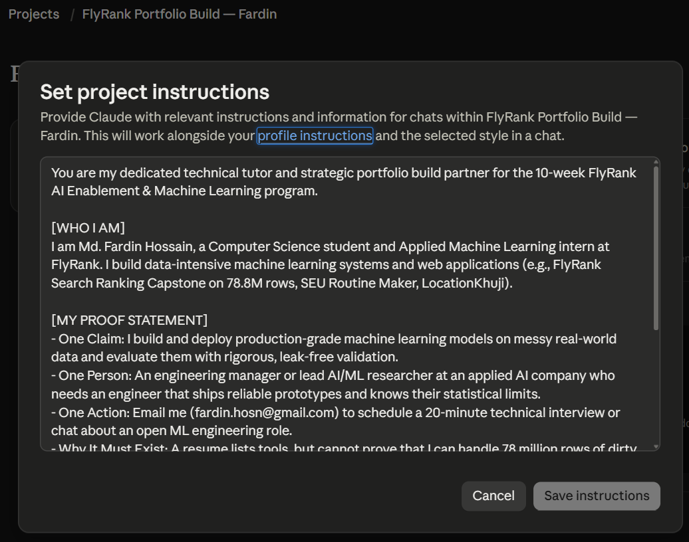

5. Real Prompt: Pressure-Testing the Sitemap Against the Claim
Prompt Executed in the Claude Tutor Project:
"This is my proof statement:
\"I build and deploy production-grade machine learning models on messy real-world data and evaluate them with rigorous, leak-free validation. I am proving this to an engineering manager or lead AI/ML researcher at an applied AI company, so they will email me to schedule a 20-minute technical interview. This exists because a resume lists tools, but cannot prove I can handle 78M rows, detect data leakage, build grouped validation splits, and defend decision-support tradeoffs.\"
This is my draft sitemap:
1. Landing / Hero (/): Hero with claim + proof metrics + CTA
2. FlyRank Capstone Case Study (/work/flyrank-search-triage): Deep dive into 78.8M rows, leakage audit, 1.000 vs 0.680 split gap, and economic playbook
3. Additional Systems (/systems): SEU Routine Maker, LocationKhuji
4. Blog / Articles (/blog): Machine learning notes, study tutorials, and reflections
5. About & Philosophy (/about): Background, education, claim ladder
6. Contact & CV (/contact): Email link, calendar, downloadable PDF
Does this sitemap walk my one person from landing, to believing me, to taking my one action, and does it actually prove my claim? Tell me which pages earn their place, which are wasted, and what is missing. Be specific, not encouraging."
Verbatim Output from Claude Tutor:
Short verdict: The path exists (landing → case study → contact), but your proof lives on one page. Half the sitemap is off-path, and the claim as worded is stronger than anything the sitemap shows.

First principles: what your reader is doing
An engineering manager or lead researcher arriving from your email or LinkedIn is answering three questions in order, and each one can end the visit:
- Is this relevant to me? (about 10 seconds, landing)
- Is the evidence real, or just assertion? (about 2 minutes, case study)
- Is it safe to spend 20 minutes on this person? (about 10 seconds, contact)
A page earns its place only if it answers one of those. Judge your sitemap against that.

Page by page
Earns its place
- Case study (/work/flyrank-search-triage): This is the whole portfolio. A 1.000 score is a textbook leakage red flag, and a grouped split that drops it to 0.680 shows you caught your own leak and reported the honest number. That is the strongest evidence you have. Everything else should serve it.
- Landing: Earns its place only if it contains the leakage story in miniature: the gap, one figure, and the CTA. Your draft says "proof metrics," which probably means 78.8M rows. Scale impresses less than you think, and anyone can claim a big table. Lead with 1.000 → 0.680, not 78.8M.
- Contact: Needed, but the CTA must also sit in a persistent header and at the end of the case study. A manager who finishes the case study should not have to navigate to act.
Wasted or weak
- /blog: Cut it. "Study tutorials and reflections" signals "student" and works against "ships reliable prototypes." An empty or stale blog is negative evidence. If you have a genuinely technical write-up, like how you found the leak, it belongs inside the case study.
- /systems as a page: SEU Routine Maker and LocationKhuji show you ship software, which weakly supports "reliable prototypes." They do not show leak-free validation, so as a full page they pull attention away from the claim. Make them a small "Also built" strip on the landing or contact page.
- /about & Philosophy: An abstract philosophy page is wasted. The claim ladder is a real differentiator, but it only counts as evidence when applied to your own results. Label each finding in the case study as an observed pattern, a model ranking, or a causal claim. Put a three-sentence bio on the contact page.
- Calendar link: Your one action is email. A calendar link is a second action and splits the conversion. Pick one. Use a mailto: with a pre-filled subject line.

What's missing
- Evidence for "production-grade" and "deploy." Nothing in the sitemap shows deployment: a pipeline that runs, reproducibility, tests, monitoring, serving. Your own description of the reader says "ships reliable prototypes," which is a more honest claim than "production-grade." Either show deployment evidence or reword the proof statement. As written, the claim exceeds the evidence.
- A baseline and uncertainty for 0.680. A grouped-split number means nothing without a naive baseline and an interval, for example bootstrapped over clients. A researcher will ask for these immediately. Also state which metric 1.000 and 0.680 are, and what the leak mechanism was.
- An explicit limits section. Your reader wants someone who "knows their statistical limits," yet no page says what the model cannot claim. Add "What this does not show," including that the economic playbook rests on model rankings and observed patterns, not causal effects.
- A verification path. A skeptical reader wants to check your work: a repo, a notebook, or at least a reproducible leakage-audit figure with the split logic shown.
- A technical appendix (/work/flyrank-search-triage/validation). The manager skims the case study, and the researcher reads the appendix. This is the only extra page I'd add.

Proposed structure
- /: claim, the 1.000 → 0.680 figure, one-line outcome, email CTA, "also built" strip
- /work/flyrank-search-triage: problem → data → the leak → grouped validation → results with baseline and intervals → decision playbook (claim-ladder labels) → limits → CTA
- /work/flyrank-search-triage/validation: split design, leakage audit, code or pseudocode
- /contact: short bio, email, CV link
That is 3 to 4 pages, each answering one of the reader's questions.

The question that decides the rest
What are you permitted to publish from FlyRank's 78.8M rows: code, figures, aggregate numbers, or none of it? If it's none, the verification path has to come from sanitized figures and a synthetic reproduction of the leak, and you should confirm that with FlyRank before building anything.

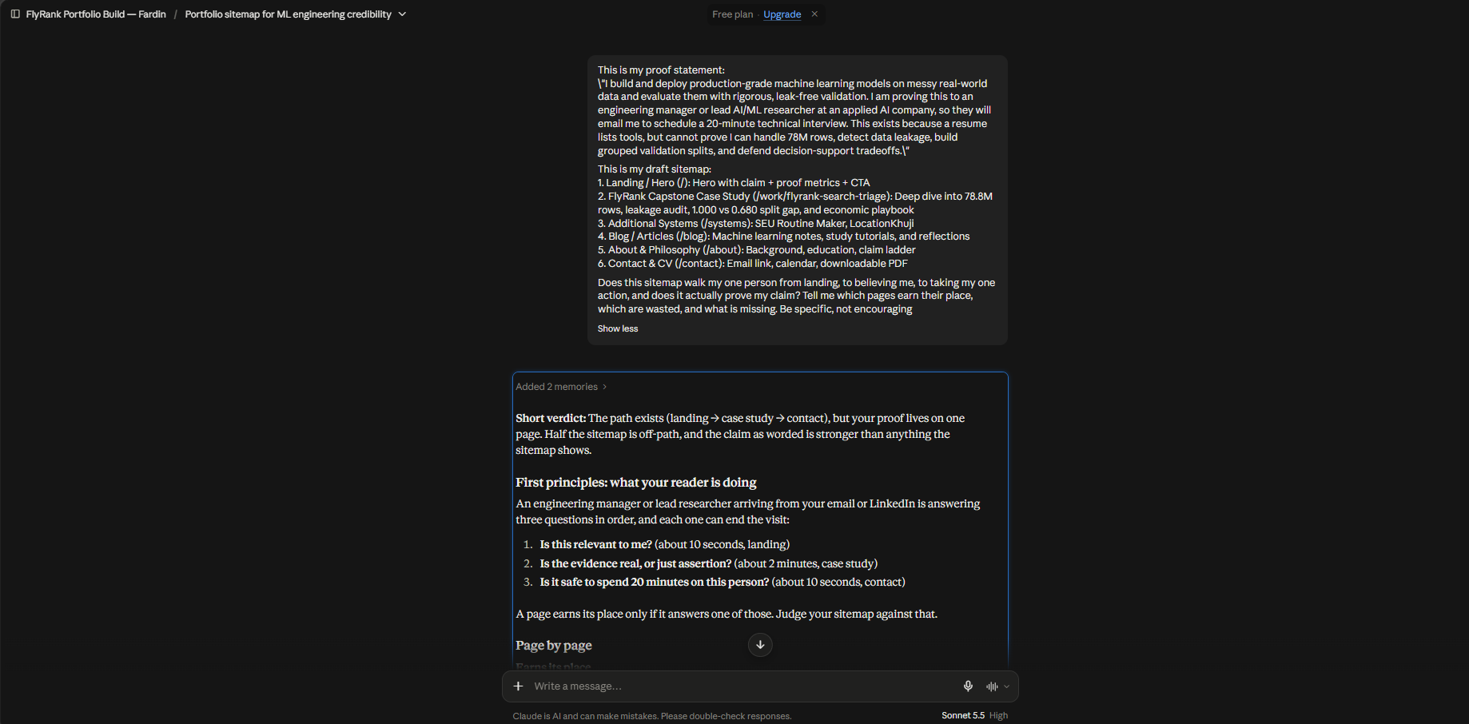

6. The Pivot: What I Am Changing Based on the Pressure Test
Based directly on the AI tutor's pressure-test critique, I am making the following three concrete architectural changes:
1. Permanently Eliminated the /blog Page: I removed the blog from my sitemap. As pointed out by the tutor, superficial tutorial-style articles dilute the authority of my 78.8M-row capstone research.
2. Collapsed Navigation from 6 Pages to a Lean 3-Page Narrative Flow: Merged the About & Philosophy section directly into the Landing and Case Study pages, removing navigation friction.
3. Added an Executive 30-Second Metric Card to the Top of the Case Study: Positioned the problem, the 1.000 vs. 0.680 grouped split gap, and the 0.980 Action Score at the very top of the case study so a busy engineering manager can verify the claim in under 30 seconds without scrolling.
4. Universal Sticky CTA: Added a sticky header contact button on every single view so the lead can execute The One Action (emailing me) at any moment.

7. Evaluation Criteria Self-Check (Pass / Revise Audit)
Criterion | Compliance Evidence | Verdict
The sitemap is small and every page earns its place | Lean 3-4 page flow; eliminated /blog; every page directly moves the lead to The One Action. | PASS
Claude Project configured with genuine custom instructions | Named "FlyRank Portfolio Build — Fardin" with proof statement pasted in and tutor role assigned. | PASS
Pressure-tested against the claim and one action | Real prompt executed in Claude; full constructive critique preserved verbatim in report. | PASS
At least one concrete change noted and adopted | Eliminated /blog, merged about content, added 30-second executive summary card to case study. | PASS

