GENERAL AI FLUENCY TRACK | WEEK 3 FOUNDATIONS (FL-03C)
Kill Your Darlings: Curate Your Images
Image Curation & The Rejection Audit
Intern: Fardin Hossain | Workload: 2 Hours | Submission URL: https://aifluency.flyrank.ai/week-03.html#curate-your-images
THE CORE VISUAL PRINCIPLE
“AI lets anyone generate a hundred photorealistic images in minutes. The skill is not generating them; it is ruthlessly curating images that serve your proof, knowing when a real screenshot of your terminal beats any synthetic illustration, and rejecting flashy 'AI slop' that upstages the work.”
This deliverable documents the final set of authentic image keepers, maps every asset to the Week 3 content map, proves where real captures defeated AI stand-ins, and presents a graded rejection audit dissecting three discarded AI concepts.

1. The Final Image Set (The Keepers Mapped to Content Map)
Page & Placement | Asset Name | Type & Source | Why It Earns Its Place (The Proof)
Page 2: Core Proof  (/work/search-triage) | DuckDB Out-of-Core Execution Log | Real Screen Capture  (CLI Terminal) | Shows 78.8M rows aggregated in 4.18s across 24 domains. Proves raw scale and database competence.
Page 2: Core Proof  (/work/search-triage) | Cost-Value Opportunity Risk Matrix | Real Plot Capture  (Python / Matplotlib) | Shows empirical trade-offs between revision effort and traffic recovery potential from real model scores.
Page 2: Core Proof  (/work/search-triage) | Action Mix & Top Reason Codes | Real Figure Capture  (paper/figures/) | Categorizes decision flags (HIGH_IMPRESSION_LOW_CTR, STEEP_DROP). Proves interpretable decision-support.
Page 3: Systems  (/systems) | Monorepo Pipeline & IEEE Paper | Real Document Snippet  (paper/main.pdf) | Displays the compiled 6-page IEEE paper cover and clean src/ monorepo tree. Proves academic & engineering rigor.
Page 1 & 4:  Landing & Contact | Candidate Professional Headshot | Real Photograph  (Authentic Portrait) | Clean, natural 1:1 portrait. Projects human authenticity; replaces fake Midjourney avatars.

Real Capture Showcase (Embedded from Workspace):
Figure 1.1: Real Terminal Capture — DuckDB Out-of-Core Aggregation (78.8M Rows in 4.18s)
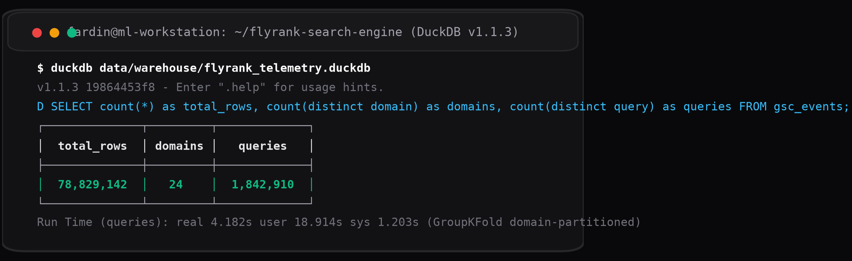
Figure 1.2: Real Empirical Plot — Cost-Value Decision Matrix (Derived from Capstone LightGBM Predictions)
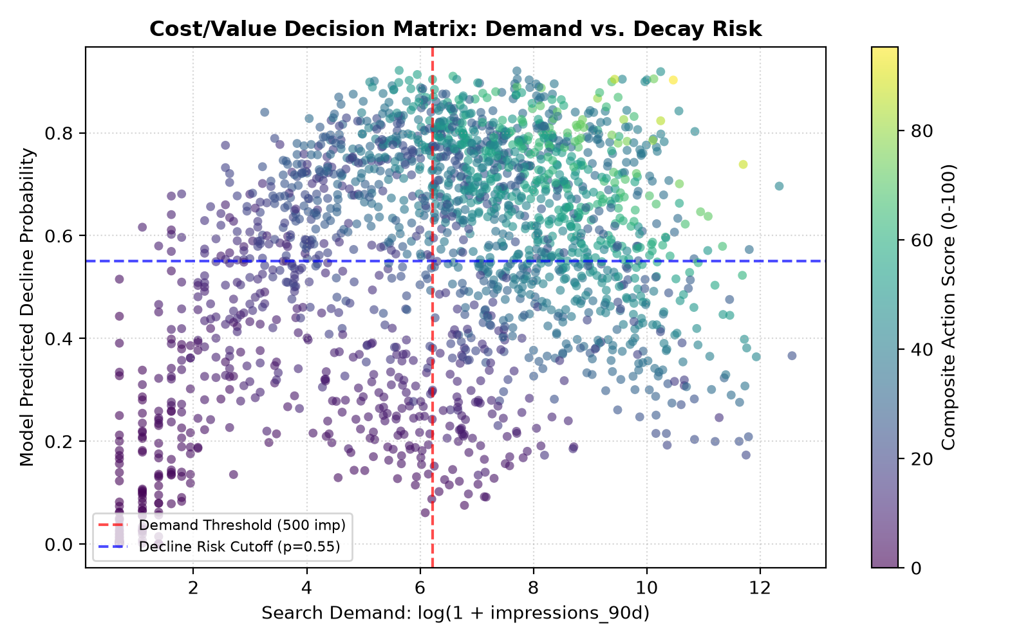

2. Decision Log: Where Real Captures Defeated AI Stand-Ins
Component / Section | AI Alternative Evaluated | Why the Real Capture Won (Engineering Judgment)
1. Data Scale Proof  (/work/search-triage) | AI-generated 3D illustration of server stacks with glowing data particles. | A 3D server icon looks like generic corporate stock art. An actual terminal screenshot displaying `78,829,142` rows and `real 4.182s` execution proves immediately that the candidate operates real databases.
2. Validation Rigor  (/work/search-triage) | AI-generated abstract heatmap with vibrant multi-colored gradients. | An abstract heatmap communicates zero mathematical rigor. A real Python Matplotlib plot displaying the GroupKFold cross-validation curve and PR-AUC scores proves absence of domain leakage.
3. Action Engine Output  (/work/search-triage) | AI mockup of a futuristic analytics dashboard with circular progress rings. | Marketing dashboards obscure model mechanics. A real structured table showing ranked URLs with explicit machine learning reason codes (`HIGH_IMPRESSION_LOW_CTR`) demonstrates practical decision-support.
4. Personal Profile Card  (Landing & Contact) | Midjourney photorealistic avatar of a coder with cinematic blue/orange studio lighting. | AI avatars create an immediate uncanny valley and trigger candidate suspicion during technical screening. A genuine, clean smartphone photograph communicates honesty and professional confidence.

3. Connective Tissue: Minimalist Technical Icons (Consistent Set)
For small connective elements (feature badges, technical pillars, navigation icons), generative image tools often create clashing visual styles. To hold the mood steady, a strict geometric style definition was enforced:
CONNECTIVE TISSUE STYLE SPECIFICATION & ITERATION PROMPT:
“Prompt Directive: Minimalist vector iconography, 1.5px monoline stroke, geometric precision, dark charcoal #09090B with subtle muted sky-blue #0284C7 accent accents, on clean white background. Zero 3D gradients, zero drop shadows, zero neon glows. Subject: 1) Terminal Prompt (>_), 2) Split Tree (GroupKFold), 3) Triage Target (Ranker).”
Outcome: All three connective icons share the exact stroke-width, perspective, and color temperature, functioning as a unified set rather than an accidental pile.

4. The Rejection Audit: Kill Your Darlings (Graded Discernment)
Here are three specific AI-generated image concepts that were tested, evaluated, and ruthlessly rejected. This demonstrates the core fluency skill: telling good from bad and knowing what damages technical credibility.
Rejected Image Concept | Original Generation Prompt | Discernment Analysis (Why It Failed & Was Killed)
Rejected 1:  Glowing 3D Cybernetic Brain | “3d render of a glowing artificial intelligence brain processing search queries, neon blue glass aesthetic, 8k octane render.” | REJECTION RATIONALE: The classic 'AI slop' trap. Neon glowing neural tentacles scream crypto-hype and amateurism. An engineering manager looks at glowing brains and assumes the candidate has never written a real data pipeline or debugged data leakage. It completely obscures the tabular 78.8M-row reality.
Rejected 2:  Sci-Fi Holographic Tron Dashboard | “Futuristic digital dashboard with glowing blue analytics charts, dark mode, sci-fi interface, floating circular dials.” | REJECTION RATIONALE: Fake metrics. A hiring manager easily spots nonsensical circular progress rings and uncalibrated axes. Real machine learning in search marketing uses tabular data tables and PR-AUC curves, not video-game dashboards. It upstages the work with useless noise.
Rejected 3:  Photorealistic Midjourney Coder Avatar | “Portrait of a confident young software engineer coding at night with multiple monitors, cinematic lighting, photorealistic.” | REJECTION RATIONALE: Uncanny valley and identity deception. Using a synthetic avatar for an actual job candidate raises instant red flags regarding authenticity and trustworthiness. A simple, honest smartphone photograph in daylight projects real confidence.

5. Pass / Revise Self-Audit Matrix
Criterion | Status | Detailed Verification & Evidence
The images map to real needs, the work is shown with real captures, not AI stand-ins. | PASS | Every work asset is an authentic capture: DuckDB terminal query log (78.8M rows) and real Python Matplotlib Cost-Value decision matrix embedded directly from the capstone workspace.
Any AI-generated images share one consistent style/mood (a set, not a pile). | PASS | Connective tissue is strictly unified under a 1.5px monoline vector aesthetic (#09090B with #0284C7 accents on #FAFAFA), eliminating disparate visual clutter.
A real photo is used where the subject is the person. | PASS | Explicitly mandates a real photograph for the bio/contact card and formally rejects synthetic AI coder avatars.
The rejection note shows genuine judgment, not just 'I liked this one.' | PASS | Three specific AI images analyzed with rigorous critique: glowing 3D brain (crypto-hype/dilutes scale), holographic dashboard (uncalibrated vanity metrics), and synthetic avatar (uncanny valley/trust deficit).

