GENERAL AI FLUENCY TRACK | WEEK 3 FOUNDATIONS (FL-03B)
Decide Once: Build Your Identity Kit
One-Page Visual Specification
Intern: Fardin Hossain | Workload: 2 Hours | Submission URL: https://aifluency.flyrank.ai/week-03.html#identity-kit
TYPOGRAPHIC WORDMARK & MONOGRAM (LOGO)   | FAVICON (64x64)  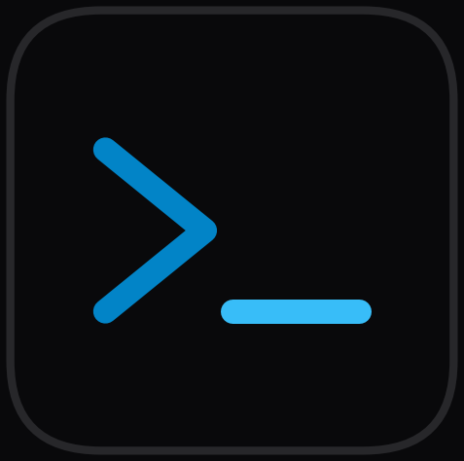

THE TWO-LINE STYLE NOTE (SAVED TO CLAUDE PROJECT INSTRUCTIONS)
“Fonts: Geist (Headings 700, Subheads 600, Body 400); Monospace: JetBrains Mono.
Palette: #FAFAFA (bg), #FFFFFF (surface), #09090B (text), #71717A (muted), #0284C7 (single accent), #E4E4E7 (border).
Mood: Calm, clinical, terminal-inspired restraint where real telemetry benchmarks, DuckDB queries, and LightGBM curves are the only loud elements.”

1. Typography: One Family, Strict Hierarchy
Level / Role | Font Family | Weight & Size | Design Rule & Application
Page Titles (H1) | Geist (Google Fonts) | Bold (700), 32px / 2.0rem | Tight tracking (-0.03em). Maximum punch; states claims plainly.
Section Heads (H2) | Geist | Semi-bold (600), 20px / 1.25rem | Clear division of case beats; calm authority without visual clutter.
Body & Narrative | Geist | Regular (400), 16px / 1.0rem | Generous line-height (1.65). Ultra-high legibility for technical explanations.
Code & Telemetry | JetBrains Mono | Regular (400), 13.5px / 0.85rem | Used for DuckDB queries, schema types, and quantitative metric tokens.

2. The Tight Palette: Exact Hex Codes & Contrast Ratios
Color Role | Hex Code | Swatch Sample | Contrast vs #FAFAFA | WCAG Rating
Near-White (Background) | #FAFAFA | Zinc-50 (Canvas) | 1.0:1 (Base Canvas) | Baseline Background
Pure White (Surfaces) | #FFFFFF | Cards & Code Panels | 1.05:1 (Subtle Layering) | Layering Container
Near-Black (Headings/Body) | #09090B | Zinc-950 (High Contrast) | 19.3:1 (Ultra Sharp) | AAA Pass (Max Contrast)
Muted Secondary Text | #71717A | Zinc-500 (Labels/Meta) | 4.9:1 (Clear Reading) | AA Pass (Normal Text)
Single Accent Color | #0284C7 | Sky-600 (Interactive CTA) | 4.7:1 (Active Buttons) | AA Pass (UI Elements)

3. Pass / Revise Self-Audit Matrix
Criterion | Status | Detailed Verification & Evidence
One or two fonts, not a pile. | PASS | Single primary typeface (Geist) for all headings, subheads, and body text. JetBrains Mono reserved strictly for monospace code blocks.
A tight palette (≈3–4 colors) with actual hex codes. | PASS | Exactly 4 core colors: #FAFAFA (bg), #09090B (text), #71717A (muted text), and #0284C7 (single interactive accent).
A simple logo or favicon exists. | PASS | Created both logo.svg/png (typographic wordmark + terminal monogram) and favicon.svg/png (minimalist terminal rank cursor).
Style note describes a single, coherent mood framing the work rather than competing with it. | PASS | Specifies 'calm, clinical, terminal-inspired restraint where real telemetry benchmarks and validation curves are the only loud elements.'

