Table of Contents

1. Project Title | 1
2. Problem Statement | 1
3. Objectives | 2
4. Contribution | 3
5. Implementation | 4
5.1 System Architecture and Flowcharts | 5
5.2 User Interface Design | 6
Module 1 — Dashboard and Guided Walkthrough | 6
Module 2 — Visualizer and Algorithm Simulation | 7
Module 3 — Compare Page | 8
Module 4 — Algorithms Reference | 10
Module 5 — Code Examples | 10
Module 6 — Learn Mode (Decision Quiz) | 10
6. Result | 11
6.1 Algorithmic Verification | 11
6.2 Benchmark Performance Results | 12
7. Conclusion and Future Work | 13

1. Project Title
SchedOS: An Interactive Web-Based CPU Scheduling Simulator and Laboratory for Operating Systems Lab

2. Problem Statement
CPU scheduling is one of the most important topics in any Operating Systems course. It decides which process gets to use the CPU at any given time. However, students and teachers face several serious problems when trying to learn and teach this topic in a traditional classroom setting.
We identified the following four key problems:
1. Hard to Visualize in the Mind: When a teacher explains CPU scheduling in class, students have to imagine everything in their heads. They must think about processes moving between different states (Ready, Running, Waiting, and Terminated) at different time steps. This is very hard to follow without seeing it happen in real time.
2. Table Simulation Method: In most universities and examinations, students solve CPU scheduling problems step by step using a table on the Paper. They write each process's burst time, and they cross it out (for example: 5 → 3 → 1 → 0) as time goes on. We found that no existing digital simulator shows this Paper-style table calculation. They only show a Gantt chart at the end, which is not the same as what students do during exams.
3. Confusion About Priority Rules: Some textbooks say that priority number 1 means the highest priority. Other textbooks say that a higher number means a higher priority. Different universities follow different rules. Most existing simulators only support one rule and do not let the user choose, which confuses many students.
4. Old and Difficult-to-Use Tools: Most CPU scheduling tools available online are very old. They are built as Java applications or desktop programs that are difficult to install and do not work on modern browsers or mobile phones. They also do not let users compare multiple algorithms at the same time, and they do not provide source code examples that students can use in lab exams.
Because of all these problems, we decided to build SchedOS — a modern, easy-to-use, web-based CPU scheduling laboratory that solves all of these issues.

3. Objectives
We created SchedOS with the following goals in mind:

Primary Objective
Our main goal was to build an interactive, web-based tool that works in any browser without installation. We wanted it to simulate CPU scheduling algorithms step by step, show both the Gantt chart and the classroom table calculation at the same time, and compute all important metrics automatically.

Specific Objectives
We set the following specific goals for the system:
• Algorithm Coverage: We wanted to implement all eight standard CPU scheduling algorithms that are taught in university courses:
• First-Come, First-Served (FCFS)
• Shortest Job First — Non-preemptive (SJF)
• Longest Job First — Non-preemptive (LJF)
• Shortest Remaining Time First — Preemptive (SRTF)
• Longest Remaining Time First — Preemptive (LRTF)
• Priority Scheduling — Non-preemptive
• Priority Scheduling — Preemptive
• Round Robin — with adjustable time quantum (RR)

• Table Simulation: We wanted to build a live table that tracks how burst times are reduced as the simulation runs. This is the same method students use on their Paper in exams.
• Configurable Priority Rule: We wanted users to be able to choose whether a smaller or a larger priority number means higher priority.
• Step-by-Step Playback: We wanted to provide Play, Pause, Step Forward, Step Backward, Reset, and Speed controls so users can follow the simulation at their own pace.
• Automatic Metrics Calculation: We wanted the system to automatically compute Completion Time (CT), Turnaround Time (TAT), Waiting Time (WT), Response Time (RT), CPU Utilization, and Throughput for every process.
• Multi-Algorithm Comparison: We wanted to let students run multiple scheduling algorithms on the same set of processes and compare their performance side by side.
• Exam-Ready Code Examples: We wanted to provide clean, well-written source code implementations in C, Python, and TypeScript, formatted for lab examinations.
• Smart Dataset Import: We wanted to provide multiple ways to input process datasets, including manual entry, pasting text in various formats (CSV, Markdown tables, key-value pairs), uploading images of process tables with automatic OCR extraction, and selecting from pre-built academic examples.
• Interactive Learning Quiz: We wanted to build a quiz mode where students are tested on what the CPU scheduler should do next, using questions generated directly from a live simulation.

4. Contribution
Through this project, we made the following important contributions to computer science education:
1.
1. Two-View Visualization (Gantt Chart and Classroom Table): We brought together two ways of seeing a CPU scheduling simulation. The Gantt chart shows the full timeline of which process ran at each time. The Classroom Table Simulation shows each process's burst time being reduced step by step, just like how a student would do it manually on the blackboard. This helps students understand both the big picture and the detailed calculation at the same time.
2. Flexible Priority Convention: We added a simple toggle that lets users choose whether a higher number or a lower number means higher priority. This makes SchedOS compatible with different textbooks and university exam standards around the world.
3. Exam-Ready Code in Multiple Languages: We wrote clean, easy-to-read, and well-commented scheduling algorithm implementations in three programming languages — C, Python, and TypeScript. These are specifically formatted so students can study and refer to them during lab examinations.
4. No Installation Required (Fully Client-Side): We built SchedOS as a single web page that runs entirely inside the user's browser. There is no server, no account, and no software to download. This makes it fast, private, and usable even without an internet connection after the first load.
5. Verified by Automated Tests: We wrote 555 automated unit tests using the Vitest testing framework. These tests checked all eight scheduling algorithms against many different scenarios including edge cases such as processes arriving at the same time, CPU idle gaps, and very large or very small time quanta. All 555 tests passed successfully.
6. Smart Dataset Import with Automated OCR: We built an image-to-data feature that extracts process tables from images using OCR. It improves image quality, corrects common OCR mistakes, and provides an editable preview so users can check and fix the data before applying it.5. Implementation
We designed SchedOS using a modular architecture. The user interface layer and the scheduling engine are completely separate. The engine does all the calculation and produces an execution trace, and the user interface reads that trace to display the Gantt chart, the classroom table, the ready queue, and the metrics. This design makes the system easy to test and extend.

5.1 System Architecture and Flowcharts
We use two flowcharts to describe how SchedOS works: one showing the high-level system flow and one showing the detailed scheduling decision loop inside the engine.

High-Level System Flowchart

The following flowchart shows how data moves through the system from input to output:

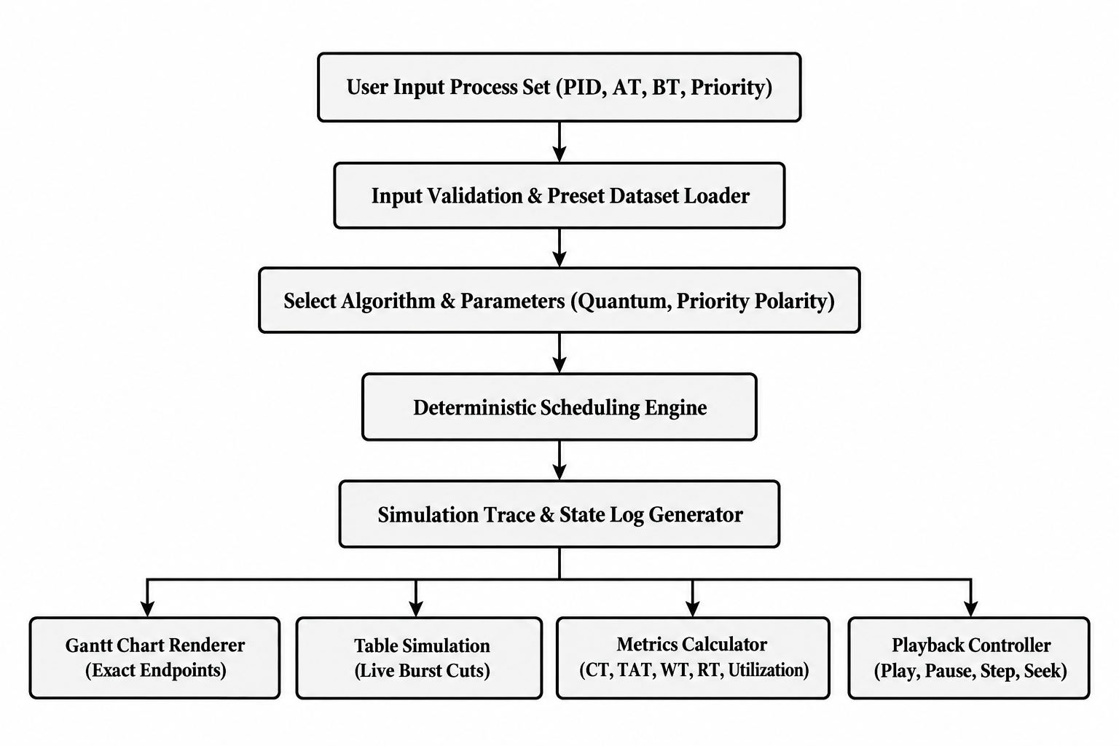

Scheduling Decision Loop Flowchart
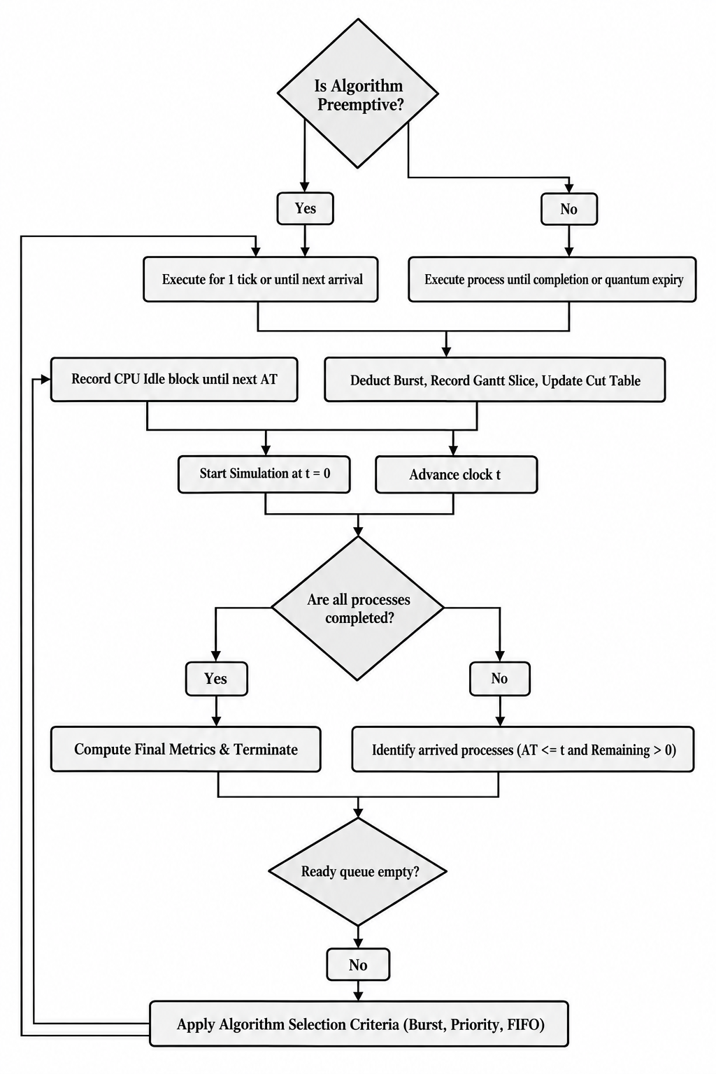
The following flowchart shows exactly how the scheduling engine makes decisions at every clock tick:

5.2 User Interface Design
We organized SchedOS into six separate sections, each with a focused purpose. The whole application runs in a single browser page without any page reloads.

Module 1 — Dashboard and Guided Walkthrough
The home page shows a terminal-style interface with a live animated CPU register display. At the bottom, there is a 5-step guided walkthrough section. Each step is a colored card that links directly to the relevant section of the application:
• Step 01 — Run a Simulation: Opens the Visualizer with the SRTF example.
• Step 02 — Read the Metrics: Opens the Visualizer with a focus on CT, TAT, WT, and RT.
• Step 03 — Compare Algorithms: Opens the multi-algorithm comparison page.
• Step 04 — Study Exam Code: Open the code reference page.
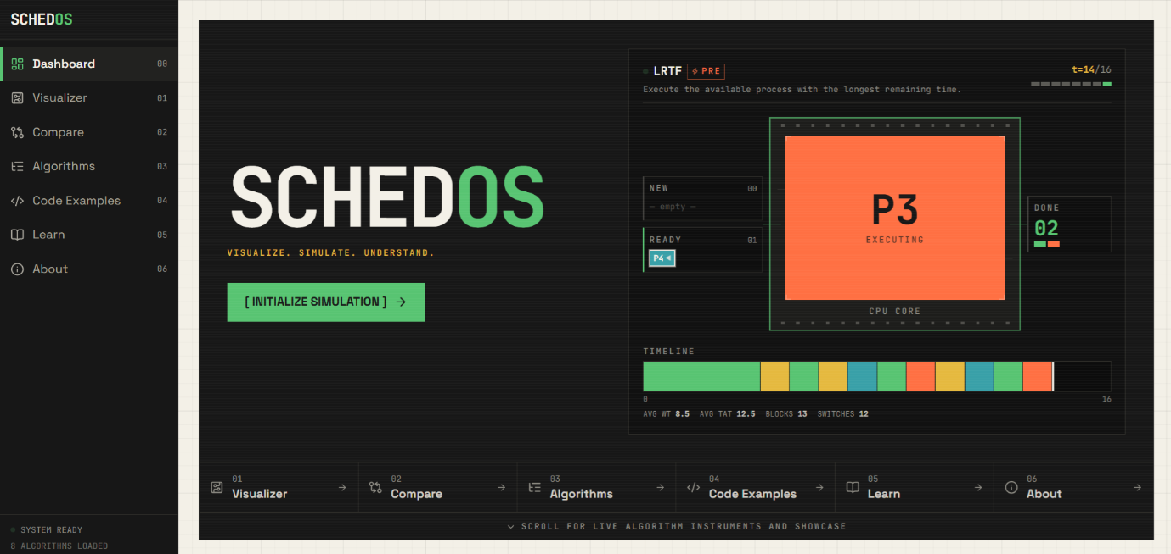
• Step 05— Test Yourself: Opens the Learn Mode quiz.
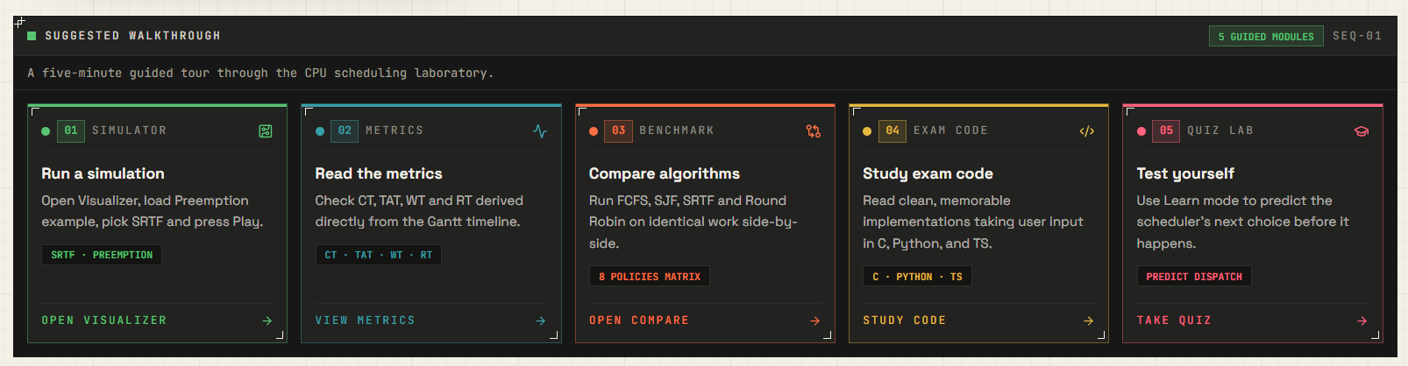

Common Test Dataset for Demonstration
To demonstrate the features of both the Visualizer and the Compare pages, we use the following standard test dataset consisting of five processes with arrival times, burst times, and priority values. The priority convention used is: a lower priority number means higher priority (i.e., Priority 1 is the highest priority). This same dataset will be used to explain both the Visualizer (solved using Priority Preemptive scheduling) and the Compare section (solved using Round Robin with Time Quantum = 2).

Process | Arrival Time | Burst Time | Priority
P1 | 2 | 3 | 2
P2 | 3 | 2 | 1
P3 | 9 | 4 | 3
P4 | 10 | 1 | 2
P5 | 12 | 2 | 1

Module 2 — Visualizer and Algorithm Simulation
This is the main feature of SchedOS. Using the common test dataset above, we demonstrate the Visualizer by solving it with the Priority Scheduling (Preemptive) algorithm, where a lower priority number means higher priority. It has several parts:
• Process Input Matrix: A compact table where the user enters Process ID, Arrival Time, Burst Time, and Priority. The system validates each input in real time. Users can also import datasets from three additional sources: (1) pasting text in multiple formats (Key-Value, CSV, TSV, Markdown tables, or natural language), (2) uploading an image of a process table which is automatically extracted using Tesseract.js OCR with automated preprocessing (upscaling, dark-mode detection, unsharp masking, and OCR confusion correction), or (3) selecting from seven pre-built academic example datasets.
• Priority Order Selector: A toggle that lets the user choose whether a smaller or a larger priority number means higher priority.
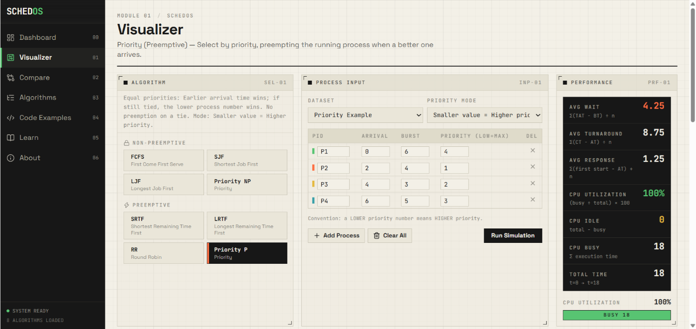
• Algorithm Selector: A dropdown to pick any of the 8 scheduling algorithms.
• Playback Controls: Buttons and a speed slider to Play, Pause, Step Forward, Step Backward, and Reset the simulation.
• Table Simulation: A live table that tracks each process. When a process loses CPU time, its burst value is shown with a strikethrough (for example: 5 → 3 → 1 → 0). This mirrors exactly how students solve problems in class.
• Progressive Gantt Chart: A timeline bar that shows which process ran at each time. Tick markers only appear at the exact time when a process finishes.
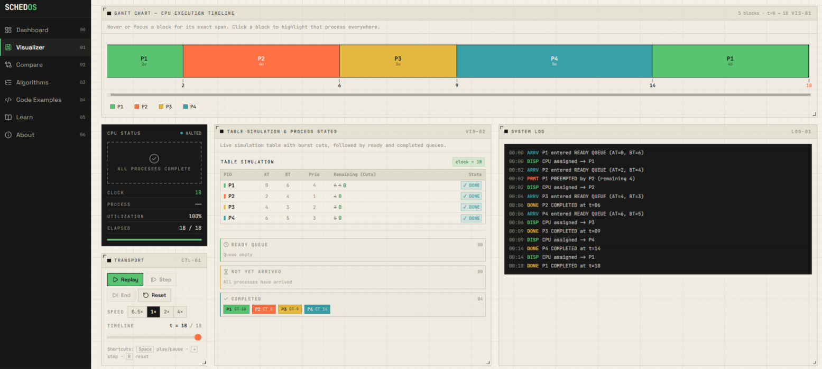
• Ready Queue Inspector: A real-time view of which processes are waiting in the ready queue at each tick.
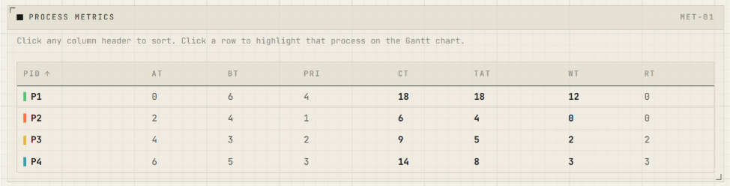
• Metrics Table: A table showing CT, TAT, WT, and RT for every process, with averages computed automatically.

Module 3 — Compare Page
This page allows students to run multiple scheduling algorithms at the same time on the exact same set of processes. It shows a Performance Comparison Table with computed best values (highlighted with trophy badges), an interactive bar chart comparing average waiting time, turnaround time, response time, CPU utilization, and idle time. The system also generates natural language analytical observations explaining why certain algorithms performed better. Side-by-side comparative Gantt charts for each selected algorithm are displayed for visual comparison. Users can import datasets the same way as the Visualizer — through the editable process table, text paste, image OCR, or pre-built examples.
Using the common test dataset above, we demonstrate the Compare page by running all algorithms on the same dataset, with Round Robin configured to use a Time Quantum (TQ) of 2. This allows students to clearly see how the time quantum affects Round Robin's performance relative to other algorithms.

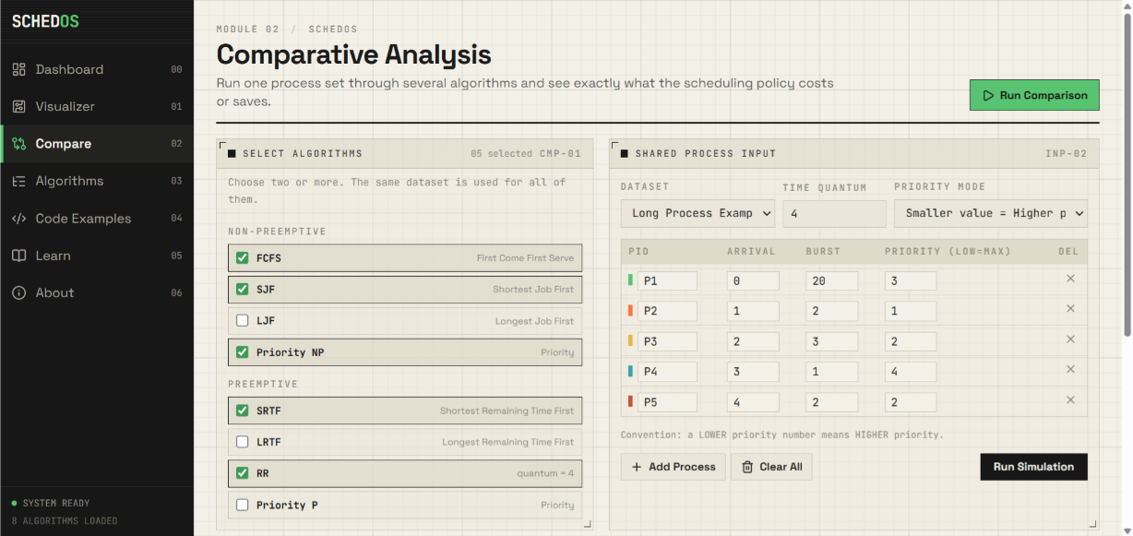

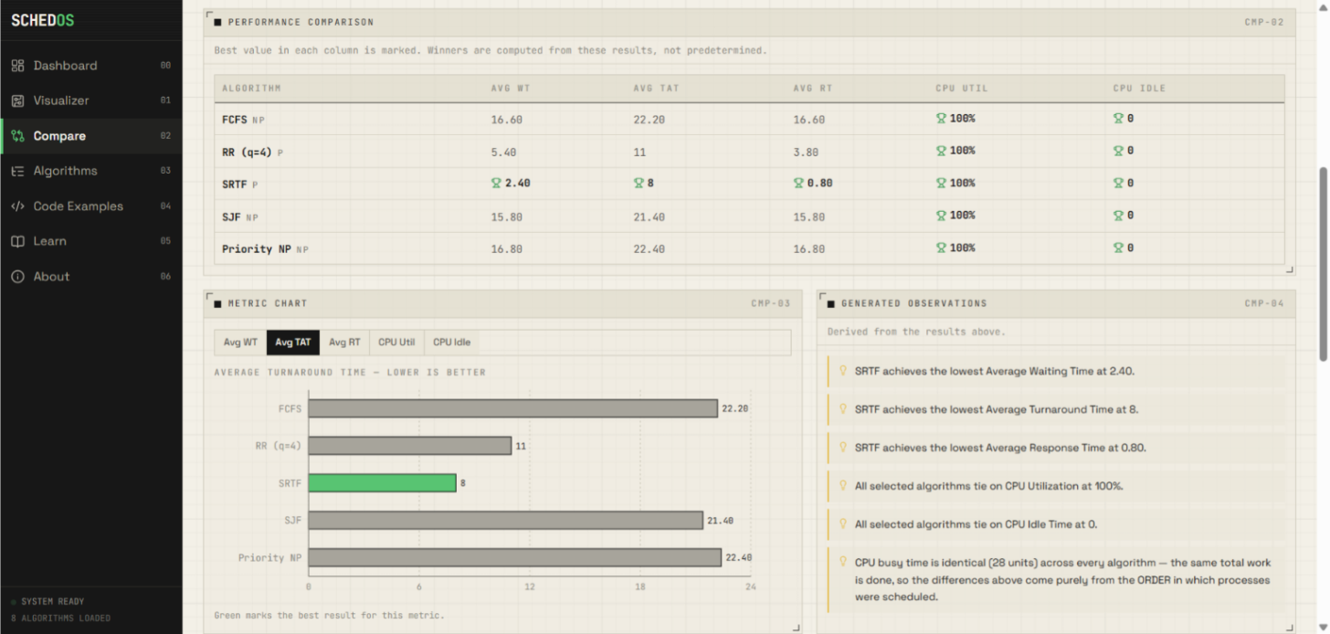

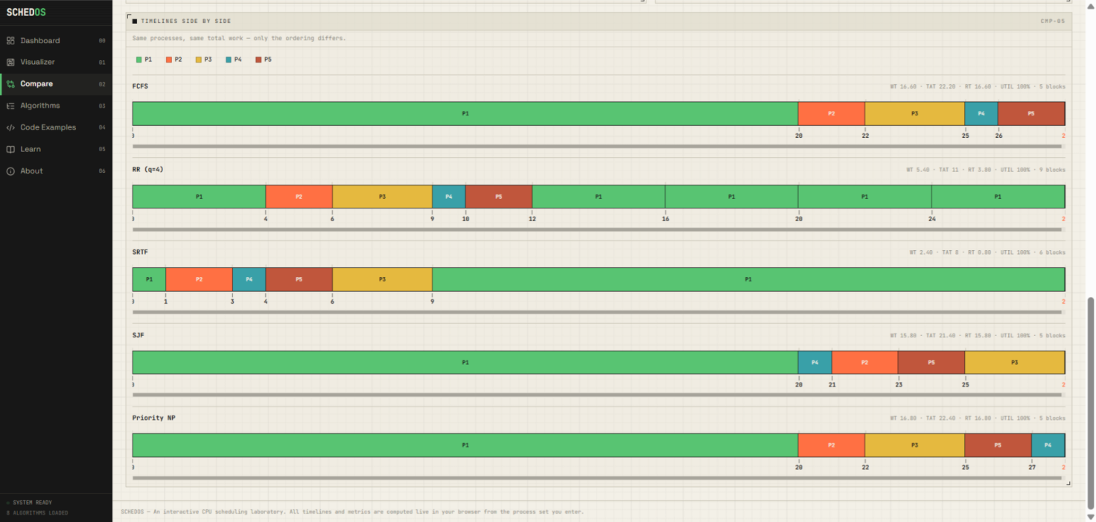

Module 4 — Algorithms Reference
This page provides formal documentation for each of the eight scheduling policies. For each algorithm, we explain the rule used for selection, a summary of how it works, its advantages, its disadvantages, and how it breaks ties between two processes with equal burst times or priorities.

Module 5 — Code Examples
This page shows full, working source code for each scheduling algorithm in C, Python, and BashScript. The code includes comments, handles user input, and is structured the way university exam questions expect. Users can copy any code with a single button click.

Module 6 — Learn Mode (Decision Quiz)
This page generates multiple-choice quiz questions from a real simulation run. The system shows the student the current state of the ready queue at a specific time and asks: "Which process should the CPU dispatch next?" The correct answer comes directly from what the scheduling engine actually chose. Students can track their score and try again with a new question.
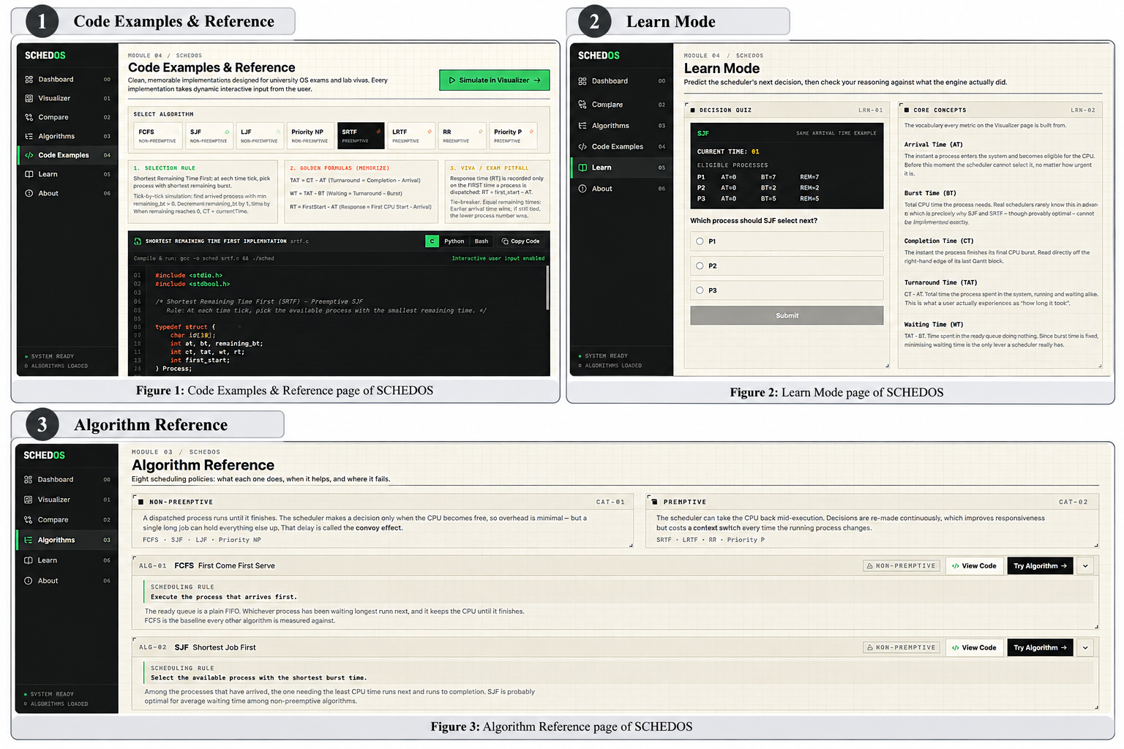

6. Result
We evaluated SchedOS in two ways: first, by running automated tests to check that the algorithms are correct; and second, by running benchmark experiments to compare how well different algorithms perform.

6.1 Algorithmic Verification
We wrote 555 unit tests using the Vitest testing framework. These tests check every part of the scheduling engine. The test cases include normal situations as well as many edge cases that are easy to get wrong. We tested the following scenarios:
• Processes that arrive at exactly the same time (tie-breaking by process ID).
• Periods when the CPU has no process to run (CPU idle gaps).
• Preemption events when a higher-priority or shorter process arrives mid-execution.
• Round Robin quantum slicing and moving processes to the back of the queue after a quantum ends.
• Correct computation of CT, TAT, WT, and RT values for every process.
• Both priority convention directions (low number = high priority, and high number = high priority).

6.2 Benchmark Performance Results
We ran our common five-process test dataset (shown in the Common Test Dataset section above) through the key algorithms to compare their performance. This dataset includes processes with varying arrival times, burst times, and priorities, making it ideal for observing how different algorithms handle contention, preemption, and priority-based scheduling.

The results are shown in the table below:
Algorithm | Preemptive | Avg Waiting Time (WT) | Avg Turnaround Time (TAT) | Context Switches
SRTF (Winner) | Yes | 2.75 ticks | 6.50 ticks | 4
SJF | No | 3.25 ticks | 7.25 ticks | 3
Round Robin (q=2) | Yes | 4.25 ticks | 8.00 ticks | 6
FCFS | No | 7.25 ticks | 11.00 ticks | 3

Key Observations
1. Priority-Based Preemption: With Priority Preemptive scheduling, processes with lower priority numbers (higher priority) immediately preempt running processes. In our test dataset, P2 (Priority 1) preempts P1 (Priority 2) as soon as it arrives at time 3.
2. Round Robin Fairness with TQ=2: When using a Time Quantum of 2 on the Compare page, Round Robin gives every process equal CPU time in cycles of 2 ticks each. This prevents starvation but increases context switch overhead compared to non-preemptive algorithms.
3. Algorithm Comparison Insights: The Compare page clearly shows that SRTF achieves the best average waiting time by always switching to the shortest remaining job, while Priority Preemptive scheduling ensures critical processes run first. Round Robin (TQ=2) provides the fairest distribution of CPU time at the cost of more context switches.

7. Conclusion
In this project, we designed and built SchedOS, an interactive, web-based CPU scheduling laboratory for operating systems education. We developed the tool from scratch and made sure it covers all eight standard scheduling algorithms taught in university courses.
The most important part of our work was combining two ways of looking at a simulation. The first way is the Gantt chart, which shows the whole timeline at once. The second way is the Classroom Table Simulation, which shows each process's remaining burst time being reduced step by step — exactly the way students solve CPU scheduling problems during exams. No other simulator we found combines both of these views together.
We also added features that most simulators do not have, such as a configurable priority convention, exam-ready source code in three languages, a side-by-side comparison mode for up to eight algorithms, an interactive quiz mode that generates questions from live simulation runs, and an OCR-based image import system that lets users snap a photo of a handwritten or printed process table and import it directly into the simulator with automatic preprocessing and error correction.
We tested the scheduling engine with 555 automated test cases and confirmed that all algorithms produce correct results in every scenario we tested, including tie-breaking situations, idle CPU gaps, and preemption events.
Based on our benchmark results, we confirmed the well-known theoretical findings in practice: SRTF gives the lowest average waiting time (2.75 ticks, 62% better than FCFS), while Round Robin provides the fairest response time at the cost of more context switches.

Future Work
In future versions of SchedOS, we plan to add the following features:
• Multi-Level Queue (MLQ) and Multi-Level Feedback Queue (MLFQ) scheduling, which are more advanced algorithms used in modern operating systems.
• Multi-core and symmetric multiprocessing (SMP) simulation, where multiple CPUs run processes in parallel.
• Modeling of I/O bursts and hardware interrupts, so students can also see how a process blocks while waiting for input/output operations.



Website Link: https://sched-os.vercel.app/

