Task 1

* Installing "ROS" system
  1. "ROS" is a middle firmware system: a software-dependant system that allows the control of the computer's hardware, which are the robot's parts in this case.
     + "ROS" needs a software to be installed on top of, such as "windows" or "Linux".
     + This task chose "Linux" system due to most types of Microcomputers being compatible with "Linux" system, in addition to the flexibility of using "ROS" on "Linux" compared to "Windows".

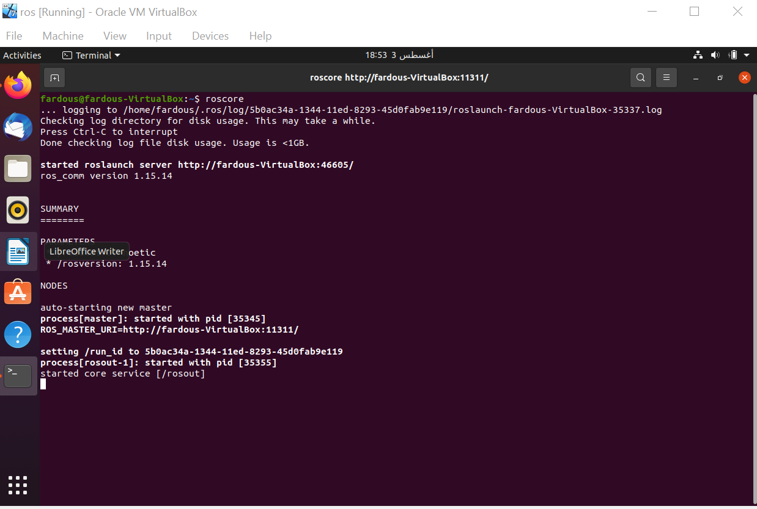

* 1. "ROS" takes several steps to install, which are:

1. Install "VirtualBox": a program that simulates a virtual computer inside yours, where you can download an individual software from the one used by the main pc.
2. Install "Ubuntu": a pack of "Linux" software made for PCs and servers.
3. Add a new virtual computer inside "VirtualBox".
4. Download "Ubuntu" as the software for the virtual computer.
5. Go to "ROS" official website (ros.org), and copy the codes from the website in the respective order, one by one.
6. Open the terminal on your virtual computer.
7. Paste the codes in the respective order, one by one.

* Installing the robotic arm package
  1. Go to (s-m.com/ros.txt) website again.
  2. Find the arm pack download codes and copy the in the respective order, one by one.
  3. Open terminal in your virtual computer.
  4. Paste the arm pack codes n the respective order, one by one.
  5. Pay attention to the last few raws, as you have a source code that you need to type at the lowest end after a series of codes, while keeping in mind to change the computer name to the virtual computer name to avoid errors.

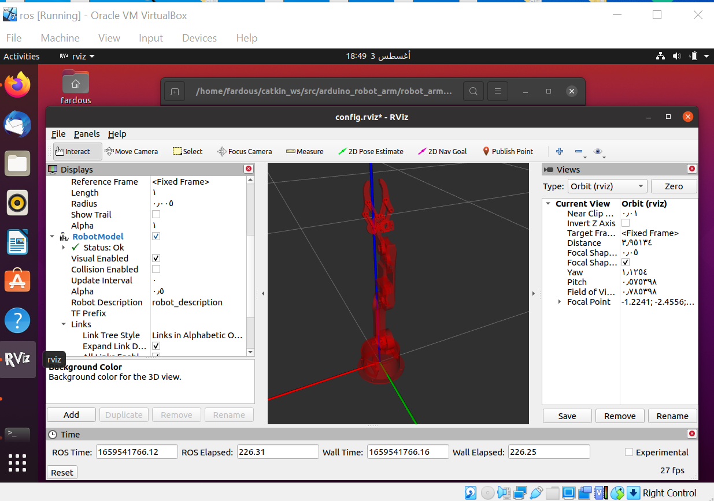Press (ctrl + o) at te end to execute the source code