PAIN RECOGNITION WITH PHYSIOLOGICAL SIGNALS USING MULTI-LEVEL CONTEXT INFORMATION

Y AMBICA¹ RUDRAVARAM SHIVA² SHAIK FAREED³ GAINABOINA MADHU⁴
¹Assistant Professor, Department of CSE(AI&ML), CMR College, Hyderabad, Telangana, India
²Student, Department of AIML, CMRCET, Hyderabad, Telangana, India ³Student, Department of AIML, CMRCET, Hyderabad, Telangana, India ⁴Student, Department of AIML, CMRCET, Hyderabad, Telangana, India.

e-mail:dr.y.ambica@cmrcet.ac.in¹ rudravaramshiva15670@gmail.com² fareedfareed2085@gmail.com³ madhugainaboina@gmail.com⁴

ABSTRACT
Automatic pain detection it plays an essential part in healthcare. Traditional methods rely on data obtained from physiological signals using medical expertise, achieving good performance but requiring manual effort. This paper introduces a deep learning-based approach that handles both feature extraction and classification without needing expert input.We propose a multi-level feature extraction strategy to distinguish between pain and no-pain states. Our experiments, conducted on the initial segment of the BioVid Heat Pain dataset .and the Emopain 2021 dataset, demonstrate that multi-level context information improves accuracy compared to single-level features. In reference to the BioVid Heat Pain database, we evaluate different pain levels (Pain 0 vs. Pain 1, Pain 0 vs. Pain 2, etc.). In the Pain 0 vs. Pain 4 classification, our model achieves an average accuracy of 84.8% (±13.3%) for 87 subjects and 87.8% (±11.4%) for 67 subjects using a Leave- One-Subject-Out cross-validation method.Our proposed approach uses deep learning to enhance pain recognition beyond conventional techniques. The original model integrates CNN and BI-LSTM for feature selection. As an improvement, we introduce a three-level feature optimization method by adding BI-GRU. Here, CNN extracts features, BI-LSTM refines them, and BI- GRU further optimizes them, leading to increased accuracy.
Keywords – Pain Recognition, Physiological Signals,Multi-Level Context Information, Convolutional Neural Networks (CNN), Bidirectional LSTM (BiLSTM), Bidirectional GRU (BiGRU)

INTRODUCTION
Pain is a fundamental reaction of the body to illness or injury, necessitating medical intervention. Conventionally, healthcare professionals and physiotherapists identify pain by analyzing a patient’s expressions, posture, and movements. However, these methods are influenced by personal judgment and depend greatly. on the observer’s expertise, leading to inconsistencies. Some individuals may suppress Their inconvenience, while some may struggle to express it clearly. To enhance precision, Systems for automatic pain identification. utilize physiological indicators such as skin conductivity, heart rate fluctuations, blood pressure levels, and brain activity (EEG). When a person experiences pain, their body undergoes involuntary changes—sweat glands become more
active, heart rate fluctuates, and muscle tension varies. These physiological responses can be recorded through electrodermal activity (EDA), electrocardiograms (ECG), and electromyograms (EMG).
A major challenge in pain classification is Identifying valuable features from unprocessed input. physiological data. Standard machine learning techniques are dependent on expert-defined feature selection, which is labor- intensive and expensive. In contrast, deep learning autonomously uncovers patterns from data, eliminating the need for manual intervention. This research focuses on designing a deep learning framework for pain assessment using physiological signals. We utilize EDA and ECG signals, as They provide important perspectives on pain responses. Our model integrates [1]Convolutional Neural Networks (CNNs) to capture spatial attributes and Recurrent Neural Networks (RNNs) to interpret temporal dynamics. The model’s effectiveness is evaluated using The Heat Pain Database of BioVid and the Dopamine 2021 dataset.

By removing the necessity for handcrafted feature selection, our approach enhances the efficiency and reliability of pain recognition.

RELATED WORKS
The use of physiological signals for pain recognition has gained notable focus due to its potential applications in healthcare and human- computer interaction. Different studies have used machine learning and deep learning strategies to advance. accuracy in pain detection.
Machine Learning-Based Approaches: Some studies have used [2]Random Forest (RF) Plus Support Vector Machines (SVM) for classifying pain from physiological signals like EMG, ECG, and EDA. Deep Learning Techniques: Researchers have explored LSTMs, Convolutional Neural Networks (CNNs), and AutoEncoders to extract features and enhance pain prediction accuracy.Feature Engineering & Preprocessing: Strategies like Principal Component Analysis (PCA) and Butterworth filtering have been used to improve signal quality before classification.

Although [3]deep learning models have improved pain recognition accuracy, many approaches rely on handcrafted feature extraction, limiting their generalizability. Additionally, noise and artifacts in physiological signals reduce model reliability. Therefore, an improved method that effectively combines feature extraction and classification is needed.

Our work introduces a multi-modal A neural network model that combines CNN and LSTM architectures to capture Space and time-related dependencies in physiological signals. Unlike previous studies that rely on handcrafted features, our approach leverages [4]automatic feature extraction and an attention mechanism to enhance classification accuracy.Pain is a complex physical and emotional experience that is difficult to measure, especially in individuals who cannot communicate, such as infants and unconscious patients. Technological advancements offer new ways to assess pain, Still, further upgrades are needed. for widespread clinical use. This paper discusses the latest innovations in pain detection, exploring its biological effects, physical and emotional responses, and common medical
assessment methods. It also examines challenges in creating reliable pain recognition systems, including dataset limitations and evaluation techniques.

Various approaches, such as facial expression analysis, voice detection, physiological signals, and multi-modal techniques, are discussed, along with the impact of external factors and the difficulty of establishing a standard measure for pain. Additionally, we highlight gaps in research, such as chronic pain detection and its integration with treatment strategies, while suggesting future directions to enhance automated pain assessment.Measuring pain objectively is difficult because it is a personal and complex experience. Traditional methods, like pain scales and questionnaires, Commonly do not perform well, especially for individuals with mental disorders. One potential solution is to analyze pain using facial expressions and biopotential signals.

However, Available systems are often not cost-effective, slow, or not well-tested. To overcome these challenges, we developed [5]The Heat Pain Database of BioVid, which collects both visual and physiological data from participants experiencing controlled heat- induced pain. The aim is to improve automated pain recognition, ensure reliable testing, and enhance system performance.Deep learning uses multiple layers of processing To understand data patterns at multiple levels of abstraction. It has greatly improved performance in areas like speech processing, image recognition, and object Sensing, as well as in fields like pharmaceutical research and genomics. With the help of the back propagation algorithm, deep learning helps systems adjust their internal settings to better represent the data at each layer.
Convolutional networks have made significant progress in analyzing images, videos, speech, and sound, Although recurrent networks have proven effective in interpreting sequences such as text and speech.[6]We hosted the first Affective Movement Recognition (AffectMove) challenge, bringing together emotionally expressive body movement datasets from real-world situations to advance research in this area. Research on automatically recognizing emotional body movements lags behind other fields, despite its importance. The challenge aimed to use existing body motion datasets to address key questions about recognizing complex emotional behaviors. Teams worked on tasks using datasets like EmoPain (for chronic pain rehab), we Draw-l Movement (for math problem-solving), and Unige-Maastricht Dance (for dance movements). Participants were encouraged to use multiple datasets to improve performance and test their methods in different contexts

3.PROPOSED SYSTEM
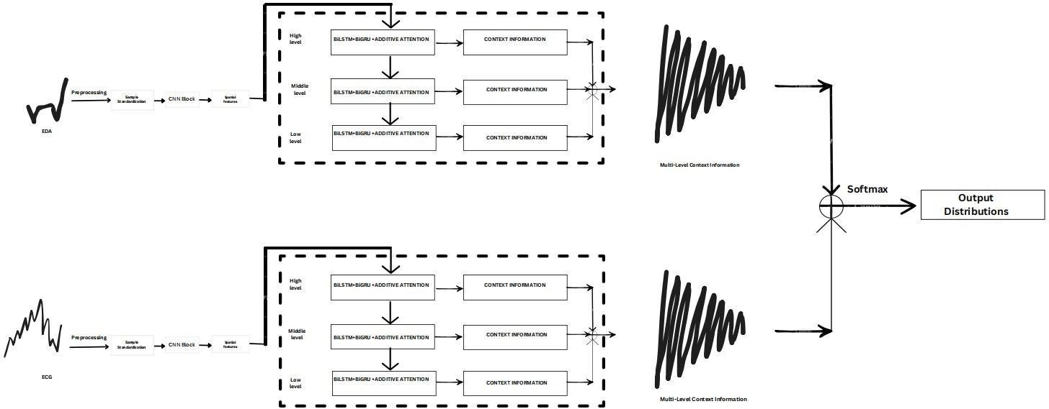

Figure.1. Overview of the proposed model

In this research, we implement multilevel deep learning algorithms for pain recognition, as traditional single-level machine learning methods struggle with accurate identification. Multilevel algorithms offer superior accuracy compared to single-level Solutions like Support Vector Machines (SVM), Random Forest, and Linear Regression.
Our proposed system focuses on optimizing, selecting features, and classifying data using multilevel deep learning models such as CNN + Bi-LSTM (Bidirectional LSTM). The CNN component is responsible for feature optimization, while [7]Bi-LSTM extracts the most relevant optimized features from CNN before training the model for pain detection.
This work utilizes a dual-stage feature selection methodology, specifically CNN + Bi-LSTM. Additionally, we extend this approach by incorporating three levels of feature optimization through CNN + Bi-LSTM + Bi- GRU (Bidirectional Gated Recurrent Unit). Here, Bi- LSTM extracts CNN-optimized features, and Bi-GRU further refines the features selected by Bi-LSTM. This three-tier optimization approach significantly enhances accuracy.

ENHANCED FEATURES:

- Our method eliminates the need for additional signal preprocessing, instead utilizing minimally preprocessed physiological signals directly from the dataset.
- The approach automates feature extraction and classification, completely replacing traditional manual methods that require extensive domain expertise.

4.IMPLEMENTATION

Figure2: Tkinter output window

Data Exploration: This module is responsible for loading and analyzing data within the system. Examining the BioVid_coords dataset to understand its structure and contents. Processing data using Pandas and NumPy for reshaping and eliminating unnecessary columns. Normalizing the training dataset using an appropriate scaling technique to ensure consistency. Visualizing data patterns with Seaborn and Matplotlib to gain insights. Applying label encoding to transform categorical attributes into numerical representations. Selecting key features to enhance model accuracy and efficiency.
Data Splitting:
Part Breaking the dataset into train and test segments to evaluate model performance.
Model Development:
Building multiple models, including Random Forest, CNN + BiLSTM, CNN + BiLSTM +
BiGRU, and Stacking Classifier. User Authentication:
Implementing user registration and login functionality.
User Input:
Allowing users to input data for prediction. Prediction Module:
Generating and displaying the final predicted results.
Note: As an enhancement, we implemented an ensemble learning approach, combining multiple models to achieve a more reliable and accurate prediction. Additionally, by utilizing techniques such as CNN + BiLSTM + BiGRU and Stacking Classifier, we achieved an accuracy of 99%.

ALGORITHMS:
Random Forest:
A powerful ensemble learning method that builds multiple decision trees during training and aggregates their predictions for classification (mode) or regression (average). It is widely used for various domains such as finance, healthcare, and image analysis, offering robustness and high accuracy.

CNN + BiLSTM:
This hybrid model integrates Convolutional Neural Networks (CNN) with Bidirectional Long Short-Term Memory (Bi-LSTM) networks, making it highly effective for sequential data tasks. CNNs extract spatial features, while BiLSTM efficiently captures temporal dependencies, making it ideal for natural language processing (NLP) and time-series forecasting.

CNN + BiLSTM + BiGRU:
An advanced deep learning architecture that combines CNN, BiLSTM, and Bidirectional Gated Recurrent Unit (BiGRU) networks. This model excels at hierarchical feature extraction and temporal pattern recognition, making it suitable for complex applications like video processing and sentiment analysis.

Stacking Classifier:
A two-stage ensemble learning process where a meta- classifier refines predictions from multiple base models.. By leveraging the strengths of different models, stacking enhances overall accuracy, Confirming its effectiveness in both ML contests and applied predictive analytics.
5.RESULTS
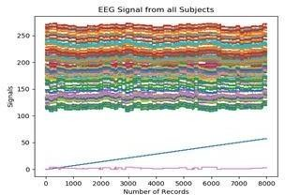
Figure 3. No.of records

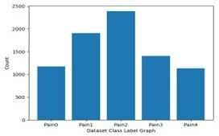
Where x-axis represents EEG record number,y-axis represents EEG signal values

Figure 4. Dataset label graph

X-axis represents pain type and y-axis represents count

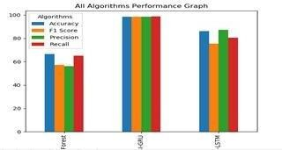

Figure 5. Performance graph
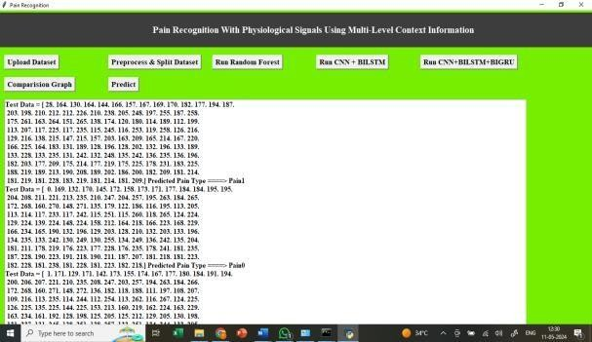

Figure 6. Result

6.CONCLUSION
This study introduces a deep learning-based framework for pain recognition using physiological signals. Our approach automates feature extraction and classification, eliminating the need for manual methods that require specialized expertise. We leverage multi-level contextual information derived from hidden sequential data, enhancing the model’s ability to detect pain levels accurately.Specifically, our architecture utilizes hidden representations within an attention mechanism to generate a context vector. By merging hidden features with the context vector, we construct multi-level contextual information that significantly improves classification performance.We implement binary classification between a baseline and varying pain levels using The first division of the BioVid Heat Pain dataset. Additionally, we conduct similar classification tasks using the EmoPain 2021 dataset. Our observations from experiments validate that multi-level context modeling is more effective than single-level approaches, leading to enhanced performance in pain classification.
Moreover, our results highlight the critical role of Electrodermal Activity (EDA) in detecting pain. The combination of EDA and Electrocardiogram (ECG) signals further strengthens classification accuracy when evaluated on the BioVid Heat Pain dataset.
In final analysis, our deep learning system exhibits substantial potential to outperform traditional pain recognition methods..By analyzing hidden patterns in physiological signal sequences, our approach achieves remarkable improvements in classification accuracy.

7.REFERENCE
- Y.Ambica, Dr N.Subhash Chandra MRI brain segmentation using correlation based on adaptively regularised kernel-based fuzzy C- means clustering Int. J. Advanced Intelligence Paradigms, Vol. 19, No. 2, 2021 ‘.
- L. Breiman, ‘‘Random forests,’’ Mach. Learn., vol. 45, no. 1, pp. 5–32, 2001.
- Y. LeCun, Y. Bengio, and G. Hinton, ‘‘Deep learning,’’ Nature, vol. 521, no. 7553, pp. 436444, Sep.2015.
- P. Werner, D. Lopez-Martinez, S. Walter, A. Al- Hamadi, S. Gruss, and R. W. Picard, ‘‘Automatic recognition methods supporting pain assessment: A survey,’’ IEEE Trans. Affect. Comput., vol. 13, no. 1, pp. 530–552, Jan. 2022.
- S. Walter, S. Gruss, H. Ehleiter, J. Tan, H. C. Traue,
S. Crawcour, P. Werner, A. Al-Hamadi, and A. O. Andrade, ‘‘The biovid heat pain database data for the advancement and systematic validation of an automated pain recognition system,’’ in Proc. IEEE Int. Conf. Cybern. (CYBCO), Jun. 2013, pp. 128–131.
- T. Olugbade, R. Sagoleo, S. Ghisio, N. Gold, C. D. C. Amanda, B. D. Gelder, A. Camurri, G. Volpe, and N. Bianchi-Berthouze, ‘‘The affectmove 2021 challenge—Affect recognition from naturalistic movement data,’’ in Proc. 9th Int. Conf. Affect. Comput. Intell. Interact. Workshops Demos (ACIIW), Sep./Oct. 2021, pp. 1–5.
- F. Pouromran, Y. Lin, and S. Kamarthi, ‘‘Personalized deep bi-LSTM RNN based model for pain intensity classification using EDA signal,’’ Sensors, vol. 22, no. 21, p. 8087, Oct. 2022.

