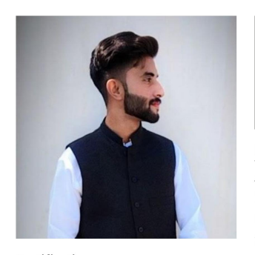  CONTACT  Aline, Okara, Punjab, Pakistan  0317 1810082  0317 6029520  fareediftikhar70@gmail.com  TECHNICAL SKILLS  - Web Development — HTML, CSS, Django, MySQL  - Programming — C++ (DSA, OOP), Python  - Mobile Development — Kotlin (Android), Node.js APIs  - Tools — Streamlit, MySQL, Node.js, Git  - Embedded Systems — ESP32-CAM, Microcontroller Programming  - Design — Adobe Photoshop, CorelDRAW  - Office Productivity — MS Word, Excel, PowerPoint  CERTIFICATIONS  Diploma in Computer Science  Muhammadia College of Computer Science, Okara  2019 – 2020  LANGUAGES  English  Professional working proficiency  Urdu  Native proficiency  INTERESTS  Teaching, Cricket, Gaming, Gardening, Coding | GHULAM FAREED  BSCS GRADUATED • ASPIRING SOFTWARE DEVELOPER  SUMMARY  Motivated Computer Science undergraduate (BSCS, Comsats University Islamabad – Sahiwal Campus) with hands-on project experience in web development, mobile application development, machine learning, and embedded systems. Skilled in Django, Python, Kotlin, and C++, with a strong foundation in data structures, algorithms, and database management. Seeking a Software Development internship to apply technical skills, contribute to real-world projects, and grow within a collaborative engineering team.  EDUCATION  Comsats University Islamabad — Sahiwal Campus 2022 – Present  Bachelor of Science in Computer Science (BSCS)  sahiwal.comsats.edu.pk  Aspire Group of Colleges, Okara Campus 2020 – 2022  Intermediate (FSc Pre-Engineering)  aspirecolleges.edu.pk  Satluj Boys High School, Okara 2018 – 2020  Matriculation (Biology)  PROJECTS  Pizza Ordering Website (Django Clone Project)  Technologies: Django, HTML, CSS, MySQL  - Built a full-stack pizza ordering website to practice Django fundamentals and reinforce exam preparation.  - Implemented a browsable product menu and a complete order-placement workflow connected to a MySQL database.  Movie Recommendation System  Technologies: Python, Streamlit  - Developed a content-based movie recommendation engine that suggests similar titles based on a user's selection.  - Applied core recommendation-system and machine learning concepts, and built an interactive Streamlit interface for real-time results.  Online Grocery Android Application  Technologies: Kotlin, MySQL, Node.js API  - Developed a native Android grocery ordering app in Kotlin, integrated with a Node.js REST API and MySQL backend.  - Implemented user authentication, persistent data storage, and end-to-end API integration for product browsing and order management.  ESP32-CAM Face Recognition Access System  Technologies: ESP32-CAM, Embedded C, Microcontroller Programming  - Configured and programmed an ESP32-CAM module to capture and process real-time images for face recognition.  - Built an automated door-access mechanism that unlocked upon successful face recognition, exploring camera connectivity and embedded systems integration.  CORE COMPETENCIES  Object-Oriented Programming • Data Structures & Algorithms • REST API Integration • Database Design (MySQL) • UI/UX Basics • Problem Solving • Team Collaboration

