JOINS

Types of join:

1)cross join

2)natural join

3)equi join

4)self join

5)outer join

1)left

2)right

3)full

1)cross join: r X s

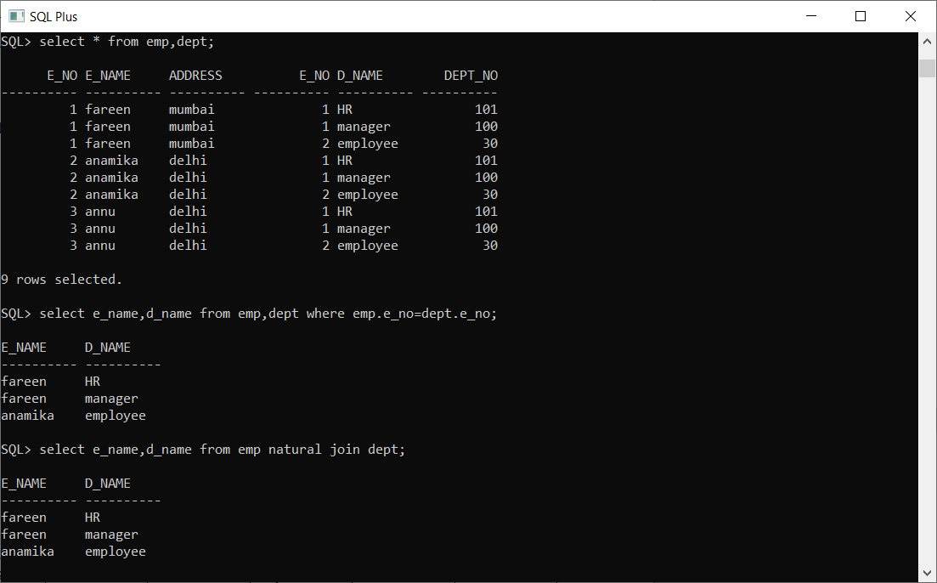example: SQL>select * from r,s;

2)natural join: it joins two tables based on same attribute name and datatypes.

syntax:select * from tbl1 natural join tbl2; OR select * from tbl1,tbl2 where tbl1.t_no=tbl2.t_no;

example:

SQL>select emp_name,dept_name from EmpTable natural join DeptTable;

3)equi join:we use ‘=’ operator in this.

example:

SQL>select * from emp,dept where emp.e_no=dept.e_no and emp.address=dept.location;

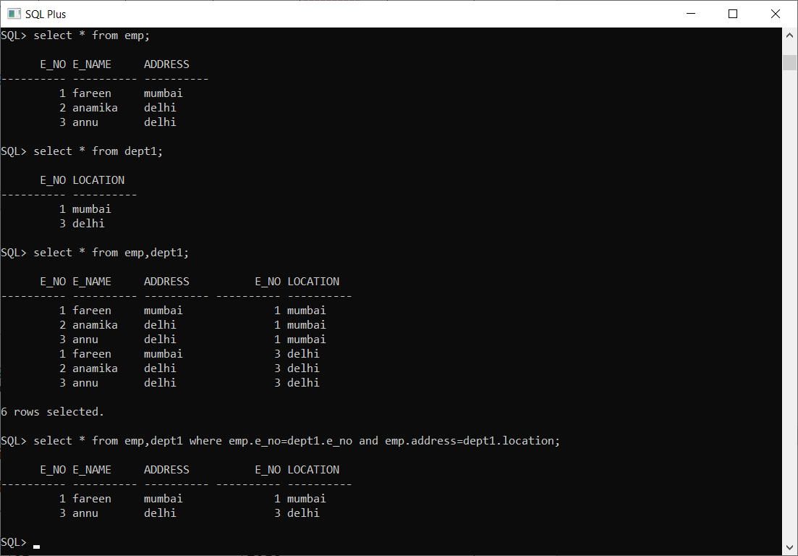

4)self join: it is usefull in situatin like to find the greatest number in self join.

example:

SQL>select a.salary from sal a, sal b where a.salary>b.salary;

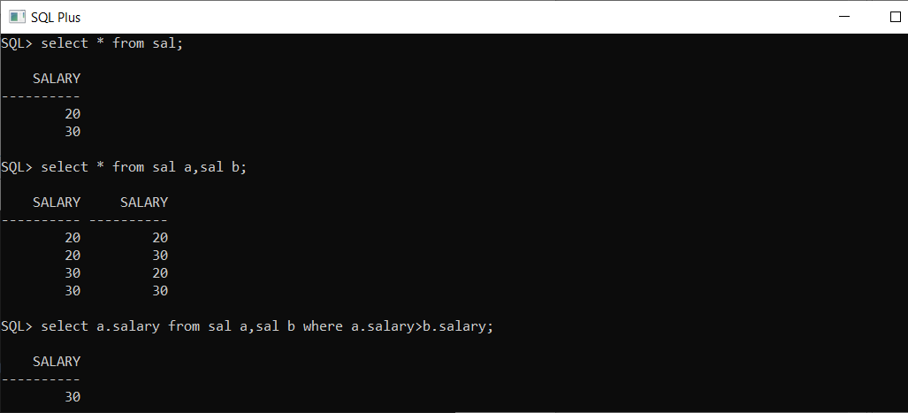

5)outer join:

i)left join: it gives the matching rows and the rows which are in left table but not in right table.

it is :Natural join+outer join

example:

SQL>select e_name,d_name from emp left outer join dept on (emp.dept_no=dept.dept_no);

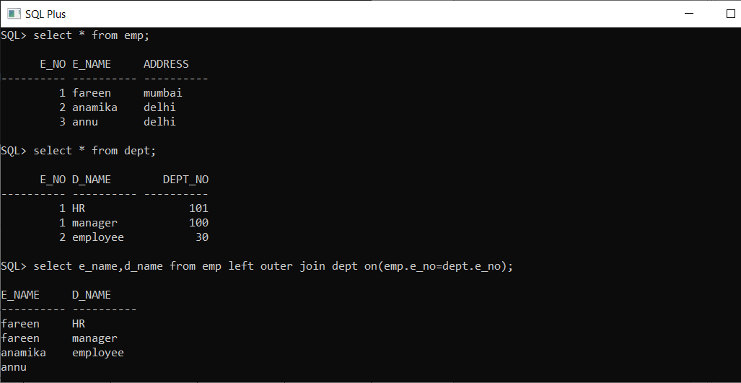

ii)right join: it gives the matching rows and the rows which are in right table but not in left table.

example:

SQL>select e_name,d_name from emp right outer join dept on (emp.dept_no=dept.dept_no);

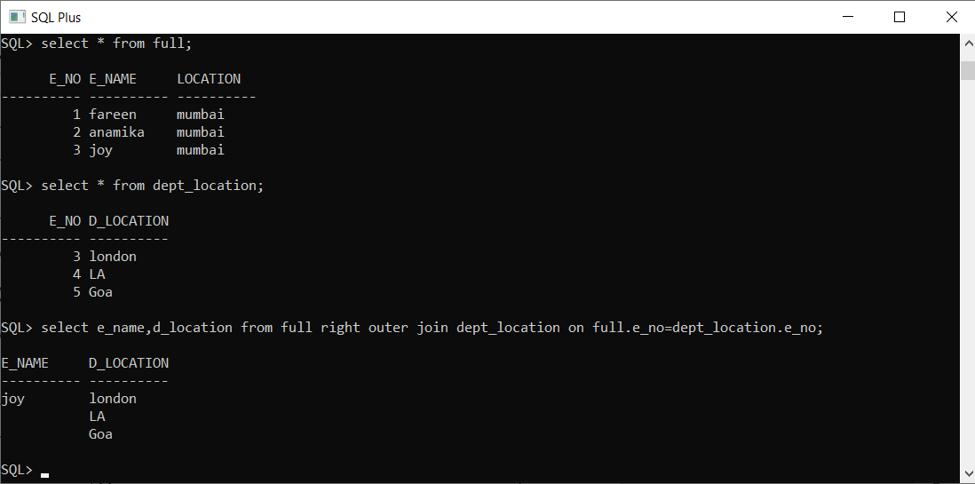

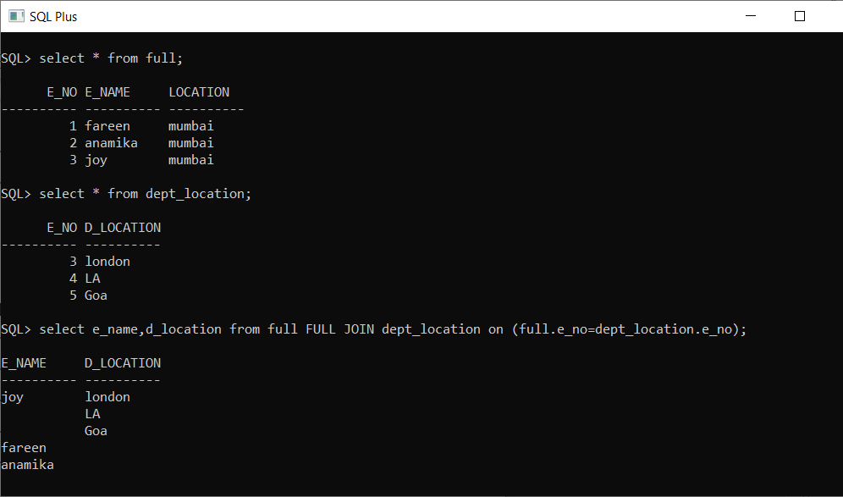iii)full join: it gives the matching rows and the rows which are on both table.