ORDER BY vs GROUP BY

Order by is user for getting data based on ascending and desc order.

Group by is used to group data(mandatory use aggregate functions).

Steps in group by :

step 1: first it will group the data

step 2: the it find the aggregate function eg: find max(marks)

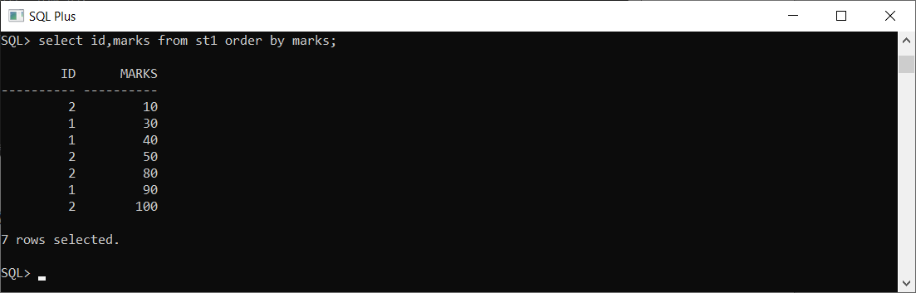1)order by: 2)group by:

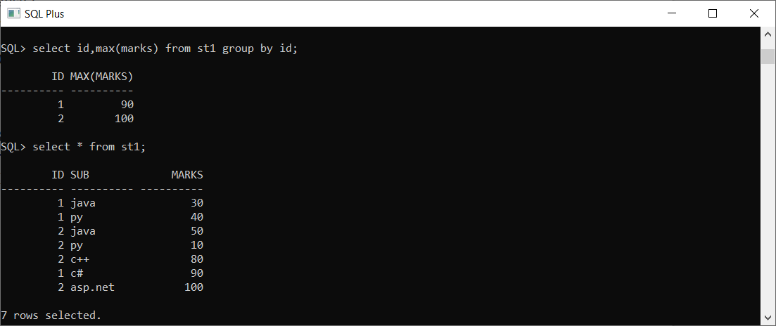

---------------------------------------------------------------------------------------------------------------------------------------------------

WHERE vs HAVING

we cannot use where clause to filter the particular record which has aggregate function, where as we can use having to filter the particular record based on aggregate function.

1)where clause: 2)having clause:

