How can I build a web page

– Lets try understand what is a web page and the difference between web page and web site, A web page is a single page you see on your browser, just as when you google “ dog” you might see, number of web sites

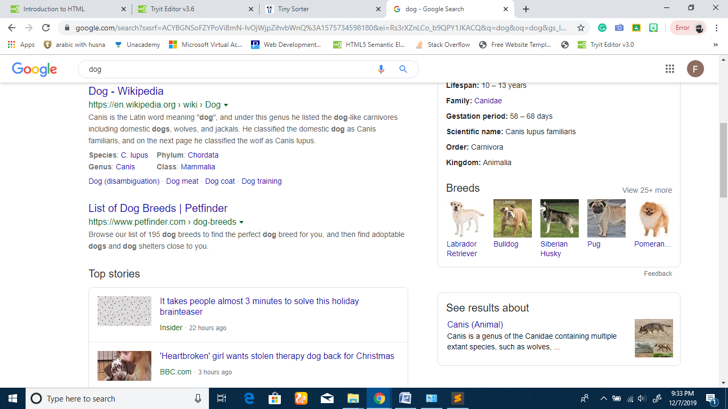

on clicking on those websites You see a nav bar and a few options, which has other related information



Clicking on the Option available on the navbar will land u up on a different web page inside the same website.

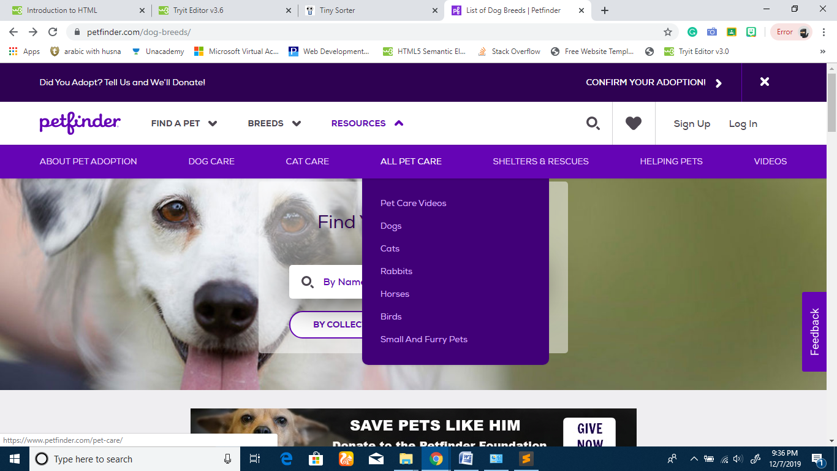

This is a web page named pet-care inside the website petfinder

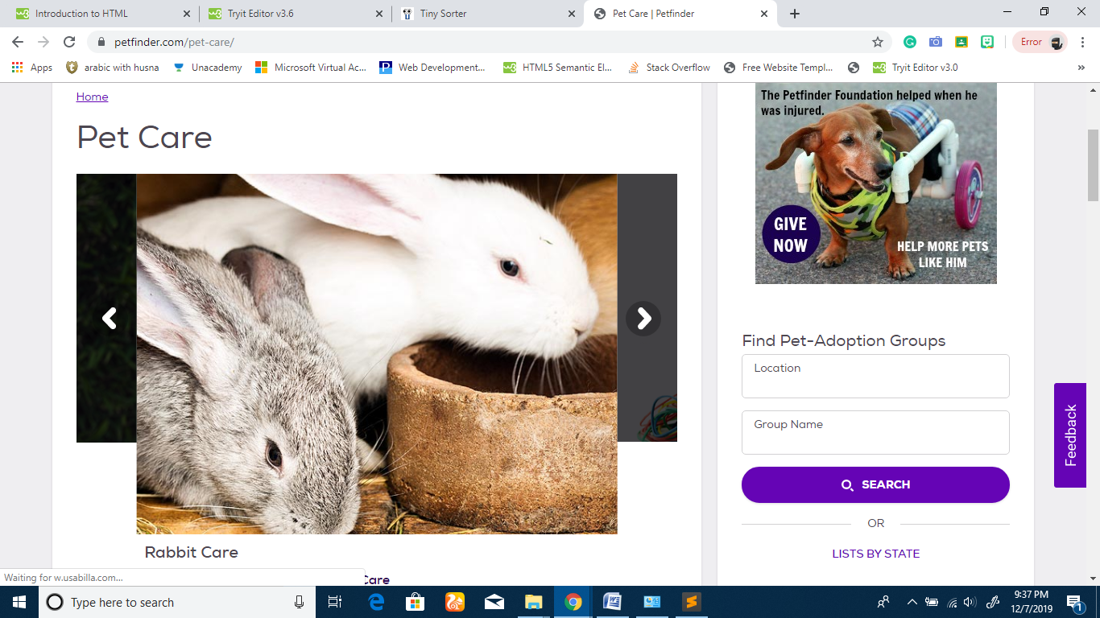

Now that we know what is a web site let’s start creating one, lets dive into different elements of a web page. Computers only understand what you say them, in the way they were built to understand so… Now for creating a web page we need to talk to the computer with the language that it can understand, to make a web page, which is HTML, Here is something which will help you to quick start.

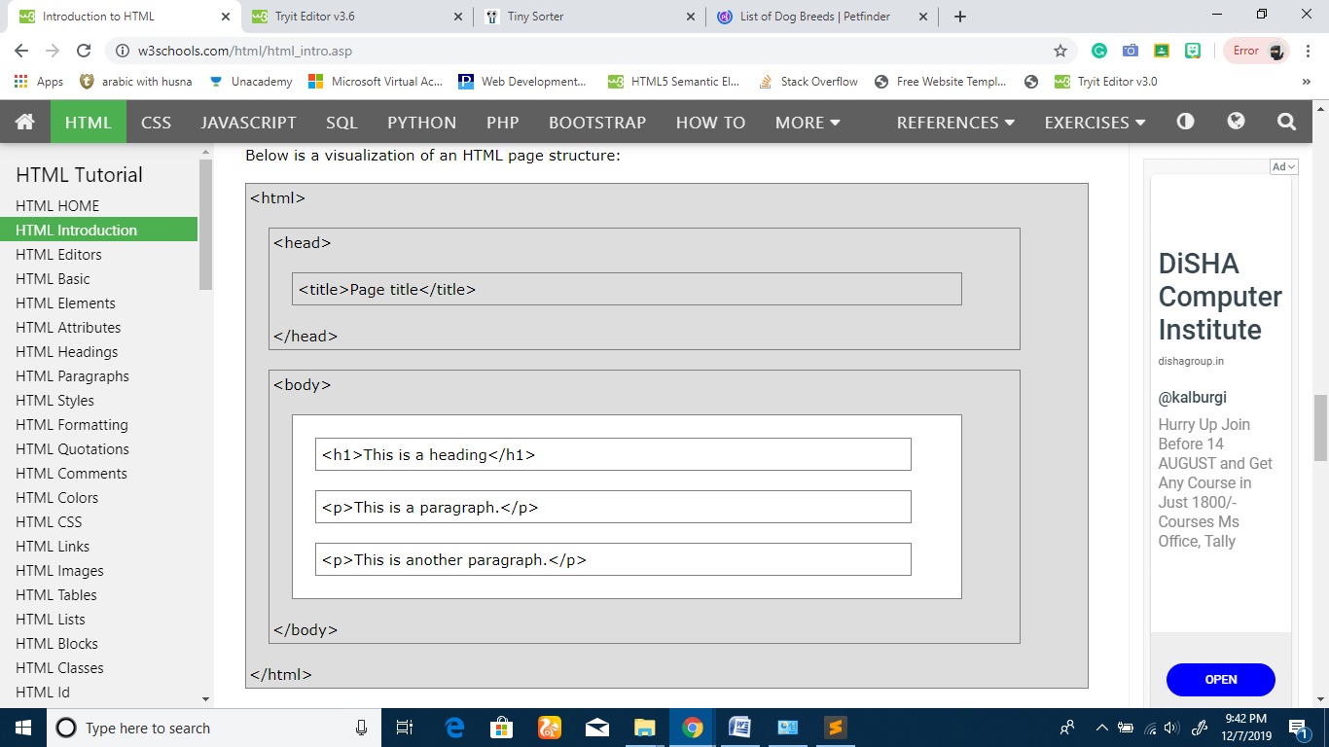

As you can see there is one big block starting and ending with <html></html> and in it two different blocks <head></head> and <body></body> and a lot other in them, and this is how we talk to computer to make webpages.

Steps

Line one should always start with DOCTYPE, so to help computer understand it is an html language document in which I want to talk to you.

The <!DOCTYPE html> declaration represents the document type, and helps browsers to display web pages correctly.

Everything you write after this should be included in the <html></html>, we call it html tag there a huge number of tags to talk to computer for making a web page and when used correctly you can build GREAT THINGS! Check out a few of them here <https://www.w3schools.com/tags/ref_byfunc.asp> in the second box of the above image is <head></head>, this is called a head tag which something that you want ot name your web page like “petcat | petfinder” is the title/name of this webpage



So how exactly this works….

Lets try out

Open notepad in your computer

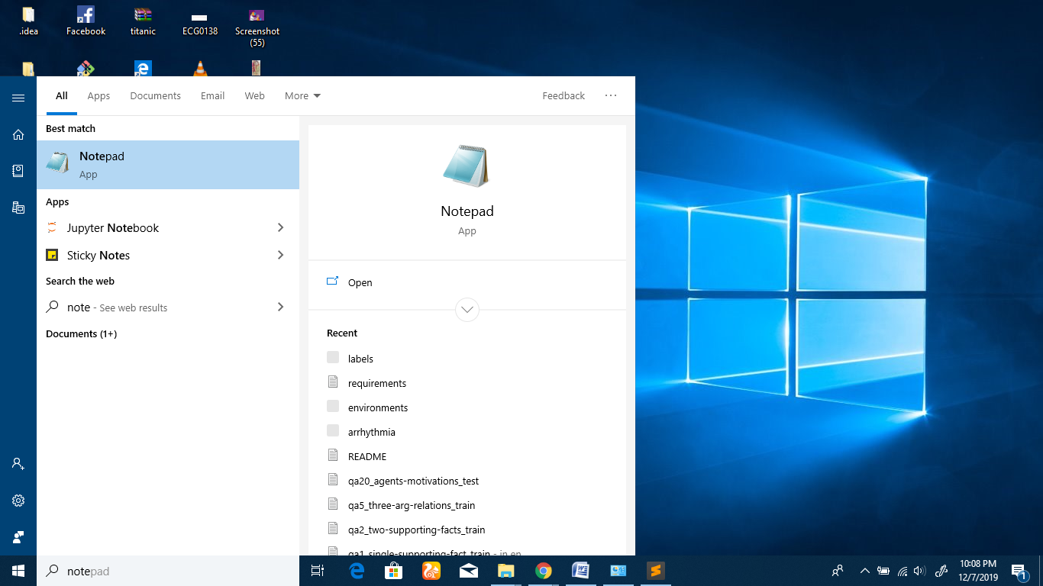

This is where you will give instruction to your computer to make a web page

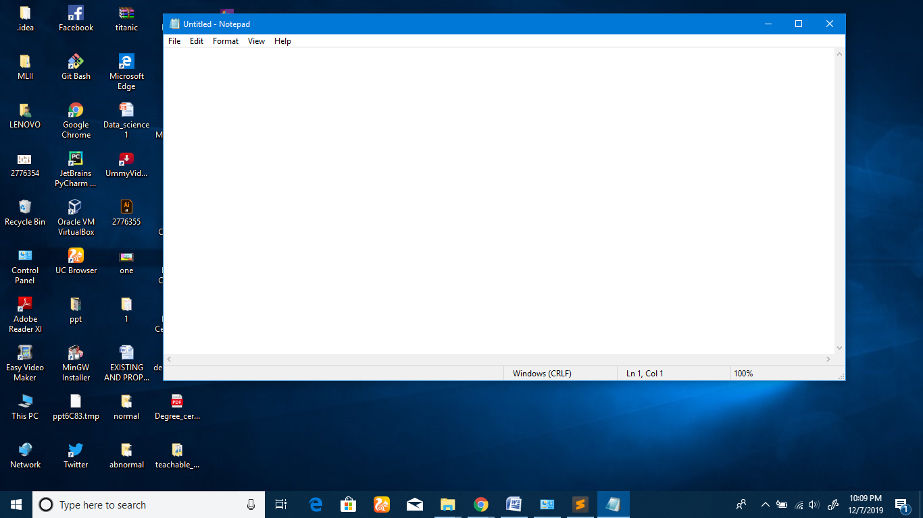

Starting with <!DOCTYPE html>, we include <html> and </html> first which defines the start and end of instruction to be given.

Helps you build great things Name, and share great things with your friends

Download a theme

Content

Make changes accorlingly

**Publish your page**

1. Create a **GitHub** account. First thing's first: get yourself a **GitHub** account! ...
2. Download and install the **GitHub** Desktop app. This is the app that we'll use to get our code up on **GitHub**. ...
3. Create a new **GitHub** project. ...
4. Copy your files to the new Repository folder. ...
5. Publish your website. ...
6. **Share** your website!

Share it with friends and family