SIMATS SCHOOL OF ENGINEERING
Saveetha Institute of Medical and Technical Sciences, Chennai - 602105
ASSIGNMENT - UNIT IV: Testing, CI/CD & Production Monitoring
Student Name | Mohammed Fareeth S A
Register Number | 192511288
Faculty Guide | Dr. R. Surendran
Subject | Software Engineering
Unit | Unit IV - Testing, CI/CD Pipelines and Production Monitoring

Question 1 — Mutation Testing and Fuzz Testing

Mutation Testing
Mutation testing is a white-box, fault-based technique that judges the quality of an existing test suite rather than the software itself. Small, deliberate changes (mutations) are injected into the source code to create many slightly altered versions of the program, called mutants.
Common mutation operators:
- Arithmetic operator replacement (+ → −)
- Relational operator replacement (< → <=)
- Logical operator replacement (&& → ||)
- Statement deletion (removing a call)
- Constant replacement (0 → 1)
The test suite is run against every mutant. A mutant is killed if some test fails on it, and survives if all tests still pass. Test-suite strength is measured as:
Mutation Score = (Killed Mutants / Total Non-Equivalent Mutants) x 100%
How it improves reliability & security:
- Surfaces weak tests that achieve high coverage but never actually assert correct behaviour.
- Forces precise assertions instead of superficial checks.
- Mimics realistic coding slips (off-by-one, wrong comparator) that manual review often misses.
- Strengthens security-critical logic (e.g., a flipped == vs != in an authorization check) by proving tests would catch such a flaw.

Fuzz Testing
Fuzz testing is a dynamic, black-box technique that feeds a running program large volumes of random, malformed, or boundary-value inputs to expose crashes, memory leaks, unhandled exceptions, and security vulnerabilities. Unlike mutation testing, which mutates code, fuzzing mutates or generates the input data.
Common fuzzer types:
- Random/dumb fuzzers — generate inputs with no knowledge of format.
- Mutation-based fuzzers — mutate valid seed inputs (e.g., AFL).
- Generation-based fuzzers — build inputs from a known grammar/protocol spec.
- Coverage-guided fuzzers — use code-coverage feedback to steer input generation toward unexplored paths.
How it improves reliability & security:
- Finds crash-causing and memory-corruption bugs (buffer overflows, null derefs) before attackers do.
- Automatically explores edge cases humans rarely think to write as test cases.
- Widely used to harden parsers, network-facing APIs, and file-format handlers, which are prime attack surfaces.
- Continuous fuzzing in CI catches regressions the moment new code introduces an unsafe path.
Question 2 — Key Stages of a CI/CD Pipeline (Jenkins / GitHub Actions)

A CI/CD pipeline automates the journey of a code change from commit to production. The typical stages are:
- Source / Trigger — a push or pull request to the repository triggers the pipeline (GitHub Actions: "on: push"; Jenkins: SCM webhook/polling).
- Build — the code is compiled/transpiled and dependencies are resolved.
- Unit & Integration Tests — automated tests run to catch regressions early; the pipeline fails fast if tests break.
- Static Analysis / Code Quality — linters, SAST tools, and style checks enforce code standards and catch vulnerabilities.
- Package / Artifact Creation — a build artifact or container image is produced and versioned (e.g., pushed to a registry).
- Deploy to Staging — the artifact is deployed to a staging/test environment automatically.
- Automated Acceptance / Regression Tests — end-to-end tests validate the staged build behaves correctly.
- Deploy to Production — promotion to production, either automatically (continuous deployment) or behind a manual approval gate (continuous delivery).
- Monitor & Rollback — post-deploy health is monitored; failures trigger an automatic or manual rollback.
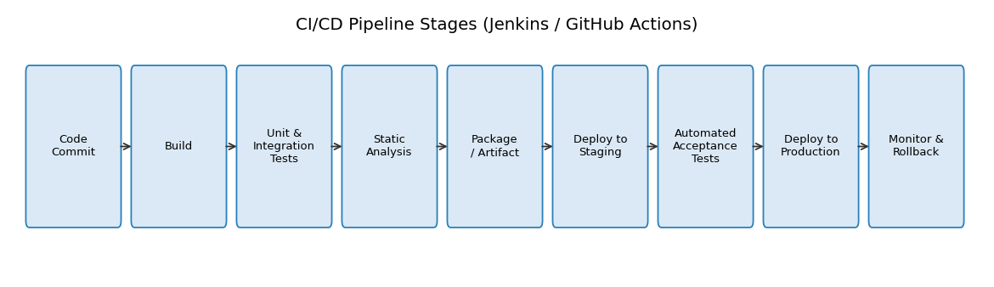
Fig 2.1 — Typical CI/CD pipeline stages
In Jenkins, these map to stages inside a declarative Jenkinsfile (pipeline { stages { stage('Build'){...} stage('Test'){...} ... } }). In GitHub Actions, they map to jobs/steps inside a YAML workflow file (.github/workflows/ci.yml), with each stage as a step under a job.

- Environment consistency: the app and its exact dependencies are packaged into an image, so it behaves identically across dev, staging, and production — eliminating "works on my machine" failures.
- Fast, reproducible builds: images are built once in CI and reused everywhere, speeding up deployments and rollbacks.
- Immutable, versioned artifacts: each image is tagged (e.g., by commit SHA or semantic version), so a specific, tested build can always be redeployed or rolled back to.
- Isolation: containers isolate app processes/dependencies, avoiding conflicts between services running on the same host.
- Registry integration: CD tools pull a tested image straight from a container registry, making promotion between environments a simple image-pull rather than a rebuild.
- Elastic scaling: orchestrators (Kubernetes, ECS) can scale identical containers up or down automatically based on load, which is core to reliable continuous delivery at scale.
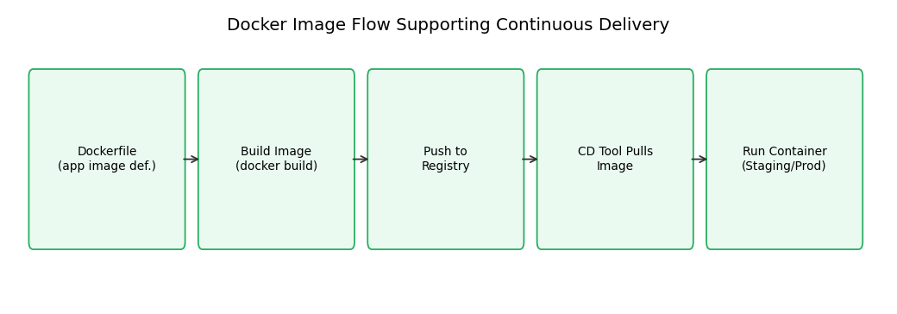
Fig 3.1 — Docker image flow inside a delivery pipeline
Question 3 — Case Study: Intermittent Slowdowns in a Large SaaS Application

Diagnosing intermittent slowdowns requires correlating metrics (what is slow, and when) with logs (why it is slow). Prometheus, Grafana, and the ELK stack each play a distinct, complementary role:
Prometheus — Detection
- Continuously scrapes time-series metrics (CPU, memory, request latency, error rate, queue depth) from every service.
- Alerting rules (via PromQL + Alertmanager) fire the moment latency or error-rate crosses a threshold, giving early warning of a slowdown as it starts.
Grafana — Diagnosis (pattern correlation)
- Visualizes Prometheus metrics on dashboards, making it easy to see that slowdowns correlate with, say, a nightly batch job, a traffic spike, or a recent deployment.
- Overlaying multiple metrics (CPU vs. latency vs. DB connections) narrows down which subsystem is the bottleneck.
ELK Stack — Root-Cause Diagnosis
- Beats/Logstash ship application and infrastructure logs into Elasticsearch, where they are indexed and searchable.
- Kibana lets engineers filter logs to the exact time window flagged by Grafana/Prometheus and search for stack traces, slow query logs, or exceptions using a correlation/trace ID.
- This typically reveals the actual cause — e.g., a slow database query, a memory leak triggering GC pauses, or a downstream API timeout.
End-to-end resolution workflow:
- Prometheus alert fires on elevated p95 latency.
- Grafana dashboard shows the spike coincides with a spike in DB connection wait time.
- Kibana log search for that window surfaces repeated slow-query warnings against one table.
- Engineers add an index / optimize the query, deploy the fix through the CI/CD pipeline, and confirm in Grafana that latency returns to baseline.
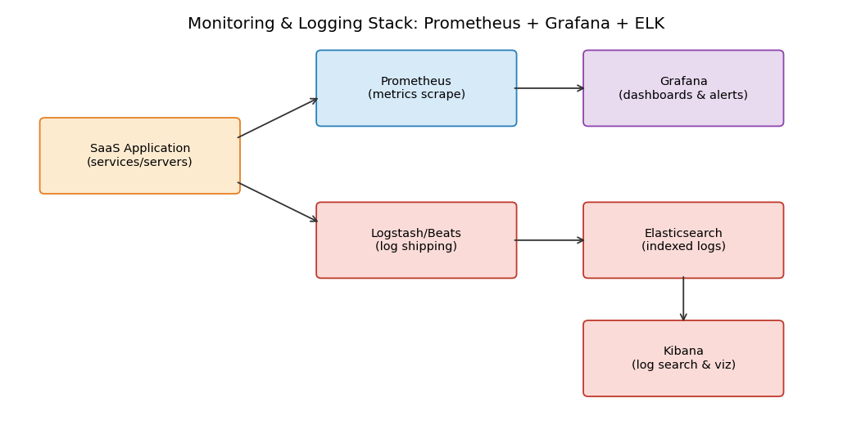
Fig 4.1 — Prometheus + Grafana + ELK monitoring & logging architecture
Together, these tools shorten mean-time-to-detect (Prometheus alerts), mean-time-to-diagnose (Grafana correlation), and mean-time-to-resolve (ELK root-cause logs) — directly improving the reliability and observability of a large SaaS system.

