Willingness to Take Advice in a Gambling Task

Simran Jaspal

Adviser: Dr. Dominic Fareri

Adelphi University

Abstract

.

**Introduction**

**Methods**

*Participants*

    Participants were Adelphi University students enrolled in psychology courses. The students signed up for participation in the study through the Adelphi Sona Systems website, and received 2 credits upon completion of the study. X subjects participated in the study (X females, X males), and ranged in age from X to X.

*Self-Report Measures*

Prior to completing the computer tasks, participants were administered self-report measures to highlight various characteristics that may influence decision- making. These measures included items from the Rosenberg self-esteem scale. (Rosenberg, 1965), which assessed both positive and negative feelings about the self. The items were scored on a 4 point scale, from 1 to 4, with corresponding statements of “Strongly Agree”, “Agree”, “Disagree”, and “Strongly Disagree”.

An individual’s perception of how much he or she receives outside social support was tested through the Multidimensional scale of perceived support. The items were scored on a 7-point scale from 1 (Very Strongly Disagree) to 7 (Very Strongly Agree).

The UPSS scale measures which traits are measured across different existing impulsivity measures in impulsive personality. Items are scored a 4 point scale, from 1 to 4 , with corresponding statements of “Strongly Agree”, “Agree”, “Disagree”, and “Strongly Disagree”.

The DOSPERT scale measures risk taking in five different domains: financial decisions, health/safety, recreational, ethical, and social decisions. Items are scored on a 5-point scale from 1 (Very Unlikely) to 5 (Very Likely).

Resistant to Peer Influence Scale is used to measure peer influence and if people will go along with certain actions or decisions even if they aren’t comfortable but will make their friends happy. The measure is a series of 10 pairs of statements and the items are scored on a 2-point scale with statements of “Sort of True for me” or “Really True for Me”. (Steinberg, 2007).

Responses for all questionnaires were acquired through Qualtrics.

*Behavioral Tasks*

After completion of the self-report measures, participants then engaged in a computer tasks developed in Psychopy 3. Subjects participated in a gambling task in which the first step was to choose an advisor. Option 1 was an undergraduate biology major and then second option was an Adelphi MBA graduate student. Participations were instructed to choose an adviser and that they would be allowed to change advisors after each trial. Participants must respond with their option by either pressing the right or left arrow keys and then pressing enter to start the trials. The first screen appointed a certain amount of money with the second screen being a stimulus. Participants were then showed both the safe option and the gamble (Figure 1). Next, they were given the option to receive advise from their chosen advisor, if “Y” was pressed for yes to receive advice, the advice was shown on the screen. If they press “N” for not to receive advice or did not choose either the “Y” or “N” option, then the participant was not given advice. Next, the screen of the safe option vs the gamble appeared again. Participants must respond within 2 seconds by pressing either the left or right arrow key on the keyboard to have made their choice.

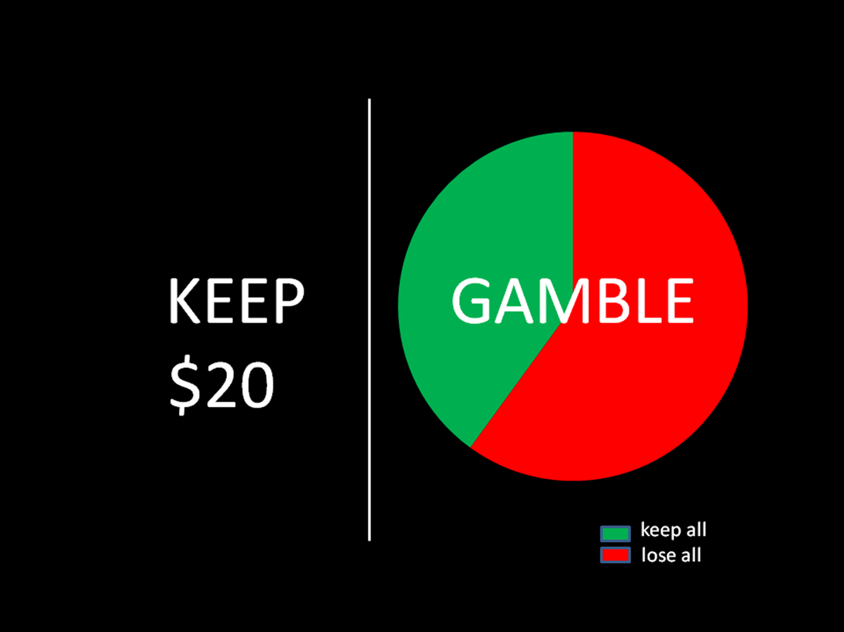

Figure 1. Participants are shown the two options: Safe or Gamble

**Results**

**Discussion**

References

Rosenberg, M. (1965). Society and the adolescent self-image. Princeton, NJ: Princeton

University Press.

Steinberg, L., & Monahan, K. C. (2007). Age differences in resistance to peer influence. *Developmental psychology*, *43*(6), 1531.