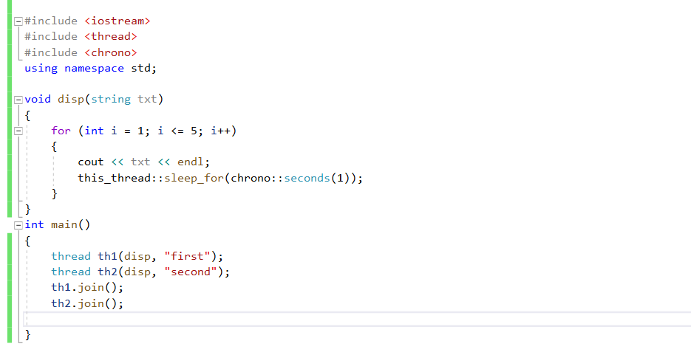هيبدأ ي main باستخدام lambda expesstion

خلي بالك lock make the tread do until it finish

And unlock

