OW Yellow Caps
Executive Insights Report
NYC Yellow Taxi Operations | January – March 2025

Prepared by the Business Intelligence Consulting Team
Data source: NYC Taxi and Limousine Commission (TLC) | 11.2 million trips

Khaled yasar 20230223

Executive Summary
The current report highlights major findings from 11.2 million NYC Yellow taxi rides taken between January and March 2025. This includes information about the locations where the trips take place, peak times, revenue per trip type, modes of payment used, and the effect of the introduction of CBD congestion fee on January 5, 2025.

Findings are organised into five sections, each supported by the actual charts generated from the cleaned dataset. Every section closes with concrete business recommendations.

01 Where Are Trips Happening?
Geographic demand: zones, pickups, and dropoffs

Knowing the origins and destinations of trips forms the basis of fleet positioning strategy. The graphs presented in this chapter provide the answers to questions: which areas of New York have the highest yellow taxi demand, and which zones in particular?

1.1 Pickup and Dropoff Frequency by Taxi Zone
The two maps below illustrate the trip density across the entire NYC taxi zones. The darker the color blue, the higher the number of trips. This applies to both pickup and dropoff map.
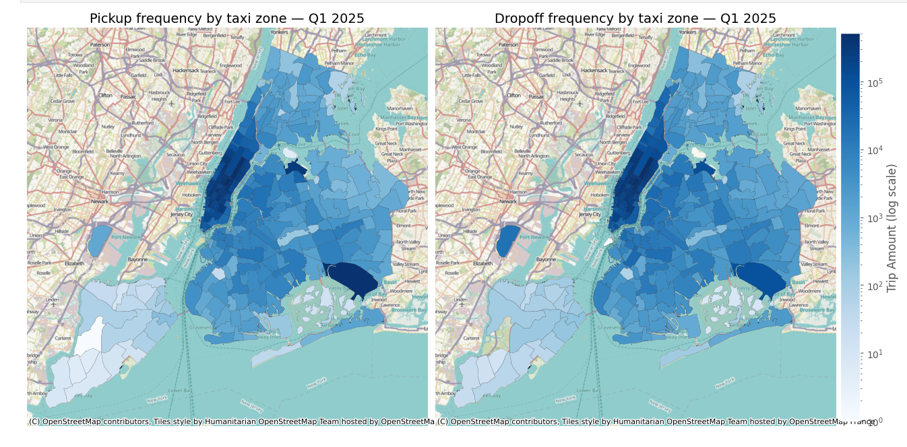
📊 What this tells the business
The pickup and drop-off intensities are practically equal, which indicates that yellow cabs form a closed loop system in Manhattan.
Certain Midtown and Lower Manhattan areas generate an unusual number of trips compared to other areas.
Airport zones in Queens seem to be isolated hotspots — even though fewer trips occur in those zones, they generate much higher revenues per trip.
- Deploy taxis in Midtown Manhattan where both pickup and drop-off densities are at their peak.
- Dedicate resources to airport zones, despite lower volumes of trips, because of their much higher revenues per trip.

1.2 Top 10 Pickup Zones by Trip Volume
Horizontal bar chart ranking the 10 busiest pickup zones in Q1 2025, labelled with trip counts in thousands.

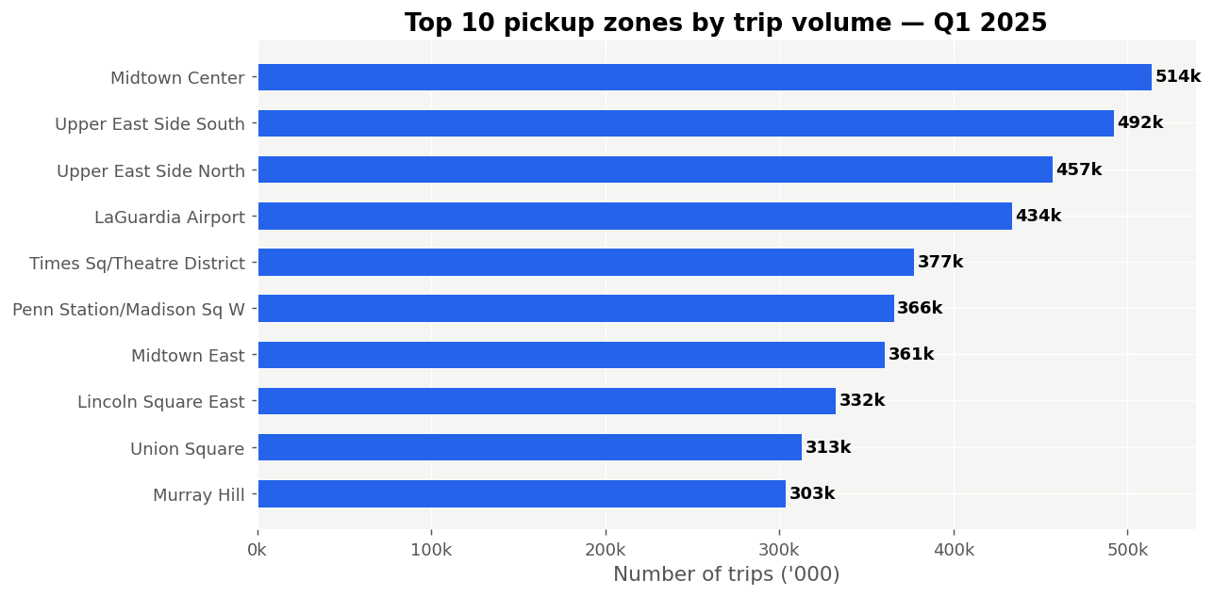

📊 What this tells the business
All top 10 pickup zones are in Midtown Manhattan. Midtown Center alone was responsible for more than 513,000 pickups.
LaGuardia Airport is the only zone outside Manhattan to make the list at number 4 with 433,000 trips.
Combined, Upper East Side South and North account for almost 1 million pickups – an inherent structural residential demand base.

- Deploy vehicles in Midtown Center and Midtown East during peak times for maximum pickups.
- Penn Station and Times Square have high volumes but are competitive. Arriving just prior to departure rushes (8AM, 5PM) will ensure demand precedes supply.
- Being ranked fourth in LaGuardia Airport ensures that any airport investment immediately focuses on a top volume zone.

1.3 Top 10 Dropoff Zones by Trip Volume
Same analysis for dropoffs — where passengers are being delivered across Q1 2025.
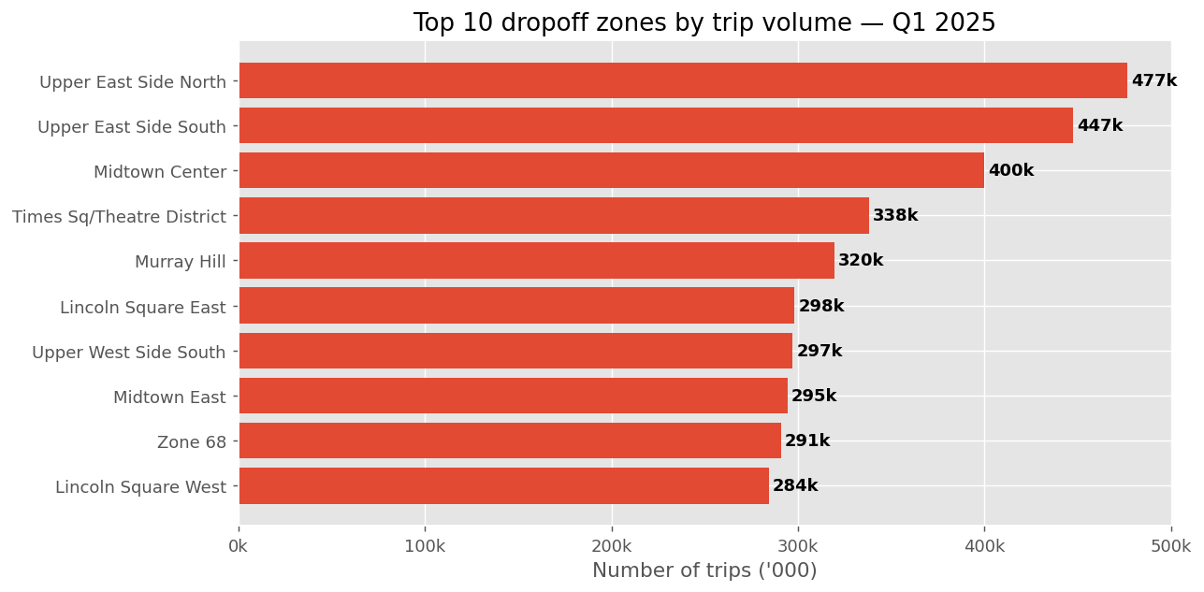

📊 What this tells the business
The top 10 dropoff locations are very similar to the top 10 pickup locations, emphasizing the point that yellow taxis are a Manhattan closed loop.
Knowing where people are being dropped off makes it easier to position the car for the return trip; for example, after making a drop off in Midtown East, the taxi is in a top 10 pickup area.
- After dropping off passengers in any top 10 location, the driver should not relocate but instead stay put; there is another demand waiting right there.

02 When Is Demand Highest?
Hourly and daily demand patterns across Q1 2025

Understanding when demand peaks is equally important because that will determine how to schedule the vehicles during the day and even the week.

2.1 Number of Taxi Trips by Hour of Day
A bar graph indicating the total number of trips per hour in the whole day for the entire quarter of 2025.
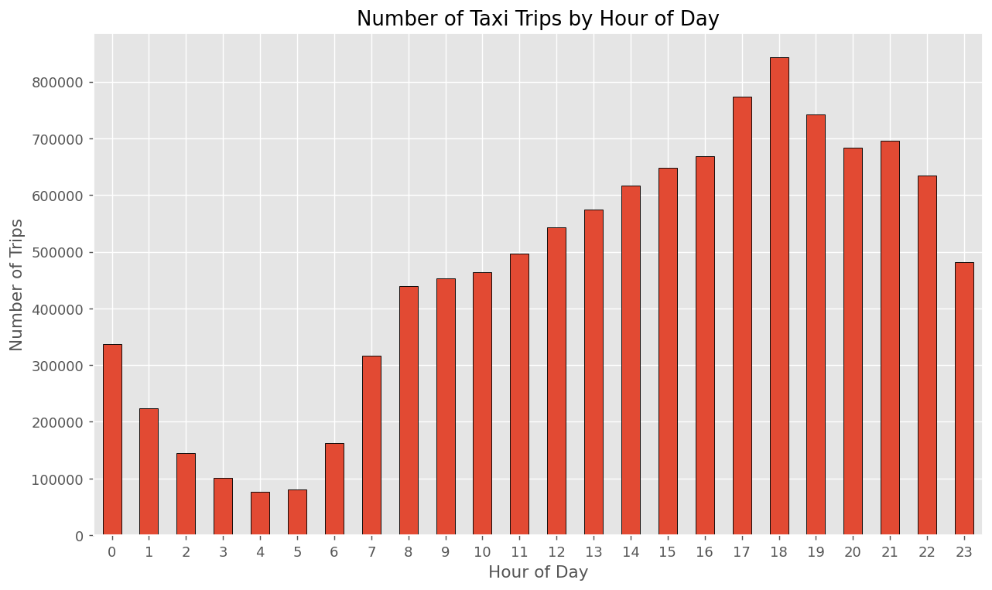

📊 What this tells the business
Distinctive two peaks: one morning peak between 7–9 am and a more pronounced evening peak between 5–8 pm.
The evening peak is always greater than the morning peak for all three months.
Midnight to 5 am shows low volumes, but not zero – there is still some overnight demand.
- Evening shift deployment is the primary staffing priority.
- The period 11 am to 2 pm is the obvious choice for maintenance and refueling.
- Owing to reduced traffic, overnight drivers make more trips per hour.

2.2 Trip Pickups by Hour and Weekday — Monthly Heatmaps
Three heatmaps on the same colour scale. Each cell represents a weekday-hour combination. Darker red means more trips.

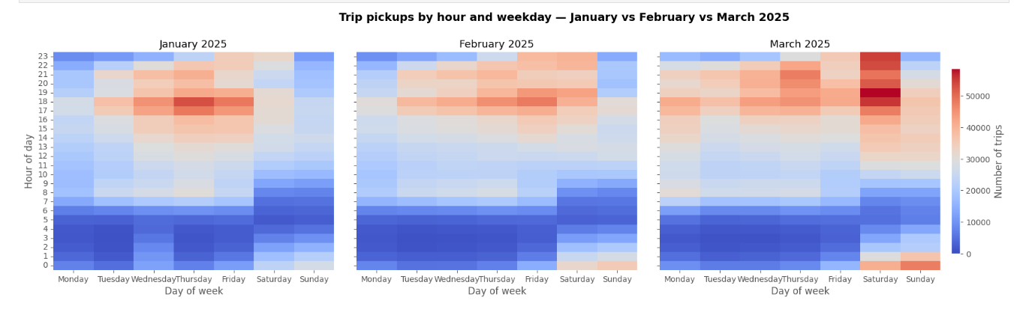

📊 What this tells the business
March is clearly darker than January – demand has recovered 24% during the quarter.
Thursday and Friday evenings (5–8 PM) are the highest demand cells in all three months. That’s structurally consistent.
Weekend hours move to late-night demand (10 PM–2 AM) caused by nightlife.
- We need two shift patterns here – one for weekdays (AM/PM peak) and one for weekends (late night).
- Progressively increase number of vehicles from January to March – it’s incorrect to treat all three months equally due to March demand.
- March Thursday and Friday evenings represent the single most valuable time slot in Q1.

2.3 Pickups by Time of Day and Weekday — Monthly Comparison
Grouped bars breaking each weekday into Late Night, Morning, Afternoon, and Evening, for each month.

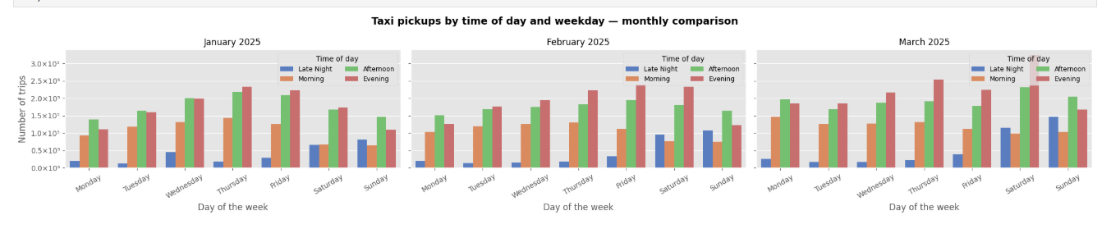

📊 What this tells the business
Evening excursions make up all of the weekdays throughout the entire three-month period.
The Evening shift increases significantly in size from January to March particularly on Thursday and Friday.
The Late Night excursions increase drastically on Fridays and Saturdays from January to March.
- Thursday and Friday evening shifts should be the highest-priority staffing windows.
- The Friday and Saturday Late Night shifts are economically crucial as these excursions earn higher tips and totals.

03 Revenue: What Are Trips Worth?
Revenue composition, fare economics, and the airport opportunity

3.1 Revenue Composition by Component and Month
Stacked bar chart showing total revenue in USD millions per month, broken down by component.

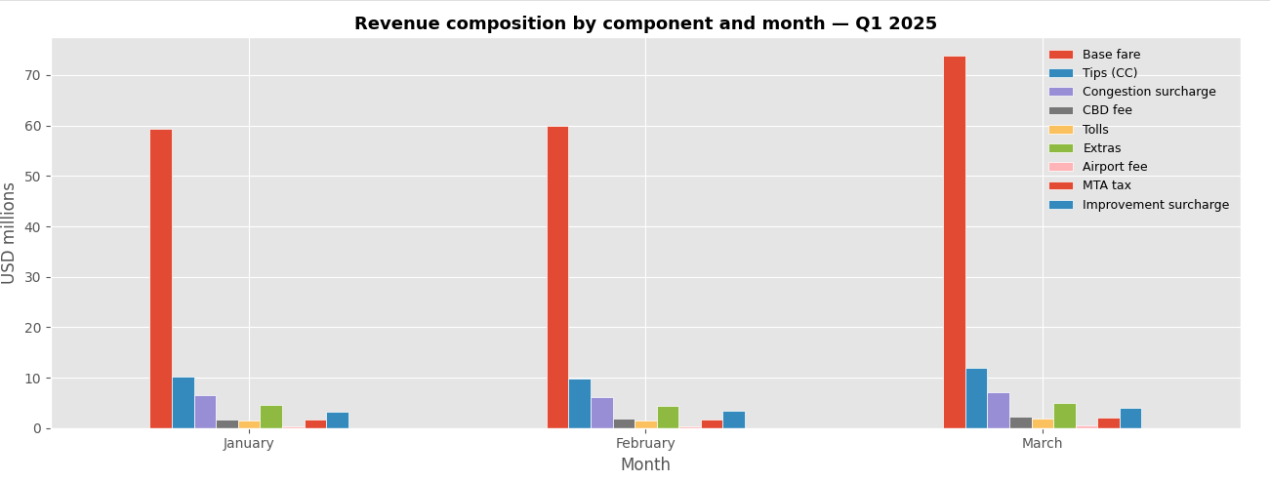

📊 What this tells the business
Base fare accounts for roughly 65% of total revenues monthly. This is the only segment that the company can significantly increase.
March total revenues ($108 million) are 24% higher than January ($87 million), due to higher and longer ride volumes.
The CBD fee increased from $1.7 million to $2.2 million monthly; however, it goes into the pockets of the MTA and not the operator.
Tips (green line) are consistently underreported – tips in cash are not recorded. Actual tip revenues are higher.
- Concentrate efforts solely on increasing trip volumes or distances – both drive the base fare, which makes up the largest segment.
- Inform drivers that the CBD fee in the passenger receipt goes to the MTA, not the driver.
- Staff at March levels from January each year. 24% revenue gap is avoidable.

3.2 Mean Total Amount by Trip Distance
Line chart with 95% confidence intervals showing average total amount at each 1-mile distance bin.

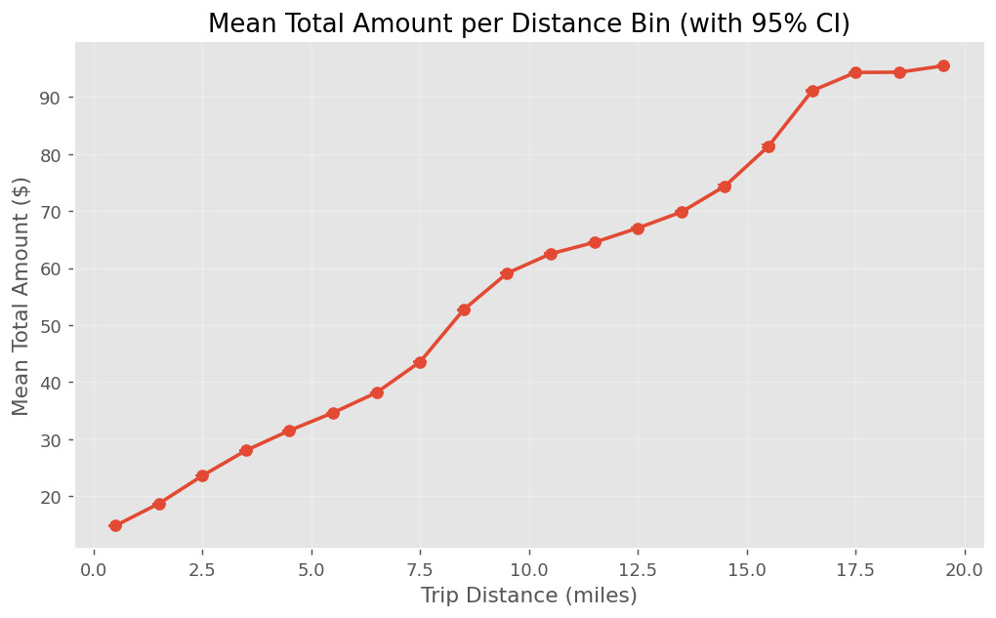

📊 What this tells the business
Total Amount increases steadily with distance. The metered fare system is functioning as expected.
Narrow confidence intervals exist at all distances — the consistency of fare is very high.
Fares beyond 10 miles have wide confidence intervals because of the presence of different fare rate codes (flat rates for airport, negotiated fares).
- Train drivers to focus on trips in the 5-15 miles distance band — these provide between $40-$70 of total amount with predictable trip durations, and provide drivers with the optimal balance between earnings and hours worked, without the unpredictability of rush hour traffic.
- Use this graph as your pricing reference while dealing with clients — the narrow confidence intervals demonstrate that the fares charged by yellow taxis are consistent, thus offering a better deal than surge priced cabs.

3.3 Airport Pickups vs City Trips
Three metrics compared side by side: average total amount, average tip, and credit card share.

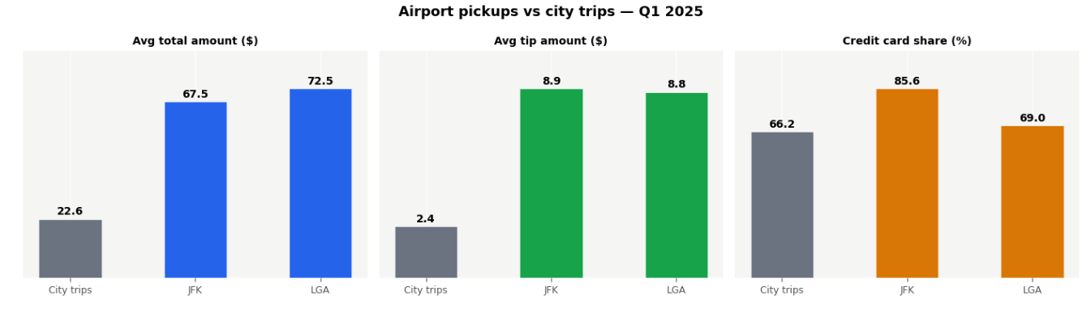

📊 What this tells the business
Airport rides provide a revenue of $67-$72 per ride while city rides bring only $22.60.
On average, tips from airports amount to $8.90 compared to $2.40 from city rides.
At airports, the use of credit cards amounts to 85%-88%, while at cities, it stands at 66% – tip income is fully transparent.
LGA airport provides more rides (433k) than EWR (283k) and should take priority.
- Make official arrangements with LGA, JFK, and EWR for guaranteed presence during peak time windows (6-9 am, 3-6 pm).
- Sponsor advertisements in airport terminals – tourists will go for app-based rides by default.
- LGA should take precedence over EWR when prioritizing resources.

3.4 Vendor Comparison — Average Total Amount
Mean and median total amount per trip by TPEP provider.

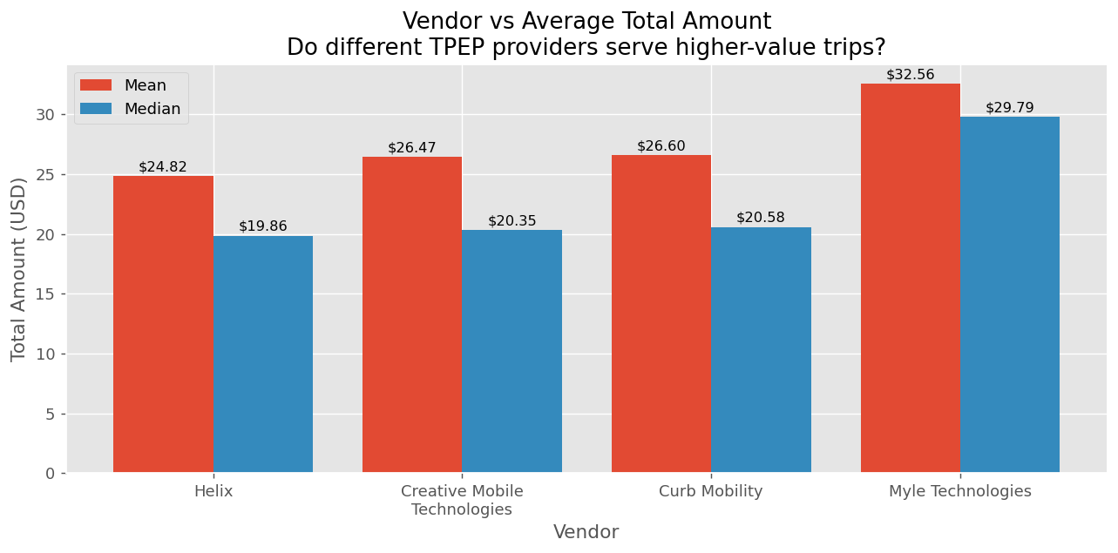

📊 What this tells the business
Different vendors show different average totals, reflecting the trip-type profile of each vendor’s network.
The gap between mean and median for each vendor indicates high-value outlier trips pulling the mean upward.
- Vendor selection should consider trip-type routing capability, not just average trip value.
- Use this as a benchmarking tool — a vendor with lower averages may be routing more short city trips versus long airport runs.

04 How Do Passengers Pay and Tip?
Payment types, passenger counts, and tipping by zone and time

4.1 Payment Type Distribution
Bar chart showing total trips by payment type with percentage share.

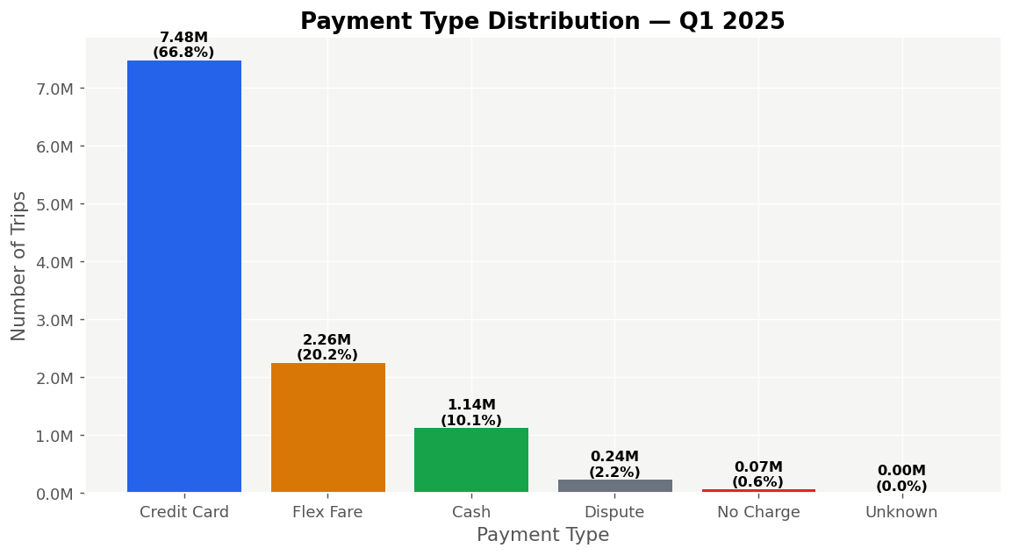

📊 What this tells the business
Credit card dominates at 66.8% (7.48M trips). Tips are fully captured for these trips.
Flex Fare at 20.2% is not a real payment type — it maps to the incomplete data batch (missing 6 fields per record).
Cash at 10.1% (1.14M trips) has zero tip visibility. True tip revenue is higher than any chart shows.
Dispute trips (2.2%, 241K) represent contested fares — a service quality signal worth monitoring.
- Promote card payment — a shift from cash increases tip visibility and likely tip amounts.
- Investigate the 241K dispute trips for patterns by zone or time of day.
- The 72K No Charge trips consume driver time for zero revenue — reducing these recovers operational efficiency.

4.2 Passenger Count Distribution
Bar chart showing number of trips by passenger count.

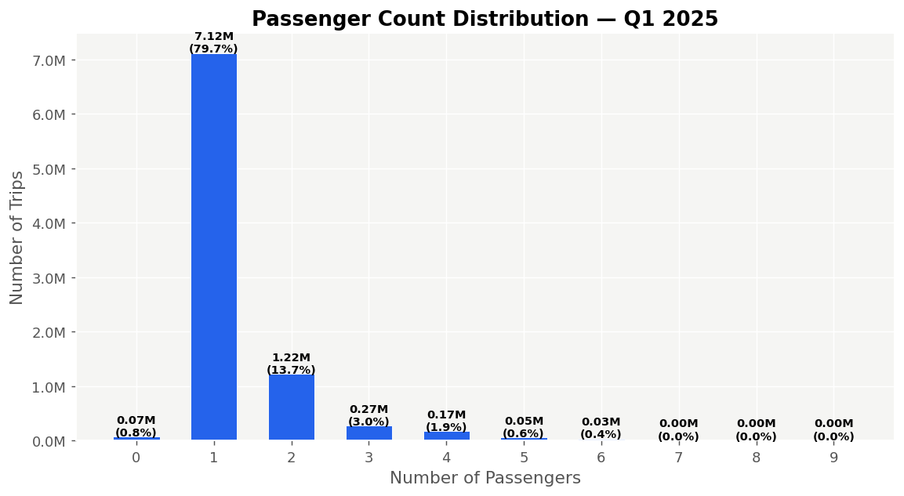

📊 What this tells the business
Solo riders are 79.7% of all trips (7.1M). Yellow taxis are structurally a single-occupancy service.
Pairs are the only meaningful secondary segment at 13.7%. All other group sizes are in low single digits.
Groups of 4+ are only 2.3% — the standard 4-seat cab serves 97%+ of demand.
Zero-passenger trips (69K) are data quality flags — likely meter tests or recording errors.
- No business case for deploying larger vehicles as standard fleet.
- Target pair travellers for airport and hotel routes — they travel further and pay more.
- Flag passenger counts above 6 for compliance review — 47 trips exceeded legal capacity.

4.3 Credit Card Tip Rate by Weekday and Hour
Heatmap of average tip as a percentage of fare, credit card transactions only.

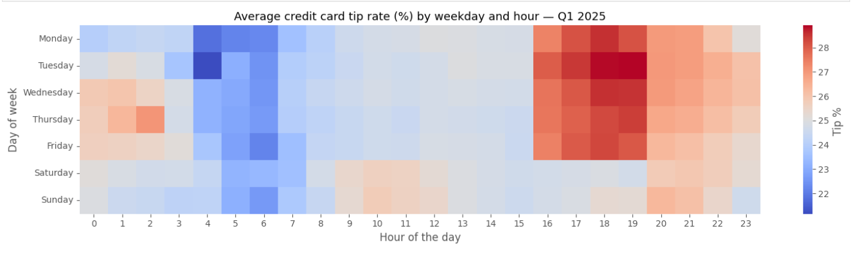

📊 What this tells the business
Evening hours (5–8 PM) show the highest tip rates at 27–28% of fare across all weekdays.
Early morning (5–7 AM) shows the lowest tip rates at ~22%.
The evening window already optimises both trip volume and tip rate simultaneously.
- This chart covers credit card only. Frame it explicitly as ‘credit card tip behaviour’ in any presentation.
- No reason to redirect drivers away from the evening peak — it is already the best window on every dimension.

4.4 Top 10 Dropoff Zones by Average Credit Card Tip
Bar chart ranking the 10 dropoff zones with the highest average tip per trip (zones with 100+ trips).
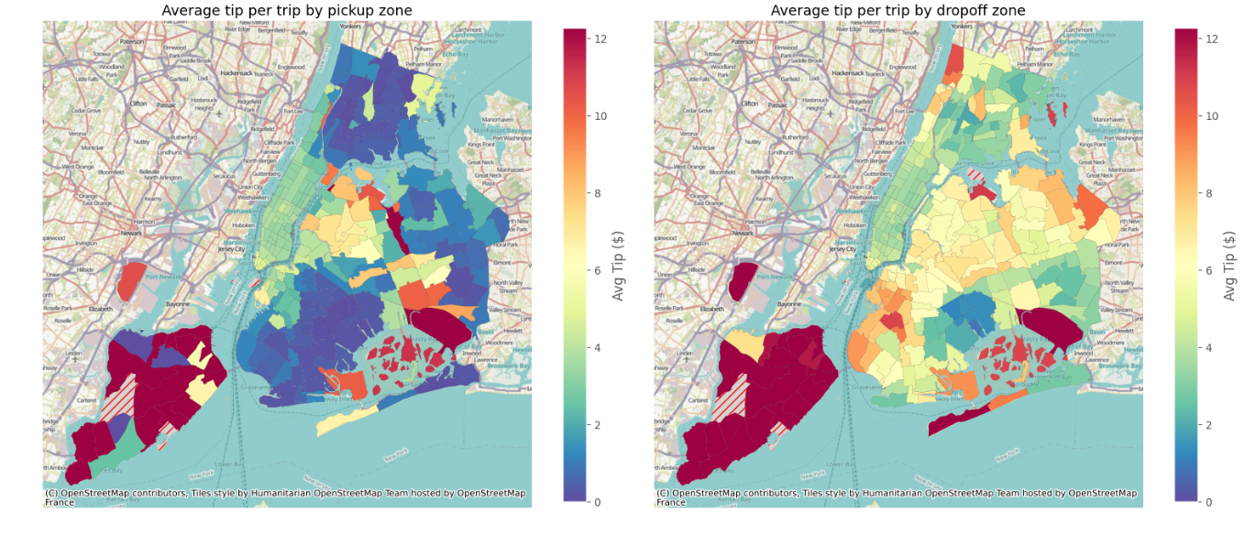

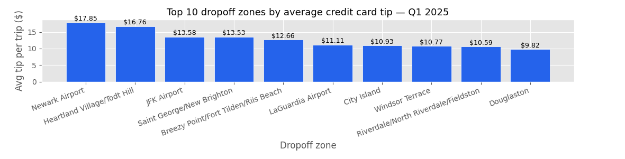

📊 What this tells the business
The top 10 dropoff zones are dominated by airports and high-end Manhattan neighbourhoods.
Drivers completing trips to these zones earn meaningfully above the fleet average in tips.
- Use this as a driver education tool. Drivers who understand which destinations are most profitable make better route decisions.
- Position vehicles near feeder zones for these destinations (Upper East Side for Midtown hotel dropoffs, residential Queens for JFK).

05 The CBD Congestion Fee Impact
January 5, 2025 policy launch and its effect on demand

On January 5, 2025, NYC introduced a $0.75 per-trip CBD congestion fee on yellow taxi trips into the Central Business District. Two charts examine its effect.

5.1 Share of Trips Charged the CBD Fee Over Time
Daily percentage of trips charged the CBD fee from January 5 to March 31, 2025.

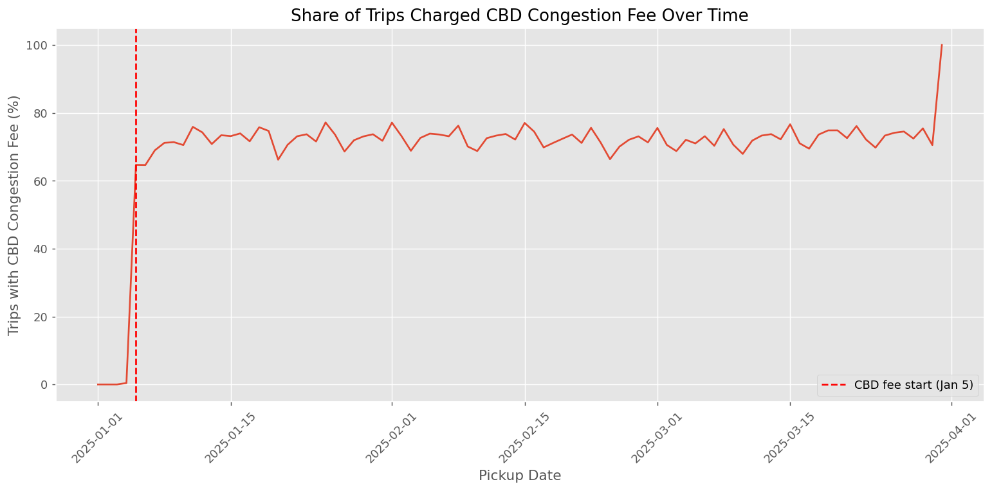

📊 What this tells the business
The CBD fee applies to 65–80% of all trips daily. Weekdays show higher coverage than weekends.
The coverage rate is stable throughout Q1 — no sign of riders gradually avoiding the CBD zone.
The fee launched cleanly on January 5 with no visible demand shock.
- Yellow taxi CBD demand has not been suppressed by the $0.75 surcharge. No operational changes needed.
- The fee is permanent. Financial reporting must reflect it as a pass-through, not operator income.

5.2 Trip Distance Distribution Before and After the Fee
Overlapping histogram comparing trip distances pre-fee (Jan 1–4) and a matched post-fee sample (Jan 5–Mar 31).

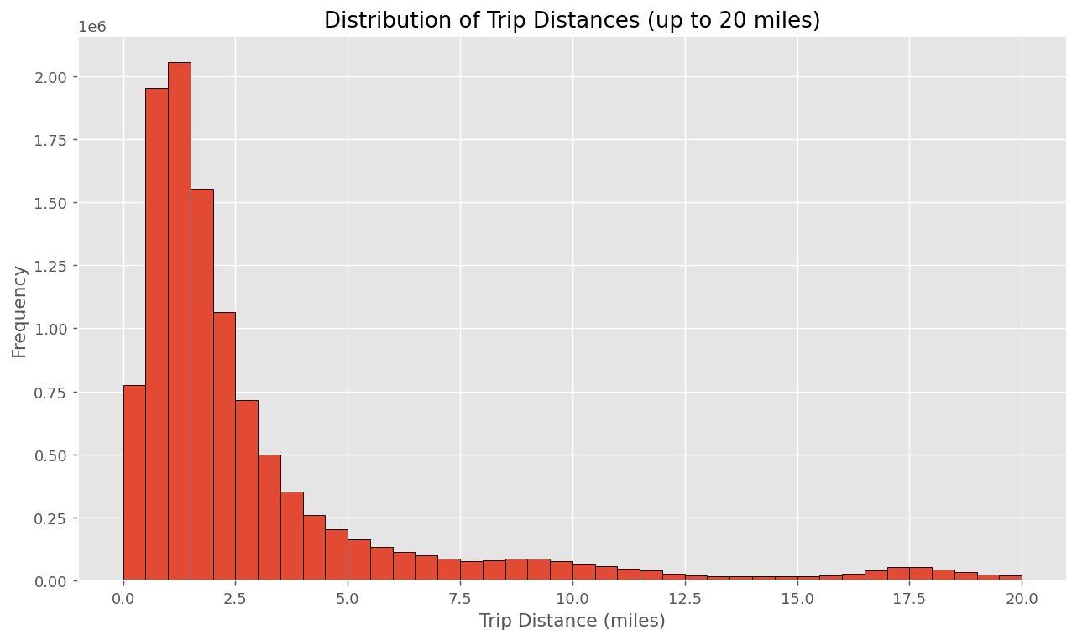

📊 What this tells the business
The post-fee distribution has a heavier right tail — more trips in the 5–20 mile range after January 5.
Shorter CBD hops may have partially shifted to walking or subway; longer trips continued by taxi.
Caveat: the pre-fee window is only 4 days including New Year’s. This comparison has limited statistical power.
- If shorter trips are declining in favour of longer ones, that is a net positive for per-trip revenue.
- A stronger comparison would use matching weekday types across January and February.

Summary of Recommendations

Theme | Recommendation | Evidence
Geography | Concentrate vehicles in Midtown Center/East during peak hours | Top 10 zones, 513K+ trips
Geography | Prioritise LaGuardia for dedicated airport allocation | #4 highest volume zone, 433K trips
Demand | Run weekday commuter shifts and separate weekend late-night shifts | Heatmap patterns Jan–Mar
Demand | Scale staffing progressively Jan→Mar each year | 24% more trips in March vs January
Revenue | Formalise agreements with LGA, JFK, EWR for peak window coverage | Airport = 3–4x city trip revenue
Revenue | Advertise inside terminals to compete with app-based rides | 85–88% CC usage at airports
Payment | Promote card payment to increase tip visibility | Cash tips entirely unrecorded
Payment | Investigate 241K dispute trips for service quality issues | 2.2% dispute rate
CBD Fee | No operational changes needed — demand unaffected | Stable rolling average post-Jan 5
CBD Fee | Update driver earnings comms to exclude MTA CBD fee | Fee goes to MTA, not operator

Data Limitation Note
20.2% of records missing six key fields (vendor reporting issue). Cash tips unrecorded throughout. Full details in Technical Preprocessing Report.

