Capstone Project IDEAS
Mentor: Bill Tubbs
Christian Farfan Centeno

Option 1 – Toronto Cycling Traffic and Collisions
According to the Census, 1.7% of the people in Toronto rode their bikes to work in 2006. This cyclist share is under reported however, as it does not include those who bike for fitness, to run errands, or for leisure. It also may exclude those who use a bike to reach public transportation for their commute, as the Census only allowed one choice for travel method to work. Thus the number of active cyclists in the city is higher than 1.7% of the population. From 2001-2006 there was over 30% increase in the number of cyclists commuting to work (http://goo.gl/sMLsfs) and in 2011 the proportion was reported higher again, despite mode of commuting being removed from the mandatory part of the Census, and becoming voluntary information.
The city of Toronto has developed a Ten Year Plan to develop the area's cycling network and become a more bicycle friendly city. Meant to outline the future investments in infrastructure between 2016-2025, the city has published maps of the proposed expanded cycling network. These maps were produced mostly by data collection on traffic, estimating potential demand by non-cycling trips and non-walking trips less than 5km (http://www.torontocyclingnetwork.info/studying-toronto/).
Identifying where to improve or add bike lanes via traffic is only one part of the equation however. A chief issue is cycling collisions, and identifying which areas or intersections require intervention sooner rather than later can be be accomplished by analyzing cycling collision data.

Client:

Toronto city council itself. They will be able to reevaluate their cycling network plans, whether by changing the proposed routes themselves, altering the type of routes, or changing the time to construction for various routes. It is quite possible that a simple “downtown raw numbers” versus “outer areas” raw numbers and cyclist anecdotal evidence was used, as suggested by the maps on the Toronto bike plan website. There may be information missed which can be revealed by thinking more statistically about the collisions.

Various bike shares, cycling shops, or simply hobbyist cyclist organizations in the city may be interested as well. Can change their own cycling patterns based on this data (individuals may have their own anecdotal beliefs already, and this can help strengthen such beliefs, or turn them on to overlooked ones). Many of them are probably involved with lobbying or working with those responsible for the ten year bike plan, and as such, this analysis could provide them with tangible statistics based evidence to modify the current plan to better suit their needs.

Data:
Bicycle collision data from Toronto Traffic Safety Unit (1986-2010).
Bicycle and vehicular traffic counts at Toronto Open Data:
http://www1.toronto.ca/wps/portal/contentonly?vgnextoid=1a66e03bb8d1e310VgnVCM10000071d60f89RCRD

Approach:
I propose to use the Toronto Traffic Safety Unit's cycling collision data between 1986-2010 to identify dangerous intersections for cyclists. The data contains the date/time, severity of injury, as well as GPS and street intersection locations of reported cycling collisions, along with other relevant data. Simply organizing via number of accidents is not viable however, as the intersections with the highest number of accidents will be those with the most traffic. I will attempt to normalize by estimated cycling traffic, via the city's Open data catalog, which contains bicycle counts for 51 different common cycling intersections. From here there are a few approaches:
1. Blanket normalize all the collision data by assuming an intersection will have the same traffic as the closest intersection(s) included in the bicycle count data set.
2. Normalize by some distance-weighted average from counted intersections.
3. Normalize based on the city's vehicular traffic data from 2011, which contains over 2000 intersections.
It is likely some combination of all three options will be necessary. A key component of this project will be in justifying and implementing an appropriate normalization procedure in the downtown core area versus the outer city neighborhoods. A quick study on the correlation between car and bike traffic in different areas of the city will probably be required.
After normalization we will have the intersections with the smallest amount of collisions dominate our data due to statistical noise. Thus I will need to put some sort of prior on our data, so that the prior dominates at these noisy intersections (http://goo.gl/obrgxF). An empirical Bayesian method can be used to estimate the prior distribution based on the data.
Once completed, we would have a list of the most “dangerous” intersections based on number of collisions and number of traffic. This can be extended further however, by grouping data based on severity of injury (fatal, major, minor, minimal, none), and producing plots/maps in this manner. A weighting system can also be assigned, where a fatal or major accident is worth more than a minimal one, and a map of the most dangerous intersections would then carry some idea of the relative risk conditional on the accident type.
By having a map/list of dangerous intersections under various criteria, one can compare this to the proposed cycling network expansion map, or the “potential demand” map of short trips. This will allow me to see if not considering the potential risk in various intersections has caused certain areas to be overlooked in the City's ten year plan, or if certain routes should be given higher priority in terms of implementation date.
Output will obviously be tabular list of dangerous intersections, with columns for total collisions, collisions by accident severity, and various possible weighted “risk” variables.
A personally attractive deliverable would be a stylized “map” of Toronto (or various sub areas), with data points sized by normalized collision rate and possible colored via a gradient that takes into account accident severity. Over laying this over a simple map of the TTC system and existing/proposed bike network could provide some visually intuitive means of conveying information to client. May be difficult to keep from looking cluttered or too “simple”, but feel like it would make excellent practice for my data story skills.

Thoughts and concerns:

Obviously, the normalization procedure for intersections which are far from a counted bicycle intersection will heavily distort the data based on my assumptions. I'll have to be careful with this.

Traffic count data is ongoing but also relatively new. It only has commenced since 2010, and each intersection was counted at wildly varying dates. Thus there is an implicit variability in this traffic data. It is also not clear how bike and vehicular traffic may have changed from 1986 to 2010 and from then to now. Thus we are bound to compare newer traffic numbers with older collision data. The open data sets don't go far back, and thus I may need to depend on second hand news reports or City papers. May need to draw inferences this way. Could possibly contact Traffic department and request if this data (if it exists) be provided.

Time of date, age of cyclist, and 'driver action' (ran red light, was impaired etc.) are contained in the collision data. There are many extensions based on this that can be made, for instance, are their locations where cyclists are more likely to be at fault than others?

Can attempt to contact whatever committee/council is responsible for the ten year bike plan, share findings, ask what sort of analysis or alterations they may be interested in. A future extension may involve comparing collision data on Bloor Street at the end of the summer bike lane trial period to collision data over summers from previous years. A positive effect on cyclist safety could be valuable ammunition in city council debate against those opposed to the bike lanes based on the possibility of increased congestion or an increase in accidents via more cyclists behaving improperly.

Option 2 – Raptors Offense
The Toronto raptors were 5th in the NBA for offensive efficiency this year with 1.07 points per possession. However in the postseason so far, the Raptors are ranked 12th of the possible 16th teams, at a rather poor 9.78 points per possession. While it is often claimed that defenses “tighten up” during the playoffs, only on of the Raptors two opponents has seen a significant improvement in defensive efficiency. Thus I propose examining the shot distribution of the Raptors offense, as compared to the regular season from and the playoffs, as well as other relevant metrics (assists, assist opportunities, rebounding percentage, turnover rate) in order to identify what changes have occurred that may correlate with the team's poor recent play.
Furthermore, by breaking down the regular season data into subsets (such as good wins, close wins, closes losses, blowouts) I would hope to identify what offensive stylistic approaches lend themselves to the Raptors' success. This can help determine which wins or losses may be outliers (due to luck or an opponent playing extremely well), be seeing which do not follow the trend.

Client:
Raptors Front Office will be able to examine the results and make critical decisions as how best to build the team moving forward, assuming the current core and identity is to be maintained. Other organizations' GMs may use this to predict how the team may adjust it's future play, or how best to run an offense if they find themselves equipped with similar personnel (i.e. all star caliber guards who favour low tempo isolation plays or simple pick and roll offense).
More short term, identifying trends which lead to efficient offensive play can allow Coach Dwayne Casey to then make future adjustments in the playoffs, or for future seasons in the immediate line up and play calling.

Data:
http://stats.nba.com/ and http://www.basketball-reference.com/

Approach:
NBA stats featuring individual player tracking and play type tracking can be scraped from the API used by the stats.nba.com website using the python requests library.
Analysis would be broken up into two main parts. First, identify correlations between eFG%, assists, pace etc. and offensive efficiency across close games, larger wins, and larger losses. Once the “typical” Raptors winning strategy is identified (need to define this), the player and play tracking data from stats.nba.com can be used to build:
1. The shot chart for the Raptors in the different categories of results, for both playoffs and regular season. This will display both the location and frequency of shots taken, allowing for easy visualization of the resulting differences. Will want shot charts for both the team, and for different plays. This would not only then show where shots are being taken from, but how. That is, are the raptors usually generating “good” looks from the roll man on a pick and roll type play during a close loss? What about catch and shoot jumpers? Are the locations of these plays changing during the playoffs? Or are the Raptors merely missing more?

Example shot chart from http://savvastjortjoglou.com/:
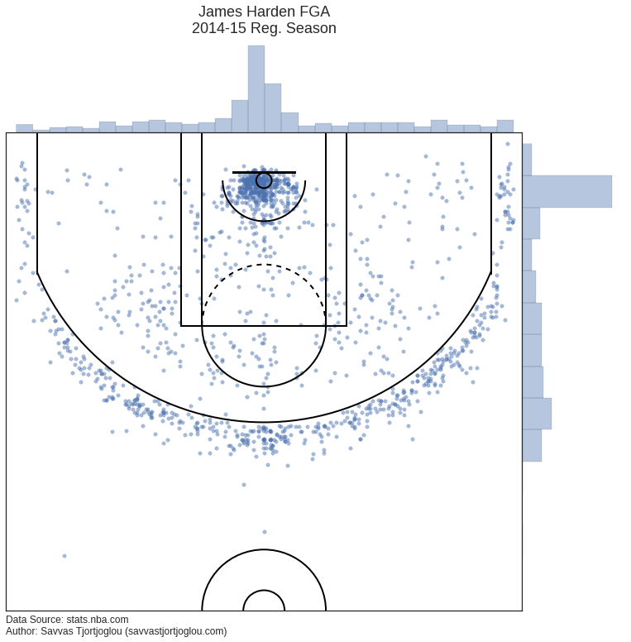

2. Most likely a table, but perhaps another plot for certain measurables, which shows the change in various stats such as assist%, turnover rate, fast break points. Etc. which cannot be easily expressed in the shot chart format.

Thoughts and Concerns:
Would take more time data scrapping and joining data set than in option 1. But analysis could be extended after workshop completion using machine learning. Can attempt to train a model on a subset of data and predict offensive efficiency for a team based on shot location and play type frequency. See how much can be “abstracted” away from thinking about individual player skills and performance.

