AMIRA
An Enterprise Platform for AI-Driven Application Development
Backed by your data lake. Built into your environment. Governed by your policies.
Commercial and Technical Proposal
Prepared for Mars, Incorporated
April 27, 2026
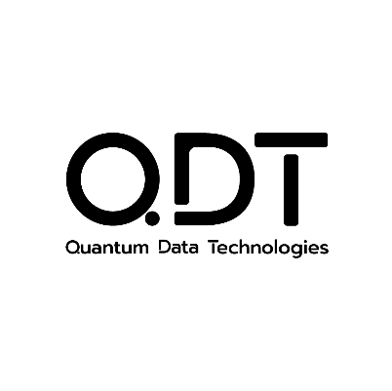

Table of Contents

1. Introduction
1.1 The Challenge
1.2 Amira at a Glance
2. Platform Architecture
2.1 The Three-Step Pipeline
2.2 Three Agents, One Workflow
3. Pipeline Phases
3.1 Specifications Phase
3.2 Development Phase (Canvas)
3.3 Artifacts Phase
3.4 Reversibility and Versioning
4. Differentiators
4.1 Proprietary APIs
4.2 How Skills Connect to Specifications
4.3 Apps Become Agents
5. Governance and Security
5.1 Human Governance and Audit
5.2 Knowledge Base and Secret Vault
6. Platform Features Summary
7. Validation and Replication
7.1 Proof Point: FinIQ
7.2 Replication Roadmap
8. Technical Implementation
8.1 Architecture Overview
8.2 Deployment Options
8.3 Authentication and API Key Strategy
9. Amira Deployment Scope
10. Commercial Model
10.1 Platform License
10.2 Skill Development
10.3 Application APIs
10.4 Compounding Model
11. Closing
Appendix A — Workflow Walkthrough
Step 1 — Home portal
Step 2 — Three ways to start a project
Step 3 — Decision Point
Step 4 — Living specification, gaps tracker, version history
Step 5 — Route for e-signature
Step 6 — Authorized approver view
Step 7 — Open Canvas
Step 8 — Build Agent chat
Step 9 — Combine skills, knowledge, and companion agents
Step 10 — Compliance matrix
Step 11 — Deploy modal
Step 12 — Skills marketplace
Step 13 — Ask Amira
Step 14 — Lineage
Step 15 — Wrap

1. Introduction

1.1 The Challenge
Today’s development cycles are too slow.
- New data-driven applications take multiple months through a vendor development cycle.
- Each project re-integrates the same data sources from scratch.
- Specifications are inconsistent across teams; rework is the norm.
- Governance, security, and deployment are applied piecemeal at the end.
- The result is a bottleneck on the velocity of Finance, Marketing, and Supply Chain analytics.
The opportunity: Mars associates should be able to specify, iterate, and enhance AI-powered analytics products themselves — with vendor support concentrated where it adds the most value.

1.2 Amira at a Glance
Amira is an internal AI-powered application platform.
- Mars associates describe what they want; the platform builds it.
- Lives in your environment, not in third-party SaaS.
- Pre-integrated with your data lake and proprietary APIs.
- Governed by your policies — row-level security, approval gates, audit.
- One workspace, three guided steps: Specify → Develop → Deploy.
A practical analogy: an enterprise-grade workbench for AI-driven app building, with your proprietary data and analytical methods as native primitives.

2. Platform Architecture

2.1 The Three-Step Pipeline
Step | What Happens | Output
1. Specifications | User iterates with an AI agent to refine requirements. | Structured specification document (IEEE 830-style).
2. Development (Canvas) | An AI builder converts the spec into a working application; user iterates in a live-preview workspace. | Running application plus automated compliance matrix.
3. Artifacts 🡪 Apps | Approved builds are tracked, versioned, and deployed. | Deployed app plus lineage record.

The pipeline is sequential but reversible: at any stage, the user can return to Specifications. This creates a new spec version (never an overwrite), which retriggers an incremental build.

2.2 Three Agents, One Workflow
The pipeline is delivered by three specialized agents, accessed from a single workspace.
Agent | Role | Inputs | Outputs
Spec Agent | Conversational elicitation of requirements. | User intent, knowledge-base files, referenced skills. | Structured specification.
Build Agent (Canvas) | Converts the spec to a working application. | Approved spec. | Running app plus compliance matrix.
Deployment Agent | Ships the built artifact to the target environment. | Approved build. | Deployed app, audit-logged.

Each agent has a clean handoff contract with the next. The specification is the durable artifact that survives across builds and deployments — the source of truth for what the app is meant to do.

3. Pipeline Phases

3.1 Specifications Phase
Turns a vague idea into a builder-ready specification.
- The user starts with natural-language intent (“I want a dashboard that…”).
- The agent asks targeted clarifying questions within a turn budget — Express (≤3), Full (≤8), or Generate-then-review (0).
- At architectural decision points, the agent proposes 2–3 alternatives with trade-offs and a recommendation, instead of silently picking one.
- The user can attach knowledge-base files (Excel, PDF, markdown, JSON) to ground the discussion.
- The user can reference skills from the platform’s skills directory (e.g., QDL data, charting, financial indicators) — these become first-class spec inputs.
- Output: a structured specification document, available as Word, markdown, JSON, or PDF.
- Stored versioned — every iteration creates a new traceable version.

3.2 Development Phase (Canvas)
A live-preview workspace for AI-built applications.
- Three-panel layout: AI chat, code editor, live preview iframe.
- The AI builder reads the spec, generates the app, and shows the result in real time.
- The user iterates by chatting: “make the chart larger,” “swap the data source.”
- Two viewing modes: Technical mode — code, logs, debug view (developers, platform engineers); Business mode — rendered application, compliance matrix, and summary (SMEs, approvers).
- Every build automatically produces a compliance matrix showing how each requirement (FR / NFR / AC) is satisfied by the running application.

3.3 Artifacts Phase
Every approved application is a tracked, versioned artifact.
- Centralized gallery of all built applications, across users and teams.
- Lineage view: which spec version produced which build, deployed where, by whom, and when.
- Export options: download, share, or deploy to environment.
- Built-in audit trail for compliance and governance reviews.
- Artifacts can be forked: take an existing application as a template, modify the spec, and regenerate.

3.4 Reversibility and Versioning
The pipeline is bidirectional. Every change is traceable.
- From Canvas or Deployment, the user can return to Specifications at any time.
- This creates a new spec version — previous versions are retained, never overwritten.
- Triggers a rebuild or incremental iteration of the application.
- Inter-version diffs are queryable: what changed between v1.3 and v1.4, why, and who approved.
- Lineage feeds back into the platform’s learning — patterns of edits inform future suggestions.
Why this matters: every Mars audit, every regulatory review, and every “why does the app do this?” question has a clear, navigable answer.

4. Differentiators

4.1 Proprietary APIs
This is what other platforms cannot offer.
- The platform exposes capabilities to AI agents through skills — reusable primitives that wrap a data source, an API, an analytical method, or a service.
- Proprietary APIs are pre-integrated as first-class skills, accessible to Mars associates through the platform — not afterthoughts, not re-built per project:

API | Capability (that can be enabled through the platform)
QDL Data | Federated access to 100,000+ data-dictionary symbols across providers — search, time-series fetch, market data, news.
QML | ML model APIs — train and deploy machine-learning models on enterprise data.
Q Marketing | Marketing analytics and campaign intelligence APIs.
General-purpose | Web search, charting (Recharts and Lightweight Charts), market hours, financial indicators, and presentation generation.

- New skills are added as wrappers around any internal tool, library, or API.
- Skills are role-restricted: a Finance user and a Marketing user may see different available skills.
- Every app shipped on the platform becomes a reusable skill for future apps — the skills library compounds with each application built (see Replication Roadmap).

4.2 How Skills Connect to Specifications
Reference, don’t bind.
- During spec elicitation, the user references a skill by name (e.g., “use QDL for macro data”).
- The reference is recorded in the specification, but the specific implementation is not bound until build time.
- The Build Agent resolves bindings via a hidden Build Plan at build time.
- Role-based access is enforced at resolution: a Finance user’s build picks the Finance-permissioned implementation; a Marketing user’s build picks theirs.
- Result: the same specification can be safely portable across user roles, regions, and time as skills evolve.
This pattern is what allows Mars to enforce data segregation, regulatory restrictions, and BU-level access without rewriting specs.

4.3 Apps Become Agents
Every application is also a callable agent. Apps are services, not just destinations.
- When a user finishes building an app on the platform, the platform auto-generates a companion agent (CLI plus Agent Skill) for that app.
- The agent inherits the app’s data access, permissions, and audit boundary — nothing is loosened.
Two interaction surfaces, same underlying agent:
Surface | When to Use
The app’s own interface | Deep, structured workflows — dashboards, voice mode, multi-step analysis, job boards.
The platform’s general chat | Quick questions, ad-hoc lookups, cross-app queries — pick an agent (FinIQ, Marketing, Supply Chain) and ask, without leaving your workflow.

- Voice-compatible — any app’s agent can be queried hands-free.
- Full audit trail — every agent interaction is logged identically to in-app activity.
Worked example
Instead of opening FinIQ to ask “what was Q3 net sales for Petcare?”, a user messages the FinIQ Agent from any chat surface and gets the answer — same data, same permissions, same audit. The next analytics app can also integrate FinIQ’s outputs natively, without bespoke API work.
The compounding effect
- Every shipped app becomes a reusable primitive for the next.
- The skills library grows with every build.
- Replication roadmap compounds: the 5th app inherits the skills, agents, and patterns of the 4 before it.

5. Governance and Security

5.1 Human Governance and Audit
Two approval gates. One audit log. Zero silent decisions.
- Gate 1 — Specification approval (before development begins).
  - Designated approver reviews the spec.
  - Compliance matrix from any prior version is presented for context.
  - Approval is recorded with identity, timestamp, and optional notes.
- Gate 2 — Deployment approval (between build and production).
  - Designated approver reviews the running application and compliance matrix.
  - Approval gates the deployment step.
- Compliance matrix at every build — automated FR/NFR/AC scoring against the spec.
- Full audit log — every spec edit, build, deployment, and approval is timestamped and attributed.
- Specifications, builds, deployments, and approvals are versioned together as a single auditable lineage.

5.2 Knowledge Base and Secret Vault
User-controlled grounding. Secrets stay out of specs.
- Knowledge base:
  - Users upload documents (PDF, Excel, CSV, markdown, JSON) per session.
  - Two scope levels: private to user (default) or shared with selected teammates or org.
  - Uploaded content is not automatically promoted to a global corpus — promotion requires explicit curation, preventing pollution.
  - Embedded into the relevant build via the standard MCP tool pattern.
- Secret vault:
  - Sensitive values (API keys, tokens, connection strings) managed in a dedicated vault.
  - Referenced from specs by name only — actual values never appear in the spec text.
  - Rotated, revoked, and audited centrally.

6. Platform Features Summary
The following table consolidates the platform’s capabilities across six functional areas.
Area | Feature | Description
Core Workflow | Specifications Agent | Conversational AI that converts user intent into structured, versioned specifications.
 | Development Canvas | Live three-panel workspace (chat, code, preview) for building and iterating applications.
 | Artifacts/Apps and Lineage | Versioned applications with full traceability from spec → build → deployment.
AI and Agents | Multi-Agent System | Spec, Build, and Deployment agents working in a unified workflow.
 | App-to-Agent Conversion | Every built app becomes a reusable, callable AI agent.
 | Voice Interaction | Voice-enabled agents for hands-free querying and workflows.
Data and Skills Layer | Proprietary APIs Integration | Native access to QDL, QML, Marketing analytics, and internal tools.
 | Skill Auto-Discovery | Dynamic detection and integration of new skills via MCP.
 | Role-Based Skill Access | Skills restricted by user role, ensuring compliance and segmentation.
Governance and Compliance | Compliance Matrix | Automatic mapping of requirements (FR/NFR/AC) to implementation.
 | Approval Workflows | Dual-gate approvals for specification and deployment.
 | Audit and Lineage Tracking | Full history of edits, builds, deployments, and approvals.
Data and Infrastructure | Data Lake Integration | Direct connection to the Mars data ecosystem (Databricks, QDL, etc.).
 | PostgreSQL plus pgvector | Unified storage for application state, vector search, and audit logs.
 | Multi-LLM Support | Flexible integration with OpenAI, Azure OpenAI, Gemini, and others.
User Environment | Secure Workspaces | Per-user environments with SSO integration.
 | Knowledge Base Uploads | Session-based document grounding (PDF, Excel, JSON, etc.).
 | Secret Vault | Secure handling of API keys and credentials.

7. Validation and Replication

7.1 Proof Point: FinIQ
The first application built on the platform — already in front of Mars finance leadership.
- What it is: a unified financial-analytics application for Mars Finance.
  - Period-end summaries (PES) generated from Databricks.
  - Competitive intelligence with cross-referenced internal and external data.
  - Macro-economic enrichment via QDL (CPI, consumer confidence, commodity futures, FX).
  - Conversational query interface — both typed and voice.
  - Job board for asynchronous analyst tasks.
- What it integrates:
  - Databricks (production financial data, billions of rows).
  - QDL (macroeconomic, market, news).
  - FMP (competitor financials).
- Build velocity: approximately two weeks of focused development.
- Status: deployed; demoed to Mars MLT; in active iteration with Finance SMEs.

7.2 Replication Roadmap
Same playbook, multiple verticals — and each one accelerates the next.
Within Mars — the platform is designed for portfolio replication:
Domain | Candidate First Application
Finance | FinIQ (built)
Marketing | Campaign performance plus competitive intelligence
Supply Chain | Inventory plus commodity exposure dashboards
Pet Care (R&D) | Diagnostic and clinical-data tools
HR / Talent | Workforce analytics

Beyond Mars — when Mars chooses to license or syndicate:
- Same architecture, different domain skills.
- Replication targets in the CPG and consumer goods sectors.
Replication isn’t repetition — it’s leverage. The fifth application inherits the skills, agents, and patterns of every app shipped before. Each new vertical is faster than the last because the platform compounds with every build, not just repeats. Cross-cutting concerns (governance, deployment, identity, skills, agents) stay solved.

8. Technical Implementation

8.1 Architecture Overview
Three-service architecture:
Service | Role
Frontend | Modern React-based web UI; SSR; live-preview Canvas.
Backend | Python-based application API; agent execution; skill orchestration.
Audio service | Voice-mode agent for hands-free interaction (optional surface).

Data and persistence:
- PostgreSQL with pgvector — vector search for RAG, all session and audit state.
- Object storage for artifacts and uploads.
- Skill packs: pluggable, versioned, and auto-discovered.
Integration points:
- Mars data lake (Databricks).
- Proprietary APIs (QDL, QML, Q Marketing) — accessed via the platform’s pre-wired skill layer.
- Existing Mars identity provider (Auth.js v5 → enterprise SSO).
- External data services (FMP, news, etc.) via skill-layer adapters.
- LLM provider — abstracted through an adapter layer; supports OpenAI, Azure OpenAI, Gemini, and other enterprise providers.

8.2 Deployment Options
Two paths, depending on Mars infrastructure readiness:
Aspect | Option A — Kubernetes (preferred) | Option B — Web-app pipeline (fallback)
Pattern | Docker images → Azure Container Registry → pipeline → YAML manifests → K8s cluster. | Existing Mars web-app deployment workflow.
Iteration speed | Continuous artifact addition; dynamic provisioning. | Slower; manual handoffs between teams.
Operational overhead | Managed by platform team. | Shared with Mars IT.
Recommended for | Production scale, multiple applications. | Initial deployment if a K8s slot is not yet available.

Both paths use the same application code. Switching from Option B to Option A is a deployment-layer change, not a rewrite.

8.3 Authentication and API Key Strategy
Mars sets the policy. The platform supports either approach.
User authentication:
- Per-user identity, integrated with Mars’s existing SSO and identity provider.
- Sessions and audit logs tied to verified user IDs.
- Standard role-based access at the data and skills layer.
LLM API key management — two options:
Aspect | Centralized Pool | Per-User Keys
Pattern | Mars maintains an enterprise key (or AI-foundry account); cost attributed by user ID or cost center. | Each user provisions their own key; billed individually.
Benefits | Predictable cost, easier governance. | Hard cost ceiling per user, individual accountability.
Best for | Most enterprise contexts. | Specialized use cases or teams with dedicated AI budgets.

The platform supports both. Mars chooses based on internal IT and finance policy.

9. Amira Deployment Scope
Six tracks, sequenced for delivery within four weeks of platform deployment.
# | Track | Deliverable
0 | Platform deployment to Mars infrastructure (prerequisite). | Amira running in Mars Azure, integrated with identity, with network whitelisting complete.
1 | Row-level security validation. | Verified behavior for users with restricted access by geography, BU, or hierarchy.
2 | Specification phase production-readiness. | Spec Agent operational end-to-end on the platform.
3 | Functional correctness validation with Finance SME. | FinIQ outputs verified against Finance ground truth.
4 | Stack-ranked enhancement delivery. | Top three from: UI/UX, charting, anomaly detection, forecasting integration, presentation generation.
5 | Knowledge grounding via Collibra and Master Data. | Mars-specific terminology (financial periods, hierarchies) understood natively.
6 | New Finance use case (SME-led). | Net-new application built on the platform by a Mars Finance team.

The first three tracks are gated by platform deployment and run in sequence. Tracks 4–6 run in parallel once the platform is live.

10. Commercial Model
Three ways to engage with Amira.

10.1 Platform License
Own the foundation.
- $1,000,000 — perpetual license.
- Optional annual maintenance subscription: $300,000/year.
- Ongoing updates, security, and new features.
Includes:
- Full Amira platform (Spec → Build → Deploy).
- Agent framework plus Canvas workspace.
- Governance, audit, and infrastructure layer.
Value: Establishes a long-term internal AI application capability.

10.2 Skill Development
Build Mars-specific intelligence.
Custom skills developed and integrated into Amira:
- Small — $25K: lightweight integrations, APIs, simple transformations.
- Medium — $50K: multi-step workflows, domain analytics modules.
- Large — $100K: advanced systems, ML models, optimization engines.
Value: Encodes proprietary knowledge into reusable building blocks across all applications.

10.3 Application APIs
Access proven capabilities instantly.
- Custom pricing, based on scope and usage.
Includes:
- API access to applications built on Amira (e.g., FinIQ).
Integration into:
- Other Amira apps.
- External enterprise systems.
- Agent workflows.
Value: Accelerates time-to-impact by reusing existing, production-tested intelligence.

10.4 Compounding Model
Platform → Skills → Applications.
Each layer reinforces the next:
- Skills enhance every build.
- Applications become reusable services.
- The platform grows more valuable with each investment.

11. Closing
Amira: build with your data, your skills, your governance.
- Specifications that capture intent, not assumptions.
- Builds that are auditable end-to-end.
- Deployments that respect Mars policy.
- Skills that compound across every new application.

Appendix A — Workflow Walkthrough
The following walkthrough shows the platform end-to-end as a sequence of 15 steps, each captured directly from the running application. The flow goes from project genesis through specification, approval, Canvas build, governance, deployment, skills marketplace, in-context chat, and lineage — closing the loop on the three-step pipeline described above.

Step 1 — Home portal
The user lands on the Amira home portal: in-flight projects, approvals inbox, and a shelf of pre-integrated skills are all visible from a single surface.
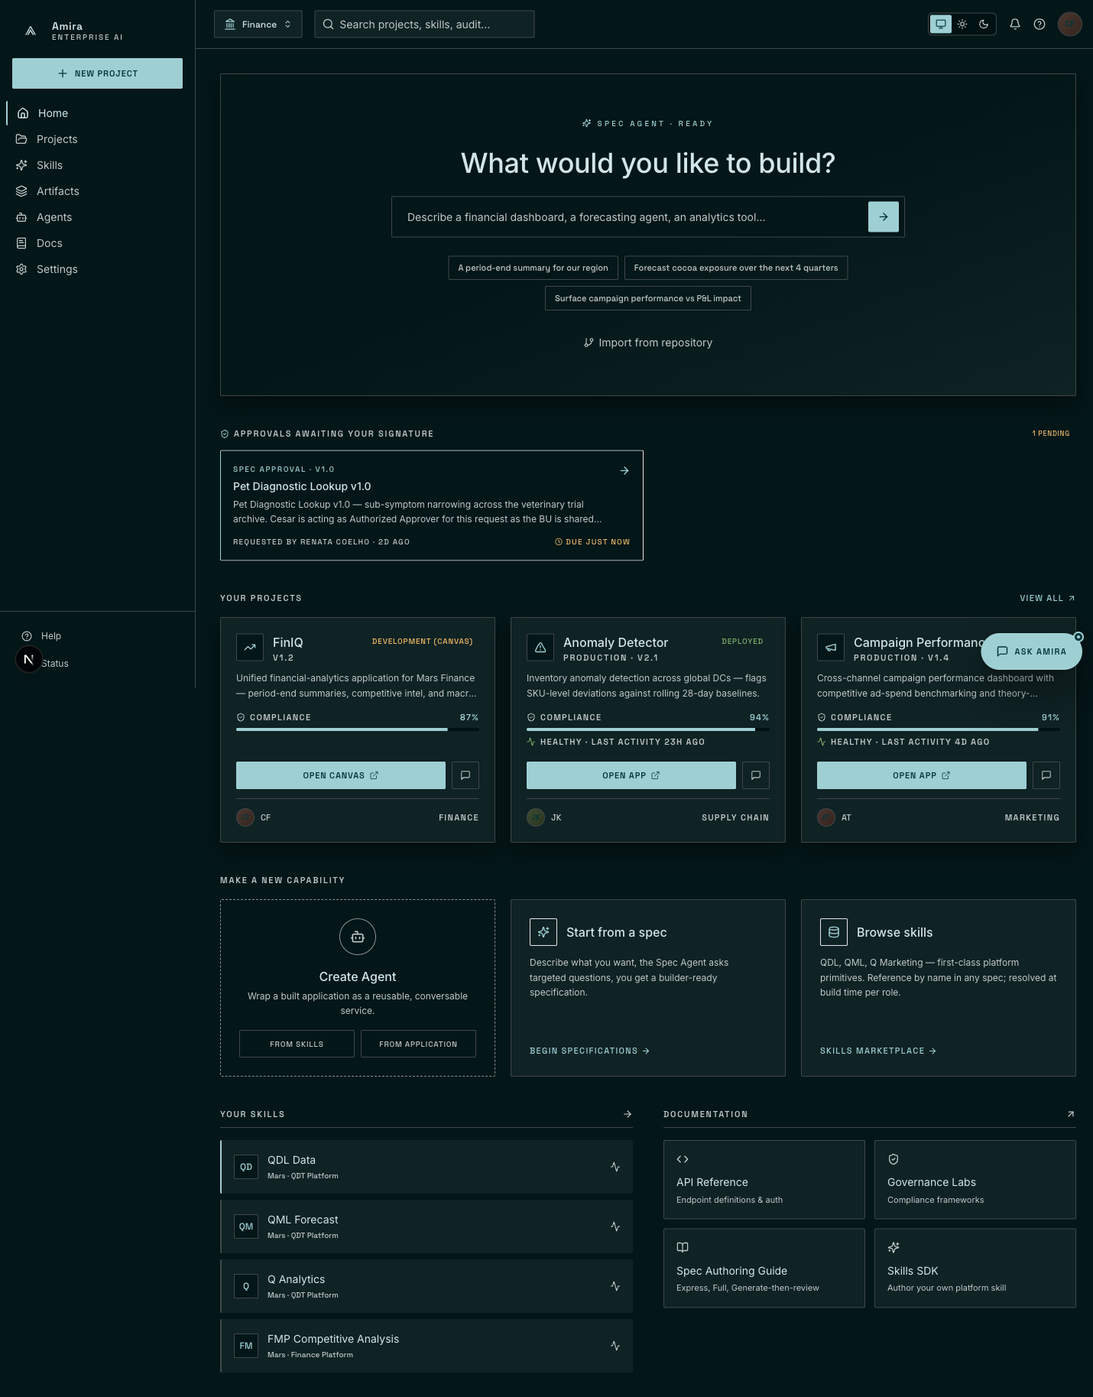
The Amira home portal — projects, approvals, and skills in one view.

Step 2 — Three ways to start a project
Amira supports three project-genesis surfaces: a natural-language entry point that hands directly to the Spec Agent; a structured creation page with a fork option for existing applications; and a guided import flow that reverse-engineers a specification from an existing repository.
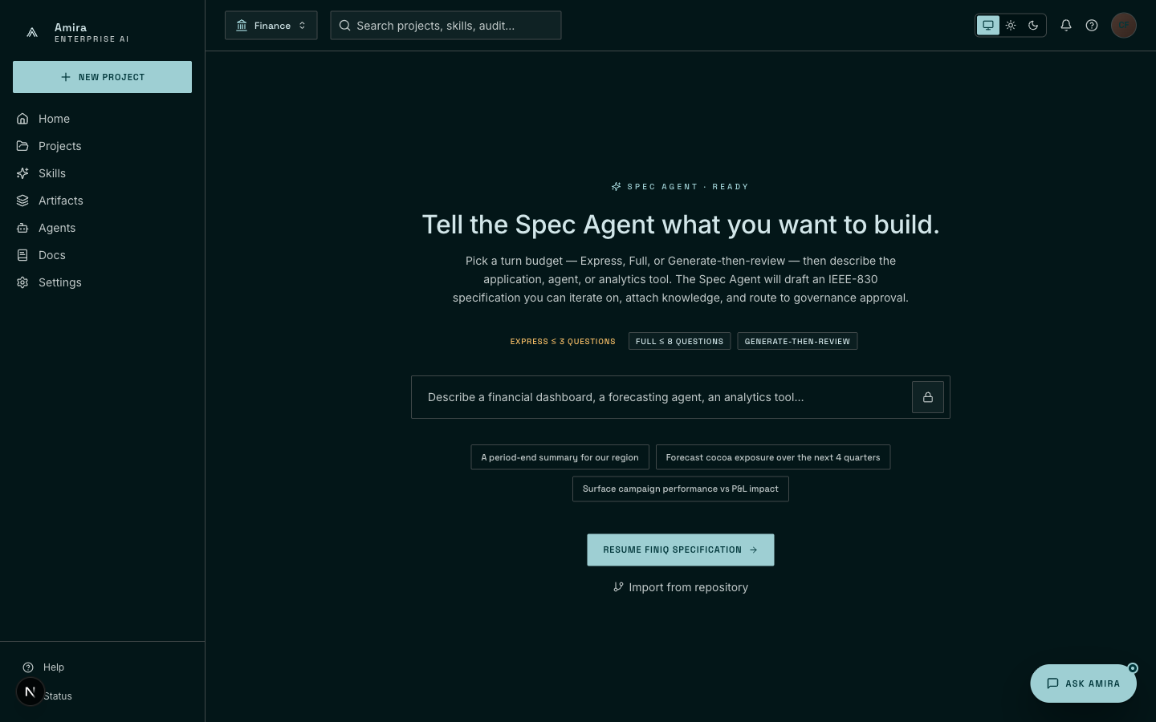
(2a) Natural-language entry — describe the application; the Spec Agent takes it from there.
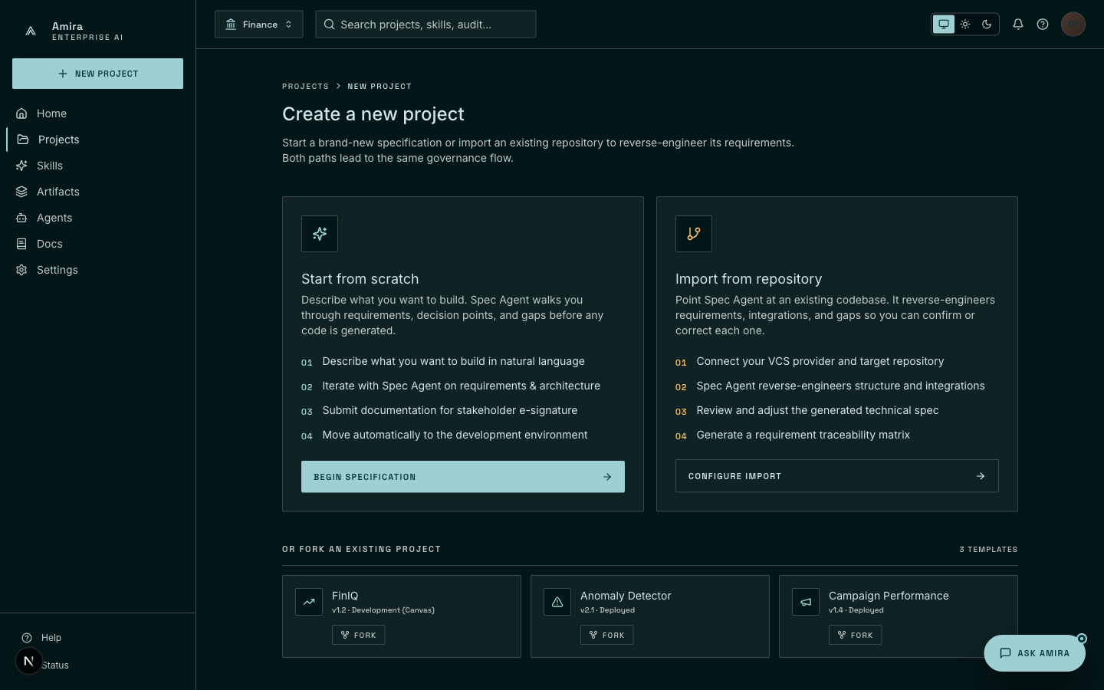
(2b) Structured project creation — from scratch, repo import, or fork.
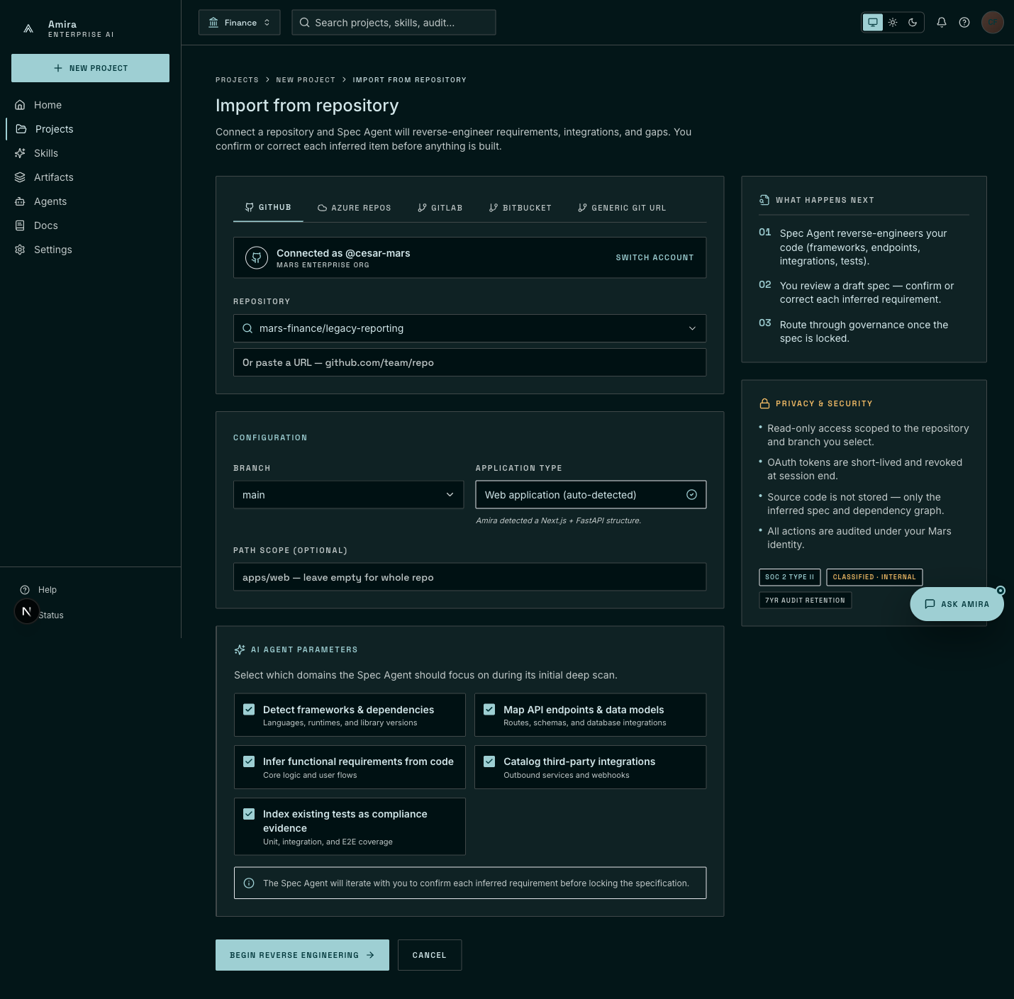
(2c) Repository import — auto-detected stack, agent extraction toggles, security badges.

Step 3 — Decision Point
The user resumes an in-flight FinIQ specification. At an architectural decision point — the source of competitive-intelligence data — the Spec Agent surfaces three alternatives with trade-offs, recommends one, and records the user’s choice against a specific functional requirement.
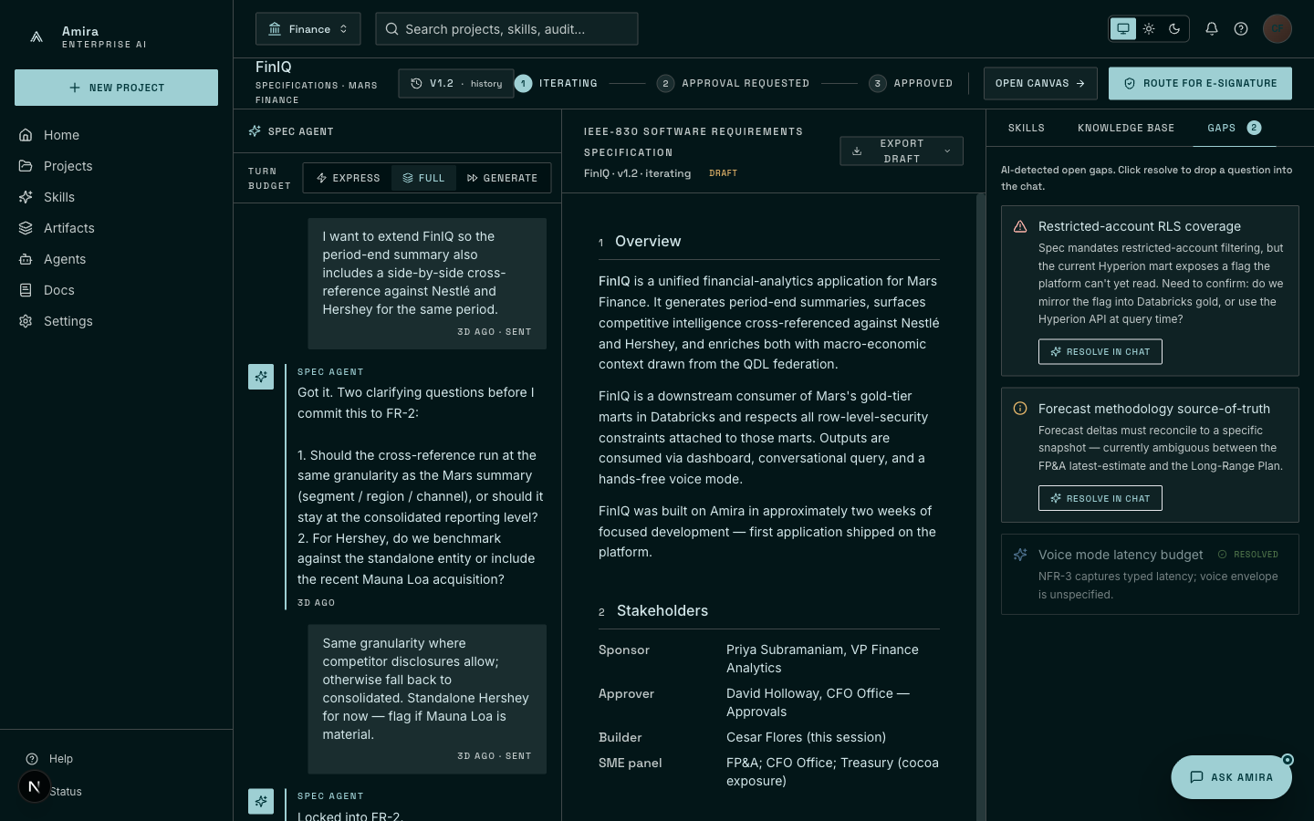
Decision Point card — alternatives surfaced rather than silently picked.

Step 4 — Living specification, gaps tracker, version history
The same workspace shows the IEEE-830 specification under iteration on the left, an open gaps-tracker on the right (warnings the agent has flagged for resolution), and a version-history dropdown listing every prior spec version with its approval state.
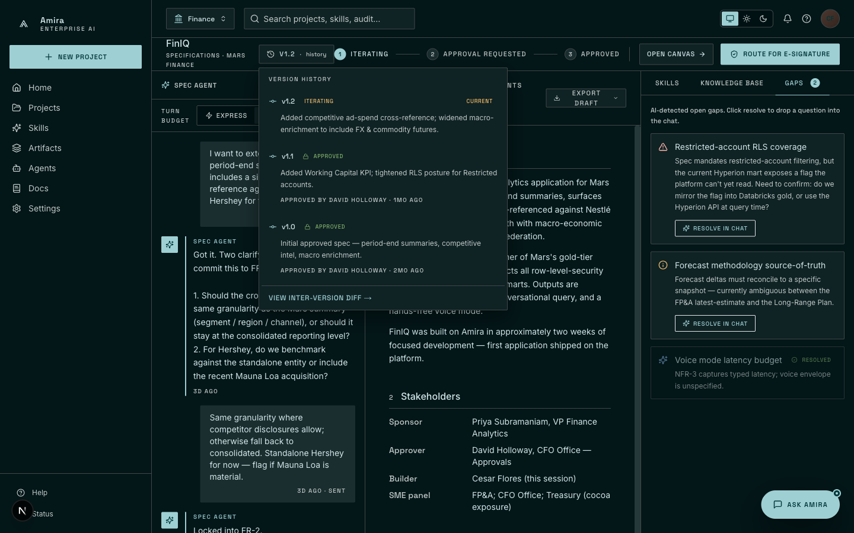
Living spec on the left, gaps on the right, version history at the top.

Step 5 — Route for e-signature
The user routes the iterating spec to the designated authorized approver. The approver is locked by governance role (CFO Office — Approvals), with pre-filled notes that summarize the spec version and current compliance score.
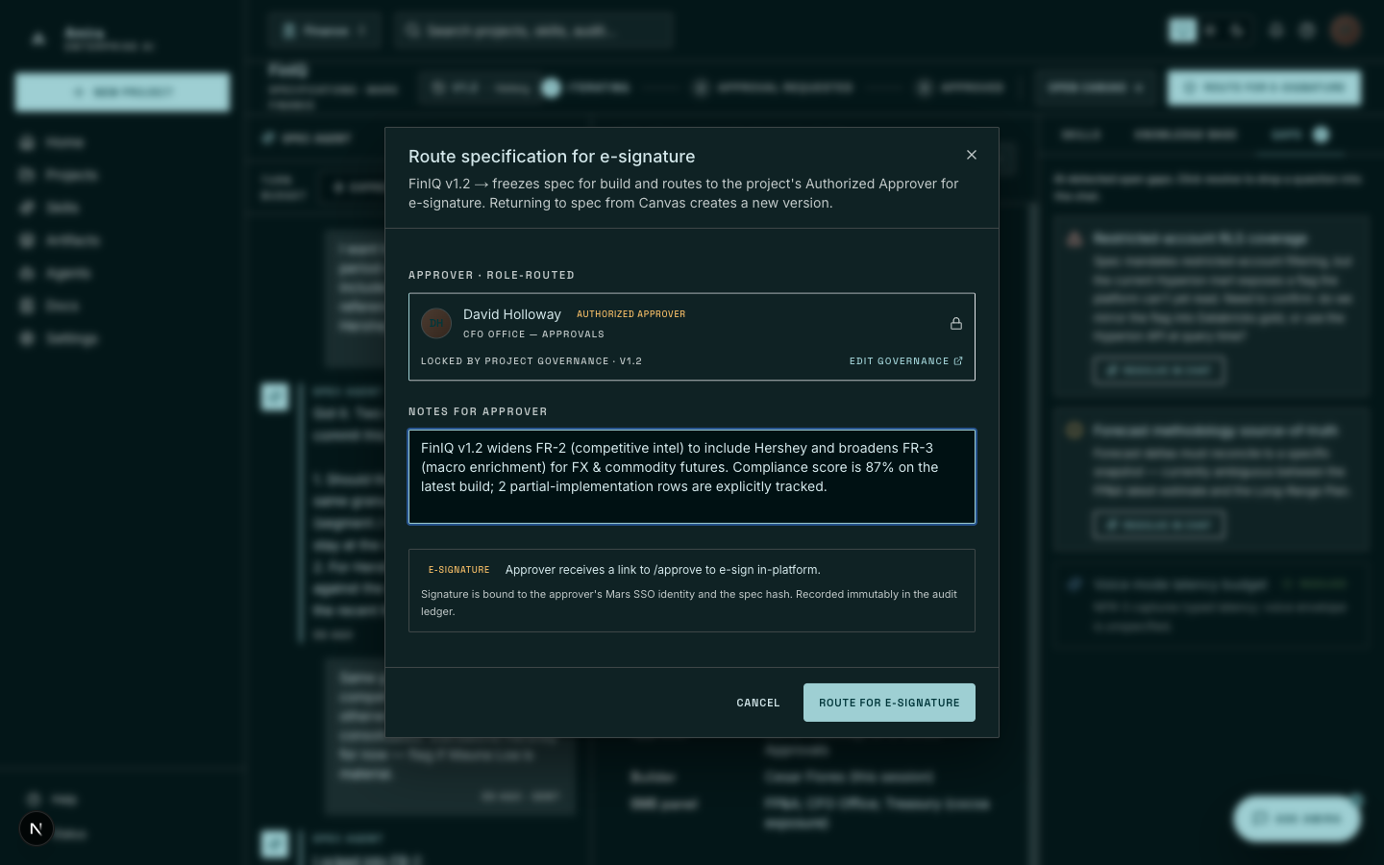
E-signature routing modal — approver locked by governance role.

Step 6 — Authorized approver view
On the approver’s side, the spec is rendered alongside a digital-signature block. The approver reviews validation results, types their name to record intent, and the signature is captured with a permanent audit ID bound to that specific spec version.
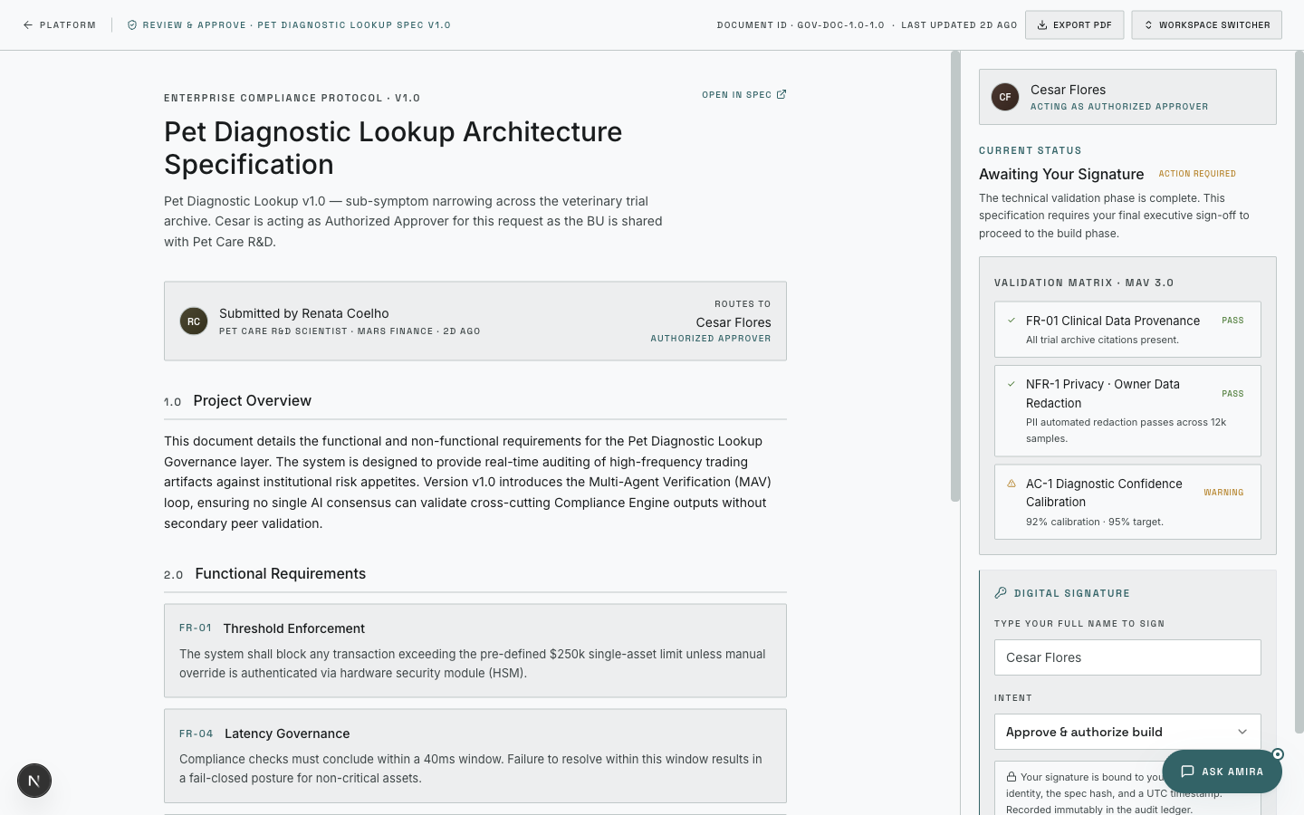
(6a) Pre-sign — spec on the left, signature block and validation matrix on the right.
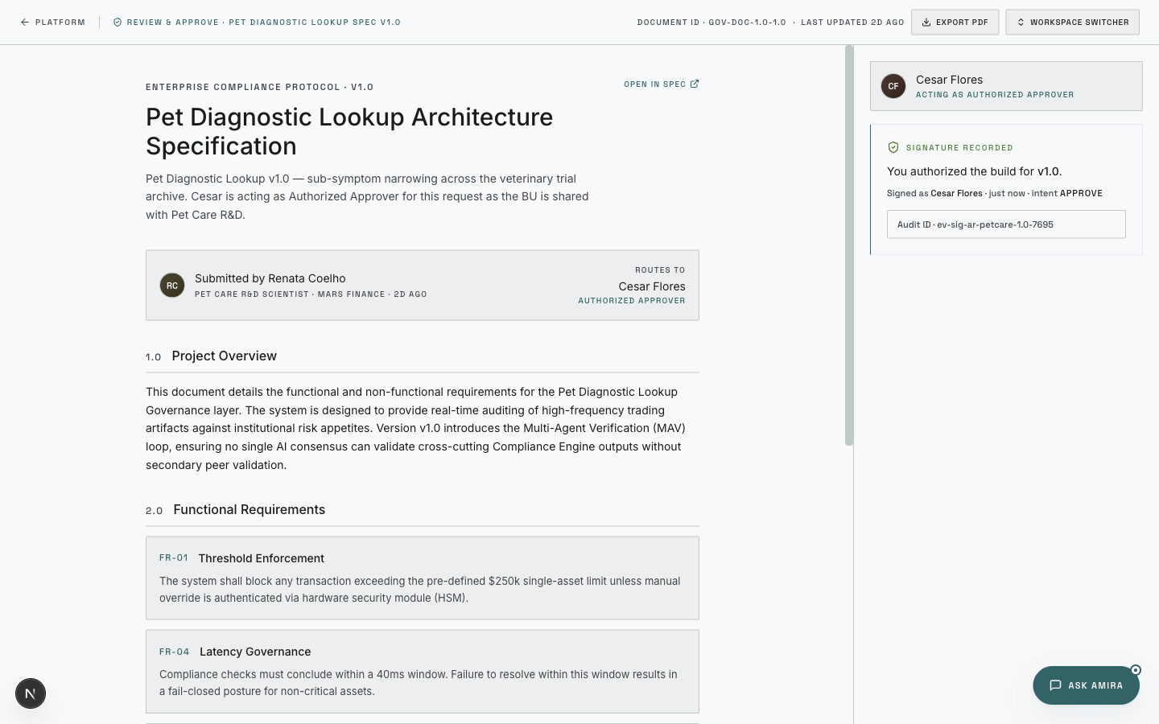
(6b) Post-sign — signature recorded with audit ID.

Step 7 — Open Canvas
After approval, the user enters Canvas: a three-panel live workspace with the Build Agent chat on the left, the file tree, and a live preview of the running application on the right. The seeded build shows FinIQ rendering against real Mars financial data.
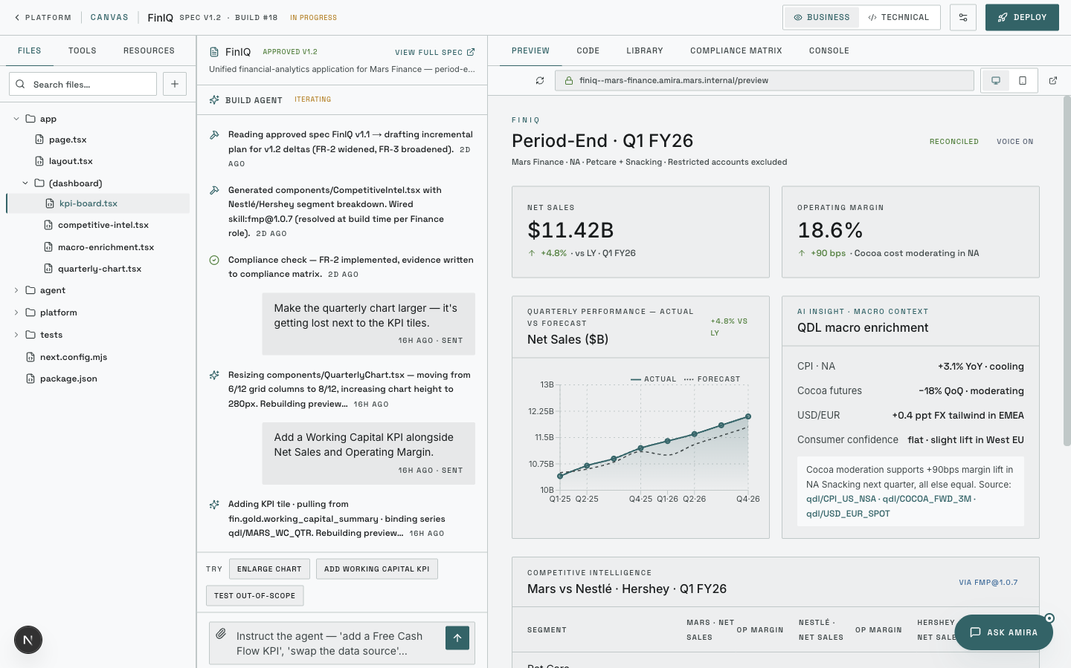
Canvas — chat, code, and live preview side by side.

Step 8 — Build Agent chat
The user iterates conversationally. Two example edits are demonstrated: enlarging the quarterly chart, and adding a new Working Capital KPI tile bound to live data — each performed by typing in natural language; the Build Agent rebuilds the preview in place.
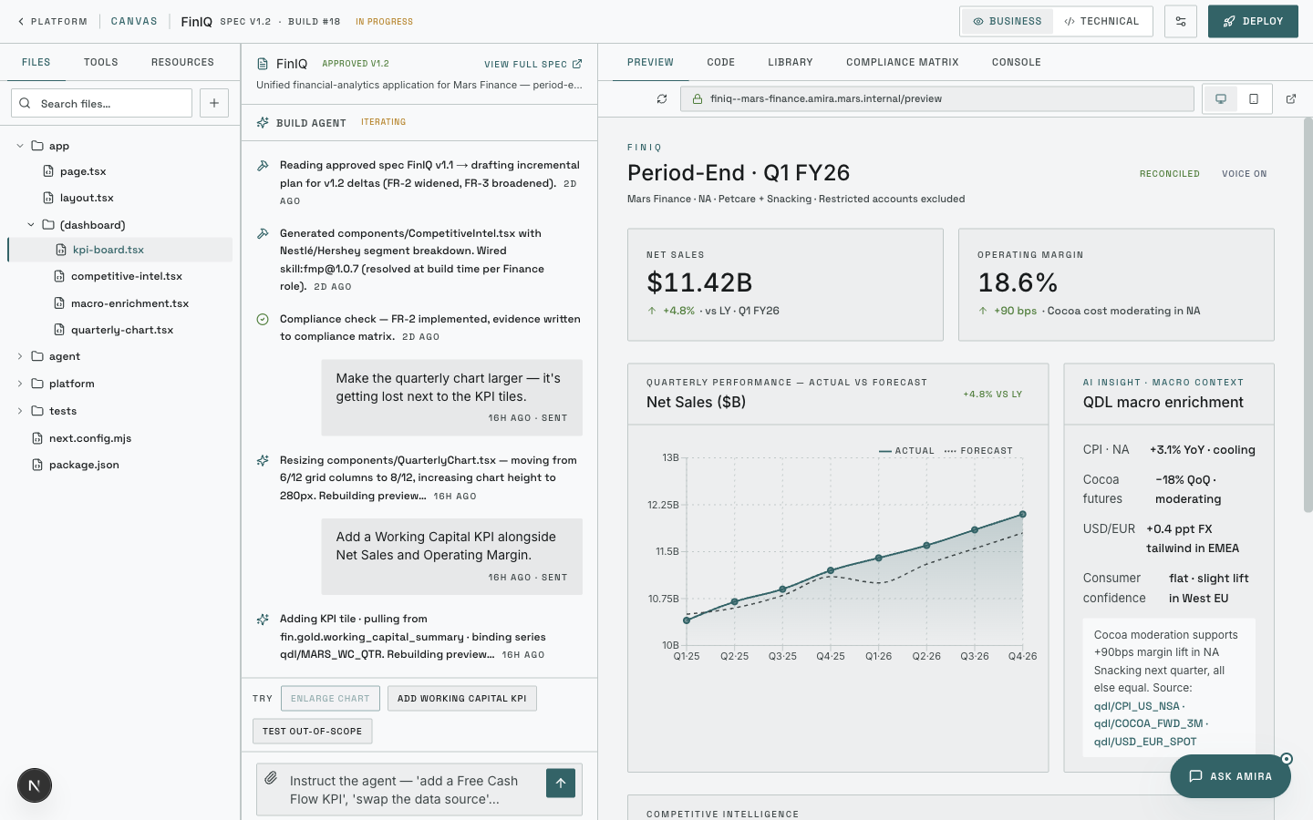
(8a) Enlarge chart — the Build Agent resizes the component and rebuilds the preview.
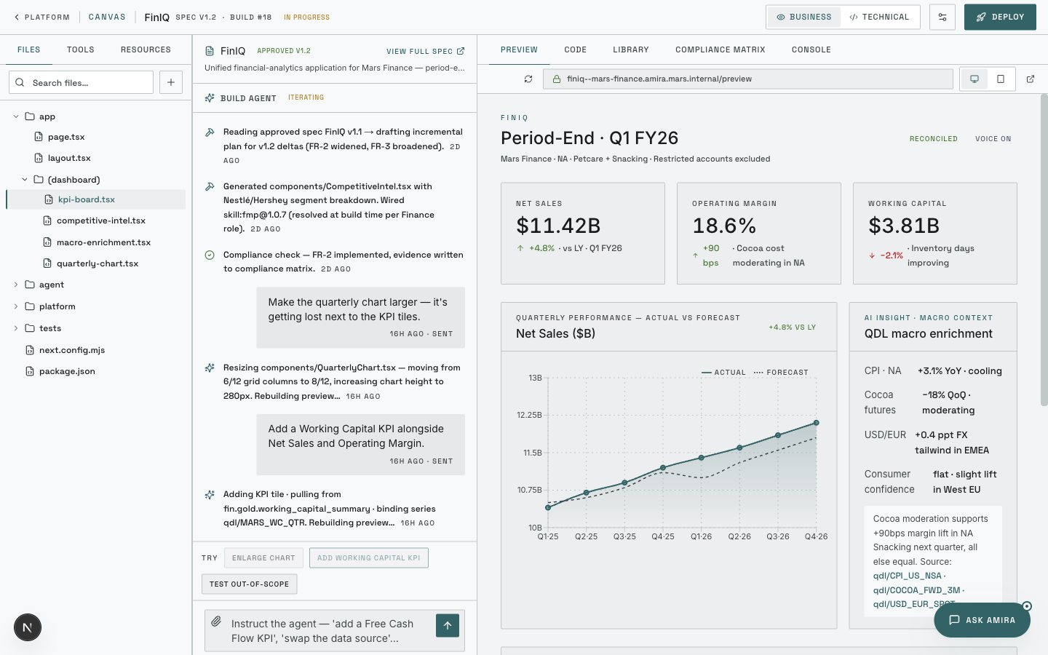
(8b) Add Working Capital KPI — a new tile bound to live data.

Step 9 — Combine skills, knowledge, and companion agents
Through the Resources tab and the Add drawer, the user attaches additional skills (QDL, QML, charting, voice), uploads knowledge files scoped to the application only, and adds companion agents from other applications — all reusable primitives that the Build Agent then composes into the running app.
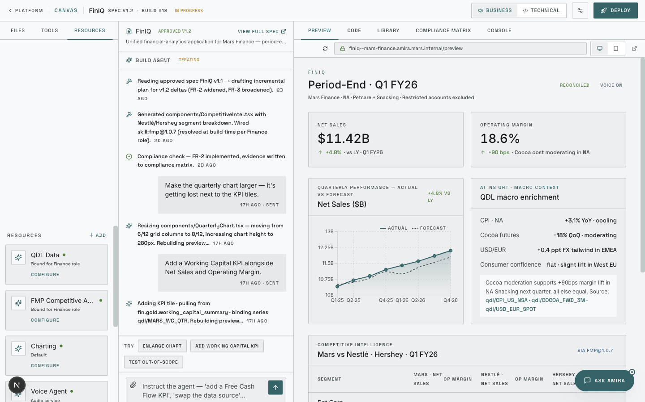
(9a) Resources tab — primitives currently bound to the app, role-scoped.
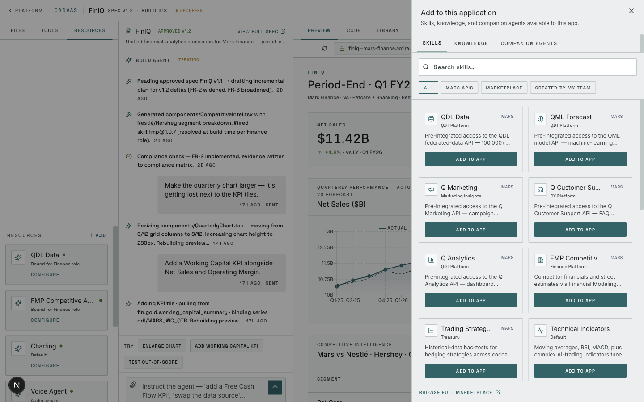
(9b) Skills tab — pre-integrated and marketplace skills available to add.
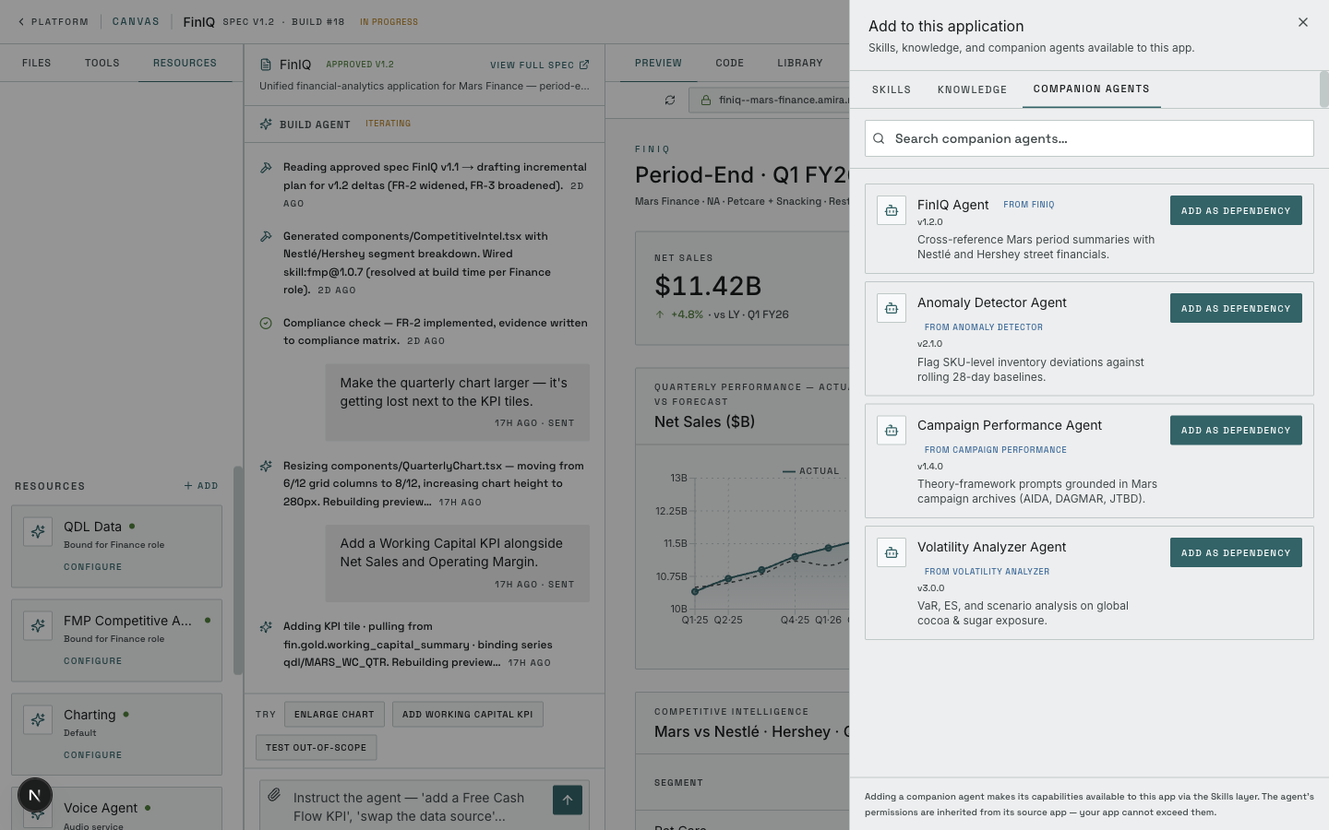
(9c) Companion Agents tab — cross-project agents available as dependencies.
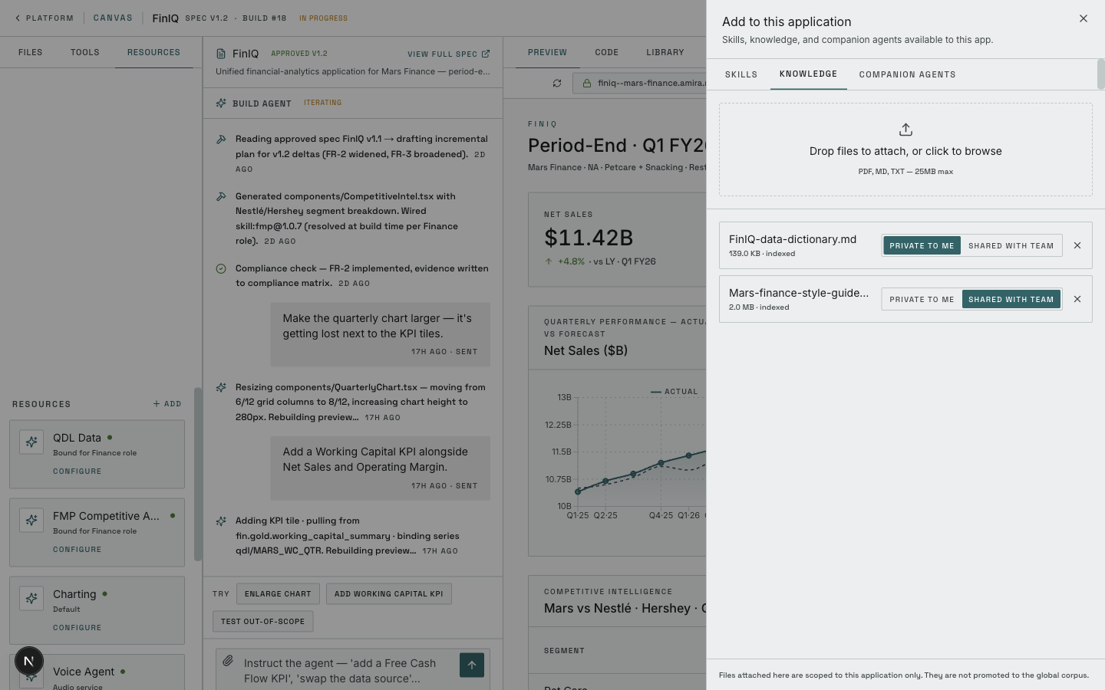
(9d) Knowledge tab — session-scoped uploads, private or team-shared.

Step 10 — Compliance matrix
The Build Agent maintains a live compliance matrix that scores the running application against every functional and non-functional requirement and acceptance criterion in the spec, with evidence pointers to source files. Failing rows block deployment.
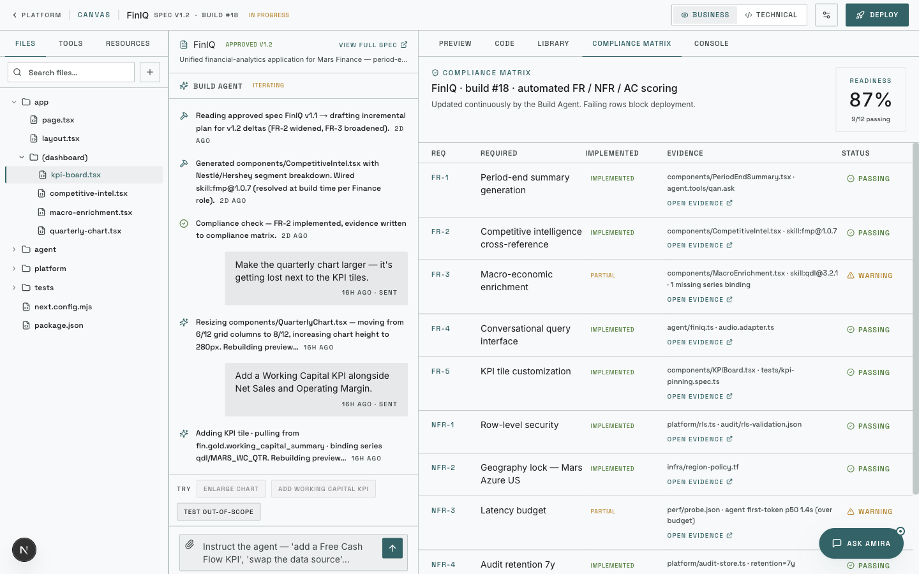
Compliance matrix — automated FR / NFR / AC scoring with evidence and status.

Step 11 — Deploy modal
The deploy flow is a four-step modal: publish details and audience scope; compliance standards and deploy-blocking thresholds; environment, network policy, and secrets resolution; and a final approval gate routed to the same governance role as the spec gate. On confirmation, build, scan, deploy, smoke test, and companion-agent registration execute sequentially.
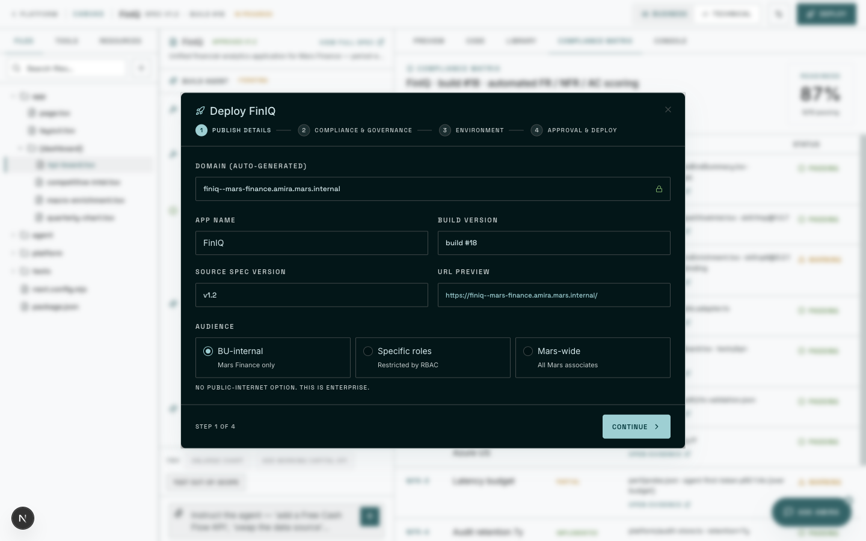
(11a) Step 1 — publish details and audience scoping.
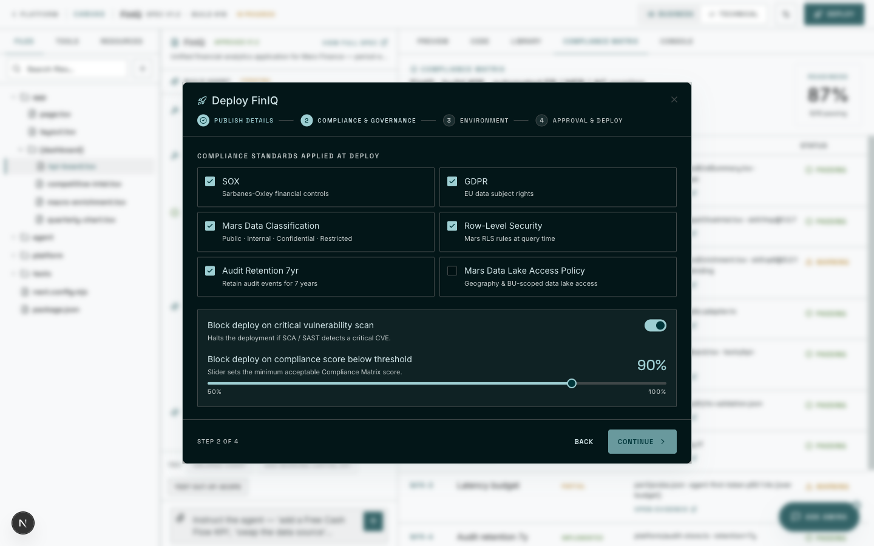
(11b) Step 2 — compliance standards and deploy-blocking thresholds.
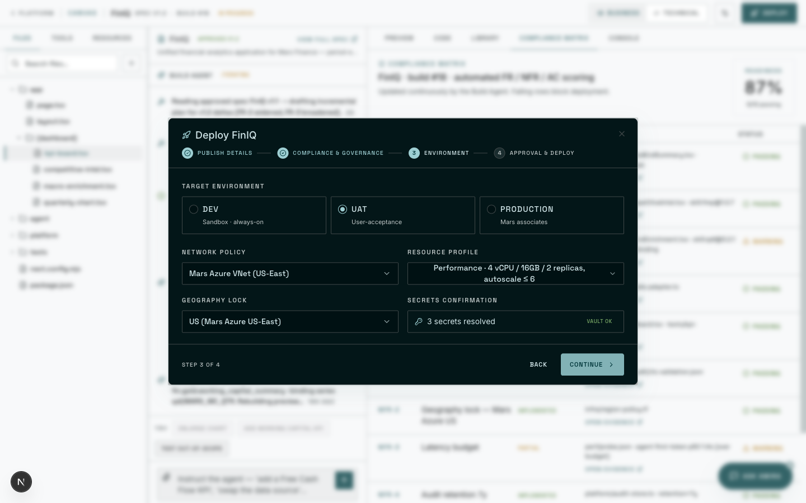
(11c) Step 3 — environment, network policy, and secrets vault confirmation.
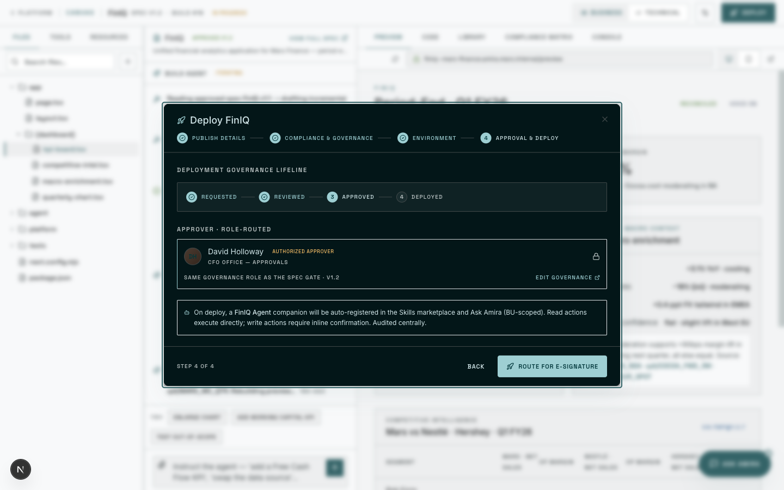
(11d) Step 4 — approval gate routed to the governance approver.
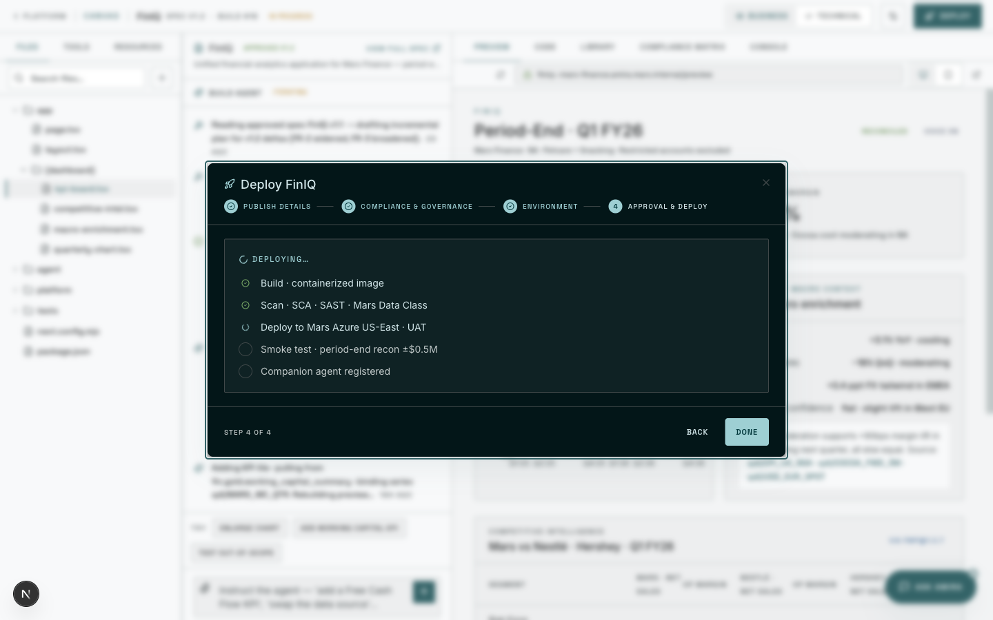
(11e) Deploy in progress — build, scan, deploy, smoke test, and agent registration.

Step 12 — Skills marketplace
The Skills marketplace exposes the full catalogue of pre-integrated primitives — Mars proprietary APIs (QDL, QML, Q Marketing, Q Analytics) and general-purpose tools (charting, web search, market hours). At the top, an Apps Become Agents section lists companion agents auto-generated from every app already shipped on the platform.
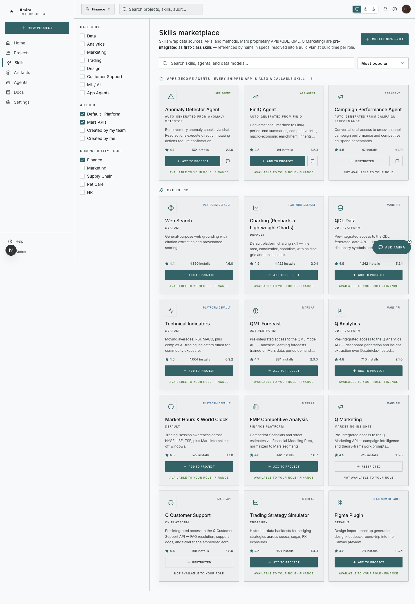
(12a) Full marketplace — skills catalog with role-scoped filtering.
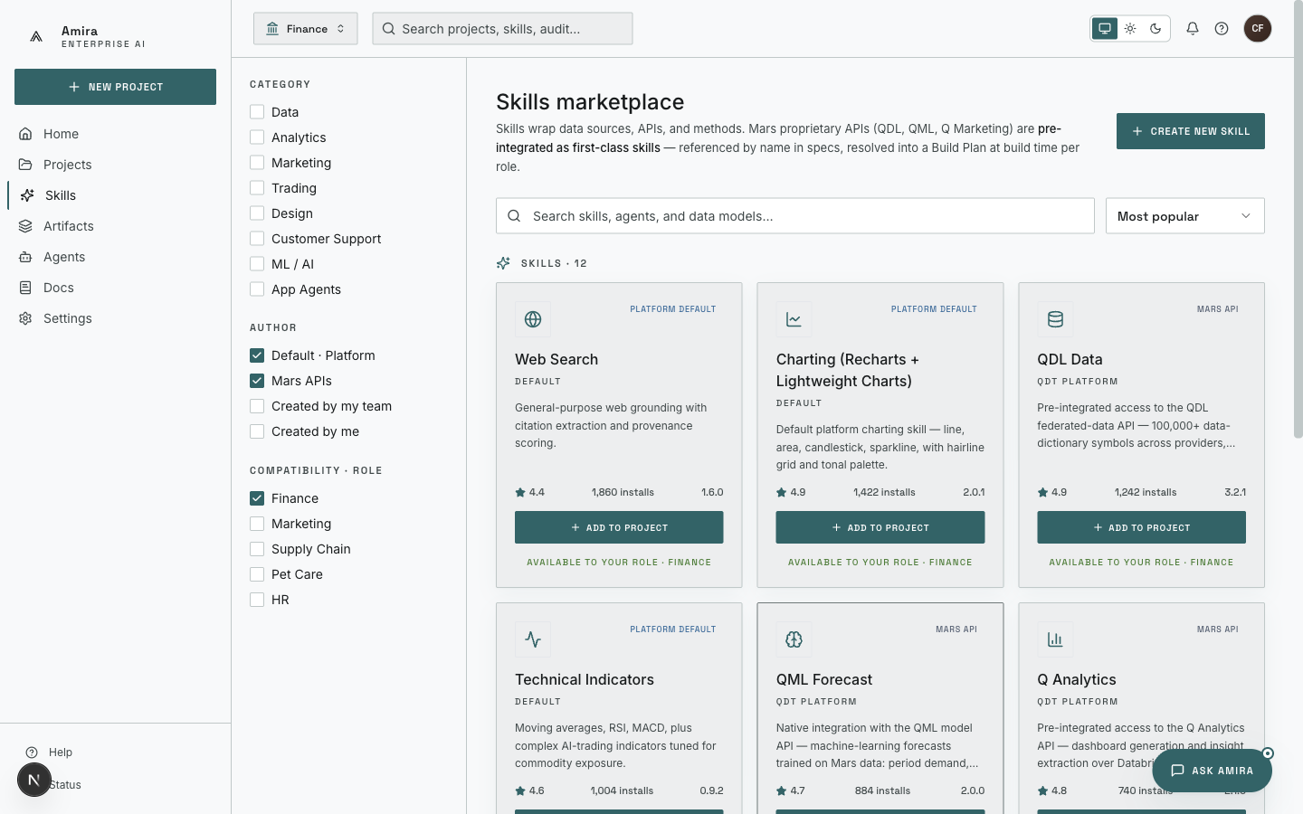
(12b) Apps Become Agents — companion agents auto-generated from shipped apps.
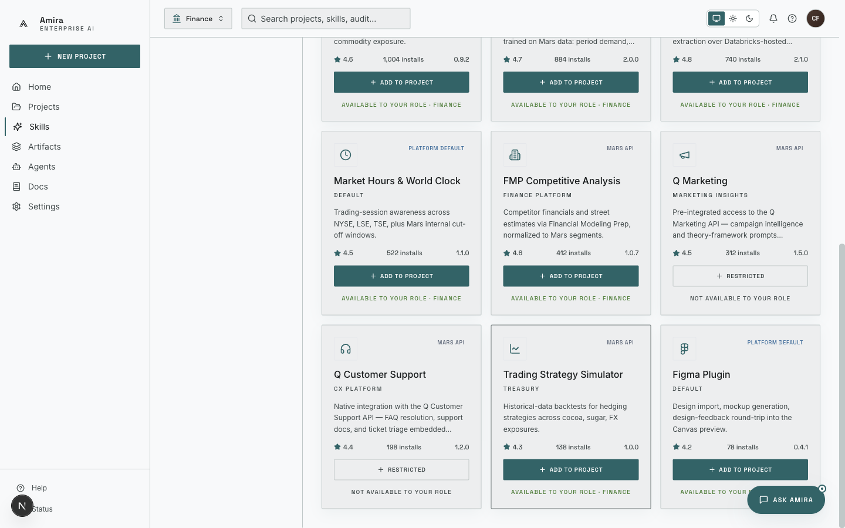
(12c) Marketplace tail — long-tail skills available to all projects.

Step 13 — Ask Amira
From any surface, the user opens an Ask Amira drawer scoped to a chosen agent. The demo shows the FinIQ Agent answering a Q3 Petcare net-sales question with chart and drivers, then a follow-up cross-competitor comparison via FMP — same data, same permissions, same audit boundary as opening FinIQ directly.
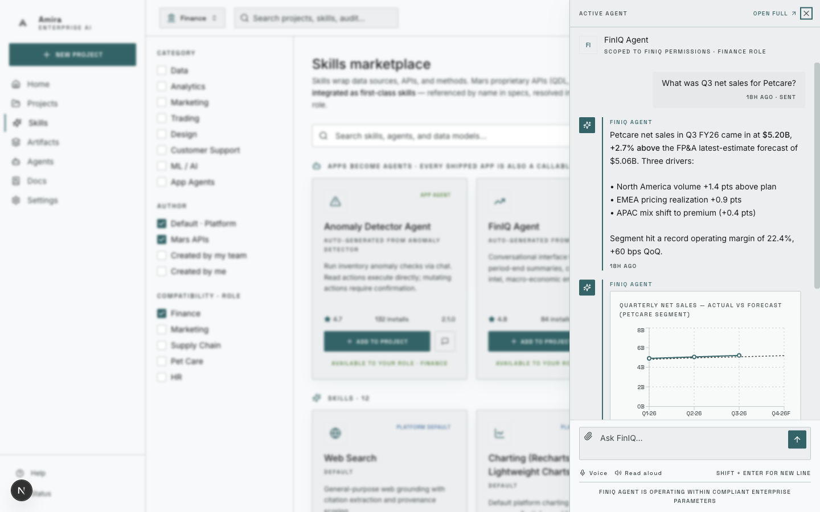
(13a) FinIQ Agent answering a Q3 Petcare question, with chart and drivers.
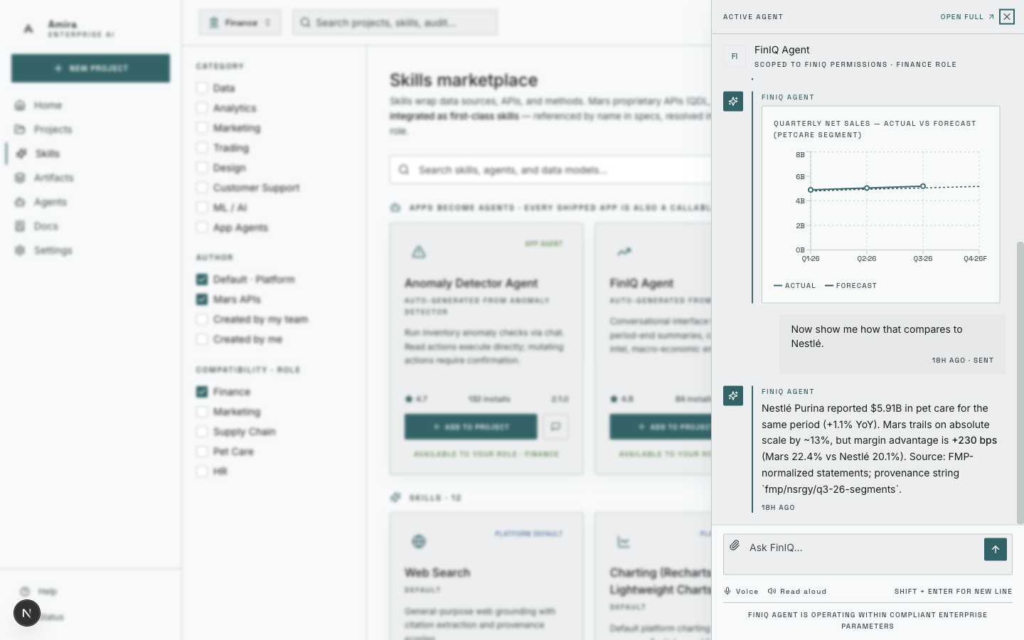
(13b) Follow-up competitor comparison via the same agent, with FMP provenance.

Step 14 — Lineage
The project page consolidates the full Spec → Build → Deploy lineage — every approved spec version, every build, every deployment, every approval. A right-rail card shows the companion FinIQ Agent’s recent activity and the audit-log preview.
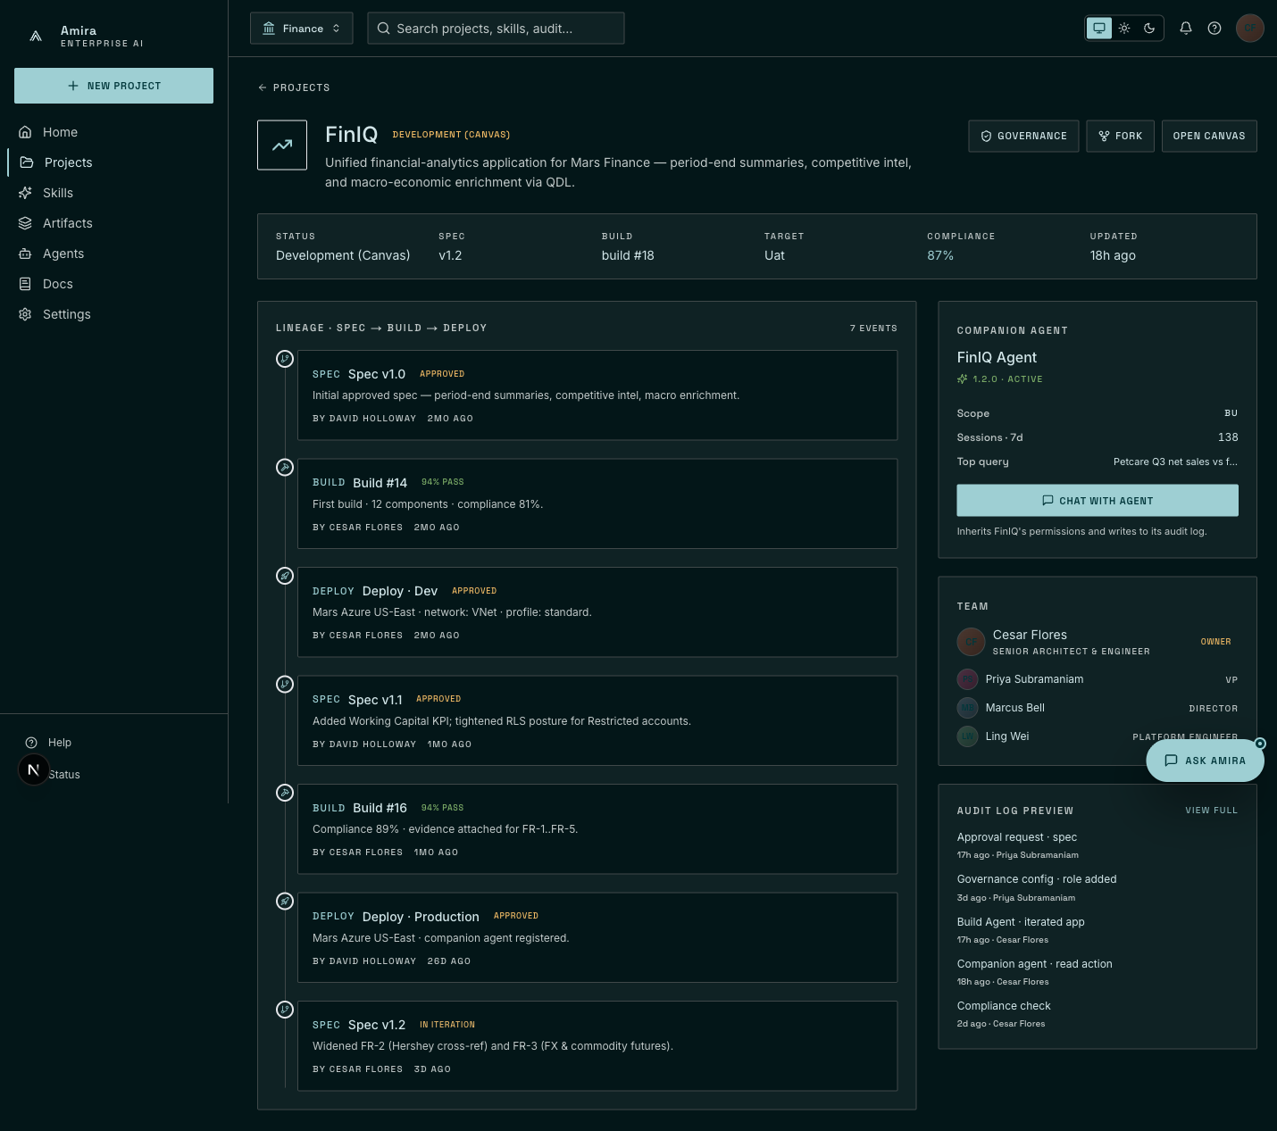
Project lineage — every spec, build, deploy, and approval, attributed and timestamped.

Step 15 — Wrap
The walkthrough closes on the same project page — the user has gone from a vague intent through specification, build, governance, deploy, marketplace, in-context chat, and lineage, with the entire journey captured as one auditable artifact.

