



Bay Area Air Quality Management District (BAAQMD)

Public Maps Data Management Workflows

|  |  |
| --- | --- |
| Prepared By  Farallon Geographics  601 Montgomery St. Ste 1095  www.fargeo.com | (415) 227-1140  April, 2019 | Prepared For  BAAQMD  **Jeffrey Matsuoka**  375 Beale Street, Suite 600  San Francisco, CA 94105 |

Table of Contents

Background 3

**Topology** 4

**Workflow Overview** 4

Geodatabase Topology Rules 5

Detailed Workflows 5

**Workflow 1: Editing Layers Using Map Topology** 5

**Workflow 2: Fixing Errors Using Geodatabase Topology Rules** 10

**Workflow 3: Export Updated Layers as Geojson** 13

**Workflow 4: Converting geojson layer to Mapbox Vector Tiles** 14

**Workflow 5: Setting Up environments for creating Mapbox vector tiles** 15

# **Background**

Farallon Geographics prepared nine feature layers (as of 4/11/2019) in the geodatabase for Bay Area Air Quality Management District (BAAQMD). The purpose of this document is to provide guidance on how to maintain these layers over time using ArcGIS, and how to publish these layers to Mapbox for use in the Public Maps website.

The prepared boundaries are as follows:

* jurisdictions
* counties
* the BAAQMD district boundary
* AQI reporting zones
* open burn sections
* impacted communities 2009
* impacted communities 2013
* ozone exceedance areas
* pm 2.5 exceedance areas

In the legacy iteration of the Public Maps interface, users found that the GIS data within the maps were out misaligned, as seen below:

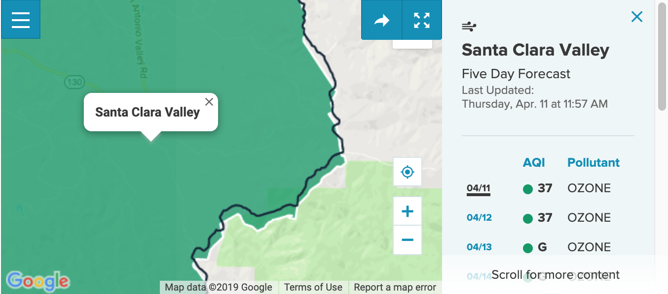

This misalignment caused confusion about accuracy of boundary information in the maps, and unnecessary questions about the accuracy of the data in the maps. To remedy that, Farallon rebuilt these boundaries using GIS tools and methodologies that ensure perfect alignment among the layers. A short summary of our approach is as follows:

Jurisdictions is a single polygon layer containing both Cities and unincorporated areas. Jurisdictions, in turn, can be dissolved into County polygons. The BAAQMD district boundary is constructed as a dissolve of the nine Bay Area counties, with specific slices of Sonoma and Solano Counties removed – per documentation provided to Farallon from BAAQMD staff.

The additional reporting zones and impacted areas are aligned with Jurisdictions, other reference features (such as streets and census blocks), and with each other to form a topologically consistent (aligned) set of set GIS polygon layers.

In addition to the data editing workflows, this document also lays out in detail how to export data from ArcGIS for use in Mapbox and the Public Maps website.

### **Topology**

Topology is a collection of rules that, coupled with a set of editing tools and techniques, enables the geodatabase to more accurately model geometric relationships. It plays a key role in the workflow for maintenance of the District’s Public Maps GIS layers.

ArcGIS implements topology through a set of rules that define how features may share a geographic space and a set of editing tools that work with features that share geometry in an integrated fashion.

A topology is stored in a geodatabase as one or more relationships that define how the features in one or more feature classes share geometry. The features participating in a topology are still simple feature classes, but the topology serves as a description of how the features can be spatially related.

Our workflow leverages both geodatabase topology rules and map topology to support the editing workflow for your layers.

1. [Map Topology](http://desktop.arcgis.com/en/arcmap/10.6/manage-data/editing-topology/creating-a-map-topology.htm)

The map topology creates the topology relationships between layers on the map that shares the part of geometry, which will allow to edit them all together. For example, the district boundary, open burn sections, and reporting zone that share the outer boundaries. So, map topology can help you edit the layers that already share geometries (such as edges) together consistently.

1. [Geodatabase Topology Rules](http://desktop.arcgis.com/en/arcmap/10.6/manage-data/topologies/topology-in-arcgis.htm)

Topology rules can be created and saved in the he geodatabase to define specific topology rules for the specific layers in an organization. Various rules were included in the default topology in the geodatabase. The rules can be added or removed from the geodatabase if necessary. Then, you can validate the topology rules to identify the errors.

The divisions within the district as in the reporting zones or the open burn sections should not overlap each other and also there should not be any gap between areas. For example, there should not be any gap between Santa Clara Valley, Eastern, and South Central Bay reporting zones and they should not overlap to each other.

The area covered by all the reporting zones and open burn sections should exactly overlap with the district boundary. Also, small areas such as impacted community areas should be inside district boundary. Various topology rules can be applied to ensure the different layers are consistent to each other.

This document shows how map topology and geodatabase topology rules maintain consistency among layers, how to validate the topology and fix any topological errors.

### **Workflow Overview**

When there is a change in one of the existing layers especially one that shares boundaries with other layers in the district, you can follow the following steps.

1. **Edit layers using map topology**

If the county boundaries have changed, you can edit the district boundary along with other relevant layers such as reporting zone and open burn sections consistently using map topology.

1. **Checking geodatabase topology and fixing errors**

After you edit existing layers, you can check they follow the topology rules in the geodatabase and fix the error if any.

1. **Export the layers as for use in Web Maps (geojson)**

After the editing is done, you can export all the layers in the boundary dataset to as geojson file formats that will be used to create vector tiles for mapbox.com using a custom tool (Python script).

**4. Convert geojson to vector tiles**

You can create vector tile for mapbox.com using a JavaScript script in command line environments.

# **Geodatabase Topology Rules**

Implemented rules are as following. You can add or remove rules if necessary.

* Jurisdictions (Must Not Have Gaps, Must Not Overlap) (1,2)

Counties (Must Not Have Gaps, Must Not Overlap) (3,4)

Reporting Zone (Must Not Have Gaps, Must Not Overlap) (5,6)

Open Burn Sections (Must Not Have Gaps, Must Not Overlap) (7,8)

Since the four boundary layers (jurisdiction, counties, reporting zones, and open burn sections) should cover the whole district area, there should not be any gap in-between within each layer and must not overlap to each other within each layer

* Jurisdiction & Counties (Must Cover Each Other) (9)

District Boundary & Open Burn Sections (Must Cover Each Other) (10)

District Boundary & Reporting Zone (Must Cover Each Other) (11)

The each area covered by the district boundary, reporting zones, and open burn sections should be the same. Also, each of county boundaries and jurisdiction should, too.

* District Boundary & Counties (Must Cover Each Other) (12)

Also, they should cover each other completely, except the part of the counties and jurisdictions. Even though two layers are not completely overlap to each, it is good to check

* Ozone Exceedance Areas (Must Be Covered By) District Boundary (13)

PM 2.5 Exceedance Areas (Must Be Covered By) District Boundary (14)

Impacted Communities 2009 (Must Be Covered By) District Boundary (15)

Impacted Communities 2013 (Must Be Covered By) District Boundary (16)

All four small areas must be inside the district boundary

# **Detailed Workflows**

### **Workflow 1: Editing Layers Using Map Topology**

In this example, the eastern boundary of Alameda County has been edited, so three other layers will be edited accordingly. The purple line represents county boundary that has changed, while light red represents the district boundary, green open burn sections, and black reporting zones. As you can see the county boundary has been changed and all other three boundaries are perfectly match. The goal in this section of the workflow is to update three boundary layer to follow the new county boundary

1. Open the existing map document (BAAQMD_MapTopology.mxd) or create a new map document
2. Add the relevant layers to the map (Counties, Reporting Zones, Open Burn Sections, District Boundary)

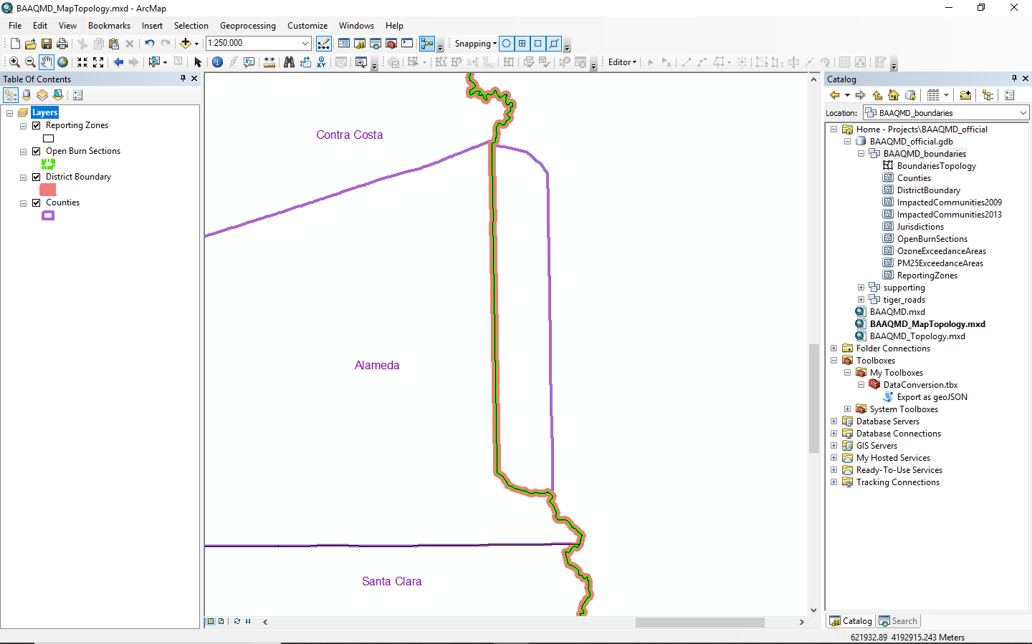

1. Display Editing and Topology toolbars if not shown in the menu by selecting the menu Customize 🡪 Toolbars and checking the toolbar names
2. Click Editor button in Editing toolbar to start editing
3. Click Select Topology to create topology
4. Check the Map Topology section and check the layers you want to or click the “select all” button to select all

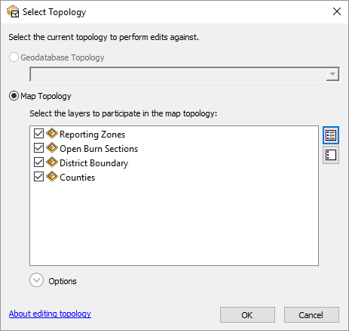

1. Click Topology Edit Tool button from topology toolbar and select the shared lines you want to edit
2. Click Shared Features from the topology toolbar, when the line will change color (pink)

(The pink line represents the line segments that three layers share as shown in the message window)

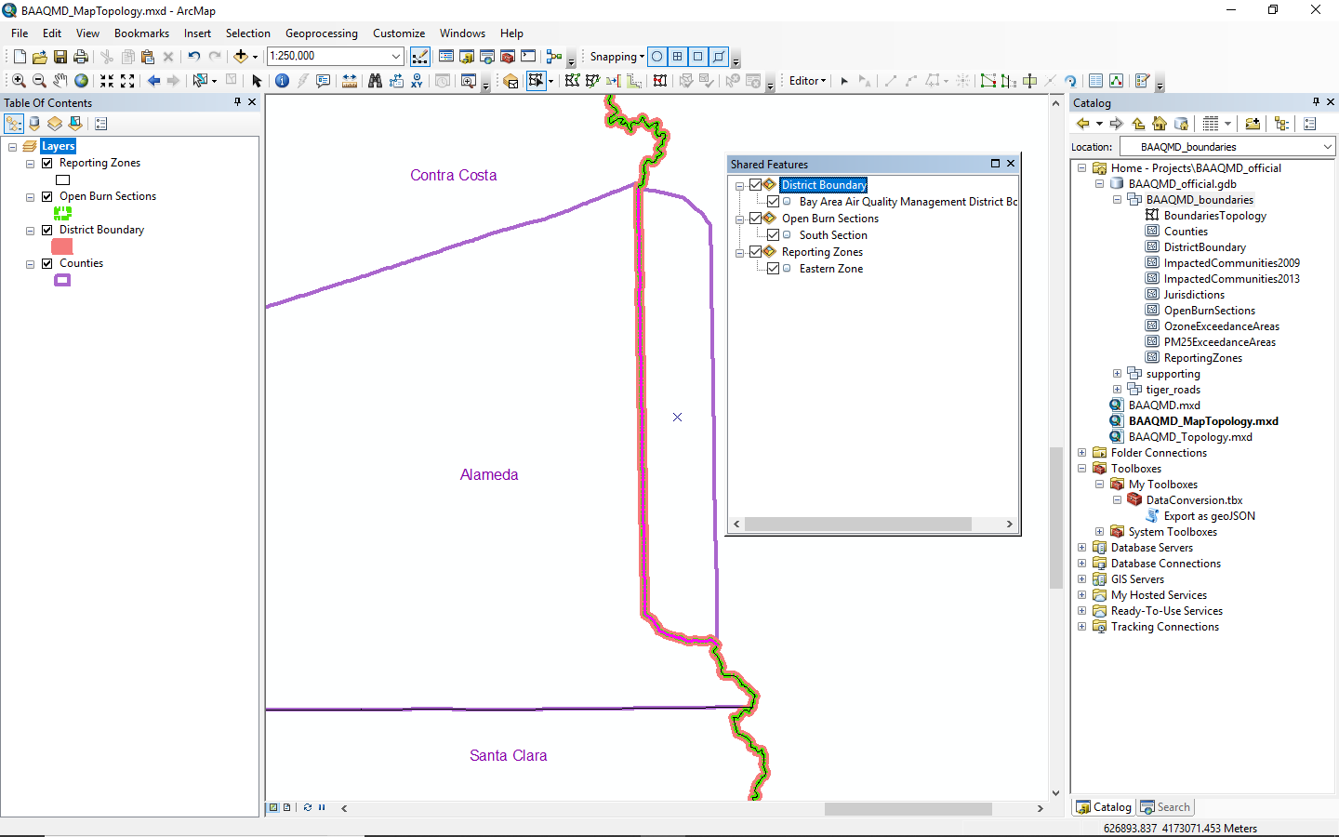

* If you have another layer that you can reference (i.e. counties in this example), go to the step 14 to continue

1. Click Reshape Edge tool from the topology toolbar
2. Click Trace from the Editing toolbar
3. Click near the vertices where two lines meet and trace the line you want to follow
4. Finish the sketch by double clicking (you have to connect at least two points shared between the layer that you want to trace and the layers you want to edit)

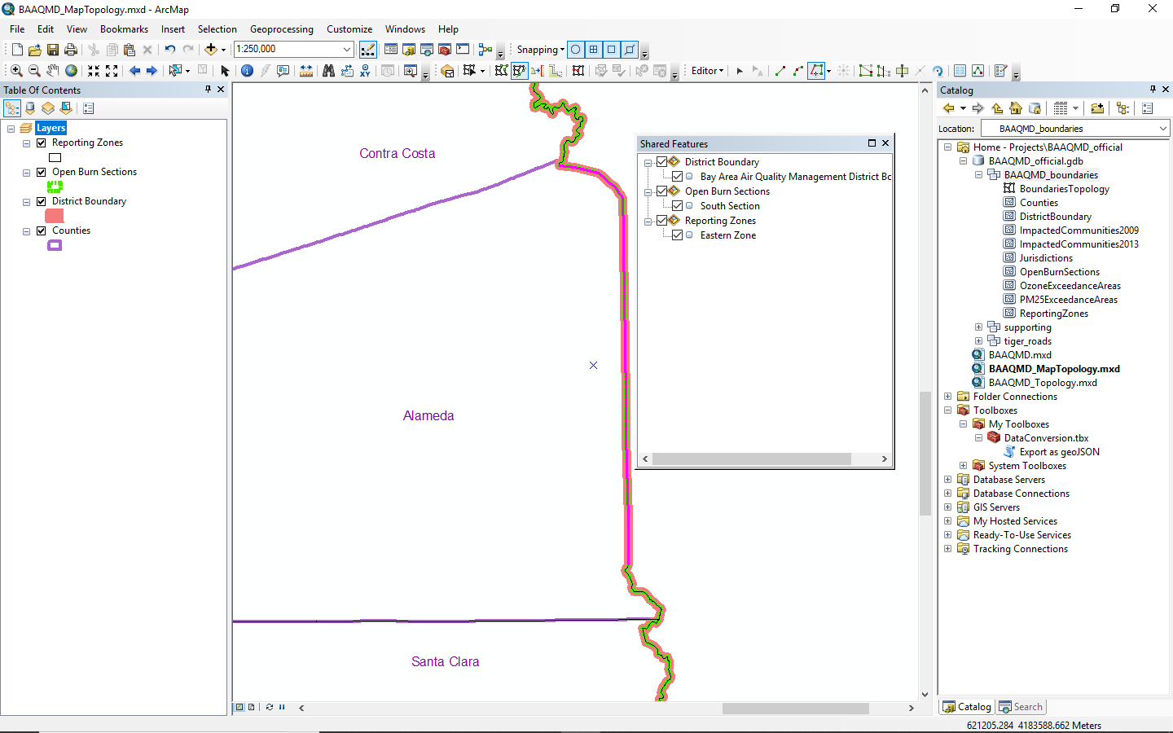

1. Click Editor from the editing toolbar and save the edits (do not forget to save the edits frequently during the edits too)

* If you do not have another layer that you can reference

1. Click Modify Edge from the topology toolbar and edit the vertices if you want to edit vertices. If you do not have other layer the you can reference, (such as counties layer in this example) this may be your only option

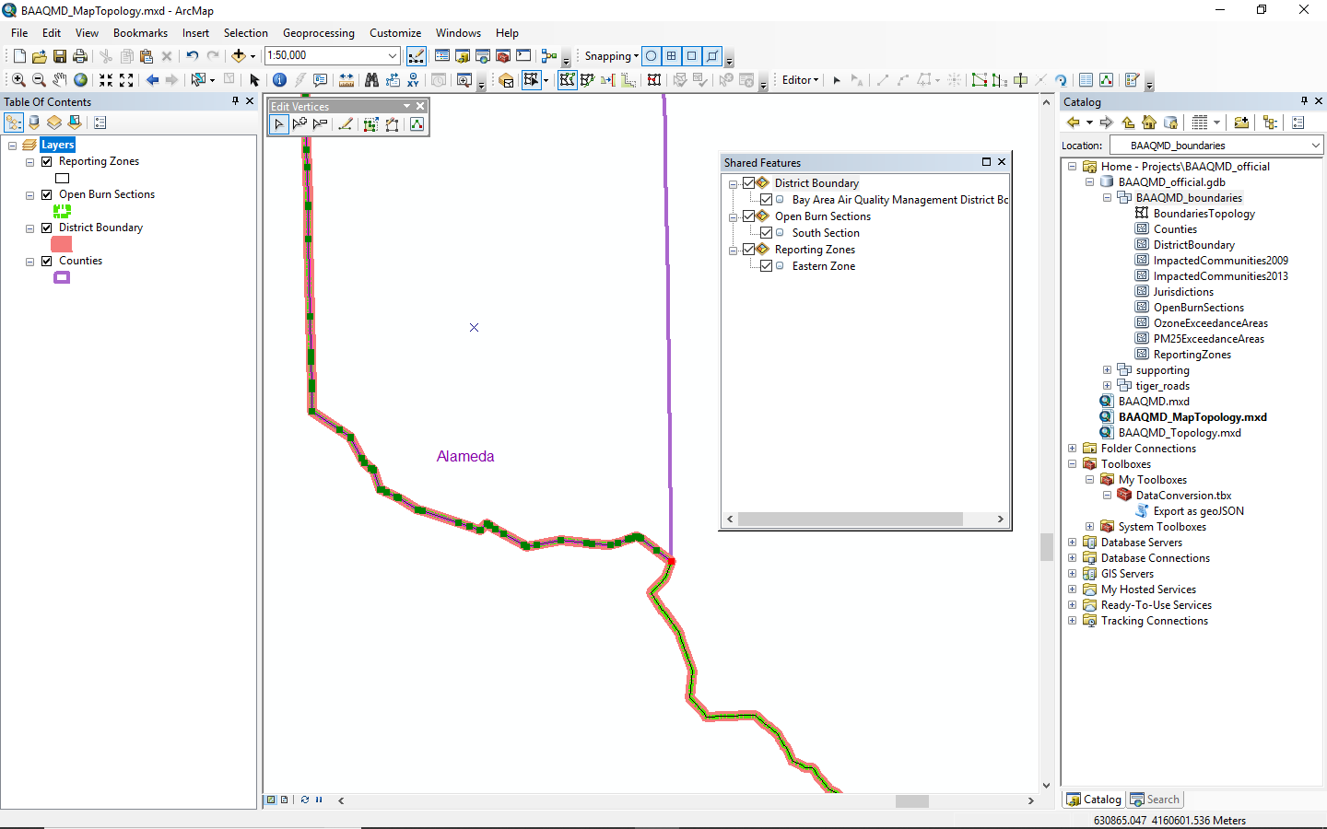

1. Click Editor from the editing toolbar and save the edits (do not forget to save the edits frequently during the edits too)

### **Workflow 2: Fixing Errors Using Geodatabase Topology Rules**

1. Open the file “BAAQMD_Topology.mxd” or create a new file
2. Add the topology feature “BoundariesTopology” from the geodatabase if the topology is not present in the current map contents and click “Yes” to the question “Do you also want to add all feature classes that participate in ‘BoundariesTopology” to the map?”
3. Display Editing and Topology toolbars if not shown in the menu by selecting the menus Customize 🡪 Tollbars and checking the toolbar names
4. Click Editor button in Editing toolbar to start editing
5. Click Select Topology to create topology
6. Check the Geodatabase Topology section and choose “BoundariesTopology”

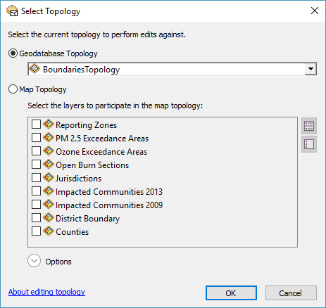

1. Click Validate Topology in Current Extent or Validate Topology in Specified Area. If you choose to specify area, you can specify the area with mouse drag (In this example, Topology in Current Extent using the whole area)

The errors will be shown as red polygons, lines, or points. Note that topology rule will consider outer boundaries as gaps so it will give you an error but you can make an exception (that will be explained in the error inspector section later)

1. Click Error Inspector from the topology toolbar and click Search Now and you will see the errors. You may see some different errors in your validation

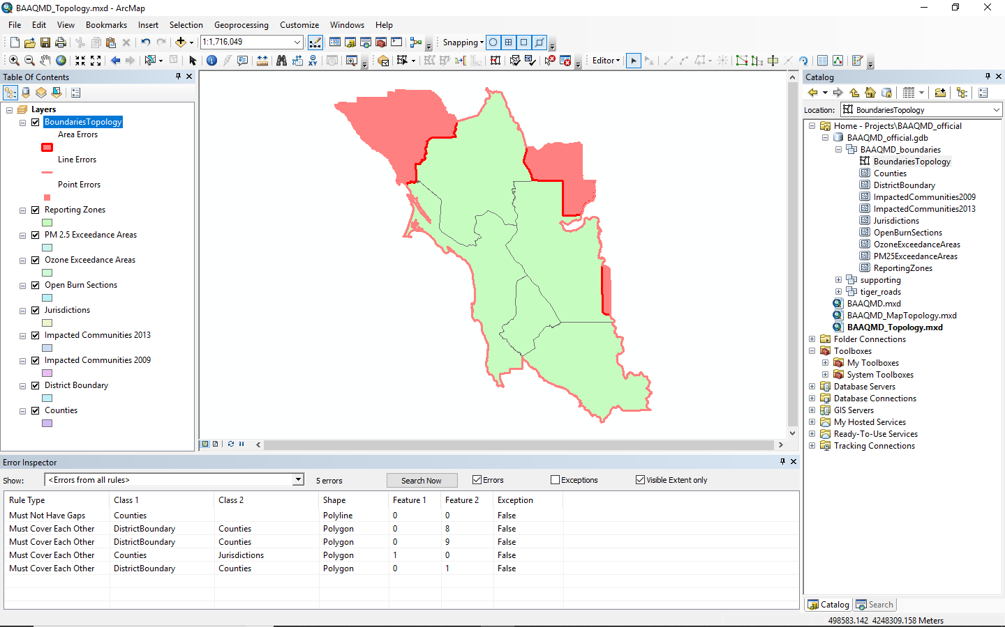

1. Right click on the errors and select Mark as Exception if you know that they are not relevant. Some examples are,
   1. “Must Not Have Gaps” rule will indicate the outer boundaries as errors since it consider them gaps
   2. We know that the district boundary and the county boundaries does not “Cover Each Other” in Solano and Sonoma County

So, you can mark these three errors as exceptions. The result will be the following figure

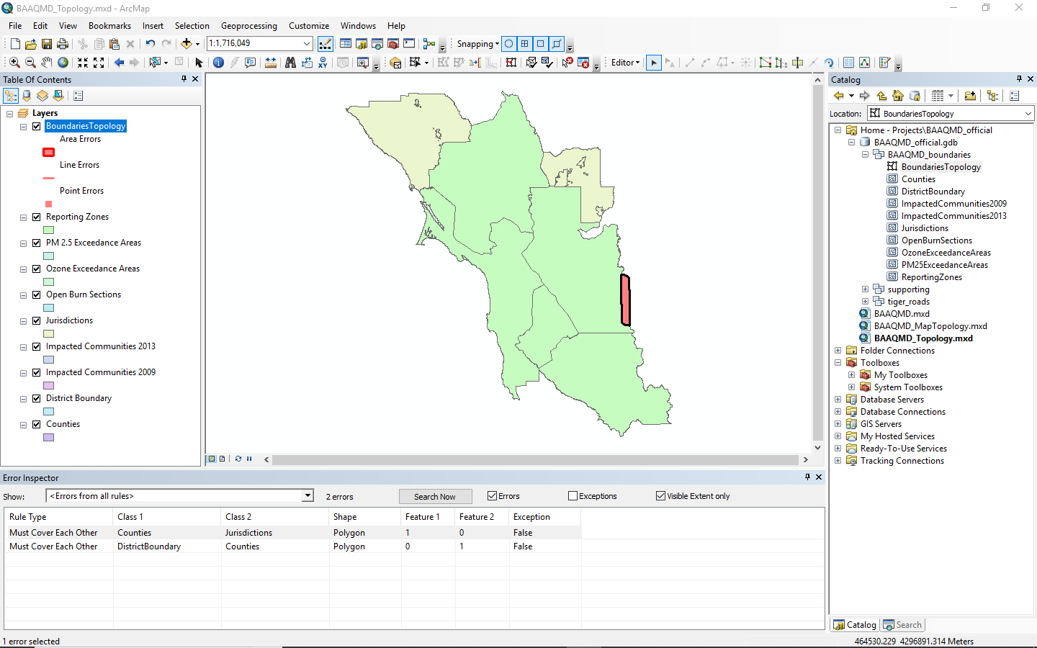

1. Select the Show dropdown menu from error inspector you can see only the specific errors. Also, the check boxes next it you can choose what to see and what not to see from the list

Two remaining error are all due to the change in the county boundary, so you can fix both errors by editing the county boundary (you may have to fix the error by editing other layers depending on the case in real situation)

1. Click Fix Topology Error Tools from the topology toolbar and right click on the error. Since the county has extra portion of polygon you can choose to use Subtract to remove it. You will have to validate again to see the result.

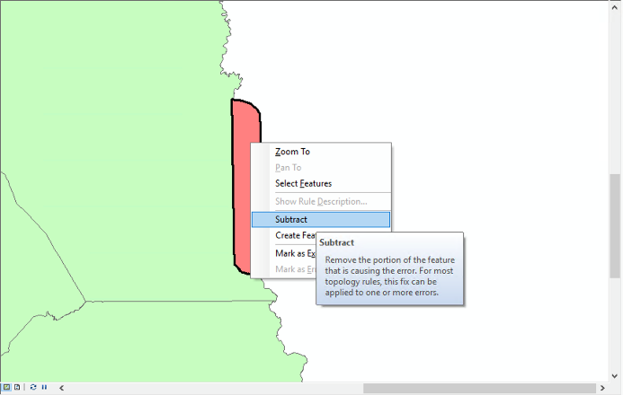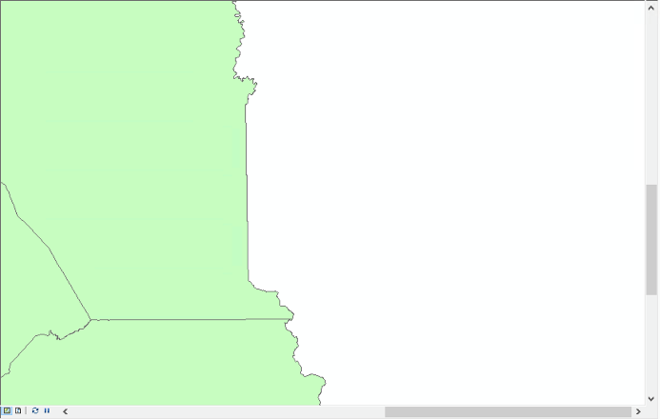

1. If do not have proper option to fix the error or if you want to fix it manually, you still can use the Modify Edge or Reshape Edge Tool from topology toolbar and edit vertices or trace other feature too as in the section 1.1.

### **Workflow 3: Export Updated Layers as Geojson**

1. Select Windows 🡪 Catalog if the catalog pane is not already open
2. Click to expand Toolboxes 🡪 My Toolboxes 🡪 DataConversion.tbx 🡪 Export as geoJSON

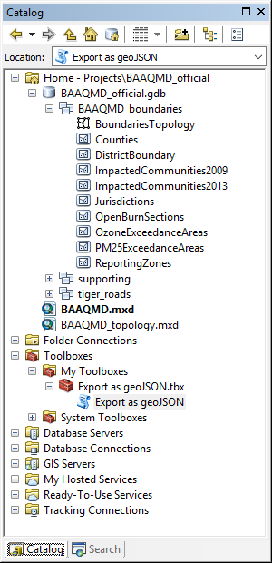

1. Double click “Export as geoJSON” tool
2. Choose the input dataset and output directory

<note> Leave the default input dataset as it is (they are probably different from the screenshot) if you are not sure but you have to make sure the output directory does not have previous geojsons since the tool does not overwrite the file with same name

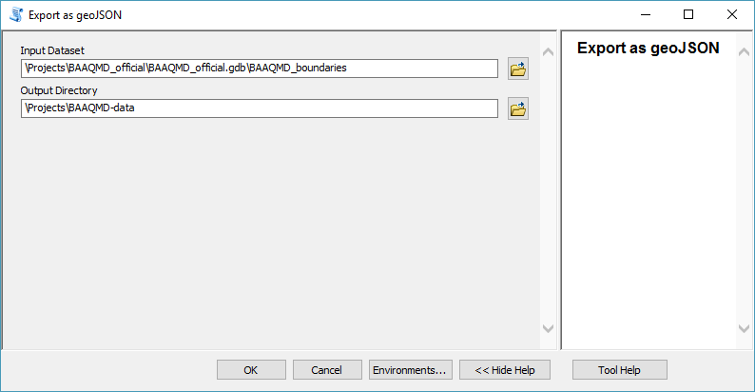

### **Workflow 4: Converting geojson layer to Mapbox Vector Tiles**

1. Create a new access token (it is recommended for each person who will upload the tile to mapbox.com to create an access token and this has to be done just once for each person) with token scopes as below so that you can upload (<https://account.mapbox.com/access-tokens>).

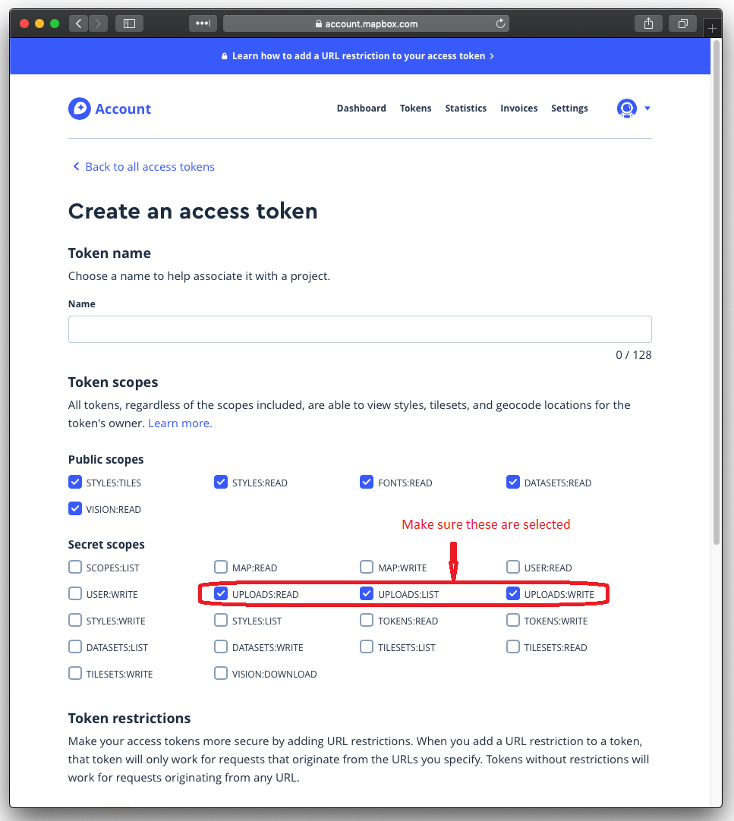

1. Create or update secret.json with the new access token

{

”mapboxKey”:”your access token inside the quotation marks”

}

1. Open Command Prompt by selecting Windows Start button and typing **cmd**

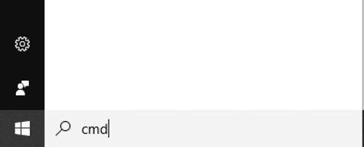

1. Run Ubuntu bash by typing ubuntu

$ ubuntu

1. Go to the project directory

$ cd /mnt/c/farallon/projects/baaqmd-maps/

1. Run the following command from the root directory to generate tiles (data/baaqmd.mbtiles) containing all layers from the latest local data (stored in data) and upload them to mapbox.com

$ yarn tiles

### **Workflow 5: Setting Up environments for creating Mapbox vector tiles**

This workflow is a one-time setup for any Windows 10 workstation which needs to publish data to the Public Maps site using Workflow 4.

**Install Ubuntu bash shell**

1. Select Programs and Features from Control Panel (or run appwiz.cpl from Windows Start button)
2. Click Turn Windows features on or off
3. Turn on Windows Subsystem for Linux

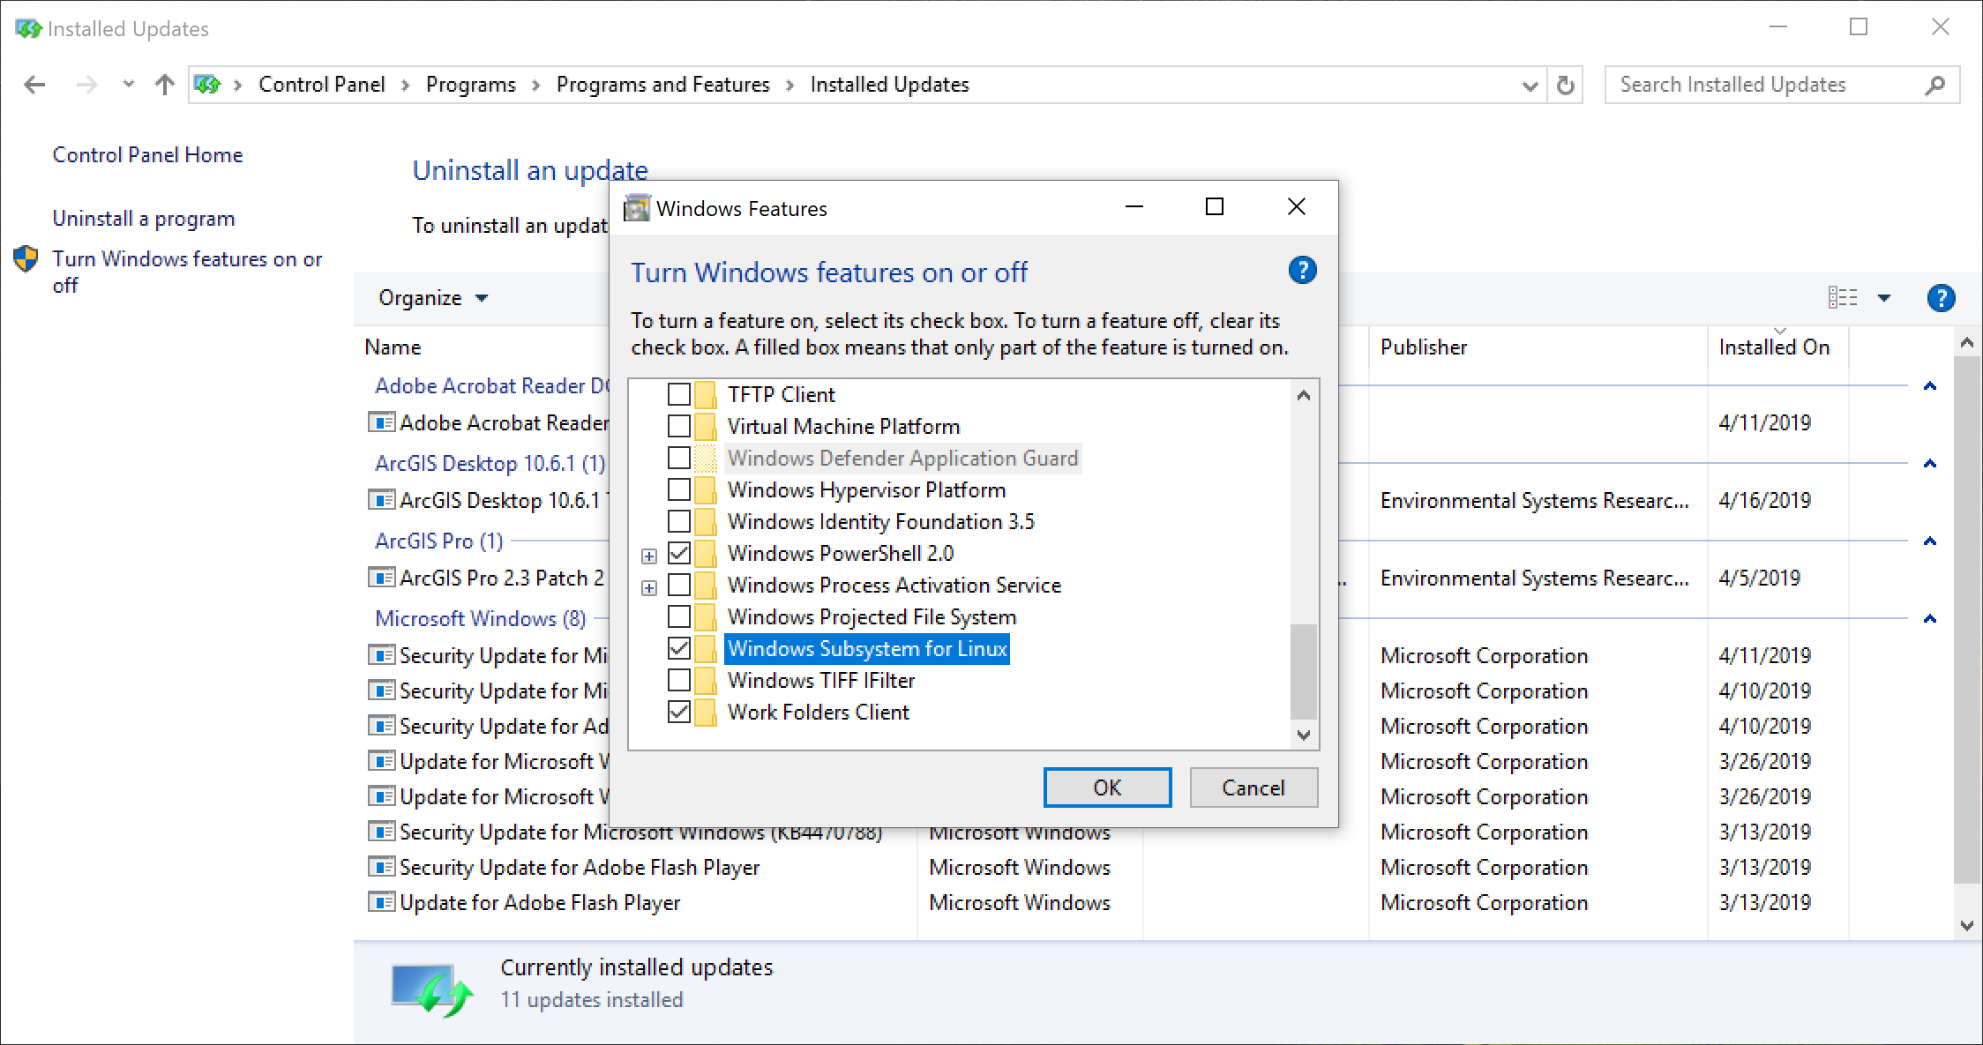

1. Go to Microsoft Store and download Ubuntu app and install

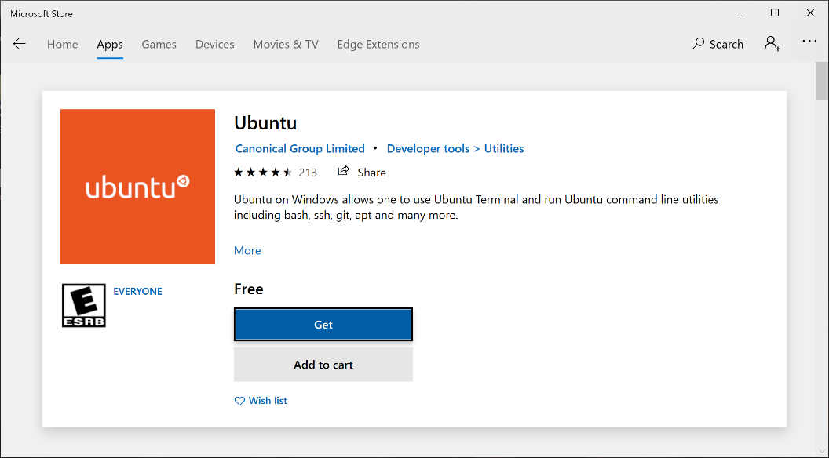

1. Run ubuntu from Windows Start menu
2. Create a project directory

$ mkdir /mnt/c/farallon/projects/

$ cd /mnt/c/farallon/projects/

1. Create a local repository by cloning the github repository

$ git clone https://github.com/fargeo/baaqmd-maps.git

$ cd baaqmd-maps

After step 7, the current full path will be

/mnt/c/farallon/projects/baaqmd-maps (in ubuntu shell)

C:\farallon\projects\baaqmd-maps (in Windows filesystem)

1. Install dependencies (node.js and yarn)

Install Node.js

$ sudo apt update && sudo apt install nodejs npm

Install yarn

$ curl -sS https://dl.yarnpkg.com/debian/pubkey.gpg | sudo apt-key add -

$ echo "deb https://dl.yarnpkg.com/debian/ stable main" | sudo tee /etc/apt/sources.list.d/yarn.list

$ sudo apt-get update && sudo apt-get install yarn

1. Install your package dependencies locally by running the following from the root directory of your cloned repository

$ yarn install

1. Install Tippecanoe and its dependencies

$ sudo apt-get install build-essential libsqlite3-dev zlib1g-dev

$ git clone https://github.com/mapbox/tippecanoe.git

$ cd tippecanoe

$ make -j

$ make install (if permission error, try $ sudo make install)

1. Go back to workflow 4 to create tiles