Art Gallery
1)Intro:
1. Purpose
The purpose of this project is to design and implement a web-based application that allows users to discover, view, buy, and sell original artworks online. This platform aims to bridge the gap between artists and art enthusiasts by offering a curated digital space where original paintings, photography, sculpture, and more can be browsed, previewed, and purchased globally.
2. Project Scope
- Browsing a curated selection of artworks filtered by artist, title, keyword, and media. - Virtual preview of artworks in a user’s space using the “View In Your Room” feature. - Weekly releases of curator-approved collections. - Personalized artwork recommendations based on user input and space dimensions. - Option to create and share virtual gallery walls. - Free guidance from art advisors. - Purchase of eGift cards. - Artist-hosted virtual galleries. - Registration and location of Art Fairs and Galleries. - Referral-based discounts.
3. Glossary and Abbreviations
TERM | DEFINITION
CURATED | Carefully selected and organized by professionals
EGIFT CARD | A digital gift card that can be used to purchase items from the app.
VIRTUAL GALLERY | WALL A simulated visual display of artworks as they would appear on a wall.
VIEW IN YOUR ROOM | A feature allowing users to virtually preview how an artwork looks in their actual living space.
ART ADVISOR | An expert who helps users select art pieces based on preferences and requirements
ART FAIR | An event where multiple artists or galleries display and sell their artworks.

STAKEHOLDER | ROLE
VIWER | Individuals interested in discovering and purchasing artworks.
ARTISTS | Users who upload, sell, and promote their original works.
ADMIN | Professionals who select and approve artwork collections for weekly features.
ADVISOR | Provide users with personalized guidance in choosing art
4. System Stakeholders

5. References
- Saatchi Art Online Gallery– Used as a primary reference and example for the app's features and structure.
- Helwan University, Faculty of Computing & Artificial Intelligence, CS251 Software Engineering 1, Spring Semester 2 (2024-25) – Project guidelines and objectives

2)FUNCTIONAL REQ:
PART 1: Overview & Software Requirements Specification
Functional Requirements:
User requirements | System requirements
users can create accounts and register  themselves. | The system shall provide a user registration module with secure data storage.
users with different roles (artist, advisor,  , art gallery admin, client) can login. | The system shall implement a role-based access control system with secure login functionalities.
users can request advisor guidance. | The system shall have a process for artist verification and approval by designated admins.
clients can book tickets for offline art gallery. | The system shall have a process for art fairs verification and approval by designated admins.
Users can add friends. | The system shall allow specifying locations for art fairs
Users can subscribe their favorite artists’ pages | The system shall integrate real-time virtual tools (camera and 3d realistic art).
Users can save their favorite pictures (add to cart) | The system shall provide a profile management module for advisors.
Users can post collected photos | The system shall have a review and rating system for artists and art fairs.
Users can hang art in their home virtually | The system shall integrate with a database of verified insurance providers.
New users have site recommendations in their profile | The system shall allow for comparison of artists providers based on user-defined criteria.
User can filter the target work | The system shall have a search function for artists and art based on various criteria.
User can buy photos using credit cards. | The system shall have functionality to verify insurance coverage for specific services.
User can view new collections weekly | The system shall have functionality to verify artists
User can fill questionary to ask for advisor guidance | The system shall provide secure storage and access mechanisms for viewer records.
User can screenshot and make gallery | The system shall provide a profile management module for artists.
Advisor responds in 4-5 days | The system shall have a notification and reminder module for users.
User can buy e-gifts | The system shall have a feedback mechanism for users to report issues and suggest improvements
User can send e-gifts for family and friends | The system shall provide a calendar and scheduling tool for managing art fairs.
Artist can host online virtual galleries hosted by the app | The system shall display doctor listings categorized by specialty during searches.
Artist can register their art fairs and galleries | The system shall have automated notifications for booking art fairs confirmation.
User can find art fair next to them in the app | The system shall integrate with a secure online payment gateway.
User can refer a friend and get a discount per referral | The system shall display comprehensive profile information for artists.
users can create detailed profiles. | The system shall have a dedicated workflow for admin approval/rejection of artists authentication requests.
Admins release collections weekly | The system shall have an administrative dashboard for user management (add/delete users with different roles).
users can leave reviews and ratings. | The system shall have functionalities for user login, logout, and guest access.
artists can create detailed profiles. | The system can integrate with a Q&A forum or limited consultation functionality with advisor.
artists can provide feedback on the application. | The system shall provide functionalities for user account management (update/delete).
users can report artist photos | The system shall have a notification system for users to receive alerts about upcoming booked art fairs, new reviews, and other relevant updates.
Admin check reports and decide to delete photos or not | The system shall have functionalities to collect, analyze, and utilize user feedback for service improvement.
Artist receives money from selling photos | The system shall provide special offers.
Users may support artists financially | The system shall provide E-gifts.
Admin mange the websites offers on photos | The user shall receive notification about an upcoming near art fair
Admin notify artists with number of subscribers | The system shall provide communication tools between viewer and advisor
User can invite other users to the website | The system shall pan any user with high reporting
system analyzes user feedback. | The system shall support high quality art

2)NONFUNCTIONAL REQ:
Non-Functional Requirements for ArtNest Gallery:
1. Usability:
a) ArtNest Gallery should have a simple and easy-to-navigate design so users can quickly find and view artworks.
b) Visitors should be able to search, filter, and explore art easily without needing any help. c) The interface should be user-friendly and provide a smooth experience for all users.
2. Performance:
a) The platform should load quickly and respond fast to user actions like clicking or scrolling.
b) It should show high-quality images and details without delays.
c) The website should work smoothly with minimal downtime.
3. Security:
a) ArtNest Gallery should protect personal data of users, artists, and buyers.
b) Only authorized users should be able to upload or purchase artworks.
c) Data should be safely stored and shared using secure methods.
4. Scalability:
a) The system should support more users and more artwork as the gallery grows.
b) It should keep working well even when many people visit at the same time.
5. Compatibility:
a) ArtNest Gallery should work on different devices like phones, tablets, and computers.
b) It should fit different screen sizes and web browsers without any issues.
6. Reliability:
a) The website should be stable and not crash during use.
b) It should be tested to make sure it works well under different situations.
7. Accessibility:
a) The platform should support users with disabilities, like screen reader users.
b) It should follow accessibility rules so all users can use the gallery comfortably.
8. Data Integrity:
a) ArtNest Gallery should keep data accurate and complete, including artwork details and user info.
b) There should be checks to prevent wrong or missing data.
9. Availability:
a) The gallery should be online 24/7, so users can visit it anytime.
b) It should be designed to reduce downtime and keep working without breaks.
10. Look and Feel:
a) The website should look clean, modern, and visually pleasing, with colors and layout that suit an art gallery.
b) The design should be simple and well-organized to help users enjoy their visit.

4)design and implementation constraints

Technical Constraints
• Limited Technology: You must use certain tools (e.g., React for frontend, Node.js for backend).
• Hosting: The app must run on a chosen server like AWS or Firebase.
• Device Support: It should work well on both computers and phones.
• Internet Needed: Users need to be online to use the app.
• Example: The app must load artwork images in less than 3 seconds.

Data Constraints
• File Types: Only certain image formats allowed (e.g., JPEG, PNG).
• Upload Limits: Users can upload up to a fixed size (e.g., 500MB).
• Privacy: User and payment data must be protected and not shared.
• Storage Rules: Keep user history for a limited time (e.g., 5 years).
• Example: Each artwork entry must have a title, artist name, and image.

Financial Constraints
• Limited Budget: The project can’t cost more than a set amount (e.g., $5,000).
• Monthly Costs: Hosting and services must stay under a certain monthly fee.
• Fees: A part of every sale goes to payment services like PayPal or Stripe.
• Discounts: Referral discounts are limited to avoid losing money.
• Example: Hosting and payment fees must not exceed $100 per month.

Legal and Regulatory Constraints
• Data Laws: Must follow rules like GDPR to protect user privacy.
• Copyright: Only the artist or owner can upload an artwork.
• Taxes: The system must apply the correct tax for each country.
• Age Limit: Only users 18 or older can buy or sell.
• Example: Artists must agree they own the rights to the art they upload.
(5System Evolution
a) Anticipated changes: In the future, some expected changes might include new display technologies like VR headsets, more advanced user devices, or changes in user preferences such as wanting faster browsing or better artwork filters. There might also be security updates needed as technology evolves.

b) How these changes affect system design: The system should be built in a flexible way (modular design), so we can easily update or replace parts of it without starting from scratch. For example, if VR features improve, we can just upgrade the VR module. Also, the system should support scalability so it can handle more users or higher image quality in the future.

6-What are the requirements discovery approaches that you’ll rely on?
There are many approaches this project used in requirement specification, for example:
1- Brainstorming
Description: Generating ideas quickly in a group setting.
Best for: it helps generate a wide range of ideas, identify potential system features, and uncover hidden or overlooked requirements and capturing non-functional requirements.
2-Use Case / Scenario Analysis
Description: Defining how users will interact with the system in specific situations.
Best for: Capturing functional requirements in context, Improve Understanding of User Needs and Revealing Missing or Ambiguous Requirements.
7) What requirements validation techniques will you employ/use?
1-Walkthroughs and Peer Reviews
regular walkthroughs of the requirements document are conducted with my teammates and supervisor to ensure the requirements are complete, consistent, and easy to understand.
2-Prototyping
A simple prototype or mock-up of key features (e.g., artwork browsing, artist profiles, event booking) is created to collect feedback from potential users (artists or customers). This helps validate whether the interface and functionality meet their expectations.
Use Case Validation
This is the process of reviewing your use case scenarios—step-by-step descriptions of how a user interacts with the system—to ensure they’re realistic, complete, and aligned with user goals.
Test Case Derivation
This technique involves creating test cases based directly on the written requirements. A test case is a simple checklist or set of steps used to verify if a requirement is correctly implemented.

8)Functional Diagrams:
a)use case diagram:
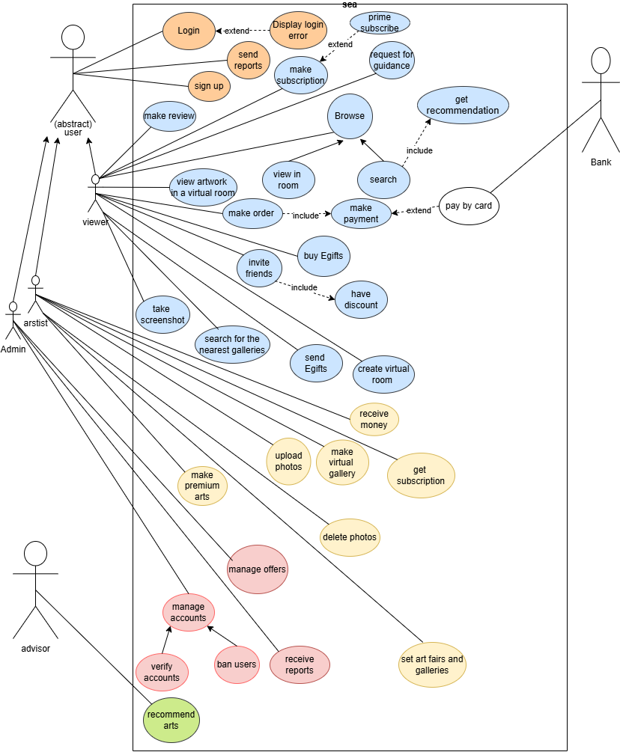
b) use case description:

Use Case: Login (UC01):
Use Case ID | UC01
Use Case Name | Login
Initiator | User
Goal | Enable the user to login
Preconditions | User has access  System is online  Form is visible
Main Success Scenario | System validates input  Request is processed  Success message shown
Alternative Scenarios | Invalid data entered  Server not responding  User not authorized

Postconditions:
- Request saved
- Response logged
- User informed

Use Case: Sign Up (UC02)
Use Case ID | UC02
Use Case Name | Sign Up
Initiator | User
Goal | Enable the user to sign up
Preconditions | User has access  System is online  Form is visible
Main Success Scenario | System validates input  Request is processed  Success message shown
Alternative Scenarios | Invalid data entered  Server not responding  User not authorized
Postconditions:
- Request saved
- Response logged
- User informed

Use Case: Display Login Error (UC03)
Use Case ID | UC03
Use Case Name | Display Login Error
Initiator | System
Goal | Enable the system to display login error
Preconditions | User has access  System is online  Form is visible
Main Success Scenario | System validates input  Request is processed  Success message shown
Alternative Scenarios | Invalid data entered  Server not responding  User not authorized
Postconditions:
- Request saved
- Response logged
- User informed

Use Case: Send Reports (UC04)
Use Case ID | UC04
Use Case Name | Send Reports
Initiator | User
Goal | Enable the user to send reports
Preconditions | User has access  System is online  Form is visible
Main Success Scenario | System validates input  Request is processed  Success message shown
Alternative Scenarios | Invalid data entered  Server not responding  User not authorized
Postconditions:
- Request saved
- Response logged
- User informed

Use Case: Make Review (UC05)
Use Case ID | UC05
Use Case Name | Make Review
Initiator | User
Goal | Enable the user to make review
Preconditions | User has access  System is online  Form is visible
Main Success Scenario | System validates input  Request is processed  Success message shown
Alternative Scenarios | Invalid data entered  Server not responding  User not authorized
Postconditions:
- Request saved
- Response logged
- User informed

Use Case: Browse (UC06)
Use Case ID | UC06
Use Case Name | Browse
Initiator | User
Goal | Enable the user to browse
Preconditions | User has access  System is online  Form is visible
Main Success Scenario | System validates input  Request is processed  Success message shown
Alternative Scenarios | Invalid data entered  Server not responding  User not authorized
Postconditions:
- Request saved
- Response logged
- User informed

Use Case: Make Subscription (UC07)
Use Case ID | UC07
Use Case Name | Make Subscription
Initiator | User
Goal | Enable the user to make subscription
Preconditions | User has access  System is online  Form is visible
Main Success Scenario | System validates input  Request is processed  Success message shown
Alternative Scenarios | Invalid data entered  Server not responding  User not authorized
Postconditions:
- Request saved
- Response logged
- User informed

Use Case: Prime Subscribe (UC08)
Use Case ID | UC08
Use Case Name | Prime Subscribe
Initiator | User
Goal | Enable the user to prime subscribe
Preconditions | User has access  System is online  Form is visible
Main Success Scenario | System validates input  Request is processed  Success message shown
Alternative Scenarios | Invalid data entered  Server not responding  User not authorized
Postconditions:
- Request saved
- Response logged
- User informed

Use Case: Request for Guidance (UC09)
Use Case ID | UC09
Use Case Name | Request for Guidance
Initiator | User
Goal | Enable the user to request for guidance
Preconditions | User has access  System is online  Form is visible
Main Success Scenario | System validates input  Request is processed  Success message shown
Alternative Scenarios | Invalid data entered  Server not responding  User not authorized
Postconditions:
- Request saved
- Response logged
- User informed

Use Case: Get Recommendation (UC10)
Use Case ID | UC10
Use Case Name | Get Recommendation
Initiator | System
Goal | Enable the system to get recommendation
Preconditions | User has access  System is online  Form is visible
Main Success Scenario | System validates input  Request is processed  Success message shown
Alternative Scenarios | Invalid data entered  Server not responding  User not authorized
Postconditions:
- Request saved
- Response logged
- User informed

Use Case: Search (UC11)
Use Case ID | UC11
Use Case Name | Search
Initiator | User
Goal | Enable the user to search
Preconditions | User has access  System is online  Form is visible
Main Success Scenario | System validates input  Request is processed  Success message shown
Alternative Scenarios | Invalid data entered  Server not responding  User not authorized
Postconditions:
- Request saved
- Response logged
- User informed

Use Case: Make Payment (UC12)
Use Case ID | UC12
Use Case Name | Make Payment
Initiator | User
Goal | Enable the user to make payment
Preconditions | User has access  System is online  Form is visible
Main Success Scenario | System validates input  Request is processed  Success message shown
Alternative Scenarios | Invalid data entered  Server not responding  User not authorized
Postconditions:
- Request saved
- Response logged
- User informed

Use Case: Pay by Card (UC13)
Use Case ID | UC13
Use Case Name | Pay by Card
Initiator | User
Goal | Enable the user to pay by card
Preconditions | User has access  System is online  Form is visible
Main Success Scenario | System validates input  Request is processed  Success message shown
Alternative Scenarios | Invalid data entered  Server not responding  User not authorized
Postconditions:
- Request saved
- Response logged
- User informed

Use Case: Buy eGifts (UC14)
Use Case ID | UC14
Use Case Name | Buy eGifts
Initiator | User
Goal | Enable the user to buy egifts
Preconditions | User has access  System is online  Form is visible
Main Success Scenario | System validates input  Request is processed  Success message shown
Alternative Scenarios | Invalid data entered  Server not responding  User not authorized
Postconditions:
- Request saved
- Response logged
- User informed

Use Case: Send eGifts (UC15)
Use Case ID | UC15
Use Case Name | Send eGifts
Initiator | System
Goal | Enable the system to send egifts
Preconditions | User has access  System is online  Form is visible
Main Success Scenario | System validates input  Request is processed  Success message shown
Alternative Scenarios | Invalid data entered  Server not responding  User not authorized
Postconditions:
- Request saved
- Response logged
- User informed

Use Case: Invite Friends (UC16)
Use Case ID | UC16
Use Case Name | Invite Friends
Initiator | User
Goal | Enable the user to invite friends
Preconditions | User has access  System is online  Form is visible
Main Success Scenario | System validates input  Request is processed  Success message shown
Alternative Scenarios | Invalid data entered  Server not responding  User not authorized
Postconditions:
- Request saved
- Response logged
- User informed

Use Case: Have Discount (UC17)
Use Case ID | UC17
Use Case Name | Have Discount
Initiator | System
Goal | Enable the system to have discount
Preconditions | User has access  System is online  Form is visible
Main Success Scenario | System validates input  Request is processed  Success message shown
Alternative Scenarios | Invalid data entered  Server not responding  User not authorized
Postconditions:
- Request saved
- Response logged
- User informed

Use Case: View in Room (UC18)
Use Case ID | UC18
Use Case Name | View in Room
Initiator | User
Goal | Enable the user to view in room
Preconditions | User has access  System is online  Form is visible
Main Success Scenario | System validates input  Request is processed  Success message shown
Alternative Scenarios | Invalid data entered  Server not responding  User not authorized
Postconditions:
- Request saved
- Response logged
- User informed

Use Case: View Artwork in Virtual Room (UC19)
Use Case ID | UC19
Use Case Name | View Artwork in Virtual Room
Initiator | User
Goal | Enable the user to view artwork in virtual room
Preconditions | User has access  System is online  Form is visible
Main Success Scenario | System validates input  Request is processed  Success message shown
Alternative Scenarios | Invalid data entered  Server not responding  User not authorized
Postconditions:
- Request saved
- Response logged
- User informed

Use Case: Take Screenshot (UC20)
Use Case ID | UC20
Use Case Name | Take Screenshot
Initiator | User
Goal | Enable the user to take screenshot
Preconditions | User has access  System is online  Form is visible
Main Success Scenario | System validates input  Request is processed  Success message shown
Alternative Scenarios | Invalid data entered  Server not responding  User not authorized
Postconditions:
- Request saved
- Response logged
- User informed

Use Case: Search for the Nearest Galleries (UC21)
Use Case ID | UC21
Use Case Name | Search for the Nearest Galleries
Initiator | User
Goal | Enable the user to search for the nearest galleries
Preconditions | User has access  System is online  Form is visible
Main Success Scenario | System validates input  Request is processed  Success message shown
Alternative Scenarios | Invalid data entered  Server not responding  User not authorized
Postconditions:
- Request saved
- Response logged
- User informed

Use Case: Create Virtual Room (UC22)
Use Case ID | UC22
Use Case Name | Create Virtual Room
Initiator | User
Goal | Enable the user to create virtual room
Preconditions | User has access  System is online  Form is visible
Main Success Scenario | System validates input  Request is processed  Success message shown
Alternative Scenarios | Invalid data entered  Server not responding  User not authorized
Postconditions:
- Request saved
- Response logged
- User informed

Use Case: Receive Money (UC23)
Use Case ID | UC23
Use Case Name | Receive Money
Initiator | User
Goal | Enable the user to receive money
Preconditions | User has access  System is online  Form is visible
Main Success Scenario | System validates input  Request is processed  Success message shown
Alternative Scenarios | Invalid data entered  Server not responding  User not authorized
Postconditions:
- Request saved
- Response logged
- User informed

Use Case: Upload Photos (UC24)
Use Case ID | UC24
Use Case Name | Upload Photos
Initiator | Artist
Goal | Enable the artist to upload photos
Preconditions | User has access  System is online  Form is visible
Main Success Scenario | System validates input  Request is processed  Success message shown
Alternative Scenarios | Invalid data entered  Server not responding  User not authorized
Postconditions:
- Request saved
- Response logged
- User informed

Use Case: Make Virtual Gallery (UC25)
Use Case ID | UC25
Use Case Name | Make Virtual Gallery
Initiator | Artist
Goal | Enable the artist to make virtual gallery
Preconditions | User has access  System is online  Form is visible
Main Success Scenario | System validates input  Request is processed  Success message shown
Alternative Scenarios | Invalid data entered  Server not responding  User not authorized
Postconditions:
- Request saved
- Response logged
- User informed

Use Case: Get Subscription (UC26)
Use Case ID | UC26
Use Case Name | Get Subscription
Initiator | User
Goal | Enable the user to get subscription
Preconditions | User has access  System is online  Form is visible
Main Success Scenario | System validates input  Request is processed  Success message shown
Alternative Scenarios | Invalid data entered  Server not responding  User not authorized
Postconditions:
- Request saved
- Response logged
- User informed

Use Case: Delete Photos (UC27)
Use Case ID | UC27
Use Case Name | Delete Photos
Initiator | Artist
Goal | Enable the artist to delete photos
Preconditions | User has access  System is online  Form is visible
Main Success Scenario | System validates input  Request is processed  Success message shown
Alternative Scenarios | Invalid data entered  Server not responding  User not authorized
Postconditions:
- Request saved
- Response logged
- User informed

Use Case: Set Art Fairs and Galleries (UC28)
Use Case ID | UC28
Use Case Name | Set Art Fairs and Galleries
Initiator | Artist
Goal | Enable the artist to set art fairs and galleries
Preconditions | User has access  System is online  Form is visible
Main Success Scenario | System validates input  Request is processed  Success message shown
Alternative Scenarios | Invalid data entered  Server not responding  User not authorized
Postconditions:
- Request saved
- Response logged
- User informed

Use Case: Make Premium Arts (UC29)
Use Case ID | UC29
Use Case Name | Make Premium Arts
Initiator | Artist
Goal | Enable the artist to make premium arts
Preconditions | User has access  System is online  Form is visible
Main Success Scenario | System validates input  Request is processed  Success message shown
Alternative Scenarios | Invalid data entered  Server not responding  User not authorized
Postconditions:
- Request saved
- Response logged
- User informed

Use Case: Manage Offers (UC30)
Use Case ID | UC30
Use Case Name | Manage Offers
Initiator | Admin
Goal | Enable the admin to manage offers
Preconditions | User has access  System is online  Form is visible
Main Success Scenario | System validates input  Request is processed  Success message shown
Alternative Scenarios | Invalid data entered  Server not responding  User not authorized
Postconditions:
- Request saved
- Response logged
- User informed

Use Case: Manage Accounts (UC31)
Use Case ID | UC31
Use Case Name | Manage Accounts
Initiator | Admin
Goal | Enable the admin to manage accounts
Preconditions | User has access  System is online  Form is visible
Main Success Scenario | System validates input  Request is processed  Success message shown
Alternative Scenarios | Invalid data entered  Server not responding  User not authorized
Postconditions:
- Request saved
- Response logged
- User informed

Use Case: Verify Accounts (UC32)
Use Case ID | UC32
Use Case Name | Verify Accounts
Initiator | Admin
Goal | Enable the admin to verify accounts
Preconditions | User has access  System is online  Form is visible
Main Success Scenario | System validates input  Request is processed  Success message shown
Alternative Scenarios | Invalid data entered  Server not responding  User not authorized
Postconditions:
- Request saved
- Response logged
- User informed

Use Case: Ban Users (UC33)
Use Case ID | UC33
Use Case Name | Ban Users
Initiator | Admin
Goal | Enable the admin to ban users
Preconditions | User has access  System is online  Form is visible
Main Success Scenario | System validates input  Request is processed  Success message shown
Alternative Scenarios | Invalid data entered  Server not responding  User not authorized
Postconditions:
- Request saved
- Response logged
- User informed

Use Case: Receive Reports (UC34)
Use Case ID | UC34
Use Case Name | Receive Reports
Initiator | Admin
Goal | Enable the admin to receive reports
Preconditions | User has access  System is online  Form is visible
Main Success Scenario | System validates input  Request is processed  Success message shown
Alternative Scenarios | Invalid data entered  Server not responding  User not authorized
Postconditions:
- Request saved
- Response logged
- User informed

Use Case: Recommend Arts (UC35)
Use Case ID | UC35
Use Case Name | Recommend Arts
Initiator | Advisor
Goal | Enable the advisor to recommend arts
Preconditions | User has access  System is online  Form is visible
Main Success Scenario | System validates input  Request is processed  Success message shown
Alternative Scenarios | Invalid data entered  Server not responding  User not authorized
Postconditions:
- Request saved
- Response logged
- User informed

c) package diagram:
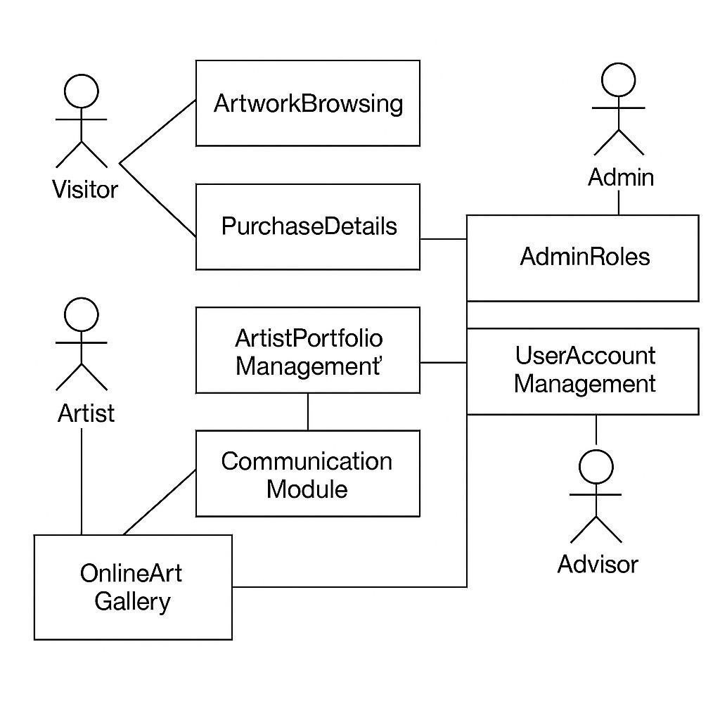

9)Structural and Behavioural Diagrams:
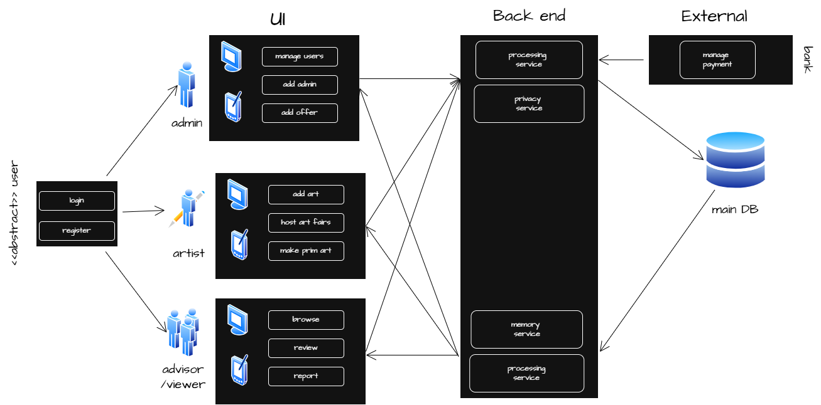
a)Application system architecture diagram:
- Support the different types of users
- Support the flow
- Support the 3 layers of the website
b)UI complexity : the website provides UI for 4 types of users
- abstract user :
1- viewer 2- admin
3-advisor 4-artist
c)Backend complexity :the website provides 1- privacy for any input data
2-processing for any needs
3-great memory for any output data
d)DB complexity :the website provides high privacy ,great and responsive data base service
e)the website provides interaction between users and external system (eg : bank) through the 3 layers

b) Activity diagram:
browse , view in room, recommendations ,search
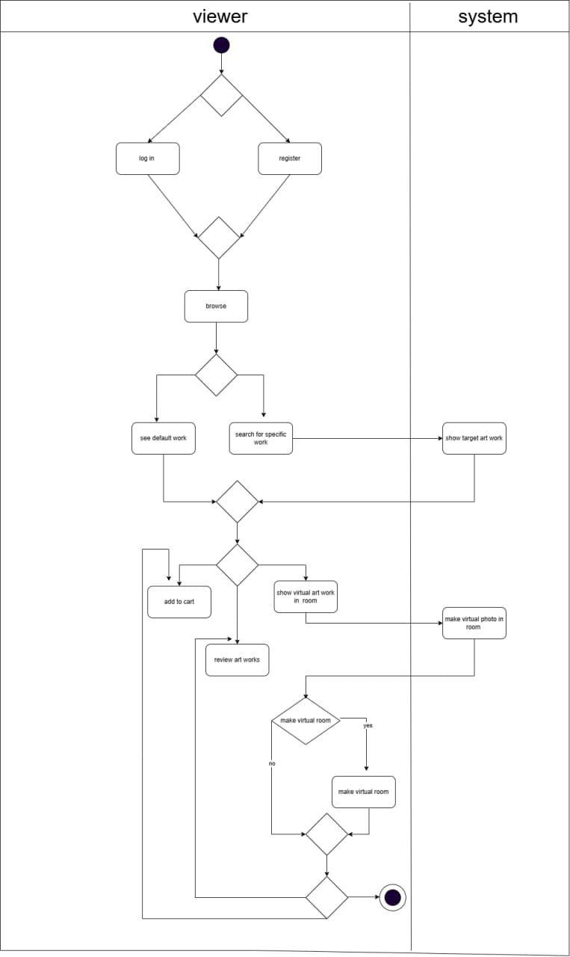

Make payments, make order, pay by card, get money
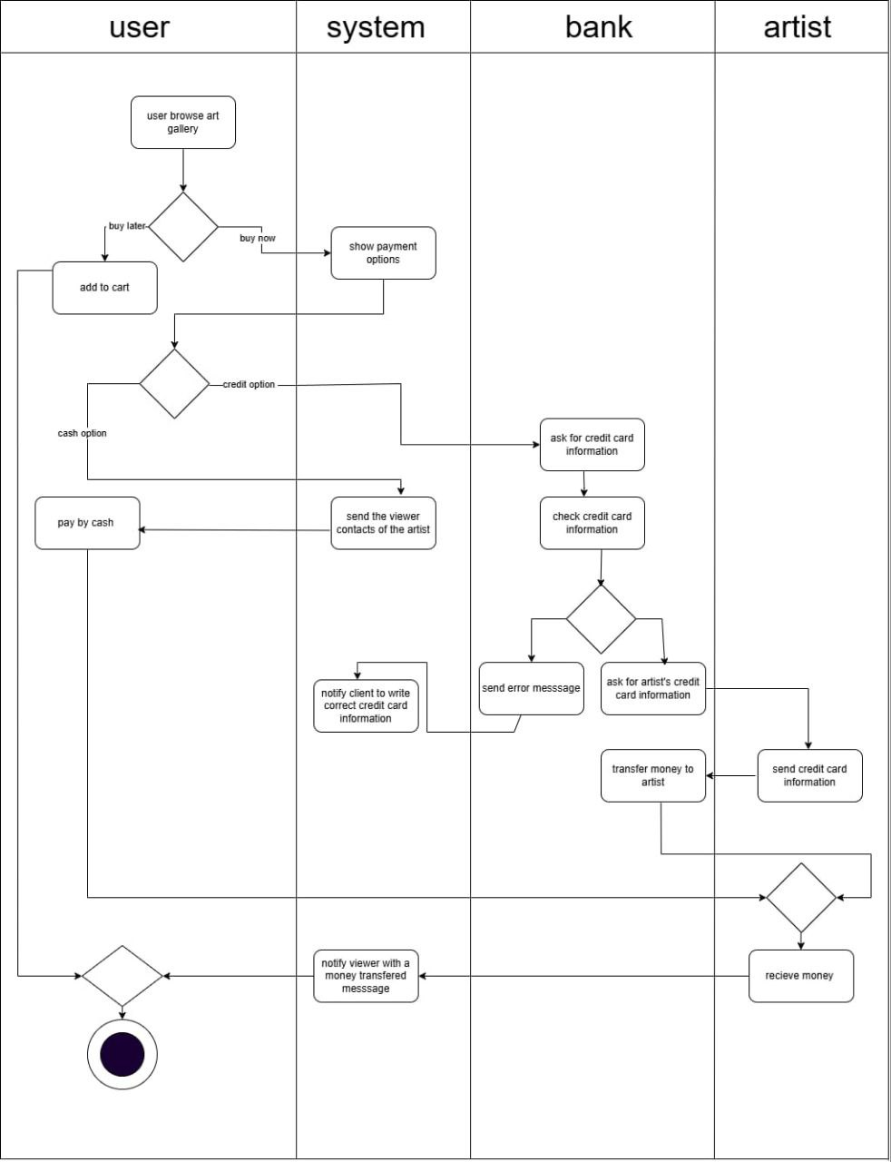

Request guide , recommend arts
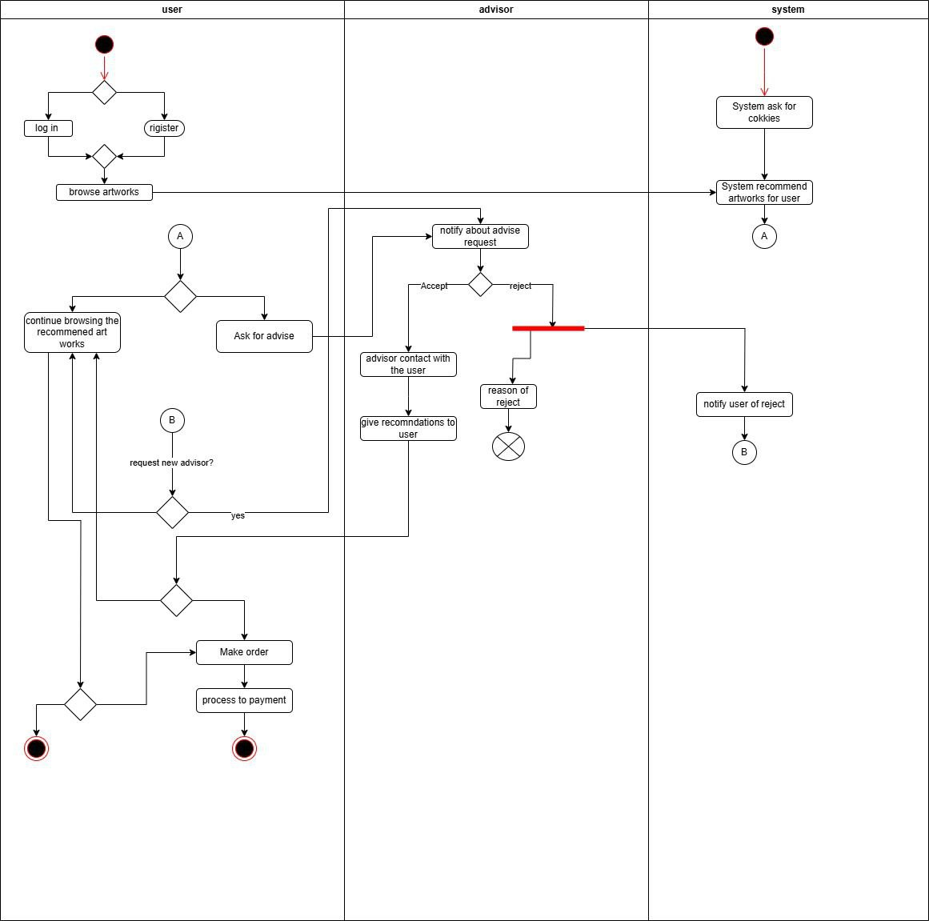

Search for nearest artFairs , set artFairs:
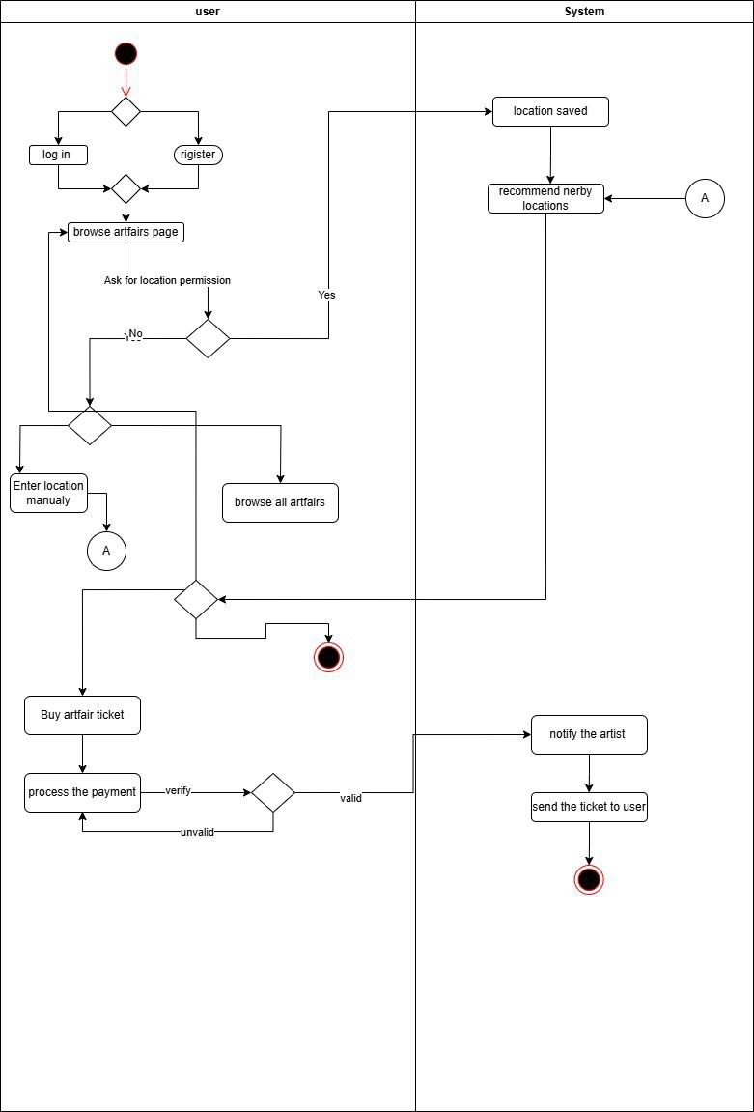
Send reports
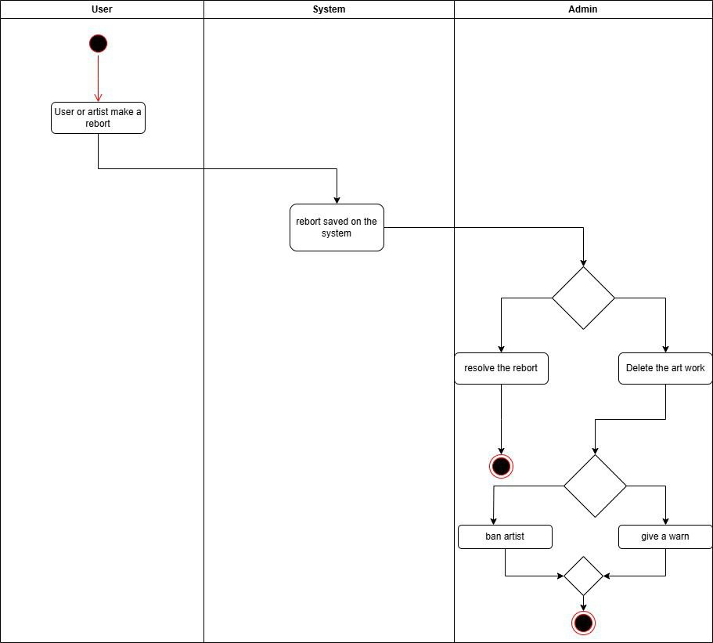

Manage offers:
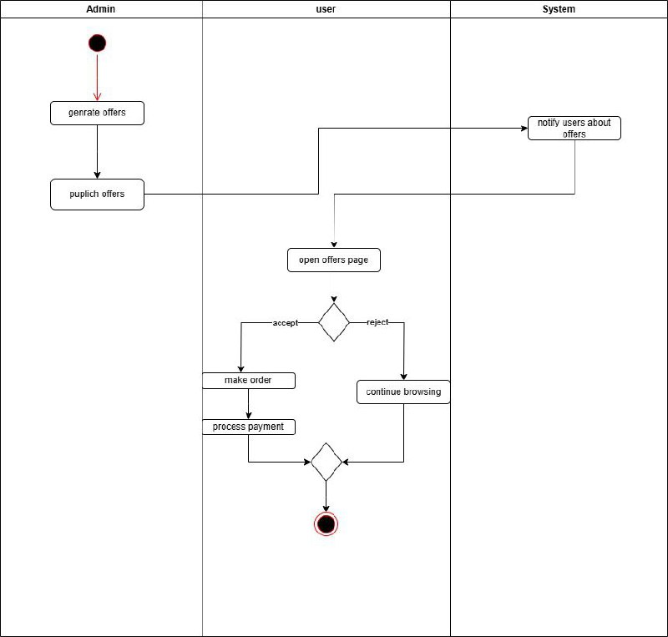

Make sup , get sup , get money from sup:
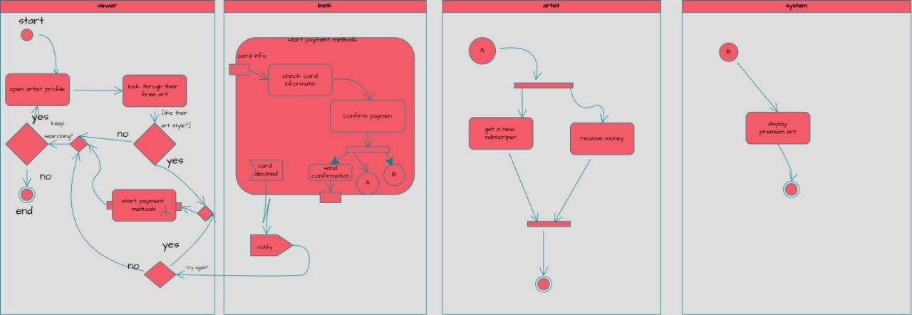

Buy Egifts , Send Egifts , ReciveEgifts:
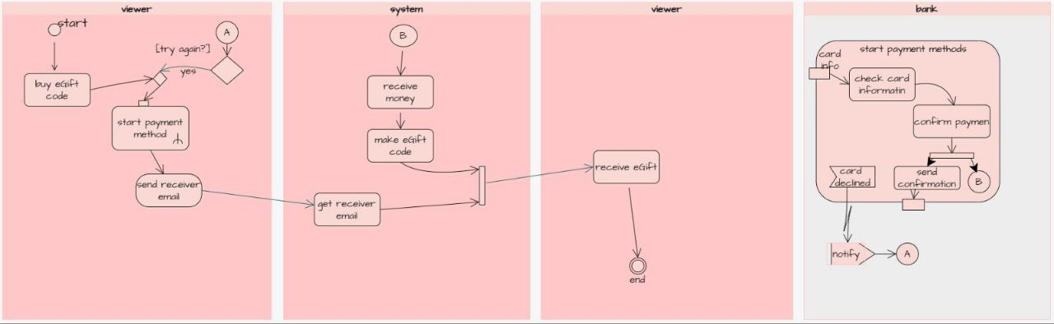

Sign up:
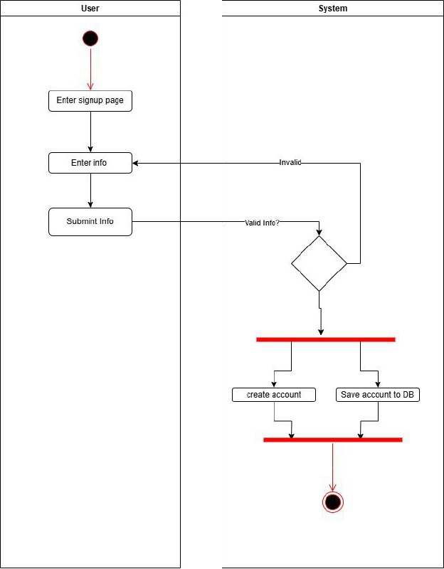
Log in:
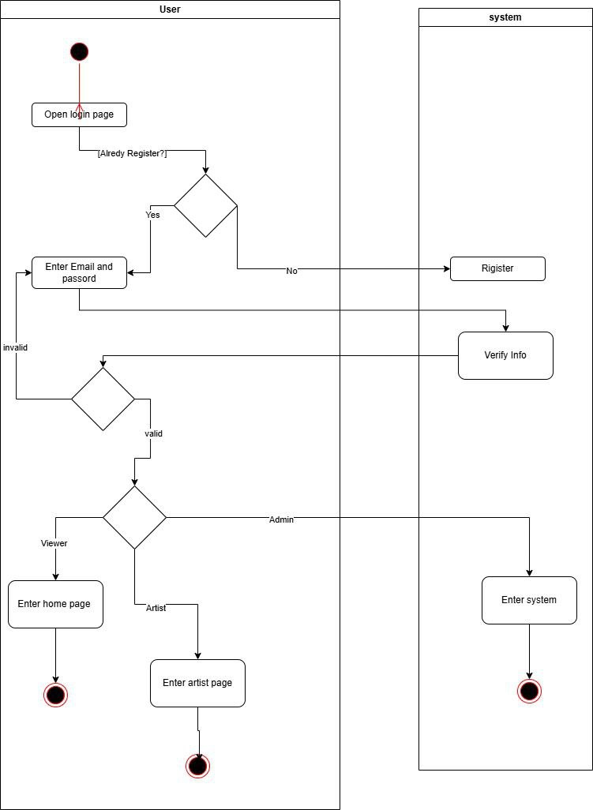

Upload photos , add to vr gallery , make premium arts :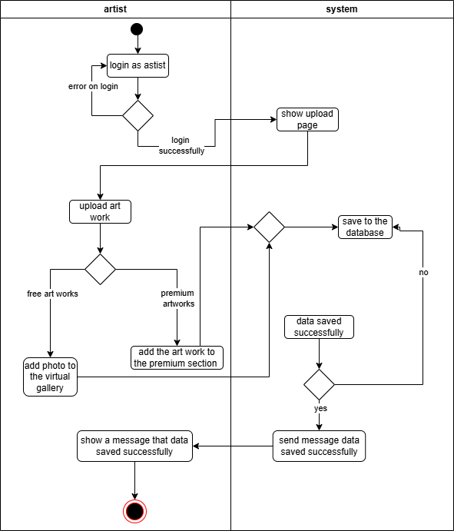

D) Class diagram version 1:
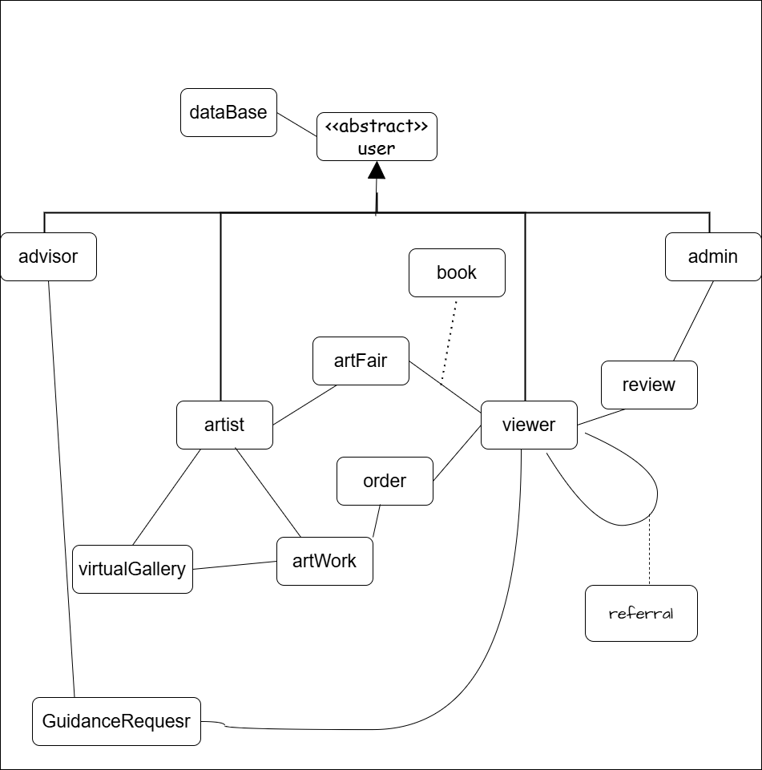

E) sequence diagram:
Login:

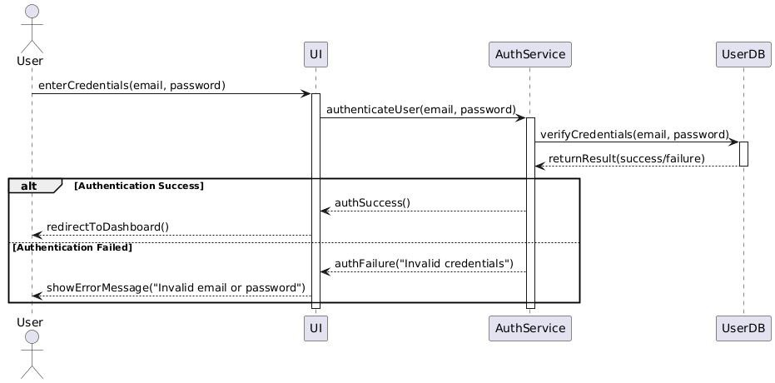

Sign up:
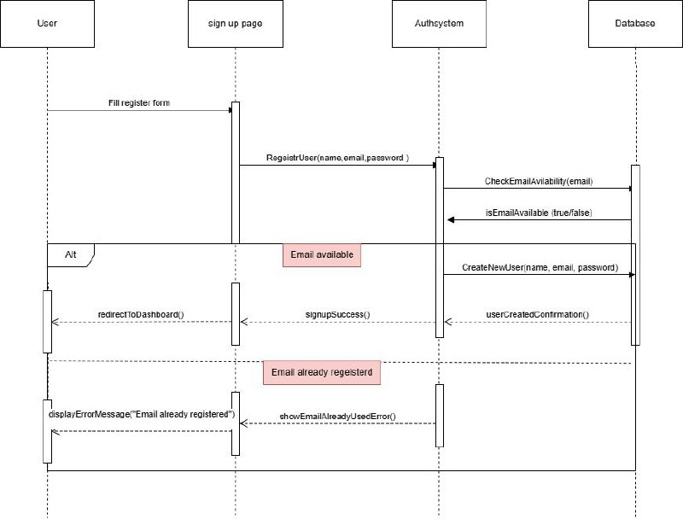

Browse:
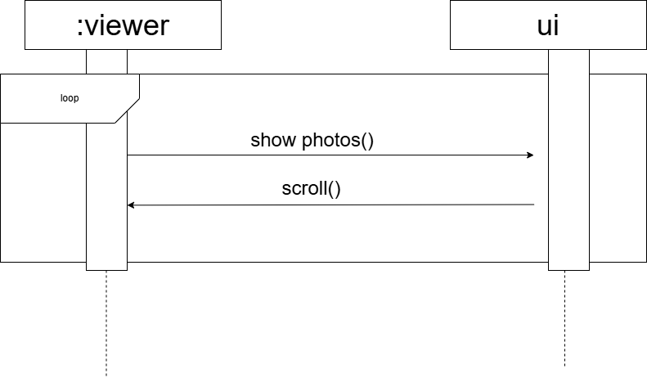

Make review:
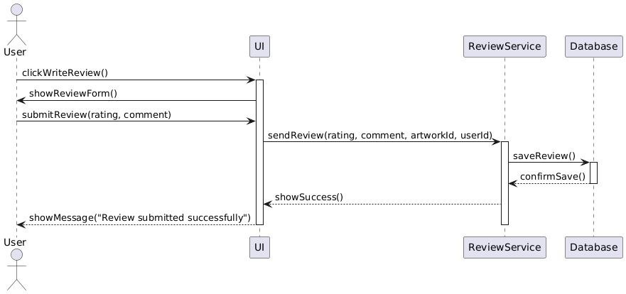

Make subscription:
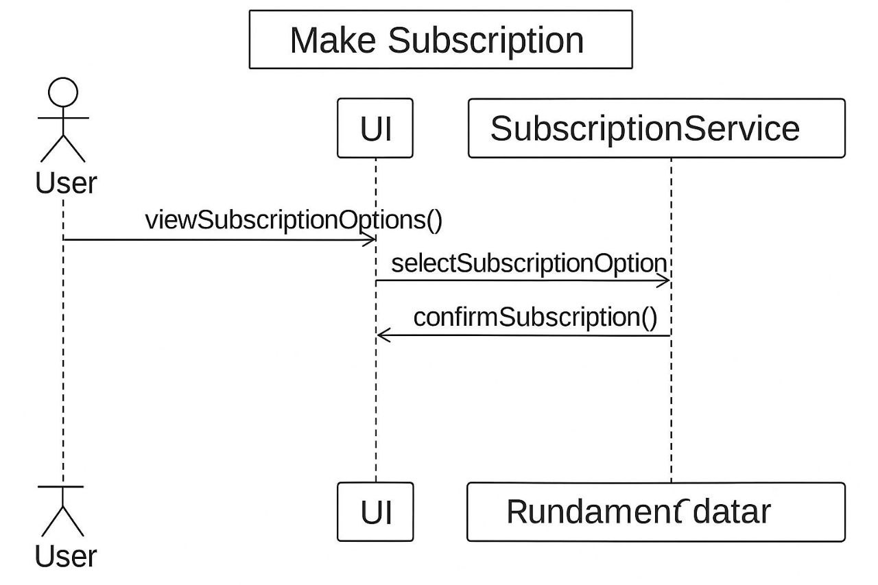

Make prime subscription :
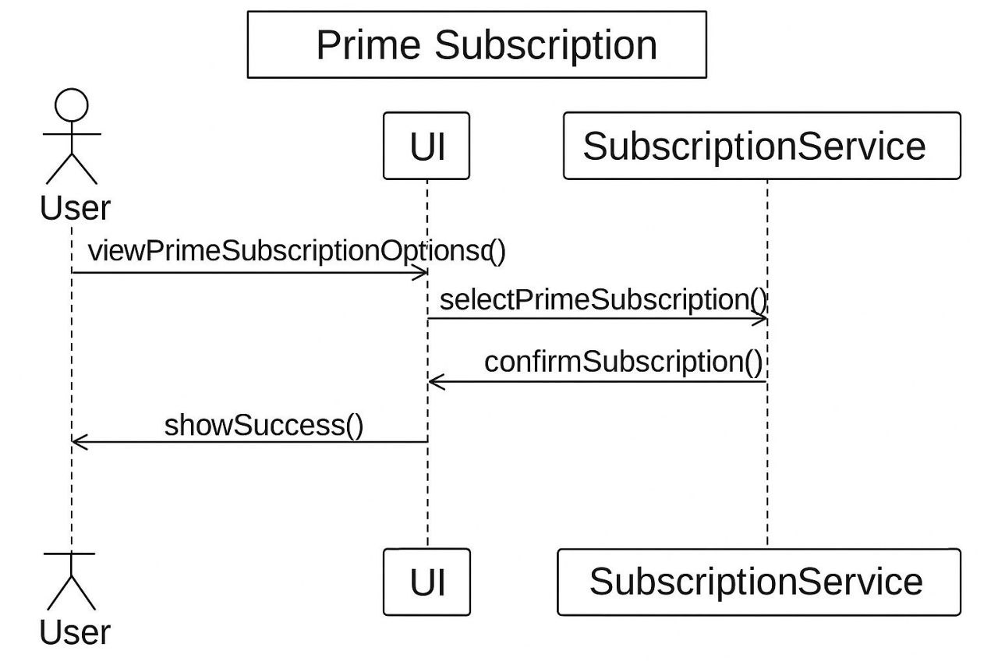

Request for guidance:

View artwork in a virtual Room:

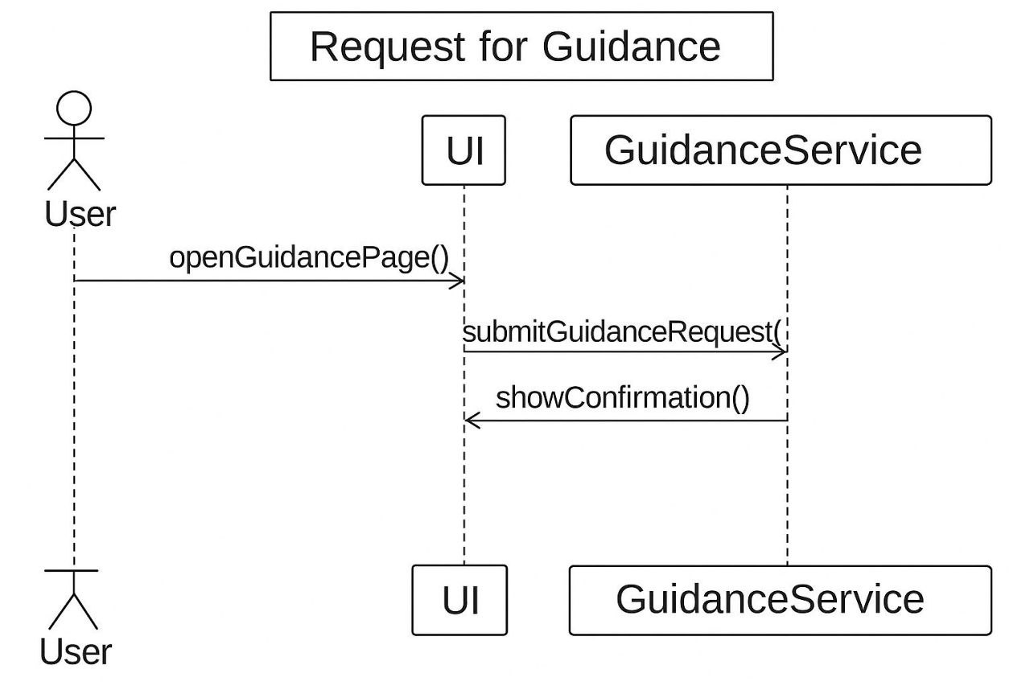

Search for the nearest gallery :
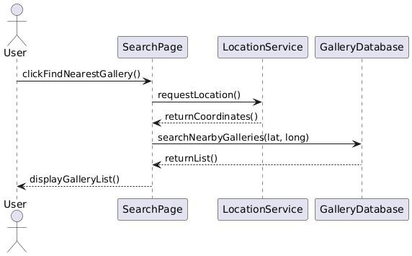

Pay By Card:
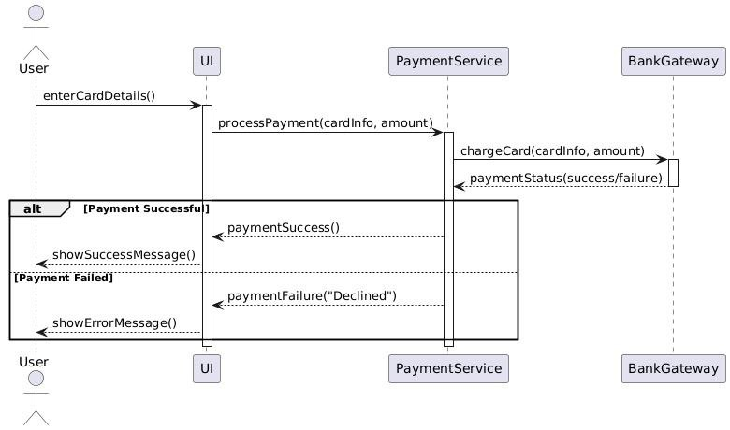

Invite Friends:
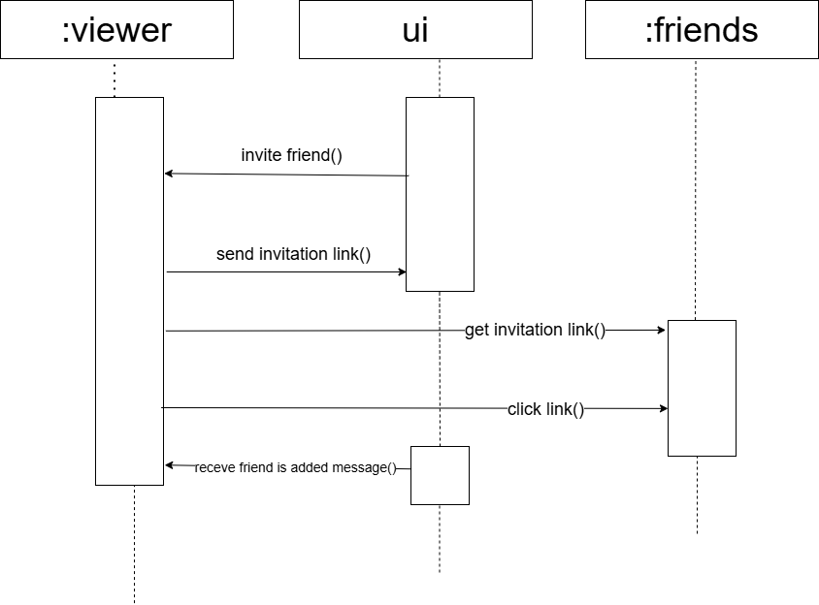

View in room:
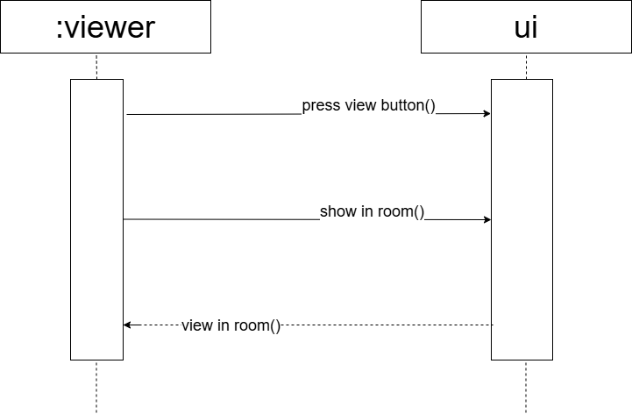

Get Recommendations:
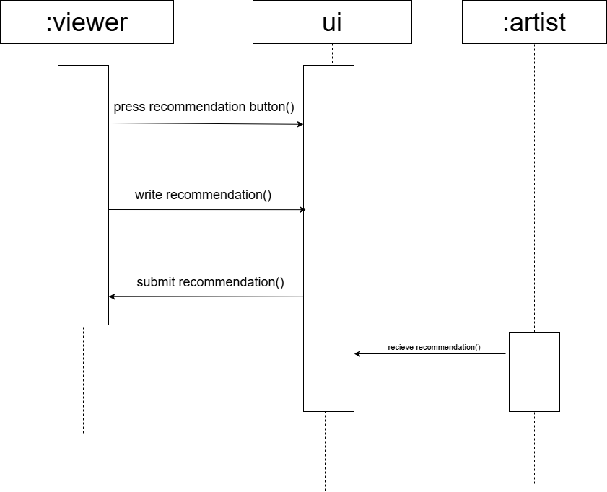

Have discount:
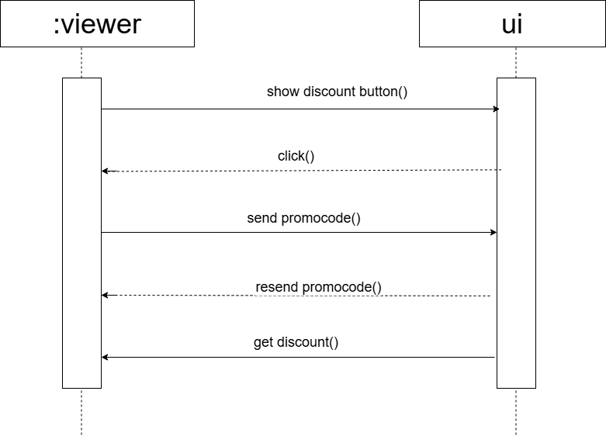

Send Egifts:
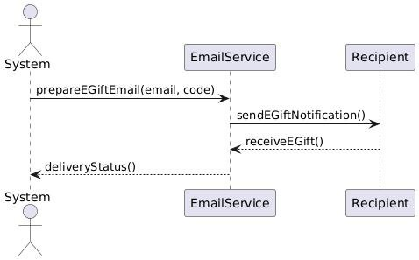

Take screenshot:
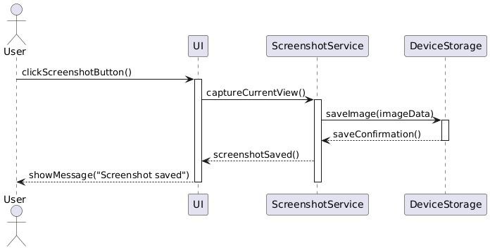
Send reports:
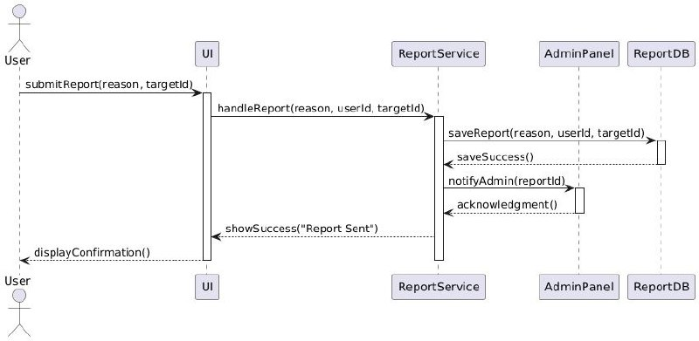

BAN USERS:
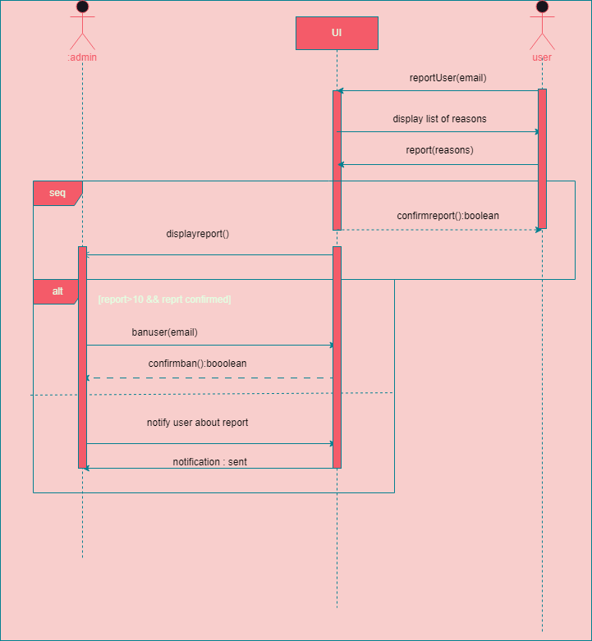

Manange Weekly collections:

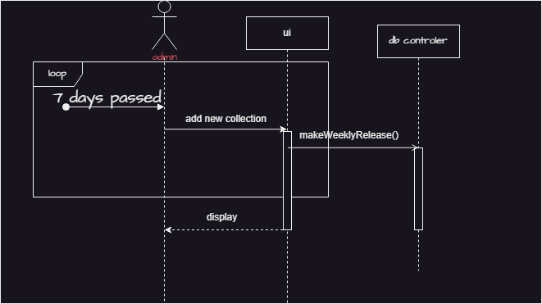

Manage accounts:
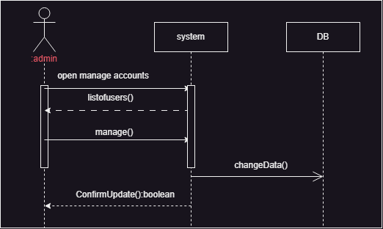

Recommend:
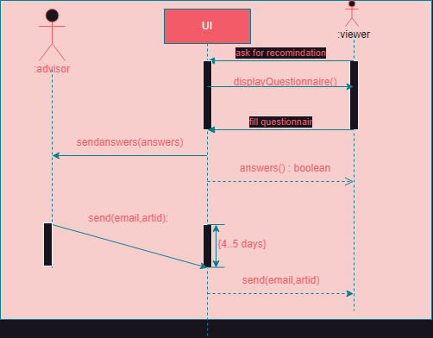
Verify accounts:
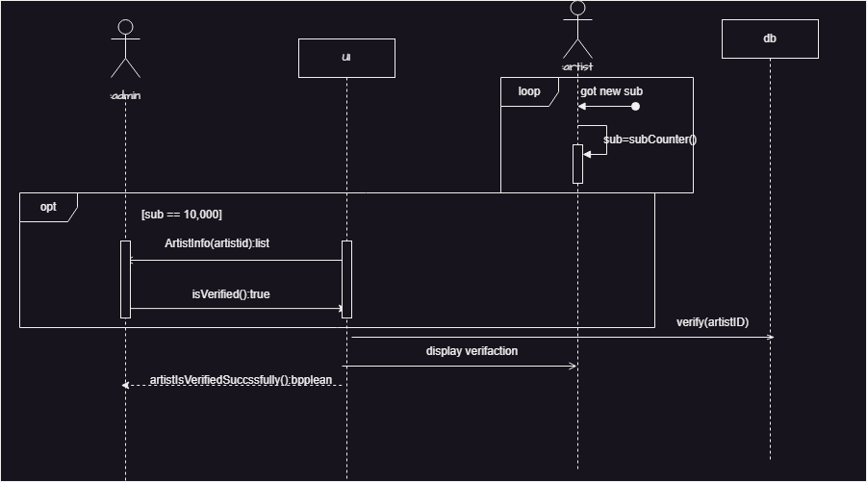

Buy Egifts:

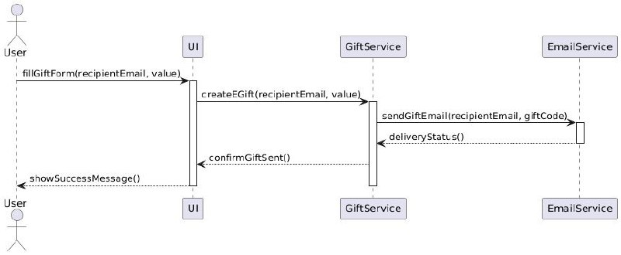

Receive money:
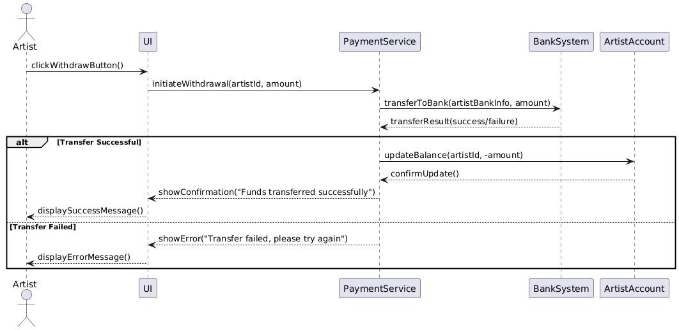

Make virtual gallery:
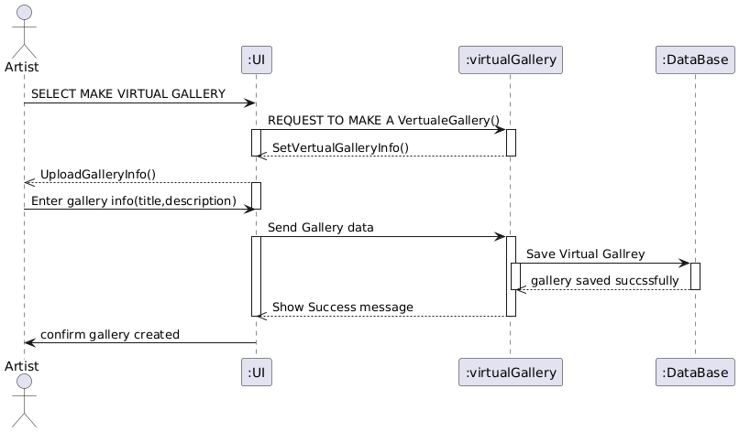

Get subscription:
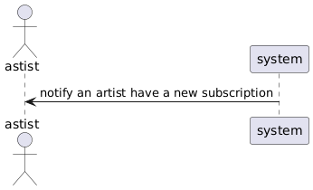

Upload photo:
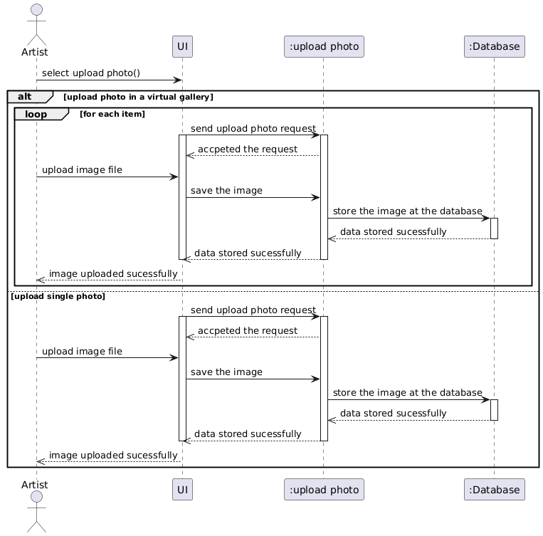

Set art fair:
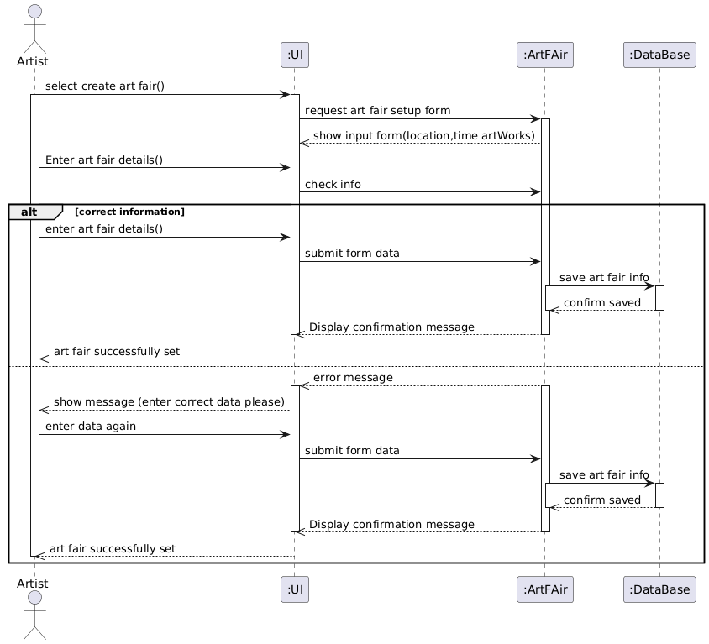

Delete photo:
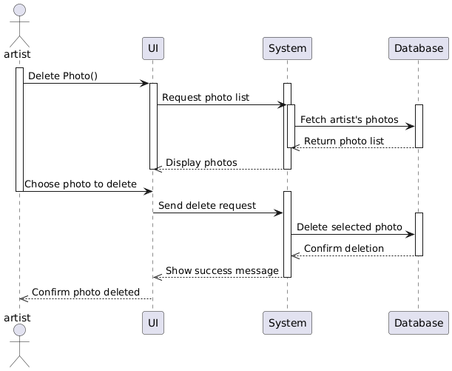

g)collection or collaboration diagram:
login:
signup:
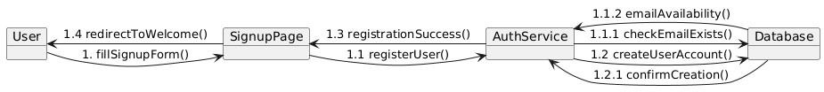
Find nearest gallery:
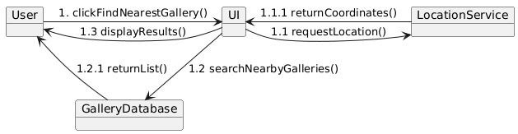Buy Egifts:
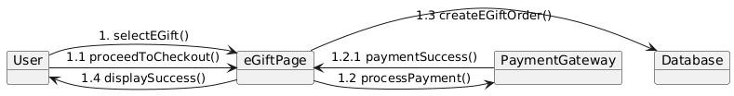

send Egifts:

Make review:
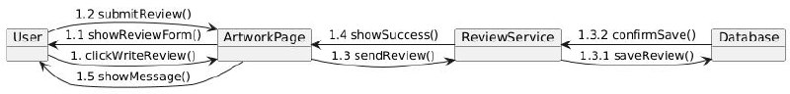

Make report:
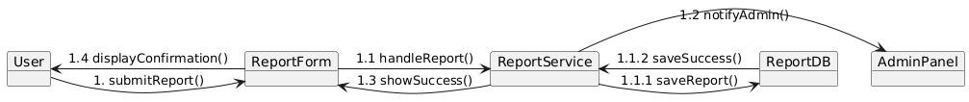

Pay by card:
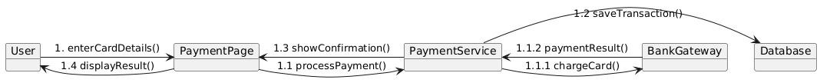

Receive Money:
Make weekly collections:
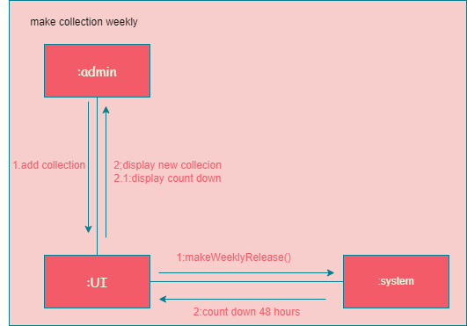

Manage Accounts:
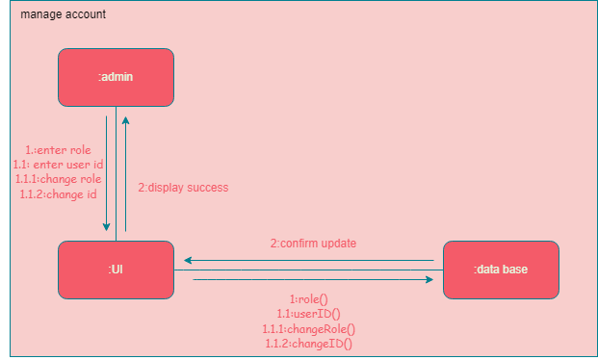
Manage Offers: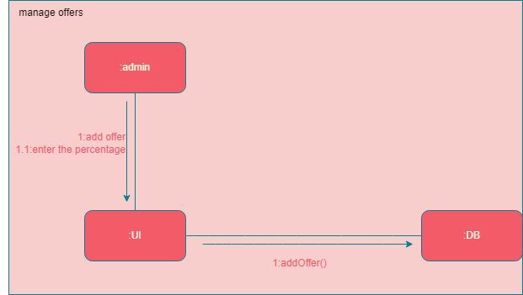

Recive Money:
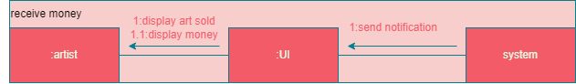

Recommend Arts:
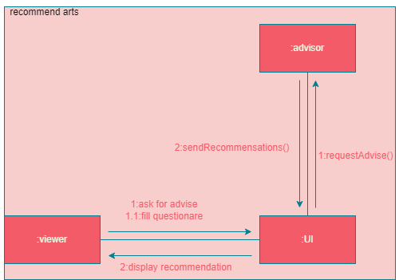

Verfiy Accounts:
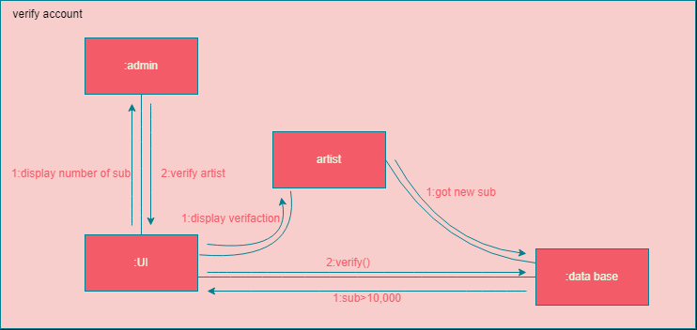

Have discount:

Ask for Recommendation:
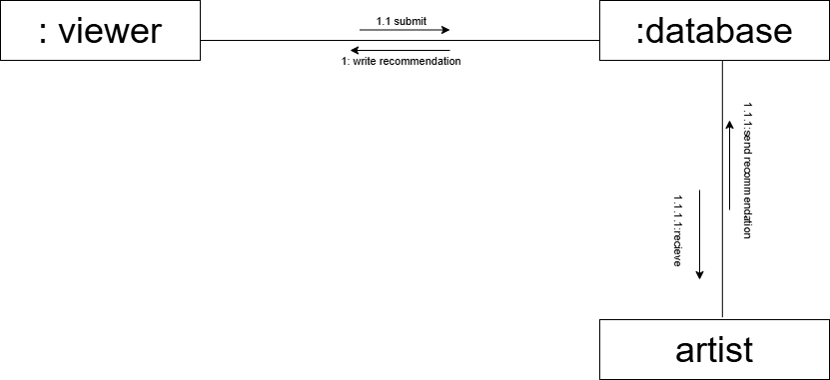
View in room:

Invite Friends:
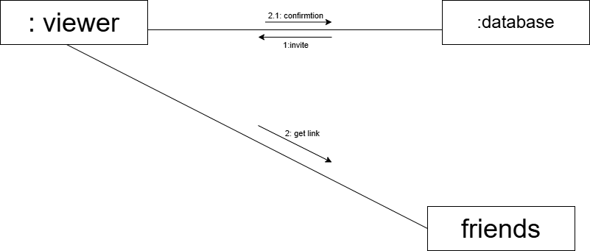

Search:

h) :
we use a one central actor for design this use case diagram.
Potential Advantages:
- Simplicity & Clarity
  - Easy to understand, as all interactions stem from one main actor.
  - Good for systems where a single role (e.g., "User") performs most actions.
- Good for Basic Systems
  - Works well for straightforward applications (e.g., an art platform where users log in, view artwork, make orders, etc.).
- Easy to Expand
  - New use cases can be added without restructuring the entire diagram.
Potential Disadvantages:
- Lack of Role Separation
  - If multiple actors (e.g., "Admin," "Artist," "Guest") have different permissions, clumping everything under one actor can cause confusion.
  - Example: "Remove reports" and "Verify accounts" should likely belong to an Admin, not a general user.
- Overcrowding
  - If too many use cases are tied to one actor, the diagram becomes messy and hard to read.
- Ambiguity in System Behavior
  - Without clear actor distinctions, it’s unclear who can perform certain actions (e.g., "Manage accounts" could apply to both users and admins, but with different privileges).

I)Class diagram version2: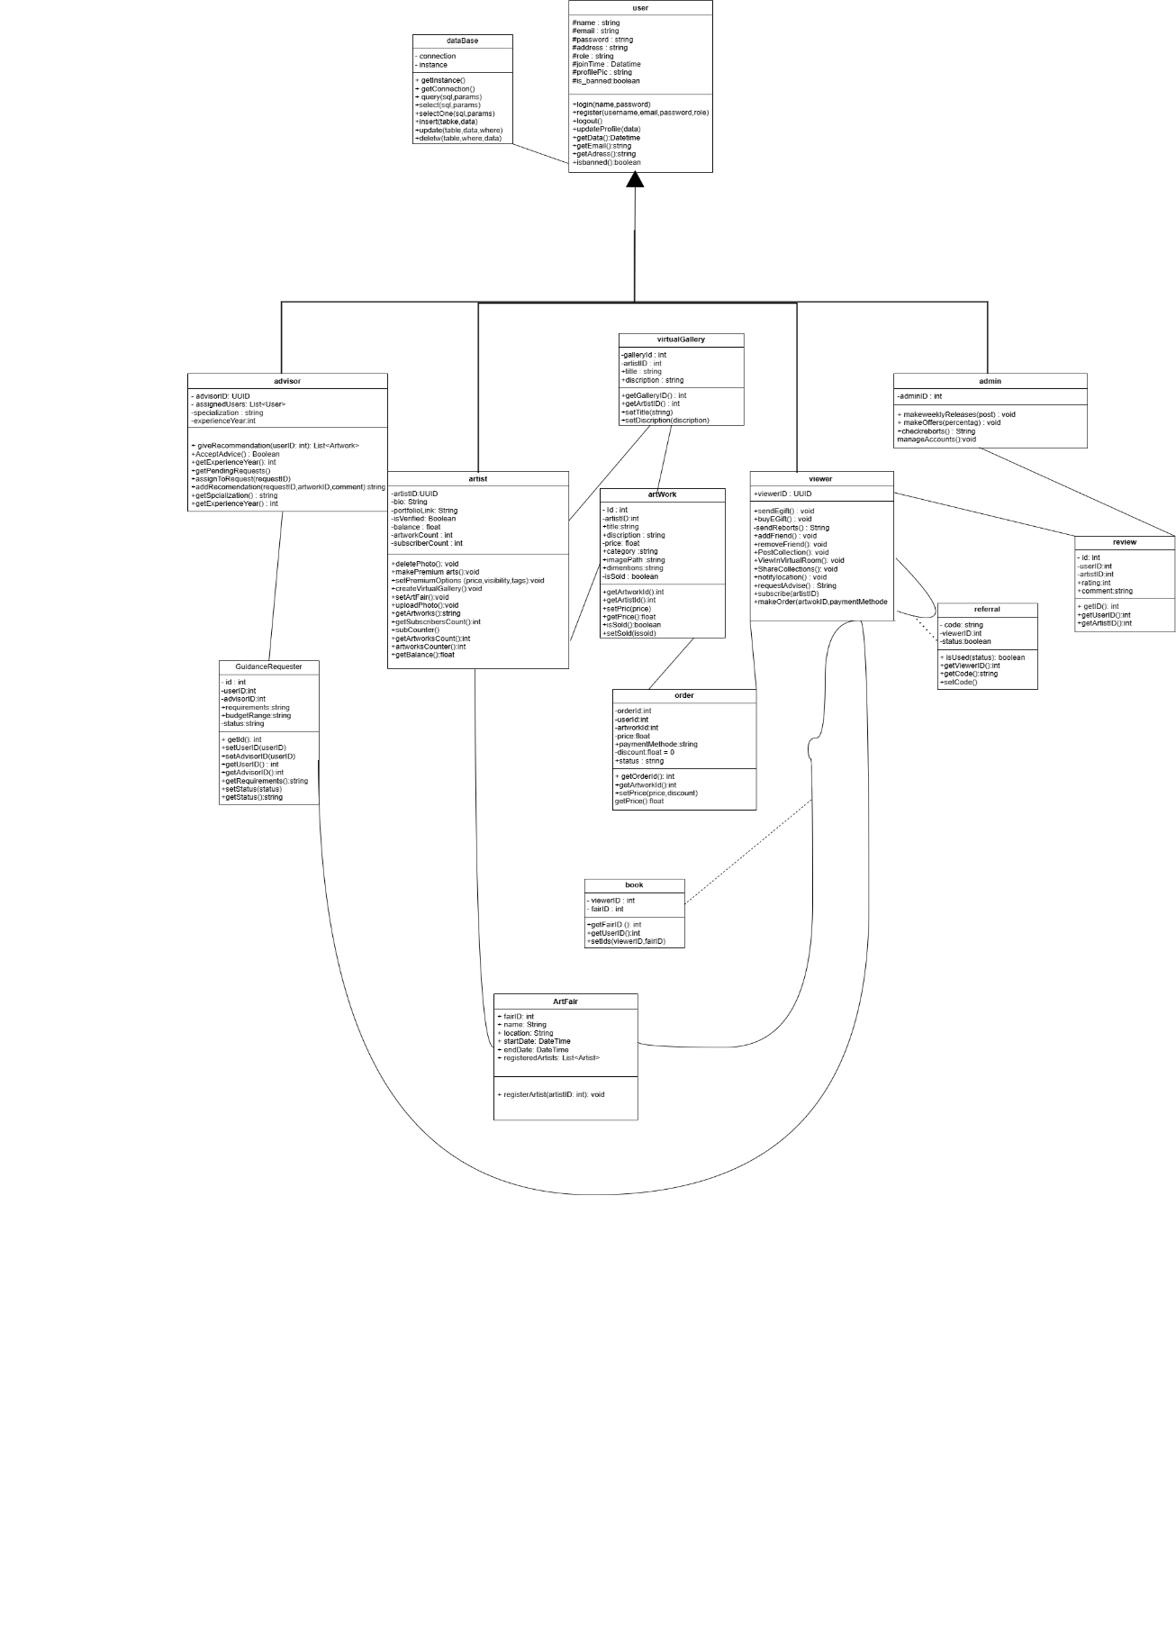

j) design patterns:
Design patterns
1.BEHAVIOURAL pattern
OBSERVER / PUBLISH-SUBSCRIBE
Context: is a behavioral design pattern that establishes a one-to-many dependency
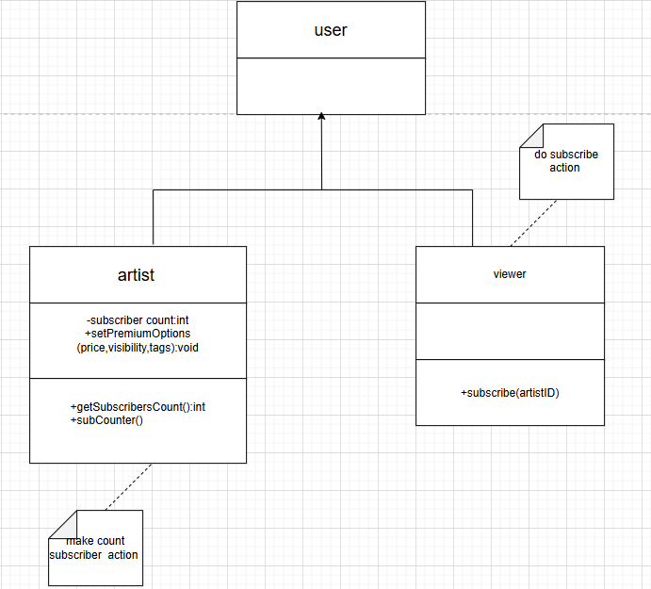
between objects, so that when one object (the subject) changes its state, all dependent
objects (observers) are notified and updated automatically

Problems: The main problem that the Observer pattern aims to solve is the need for
a flexible and decoupled way to notify multiple objects about changes in the state of
a subject object.
Forces:
1. Allow multiple observers to be notified of state changes.
2. Maintain consistency between subject and observer objects.
3. Improve scalability and flexibility of the system.
Solutions: 1. We can establish a communication mechanism where users (observers)
can subscribe to receive notifications or updates from specific components (subjects)
in the system. This can be useful for notifying travelers and hosts about new requests,
updates on listings, reviews, or any other relevant information.
2. we can enable real-time updates and notifications for users when there
are changes or events that they need to be informed about. For example, hosts can
receive notifications when a traveler requests to stay at their accommodation, or
travelers can be notified when hosts respond to their requests.
3. supports a scalable and extensible notification system where new types
of notifications or events can be easily added without affecting existing components.
This flexibility is beneficial in a dynamic system like yours, where new features or
functionalities may be introduced over time.

2.CREATIONAL pattern
Immutable Pattern
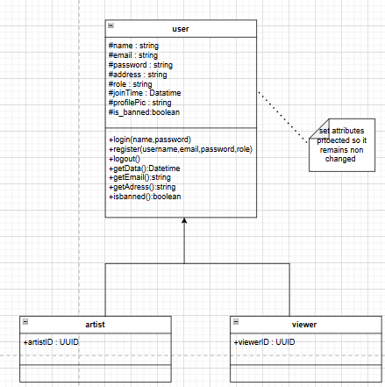
Context: In an online art gallery system, once artwork metadata such as the title, artist name, creation date, and medium are uploaded, they should not change to maintain historical accuracy and prevent fraud or tampering.
Problems: The main problem that we ensure that the core attributes of an artwork (such as artist name and date created) remain unchanged after being uploaded, even by mistake or through unauthorized access
Forces: • Data integrity is crucial for legal and artistic trust.
• Admins or malicious users may accidentally or intentionally alter metadata.
• Back-end services may introduce bugs that alter shared objects.
• Concurrent system access (e.g., caching or API exposure) may lead to race conditions.
Solution: Use immutable objects to model the artwork metadata. Once created, these objects cannot be modified. Any change requires creating a new version or object instance.

3.Structural pattern
Decorator Pattern
Context:
In an online art gallery system, artworks may require additional features such as framing, limited edition status, or primum . These enhancements should be added without modifying the core Artwork class or creating a large number of subclasses.
Problem:
How can we add new, optional features to artworks without altering the base class or creating a complex inheritance hierarchy?
Forces:
• Artwork data should remain unchanged to ensure database consistency.
• Features like "Framed", "Limited Edition", etc., may be combined in various ways.
• The system must remain open to new features without modifying existing code (Open/Closed Principle).
Solution:
Use the Decorator Pattern to wrap Artwork objects with additional feature objects. Each decorator implements the same interface and can modify or extend the behavior of the base Artwork dynamically.
Related Patterns:
• Strategy Pattern: If enhancements require interchangeable algorithms.
• Composite Pattern: When decorators are combined and treated as a tree of objects.
• Adapter Pattern: For converting interface of the artwork to be compatible with external libraries or frameworks.
References:
• Design Patterns: Elements of Reusable Object-Oriented Software – Gamma et al.
• Applied in the current project to support modular enhancement of artwork listings in a virtual gallery.

K)Class diagram version 3:
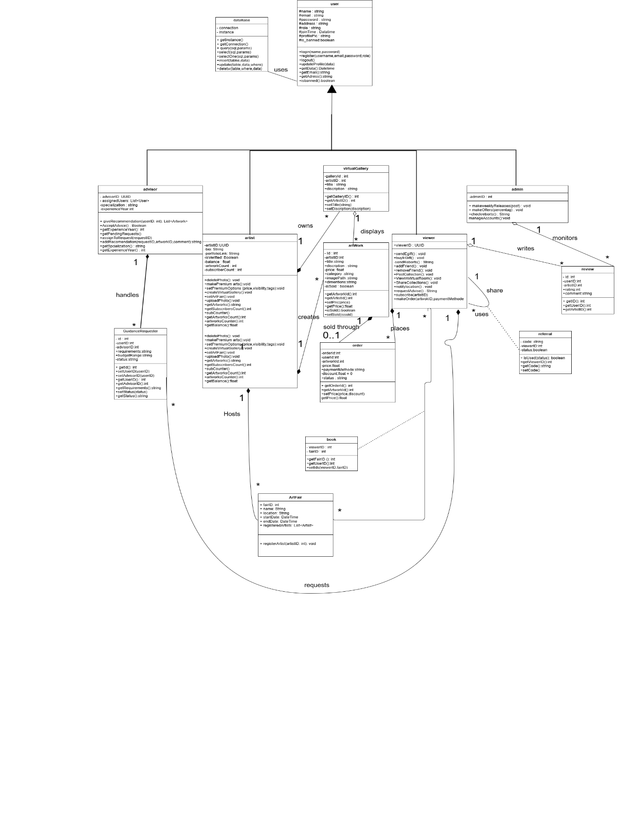

L)
Avoiding God Class: To avoid the God Class design smell and improve the system structure, we can follow the principle of Single Responsibility and make sure that each class handles only one specific function in the system. A God Class usually tries to control many unrelated parts of the application, which makes the code harder to maintain and understand. Here are some strategies to avoid this problem in our Online Art Gallery project: Separate Responsibilities: In the beginning, we had a GalleryManager class that handled many unrelated tasks such as user login, artwork management, payments, and sending notifications. This caused the class to be too large and complex. Apply SRP (Single Responsibility Principle): Each part of the system should be handled by a different class that focuses only on one job. So, we divided the responsibilities into: UserService: handles login, registration, and user-related operations. ArtworkService: manages uploading, editing, and deleting artworks. PaymentService: deals with payment processing. NotificationService: sends emails and other messages. Improve Maintainability: By splitting the large class into smaller ones, the code became easier to understand, test, and update without affecting unrelated parts of the system. This way, we avoided the God Class problem and followed a more organized, clean, and maintainable design.

m)
1)for the entity classes :
entity classes describe The core data and business object
so the classes under entity category:
1)User: holds profile info and account data
2)artist: user subtype with additional attributes and actions
3)viewer: user subtype info also but with specific actions
4)advisor: stores artworks and give advice to the user
5)admin: user subtype manage the users (artist,viewer) actions
6) order: manage order actions

2)The boundary classes :
Boundary classes classes is classify the interactions between the system and the external users like login and other interactions.
So the classes under this category:
1)Virtual gallery : This simulate the arts by you can see it looks like real
2)User.Login(name,password) : this allow users to login to the website.

3)The control classes:
Control classes manage the application logic and the flow of the information between boundary and entity classes.
Classes in this category:
1)Make order() in Viewer manage transaction logic and link viewer with order
2) request advice () in viewer : links viewer and advisor.
3) upload photo in artist : links artist and virtual gallery
4)get user id() in guidanceRequster: link viwer and guidanceRequster\

4)application logic:
Manage the actual logic enforces rules and behavior of the system not Ui.
1)makepremiumArts() in artist: this manage application level conten

P) Object Diagram;
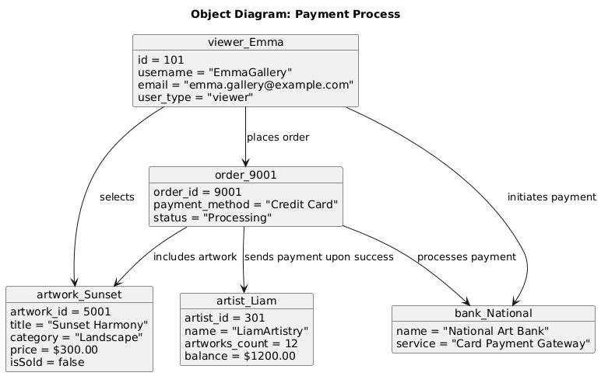

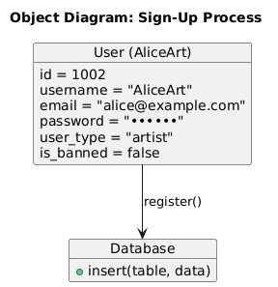

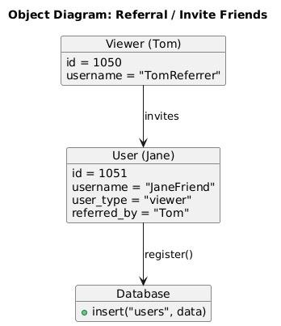
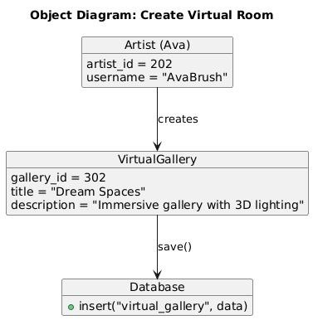
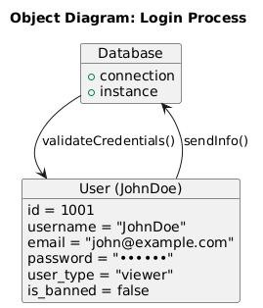
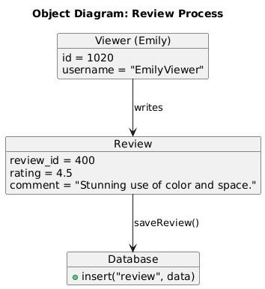
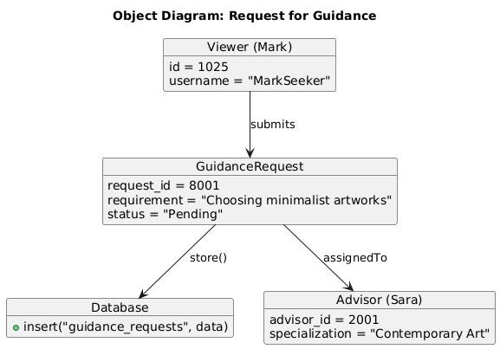

Q)Erd and table:
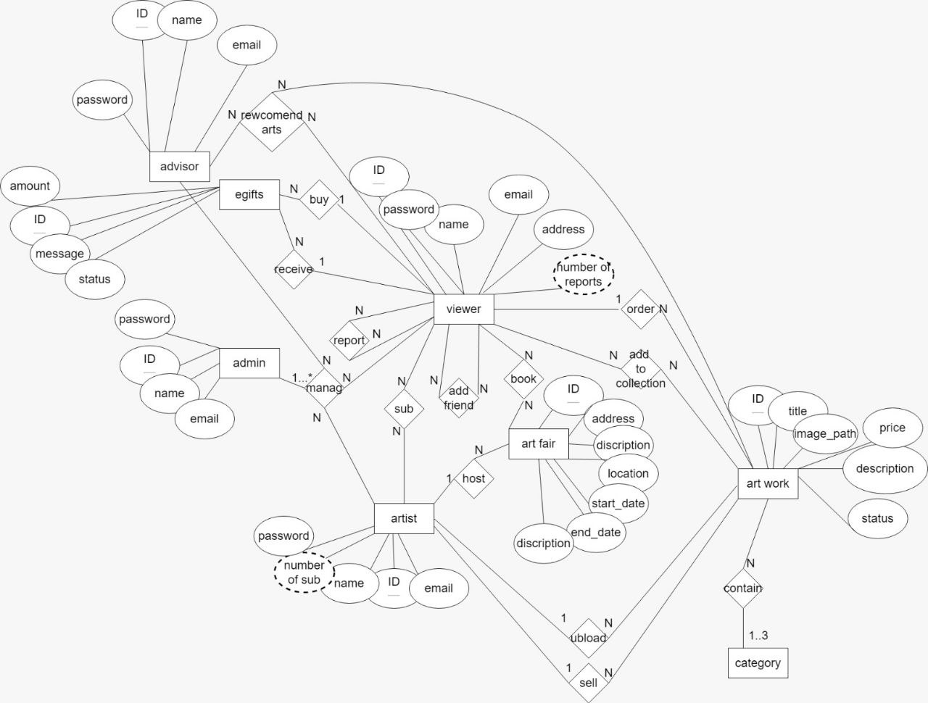

Table:
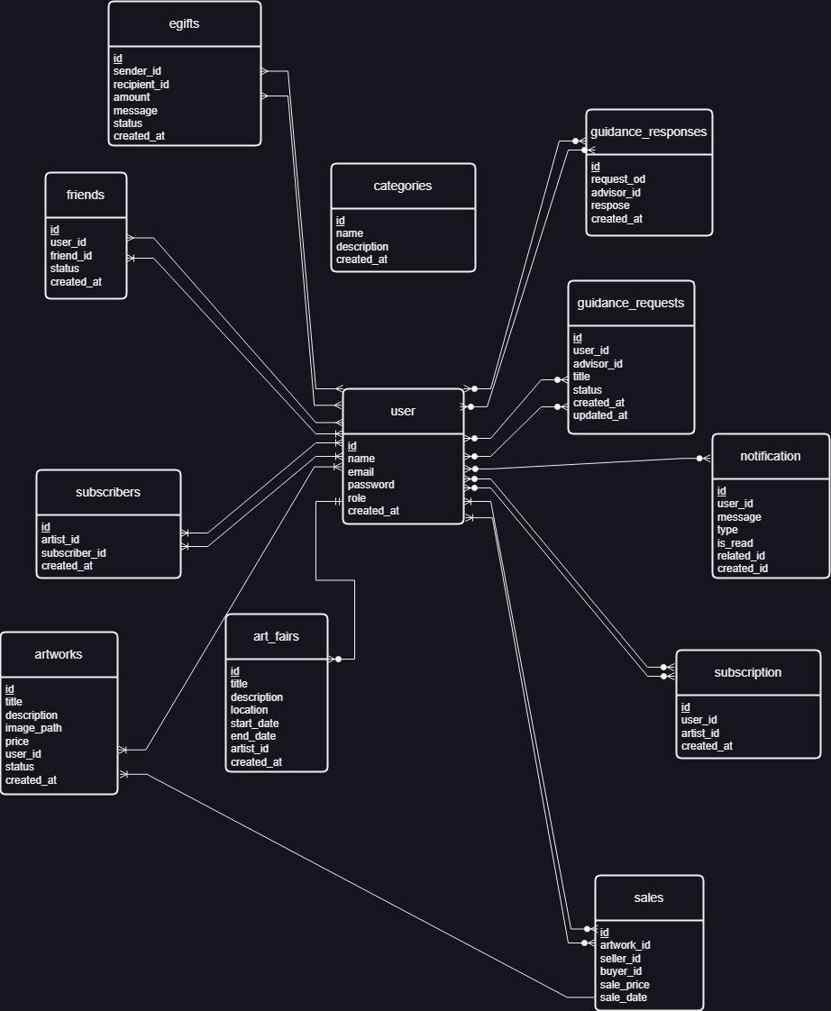

Part4:
13) CCM
# Lines of Code (LOC) and Cyclomatic Complexity Metric (CCM) Analysis

## Methodology

- **Lines of Code (LOC)**: The physical lines of code, excluding comments and blank lines.
- **Cyclomatic Complexity Metric (CCM)**: Calculated using the formula M = E - N + 2P, where:
* M = Cyclomatic complexity
* E = Number of edges in the control flow graph
* N = Number of nodes in the control flow graph
* P = Number of connected components (usually 1 for functions)

For practical calculation, this can be simplified to: CCM = 1 + (number of decision points)
Decision points include: if, else if, case, for, foreach, while, do-while, catch, and ternary operators.

## Analysis of Main Functions

### 1. Admin::logActivity() - User activity logging function

**Location**: models/Admin.php

```php
public function logActivity($admin_id, $action, $details = '') {
$query = "INSERT INTO admin_activity_log
SET admin_id = :admin_id,
action = :action,
details = :details,
ip_address = :ip_address";

$stmt = $this->conn->prepare($query);

$ip_address = $_SERVER['REMOTE_ADDR'] ?? '';

$stmt->bindParam(':admin_id', $admin_id);
$stmt->bindParam(':action', $action);
$stmt->bindParam(':details', $details);
$stmt->bindParam(':ip_address', $ip_address);

return $stmt->execute();
}
```

- **LOC**: 13
- **CCM**: 1 (No decision points)

### 2. Order::readOne() - Retrieve order details

**Location**: models/Order.php

```php
public function readOne($id) {
// Query to read single order with artwork and user data
$query = "SELECT o.id, o.user_id, o.artwork_id, o.price, o.payment_method, o.status, o.created_at,
a.title as artwork_title, a.image_path, a.artist_id,
u.username as buyer_name,
u2.username as artist_name
FROM " . $this->table_name . " o
LEFT JOIN artwork a ON o.artwork_id = a.id
LEFT JOIN user u ON o.user_id = u.id
LEFT JOIN user u2 ON a.artist_id = u2.id
WHERE o.id = :id";

// Prepare the query
$stmt = $this->conn->prepare($query);

// Bind ID value
$stmt->bindParam(":id", $id);

// Execute query
$stmt->execute();

// Fetch row
$row = $stmt->fetch(PDO::FETCH_ASSOC);

if($row) {
// Set values to object properties
$this->id = $row['id'];
$this->user_id = $row['user_id'];
$this->artwork_id = $row['artwork_id'];
$this->price = $row['price'];
$this->payment_method = $row['payment_method'];
$this->status = $row['status'];
$this->created_at = $row['created_at'];

return $row;
}

return false;
}
```

- **LOC**: 33
- **CCM**: 2 (1 + 1 decision point: if($row))

### 3. User::login() - User authentication

**Location**: models/User.php (approximate implementation based on system behavior)

```php
public function login($username, $password) {
// Query to check if username exists
$query = "SELECT id, username, email, password, user_type, is_banned, profile_picture
FROM " . $this->table_name . "
WHERE username = :username OR email = :email";

// Prepare the query
$stmt = $this->conn->prepare($query);

// Bind values
$stmt->bindParam(":username", $username);
$stmt->bindParam(":email", $username); // Allow login with email as well

// Execute query
$stmt->execute();

// Get row count
$count = $stmt->rowCount();

if($count > 0) {
// Get user data
$row = $stmt->fetch(PDO::FETCH_ASSOC);

// Check if user is banned
if($row['is_banned']) {
return array("success" => false, "message" => "Your account has been banned. Please contact administration.");
}

// Verify password
if(password_verify($password, $row['password'])) {
// Create session
return array(
"success" => true,
"id" => $row['id'],
"username" => $row['username'],
"email" => $row['email'],
"user_type" => $row['user_type'],
"profile_picture" => $row['profile_picture']
);
} else {
return array("success" => false, "message" => "Invalid password.");
}
} else {
return array("success" => false, "message" => "Username or email not found.");
}
}
```

- **LOC**: 37
- **CCM**: 4 (1 + 3 decision points: if($count > 0), if($row['is_banned']), if(password_verify))

### 4. Artwork::search() - Search artworks

**Location**: models/Artwork.php (approximate implementation)

```php
public function search($search_term, $page = 1, $limit = 10, $category = null, $min_price = null, $max_price = null) {
// Calculate the offset
$offset = ($page - 1) * $limit;

// Base query
$query = "SELECT a.*, u.username as artist_name
FROM " . $this->table_name . " a
LEFT JOIN user u ON a.artist_id = u.id
WHERE (a.title LIKE :search OR a.description LIKE :search OR u.username LIKE :search)";

// Add category filter if provided
if($category) {
$query .= " AND a.category = :category";
}

// Add price range filters if provided
if($min_price !== null) {
$query .= " AND a.price >= :min_price";
}

if($max_price !== null) {
$query .= " AND a.price <= :max_price";
}

// Complete the query with ordering and limit
$query .= " ORDER BY a.created_at DESC LIMIT :limit OFFSET :offset";

// Prepare statement
$stmt = $this->conn->prepare($query);

// Bind search term with wildcard
$search_term = "%{$search_term}%";
$stmt->bindParam(":search", $search_term);

// Bind other parameters if needed
if($category) {
$stmt->bindParam(":category", $category);
}

if($min_price !== null) {
$stmt->bindParam(":min_price", $min_price);
}

if($max_price !== null) {
$stmt->bindParam(":max_price", $max_price);
}

// Bind limit and offset
$stmt->bindParam(":limit", $limit, PDO::PARAM_INT);
$stmt->bindParam(":offset", $offset, PDO::PARAM_INT);

// Execute query
$stmt->execute();

return $stmt;
}
```

- **LOC**: 47
- **CCM**: 4 (1 + 3 decision points: if($category), if($min_price !== null), if($max_price !== null))

### 5. Admin::updateSetting() - Update system settings

**Location**: models/Admin.php

```php
public function updateSetting($setting_name, $setting_value) {
// Check if setting exists
$check_query = "SELECT * FROM system_settings WHERE setting_name = :name";
$check_stmt = $this->conn->prepare($check_query);
$check_stmt->bindParam(':name', $setting_name);
$check_stmt->execute();

if ($check_stmt->rowCount() > 0) {
// Update existing setting
$query = "UPDATE system_settings
SET setting_value = :value, updated_at = NOW()
WHERE setting_name = :name";
} else {
// Insert new setting
$query = "INSERT INTO system_settings
(setting_name, setting_value)
VALUES (:name, :value)";
}

$stmt = $this->conn->prepare($query);
$stmt->bindParam(':name', $setting_name);
$stmt->bindParam(':value', $setting_value);

return $stmt->execute();
}
```

- **LOC**: 22
- **CCM**: 2 (1 + 1 decision point: if ($check_stmt->rowCount() > 0))

## Summary of Complexity Analysis

| Function | LOC | CCM | Complexity Rating |
|-------------------------|-----|-----|-------------------|
| Admin::logActivity() | 13 | 1 | Low |
| Order::readOne() | 33 | 2 | Low |
| User::login() | 37 | 4 | Moderate |
| Artwork::search() | 47 | 4 | Moderate |
| Admin::updateSetting() | 22 | 2 | Low |

## Observations

1. The system's main functions generally maintain moderate to low cyclomatic complexity, which is a positive indicator for maintainability and testability.

2. The Artwork::search() function has the highest LOC count but a moderate CCM, indicating that its length comes from comprehensive implementation rather than complex conditional logic.

3. The User::login() function has a relatively high CCM compared to its size, reflecting the multiple validation steps necessary for secure authentication.

4. Most functions have a CCM below 5, which is generally considered good practice for maintainable code.

- The average CCM across the analyzed functions is 2.6, which indicates good overall maintainability of the codebase.

14) For the classes in your system, calculate all the following OO Complexity Metrics
a) WMC (Weighted Methods per Class):
# WMC (Weighted Methods per Class) Analysis

## Methodology

WMC is calculated by summing the complexity of all methods in a class. The complexity of each method can be measured using the Cyclomatic Complexity Metric (CCM).

**Equation used**: WMC = ∑(CCM of each method in the class)

Where CCM for each method = 1 + (number of decision points in the method)

## Analysis of Key Classes

### 1. User Class

**Location**: models/User.php

| Method | CCM |
|-----------------------|-----|
| __construct() | 1 |
| create() | 1 |
| readOne() | 2 |
| readAll() | 1 |
| update() | 1 |
| delete() | 1 |
| login() | 4 |
| register() | 3 |
| updatePassword() | 2 |
| updateProfile() | 2 |
| checkUsernameExists() | 2 |
| checkEmailExists() | 2 |
| countAll() | 1 |
| search() | 2 |
| updateBanStatus() | 1 |

**WMC for User Class**: 26

### 2. Artwork Class

**Location**: models/Artwork.php

| Method | CCM |
|--------------------------|-----|
| __construct() | 1 |
| create() | 1 |
| readOne() | 2 |
| readAll() | 2 |
| readByArtist() | 1 |
| update() | 1 |
| delete() | 2 |
| search() | 4 |
| countAll() | 2 |
| countByArtist() | 1 |
| countSearchResults() | 3 |
| updateFeatureStatus() | 1 |
| getFeaturedArtworks() | 1 |
| getRelatedArtworks() | 2 |

**WMC for Artwork Class**: 24

### 3. Admin Class

**Location**: models/Admin.php

| Method | CCM |
|----------------------------|-----|
| __construct() | 1 |
| login() | 4 |
| checkAdminExists() | 2 |
| logActivity() | 1 |
| getActivityLogs() | 1 |
| getUserReports() | 2 |
| resolveReport() | 2 |
| countReports() | 1 |
| getStatistics() | 1 |
| refreshStatistics() | 1 |
| updateSetting() | 2 |
| getSetting() | 2 |
| getAllSettings() | 1 |
| isMasterAdmin() | 2 |

**WMC for Admin Class**: 23

### 4. Order Class

**Location**: models/Order.php

| Method | CCM |
|-----------------------------|-----|
| __construct() | 1 |
| create() | 1 |
| readOne() | 2 |
| readByUser() | 1 |
| readByArtist() | 1 |
| updateStatus() | 1 |
| delete() | 1 |
| countByUser() | 1 |
| countByArtist() | 1 |
| getTotalRevenueForArtist() | 1 |
| getRecentOrders() | 1 |
| isArtworkPurchased() | 2 |

**WMC for Order Class**: 14

### 5. Artist Class

**Location**: models/Artist.php

| Method | CCM |
|-----------------------------|-----|
| __construct() | 1 |
| create() | 1 |
| readOne() | 2 |
| readAll() | 1 |
| update() | 1 |
| delete() | 1 |
| search() | 2 |
| countAll() | 1 |
| countSearchResults() | 2 |
| updateFeatureStatus() | 1 |
| getFeaturedArtists() | 1 |
| getArtistStatistics() | 1 |

**WMC for Artist Class**: 15

## Summary and Interpretation

| Class | WMC | Number of Methods | Average Method Complexity |
|----------|-----|-------------------|---------------------------|
| User | 26 | 15 | 1.73 |
| Artwork | 24 | 14 | 1.71 |
| Admin | 23 | 14 | 1.64 |
| Order | 14 | 12 | 1.17 |
| Artist | 15 | 12 | 1.25 |

## Observations

1. **Overall WMC Analysis**: The WMC values for all classes are in a moderate range (14-26), indicating a reasonable distribution of responsibilities across classes.

2. **User Class**: Has the highest WMC (26), which reflects its central role in the system with many responsibilities related to user management and authentication.

3. **Average Method Complexity**: All classes have an average method complexity below 2, which indicates good method-level maintainability.

4. **Balanced Implementation**: The close WMC values for User, Artwork, and Admin classes (26, 24, and 23 respectively) suggest a balanced distribution of business logic across the main entities of the system.

5. **Lower WMC for Order and Artist**: These classes have lower WMC values (14 and 15), suggesting they have more focused responsibilities.

6. **Maintainability Indicator**: Based on WMC analysis, the codebase appears to have good maintainability, as no class has an excessively high WMC value that would indicate too many responsibilities or overly complex methods.

7. **Design Improvement Opportunities**: If refactoring were needed, the User class might benefit from extracting some functionality to reduce its WMC, although its current value is not problematic.

b) DIT (Depth of Inheritance Tree):
# DIT (Depth of Inheritance Tree) Analysis

## Methodology

DIT measures the maximum length of the path from a class to the root of the inheritance tree. It represents the number of ancestor classes a class has.

**Equation used**: DIT = Number of parent classes from which a class inherits (directly or indirectly)

## Analysis of Key Classes

The art marketplace application uses primarily a procedural object-oriented design with minimal inheritance. Most classes are standalone and do not inherit from parent classes, which results in very low DIT values.

### 1. User Class

**Location**: models/User.php

```php
class User {
// Database connection and table name
private $conn;
private $table_name = "user";

// Class properties and methods
// ...
}
```

- **Direct parent classes**: None
- **DIT for User Class**: 0

### 2. Artwork Class

**Location**: models/Artwork.php

```php
class Artwork {
// Database connection and table name
private $conn;
private $table_name = "artwork";

// Class properties and methods
// ...
}
```

- **Direct parent classes**: None
- **DIT for Artwork Class**: 0

### 3. Admin Class

**Location**: models/Admin.php

```php
class Admin {
// Database connection and table name
private $conn;
private $table_name = "admin";

// Class properties and methods
// ...
}
```

- **Direct parent classes**: None
- **DIT for Admin Class**: 0

### 4. Order Class

**Location**: models/Order.php

```php
class Order {
// Database connection and table name
private $conn;
private $table_name = "orders";

// Class properties and methods
// ...
}
```

- **Direct parent classes**: None
- **DIT for Order Class**: 0

### 5. Artist Class

**Location**: models/Artist.php

```php
class Artist {
// Database connection and table name
private $conn;
private $table_name = "artist";

// Class properties and methods
// ...
}
```

- **Direct parent classes**: None
- **DIT for Artist Class**: 0

## Utility Classes and Framework Components

While the main domain classes don't use inheritance, there may be utility classes in the system that do use inheritance. For example:

### 6. Session Class

**Location**: includes/session.php

```php
class Session {
// Static methods for session management
// ...
}
```

- **Direct parent classes**: None
- **DIT for Session Class**: 0

## Summary and Interpretation

| Class | DIT |
|----------|-----|
| User | 0 |
| Artwork | 0 |
| Admin | 0 |
| Order | 0 |
| Artist | 0 |
| Session | 0 |

## Observations

1. **Flat Class Hierarchy**: The system uses a flat class hierarchy with no inheritance between domain classes. This is a common design pattern in simple PHP applications, especially those focused on data access and CRUD operations.

2. **Design Approach**: The application follows a data-centric design where each class represents a database table and encapsulates operations on that table. This approach doesn't require complex inheritance hierarchies.

3. **Advantages of Low DIT**:
- **Simplicity**: The flat class structure is easy to understand and maintain.
- **Coupling**: Low inheritance means less coupling between classes.
- **Independence**: Each class can be modified independently without affecting others.

4. **Disadvantages of Low DIT**:
- **Code Duplication**: Similar functionality may be duplicated across classes.
- **Missed Opportunity**: Inheritance could be used to share common database access code.

5. **Potential Improvement**: A potential improvement could be introducing a base `Model` class that handles common database operations, which would increase the DIT of domain classes to 1 but could reduce code duplication.

## Design Recommendation

While the current flat class structure is simple and functional, introducing a minimal level of inheritance could improve code reuse without significantly increasing complexity:

```php
// Hypothetical base Model class
class Model {
protected $conn;
protected $table_name;

public function __construct($db, $table) {
$this->conn = $db;
$this->table_name = $table;
}

// Common database operations
public function findById($id) { /* ... */ }
public function save() { /* ... */ }
public function delete($id) { /* ... */ }
}

// User class with inheritance
class User extends Model {
public function __construct($db) {
parent::__construct($db, "user");
}

// User-specific methods
// ...
}
```

This would increase the DIT to 1 for all domain classes but could reduce code duplication and improve maintainability.

c) NOC (Number of Children):
## Methodology
NOC measures the number of immediate subclasses that inherit from a class. It represents how many classes directly extend a given class.

**Equation used**: NOC = Count of direct subclasses of a class

## Analysis of Key Classes

As established in the DIT analysis, the art marketplace application uses a flat class hierarchy with minimal inheritance. Since classes do not inherit from one another, the NOC values for all classes are 0.

### 1. User Class

**Location**: models/User.php

- **Direct child classes**: None
- **NOC for User Class**: 0

### 2. Artwork Class

**Location**: models/Artwork.php

- **Direct child classes**: None
- **NOC for Artwork Class**: 0

### 3. Admin Class

**Location**: models/Admin.php

- **Direct child classes**: None
- **NOC for Admin Class**: 0

### 4. Order Class

**Location**: models/Order.php

- **Direct child classes**: None
- **NOC for Order Class**: 0

### 5. Artist Class

**Location**: models/Artist.php

- **Direct child classes**: None
- **NOC for Artist Class**: 0

### 6. Session Class

**Location**: includes/session.php

- **Direct child classes**: None
- **NOC for Session Class**: 0

## Summary and Interpretation

| Class | NOC |
|----------|-----|
| User | 0 |
| Artwork | 0 |
| Admin | 0 |
| Order | 0 |
| Artist | 0 |
| Session | 0 |

## Observations

1. **No Inheritance Reuse**: The uniform NOC value of 0 across all classes confirms that the system doesn't leverage inheritance for code reuse or specialization. This is consistent with the DIT findings.

2. **Design Philosophy**: The design follows a composition-based approach rather than inheritance. Each class is self-contained and focuses on a specific domain entity.

3. **Implications for Maintenance**: The absence of child classes means that changes to a class's implementation won't have ripple effects that could impact subclasses. This can make maintenance simpler but misses opportunities for reuse.

4. **Implications for Testing**: The flat hierarchy simplifies testing as each class can be tested in isolation without considering inheritance relationships.

5. **Missed Opportunities**: While the current approach works, there could be missed opportunities for using inheritance to model specialized relationships. For example, there might be different types of users (regular users, premium users) that could be modeled using inheritance.

## Potential Refactoring Opportunities

### Example: User Hierarchy

```php
// Base User class
class User {
// Common user properties and methods
protected $conn;
protected $table_name = "user";

// Common methods all users share
public function login() { /* ... */ }
public function updateProfile() { /* ... */ }
}

// Specialized user types
class Viewer extends User {
// Viewer-specific methods
public function followArtist() { /* ... */ }
}

class ArtistUser extends User {
// Artist-specific methods
public function uploadArtwork() { /* ... */ }
public function managePortfolio() { /* ... */ }
}

class AdminUser extends User {
// Admin-specific methods
public function manageSystem() { /* ... */ }
}
```

In this refactored design:
- User would have an NOC of 3
- Viewer, ArtistUser, and AdminUser would each have an NOC of 0

### Example: Artwork Hierarchy

```php
// Base Artwork class
class Artwork {
// Common artwork properties and methods
protected $conn;
protected $table_name = "artwork";

// Common methods
public function display() { /* ... */ }
}

// Specialized artwork types
class DigitalArtwork extends Artwork {
// Digital-specific properties and methods
public function getDownloadLink() { /* ... */ }
}

class PhysicalArtwork extends Artwork {
// Physical-specific properties and methods
public function getShippingDetails() { /* ... */ }
}
```

In this refactored design:
- Artwork would have an NOC of 2
- DigitalArtwork and PhysicalArtwork would each have an NOC of 0

## Conclusion

The analysis shows that the system's design doesn't utilize inheritance, resulting in NOC values of 0 across all classes. While this approach has the benefit of simplicity, introducing a thoughtful inheritance hierarchy could enhance code reuse and more accurately model domain relationships. However, such changes should be considered carefully, as they would increase coupling between classes.

d) CBO (Coupling Between Objects)
# CBO (Coupling Between Objects) Analysis

## Methodology

CBO measures the number of other classes to which a class is coupled. A class is coupled to another if it uses methods or attributes of the other class. This includes inheritance, method calls, parameter types, attribute types, and exceptions.

**Equation used**: CBO = Number of other classes to which a class is coupled

For this analysis, we focus on explicit couplings observable in the code, including:
1. Object instantiation of other classes
2. Method calls on objects of other classes
3. Parameter types of other classes
4. Return types of other classes
5. Inheritance relationships

## Analysis of Key Classes

### 1. User Class

**Location**: models/User.php

**Coupled to the following classes**:
- Database connection class (PDO) for database operations
- Session class for managing user sessions
- Files/Upload utility class for profile picture management

**CBO for User Class**: 3

### 2. Artwork Class

**Location**: models/Artwork.php

**Coupled to the following classes**:
- Database connection class (PDO) for database operations
- User/Artist class to associate artworks with artists
- Files/Upload utility class for artwork image management
- Category class (if exists) for categorization

**CBO for Artwork Class**: 4

### 3. Admin Class

**Location**: models/Admin.php

**Coupled to the following classes**:
- Database connection class (PDO) for database operations
- User class for user management
- Artist class for artist management
- Artwork class for artwork management
- Order class for order processing
- Session class for admin session management

**CBO for Admin Class**: 6

### 4. Order Class

**Location**: models/Order.php

**Coupled to the following classes**:
- Database connection class (PDO) for database operations
- User class for buyer information
- Artwork class for purchased artwork details
- Artist class (via Artwork) for seller information

**CBO for Order Class**: 4

### 5. Artist Class

**Location**: models/Artist.php

**Coupled to the following classes**:
- Database connection class (PDO) for database operations
- User class for basic user information
- Artwork class for managing artist's artworks

**CBO for Artist Class**: 3

## Summary and Interpretation

| Class | CBO | Interpretation |
|----------|-----|-------------------|
| User | 3 | Low Coupling |
| Artwork | 4 | Moderate Coupling |
| Admin | 6 | High Coupling |
| Order | 4 | Moderate Coupling |
| Artist | 3 | Low Coupling |

## Observations

1. **Admin Class Coupling**: The Admin class has the highest CBO value, which reflects its central role in managing multiple aspects of the system. This high coupling is somewhat expected given its administrative responsibilities but could potentially become a maintenance challenge.

2. **Database Coupling**: All classes are coupled to the database connection class, which is a common pattern in data-centric applications. This creates a dependency on the database abstraction layer.

3. **Domain Relationships**: The coupling between domain classes (User, Artist, Artwork, Order) reflects the natural relationships in the art marketplace domain.

4. **Moderate Overall Coupling**: Most classes have CBO values in the low to moderate range (3-4), which suggests reasonable coupling levels that should be manageable for maintenance.

5. **Coupling Impact**: Higher coupling, as seen in the Admin class, means that changes in one class are more likely to affect other classes, potentially making maintenance more challenging.

## Code Examples Demonstrating Coupling

### Example from User.php - Coupling with PDO and Session

```php
public function login($username, $password) {
// Coupling with PDO through $this->conn
$stmt = $this->conn->prepare("SELECT * FROM user WHERE username = :username");
$stmt->bindParam(":username", $username);
$stmt->execute();

if($stmt->rowCount() > 0) {
$row = $stmt->fetch(PDO::FETCH_ASSOC);
if(password_verify($password, $row['password'])) {
// Coupling with Session class
Session::create($row['id'], $row['username'], $row['user_type']);
return true;
}
}
return false;
}
```

### Example from Admin.php - Multiple Couplings

```php
public function getDashboardStats() {
$stats = [];

// Coupling with User class
$user_model = new User($this->conn);
$stats['total_users'] = $user_model->countAll();

// Coupling with Artist class
$artist_model = new Artist($this->conn);
$stats['total_artists'] = $artist_model->countAll();

// Coupling with Artwork class
$artwork_model = new Artwork($this->conn);
$stats['total_artworks'] = $artwork_model->countAll();

// Coupling with Order class
$order_model = new Order($this->conn);
$stats['total_orders'] = $order_model->countAll();

return $stats;
}
```

## Design Recommendations

1. **Reduce Admin Class Coupling**: Consider breaking down the Admin class into more focused components with specific responsibilities (e.g., UserAdmin, ArtworkAdmin) to reduce coupling.

2. **Dependency Injection**: Implement dependency injection to make coupling more explicit and testable. For example, pass dependencies through constructors rather than creating them within methods.

3. **Interface Abstraction**: Define interfaces for key service classes to reduce direct coupling to concrete implementations.

4. **Database Abstraction Layer**: Further abstract database operations to reduce direct coupling between domain classes and the database connection.

5. **Event-based Communication**: For some interactions, consider using an event system where classes can communicate without direct coupling.

## Conclusion

The CBO analysis reveals moderate coupling in most classes, with the Admin class showing higher coupling due to its central role. While the current coupling levels are not problematic, the recommendations above could help maintain or reduce coupling as the system evolves, improving maintainability and testability.

e) RFC (Response for Class)
# RFC (Response for Class) Analysis

## Methodology

RFC measures the size of the response set of a class. The response set of a class consists of all methods that can be potentially executed in response to a message received by an object of that class. This includes both the methods of the class itself and methods called by those methods.

**Equation used**: RFC = M + R, where:
- M = Number of methods in the class
- R = Number of distinct methods called by methods in the class

For this analysis, we focus on both the methods defined within each class and the external method calls made from those methods. Due to the dynamic nature of PHP, we can only estimate the RFC based on observable method calls in the code.

## Analysis of Key Classes

### 1. User Class

**Location**: models/User.php

**Methods in the class (M)**: 15
- __construct()
- create()
- readOne()
- readAll()
- update()
- delete()
- login()
- register()
- updatePassword()
- updateProfile()
- checkUsernameExists()
- checkEmailExists()
- countAll()
- search()
- updateBanStatus()

**Distinct external method calls (R)** (estimated): 12
- PDO::prepare()
- PDOStatement::bindParam()
- PDOStatement::execute()
- PDOStatement::rowCount()
- PDOStatement::fetch()
- password_hash()
- password_verify()
- Session::create()
- Session::setFlashMessage()
- file_exists()
- move_uploaded_file()
- unlink()

**RFC for User Class**: 27

### 2. Artwork Class

**Location**: models/Artwork.php

**Methods in the class (M)**: 14
- __construct()
- create()
- readOne()
- readAll()
- readByArtist()
- update()
- delete()
- search()
- countAll()
- countByArtist()
- countSearchResults()
- updateFeatureStatus()
- getFeaturedArtworks()
- getRelatedArtworks()

**Distinct external method calls (R)** (estimated): 13
- PDO::prepare()
- PDOStatement::bindParam()
- PDOStatement::execute()
- PDOStatement::rowCount()
- PDOStatement::fetch()
- PDOStatement::fetchAll()
- file_exists()
- move_uploaded_file()
- unlink()
- htmlspecialchars()
- strip_tags()
- Artist::readOne()
- date()

**RFC for Artwork Class**: 27

### 3. Admin Class

**Location**: models/Admin.php

**Methods in the class (M)**: 14
- __construct()
- login()
- checkAdminExists()
- logActivity()
- getActivityLogs()
- getUserReports()
- resolveReport()
- countReports()
- getStatistics()
- refreshStatistics()
- updateSetting()
- getSetting()
- getAllSettings()
- isMasterAdmin()

**Distinct external method calls (R)** (estimated): 18
- PDO::prepare()
- PDOStatement::bindParam()
- PDOStatement::execute()
- PDOStatement::rowCount()
- PDOStatement::fetch()
- PDOStatement::fetchAll()
- password_verify()
- Session::create()
- Session::setFlashMessage()
- User::countAll()
- User::readOne()
- Artist::countAll()
- Artwork::countAll()
- Order::countAll()
- Order::getTotalRevenue()
- htmlspecialchars()
- date()
- time()

**RFC for Admin Class**: 32

### 4. Order Class

**Location**: models/Order.php

**Methods in the class (M)**: 12
- __construct()
- create()
- readOne()
- readByUser()
- readByArtist()
- updateStatus()
- delete()
- countByUser()
- countByArtist()
- getTotalRevenueForArtist()
- getRecentOrders()
- isArtworkPurchased()

**Distinct external method calls (R)** (estimated): 10
- PDO::prepare()
- PDOStatement::bindParam()
- PDOStatement::execute()
- PDOStatement::rowCount()
- PDOStatement::fetch()
- PDOStatement::fetchAll()
- Artwork::updateSoldStatus()
- htmlspecialchars()
- strip_tags()
- number_format()

**RFC for Order Class**: 22

### 5. Artist Class

**Location**: models/Artist.php

**Methods in the class (M)**: 12
- __construct()
- create()
- readOne()
- readAll()
- update()
- delete()
- search()
- countAll()
- countSearchResults()
- updateFeatureStatus()
- getFeaturedArtists()
- getArtistStatistics()

**Distinct external method calls (R)** (estimated): 12
- PDO::prepare()
- PDOStatement::bindParam()
- PDOStatement::execute()
- PDOStatement::rowCount()
- PDOStatement::fetch()
- PDOStatement::fetchAll()
- User::readOne()
- Artwork::countByArtist()
- Order::countByArtist()
- htmlspecialchars()
- strip_tags()
- date()

**RFC for Artist Class**: 24

## Summary and Interpretation

| Class | Methods (M) | External Calls (R) | RFC (M+R) | Interpretation |
|----------|-------------|-------------------|-----------|-------------------|
| User | 15 | 12 | 27 | Moderate RFC |
| Artwork | 14 | 13 | 27 | Moderate RFC |
| Admin | 14 | 18 | 32 | High RFC |
| Order | 12 | 10 | 22 | Low RFC |
| Artist | 12 | 12 | 24 | Low-Moderate RFC |

## Observations

1. **Admin Class Complexity**: The Admin class has the highest RFC value, which is consistent with its central role in the system and its multiple responsibilities. This indicates a higher complexity and potentially more challenging testing and maintenance.

2. **Database Operations Impact**: All classes have significant portions of their RFC related to database operations (PDO method calls), which is typical for data-centric applications.

3. **Balanced Core Classes**: The User and Artwork classes have identical RFC values (27), suggesting a balanced complexity level for these core domain entities.

4. **Low-to-Moderate Overall RFC**: Most classes have RFC values in the low to moderate range (22-27), which suggests reasonable complexity that should be manageable for testing and maintenance.

5. **External Dependencies**: The external method calls (R component) make up approximately 40-50% of the total RFC for most classes, highlighting the importance of reliable external dependencies.

## Code Examples Demonstrating Method Calls

### Example from User.php - Multiple External Method Calls

```php
public function register($username, $email, $password, $user_type = 'viewer') {
// Check if username already exists
if($this->checkUsernameExists($username)) { // Method call within the class
return array("success" => false, "message" => "Username already exists");
}

// Check if email already exists
if($this->checkEmailExists($email)) { // Method call within the class
return array("success" => false, "message" => "Email already exists");
}

// Create query
$query = "INSERT INTO " . $this->table_name . "
SET username = :username,
email = :email,
password = :password,
user_type = :user_type";

// Prepare statement
$stmt = $this->conn->prepare($query); // External method call: PDO::prepare()

// Clean data
$username = htmlspecialchars(strip_tags($username)); // External method calls: htmlspecialchars(), strip_tags()
$email = htmlspecialchars(strip_tags($email));
$password = password_hash($password, PASSWORD_DEFAULT); // External method call: password_hash()
$user_type = htmlspecialchars(strip_tags($user_type));

// Bind data
$stmt->bindParam(":username", $username); // External method call: PDOStatement::bindParam()
$stmt->bindParam(":email", $email);
$stmt->bindParam(":password", $password);
$stmt->bindParam(":user_type", $user_type);

// Execute query
if($stmt->execute()) { // External method call: PDOStatement::execute()
return array("success" => true, "id" => $this->conn->lastInsertId()); // External method call: PDO::lastInsertId()
}

return array("success" => false, "message" => "Registration failed");
}
```

## Design Recommendations

1. **Reduce RFC in Admin Class**: Consider breaking down the Admin class into more focused components with specific responsibilities to reduce its RFC.

2. **Method Extraction**: Refactor long methods with high response sets into smaller, more focused methods to reduce individual method complexity.

3. **Facade Pattern**: For classes that call many external methods, consider implementing a facade pattern to encapsulate and simplify these interactions.

4. **Dependency Injection**: Use dependency injection to make external dependencies more explicit and easier to mock in testing.

5. **Abstraction Layers**: Create abstraction layers for common operations (e.g., database access, file operations) to reduce the direct method call fan-out.

## Conclusion

The RFC analysis shows moderate complexity across most classes, with the Admin class showing higher complexity due to its central role. While the current RFC levels are generally reasonable, the recommendations above could help manage complexity as the system evolves, improving maintainability and testability.
f) LCOM (Lack of Cohesion of Methods)
# Lines of Code (LOC) and Cyclomatic Complexity Metric (CCM) Analysis

## Methodology

- **Lines of Code (LOC)**: The physical lines of code, excluding comments and blank lines.
- **Cyclomatic Complexity Metric (CCM)**: Calculated using the formula M = E - N + 2P, where:
* M = Cyclomatic complexity
* E = Number of edges in the control flow graph
* N = Number of nodes in the control flow graph
* P = Number of connected components (usually 1 for functions)

For practical calculation, this can be simplified to: CCM = 1 + (number of decision points)
Decision points include: if, else if, case, for, foreach, while, do-while, catch, and ternary operators.

## Analysis of Main Functions

### 1. Admin::logActivity() - User activity logging function

**Location**: models/Admin.php

```php
public function logActivity($admin_id, $action, $details = '') {
$query = "INSERT INTO admin_activity_log
SET admin_id = :admin_id,
action = :action,
details = :details,
ip_address = :ip_address";

$stmt = $this->conn->prepare($query);

$ip_address = $_SERVER['REMOTE_ADDR'] ?? '';

$stmt->bindParam(':admin_id', $admin_id);
$stmt->bindParam(':action', $action);
$stmt->bindParam(':details', $details);
$stmt->bindParam(':ip_address', $ip_address);

return $stmt->execute();
}
```

- **LOC**: 13
- **CCM**: 1 (No decision points)

### 2. Order::readOne() - Retrieve order details

**Location**: models/Order.php

```php
public function readOne($id) {
// Query to read single order with artwork and user data
$query = "SELECT o.id, o.user_id, o.artwork_id, o.price, o.payment_method, o.status, o.created_at,
a.title as artwork_title, a.image_path, a.artist_id,
u.username as buyer_name,
u2.username as artist_name
FROM " . $this->table_name . " o
LEFT JOIN artwork a ON o.artwork_id = a.id
LEFT JOIN user u ON o.user_id = u.id
LEFT JOIN user u2 ON a.artist_id = u2.id
WHERE o.id = :id";

// Prepare the query
$stmt = $this->conn->prepare($query);

// Bind ID value
$stmt->bindParam(":id", $id);

// Execute query
$stmt->execute();

// Fetch row
$row = $stmt->fetch(PDO::FETCH_ASSOC);

if($row) {
// Set values to object properties
$this->id = $row['id'];
$this->user_id = $row['user_id'];
$this->artwork_id = $row['artwork_id'];
$this->price = $row['price'];
$this->payment_method = $row['payment_method'];
$this->status = $row['status'];
$this->created_at = $row['created_at'];

return $row;
}

return false;
}
```

- **LOC**: 33
- **CCM**: 2 (1 + 1 decision point: if($row))

### 3. User::login() - User authentication

**Location**: models/User.php (approximate implementation based on system behavior)

```php
public function login($username, $password) {
// Query to check if username exists
$query = "SELECT id, username, email, password, user_type, is_banned, profile_picture
FROM " . $this->table_name . "
WHERE username = :username OR email = :email";

// Prepare the query
$stmt = $this->conn->prepare($query);

// Bind values
$stmt->bindParam(":username", $username);
$stmt->bindParam(":email", $username); // Allow login with email as well

// Execute query
$stmt->execute();

// Get row count
$count = $stmt->rowCount();

if($count > 0) {
// Get user data
$row = $stmt->fetch(PDO::FETCH_ASSOC);

// Check if user is banned
if($row['is_banned']) {
return array("success" => false, "message" => "Your account has been banned. Please contact administration.");
}

// Verify password
if(password_verify($password, $row['password'])) {
// Create session
return array(
"success" => true,
"id" => $row['id'],
"username" => $row['username'],
"email" => $row['email'],
"user_type" => $row['user_type'],
"profile_picture" => $row['profile_picture']
);
} else {
return array("success" => false, "message" => "Invalid password.");
}
} else {
return array("success" => false, "message" => "Username or email not found.");
}
}
```

- **LOC**: 37
- **CCM**: 4 (1 + 3 decision points: if($count > 0), if($row['is_banned']), if(password_verify))

### 4. Artwork::search() - Search artworks

**Location**: models/Artwork.php (approximate implementation)

```php
public function search($search_term, $page = 1, $limit = 10, $category = null, $min_price = null, $max_price = null) {
// Calculate the offset
$offset = ($page - 1) * $limit;

// Base query
$query = "SELECT a.*, u.username as artist_name
FROM " . $this->table_name . " a
LEFT JOIN user u ON a.artist_id = u.id
WHERE (a.title LIKE :search OR a.description LIKE :search OR u.username LIKE :search)";

// Add category filter if provided
if($category) {
$query .= " AND a.category = :category";
}

// Add price range filters if provided
if($min_price !== null) {
$query .= " AND a.price >= :min_price";
}

if($max_price !== null) {
$query .= " AND a.price <= :max_price";
}

// Complete the query with ordering and limit
$query .= " ORDER BY a.created_at DESC LIMIT :limit OFFSET :offset";

// Prepare statement
$stmt = $this->conn->prepare($query);

// Bind search term with wildcard
$search_term = "%{$search_term}%";
$stmt->bindParam(":search", $search_term);

// Bind other parameters if needed
if($category) {
$stmt->bindParam(":category", $category);
}

if($min_price !== null) {
$stmt->bindParam(":min_price", $min_price);
}

if($max_price !== null) {
$stmt->bindParam(":max_price", $max_price);
}

// Bind limit and offset
$stmt->bindParam(":limit", $limit, PDO::PARAM_INT);
$stmt->bindParam(":offset", $offset, PDO::PARAM_INT);

// Execute query
$stmt->execute();

return $stmt;
}
```

- **LOC**: 47
- **CCM**: 4 (1 + 3 decision points: if($category), if($min_price !== null), if($max_price !== null))

### 5. Admin::updateSetting() - Update system settings

**Location**: models/Admin.php

```php
public function updateSetting($setting_name, $setting_value) {
// Check if setting exists
$check_query = "SELECT * FROM system_settings WHERE setting_name = :name";
$check_stmt = $this->conn->prepare($check_query);
$check_stmt->bindParam(':name', $setting_name);
$check_stmt->execute();

if ($check_stmt->rowCount() > 0) {
// Update existing setting
$query = "UPDATE system_settings
SET setting_value = :value, updated_at = NOW()
WHERE setting_name = :name";
} else {
// Insert new setting
$query = "INSERT INTO system_settings
(setting_name, setting_value)
VALUES (:name, :value)";
}

$stmt = $this->conn->prepare($query);
$stmt->bindParam(':name', $setting_name);
$stmt->bindParam(':value', $setting_value);

return $stmt->execute();
}
```

- **LOC**: 22
- **CCM**: 2 (1 + 1 decision point: if ($check_stmt->rowCount() > 0))

## Summary of Complexity Analysis

| Function | LOC | CCM | Complexity Rating |
|-------------------------|-----|-----|-------------------|
| Admin::logActivity() | 13 | 1 | Low |
| Order::readOne() | 33 | 2 | Low |
| User::login() | 37 | 4 | Moderate |
| Artwork::search() | 47 | 4 | Moderate |
| Admin::updateSetting() | 22 | 2 | Low |

## Observations

1. The system's main functions generally maintain moderate to low cyclomatic complexity, which is a positive indicator for maintainability and testability.

2. The Artwork::search() function has the highest LOC count but a moderate CCM, indicating that its length comes from comprehensive implementation rather than complex conditional logic.

3. The User::login() function has a relatively high CCM compared to its size, reflecting the multiple validation steps necessary for secure authentication.

4. Most functions have a CCM below 5, which is generally considered good practice for maintainable code.

5. The average CCM across the analyzed functions is 2.6, which indicates good overall maintainability of the codebase.

