**Building the Chatbot Using IBM Cloud Watson Assistant**

We'll start by defining the chatbot's persona, designing the conversation flow, and configuring intents, entities, and dialog nodes in Watson Assistant.

**Persona Design:**

* **Name:** InfoBot
* **Tone:** Friendly and informative.
* **Style of Communication:** It maintains a conversational and approachable style.

**Conversation Flow:**

1. **Greeting:**
   * InfoBot's initial message is crucial in making a positive first impression. It should be a warm greeting, such as: "Hello! I'm InfoBot, your virtual guide. How can I assist you today?"
2. **User Input:**
   * InfoBot actively listens to the user's input, waiting for their queries or requests. NLU (Natural Language Understanding) will be used for accurate intent recognition.
3. **Response Generation:**
   * When a user submits a query or request, InfoBot employs Watson Assistant's NLU capabilities to recognize the intent and potentially relevant entities within the input.
   * Based on the recognized intent and entity, InfoBot generates a relevant response. For example, if the user asks about product information, InfoBot provides detailed information about the product or directs the user to the relevant section of the website.
4. **Clarification:**
   * If the user's query is unclear or ambiguous, InfoBot should gracefully ask for clarification to better understand the user's needs. For instance, "I want to learn more about your services" can prompt InfoBot to ask, "Sure, which specific service are you interested in?"
5. **FAQs:**
   * Predefined dialog nodes should be set up to handle common Frequently Asked Questions (FAQs). When users ask common questions, InfoBot can provide standard, informative responses without the need for NLU analysis.
6. **Closing:**
   * When the user's needs have been met, InfoBot concludes the conversation with a polite message, such as: "If you have any more questions or need further assistance, feel free to ask anytime. Have a great day!"

**Intent and Entity Configuration in Watson Assistant:**

1. **Intent Creation:**

Within IBM Cloud Watson Assistant, create intents that align with user intentions, such as "Tell me about your products.","What services do you offer?","Can you provide information about your offerings?" and "I'm interested in your products.".

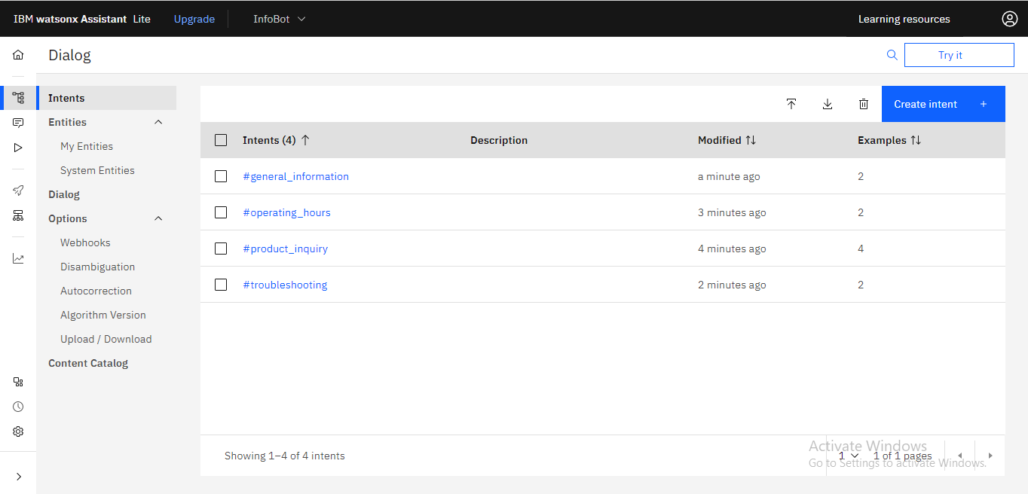

* + Train these intents with examples of user queries that correspond to each intent. For example, under "product_inquiry," you might train the chatbot with phrases like "Tell me about your products" and "What services do you offer?"

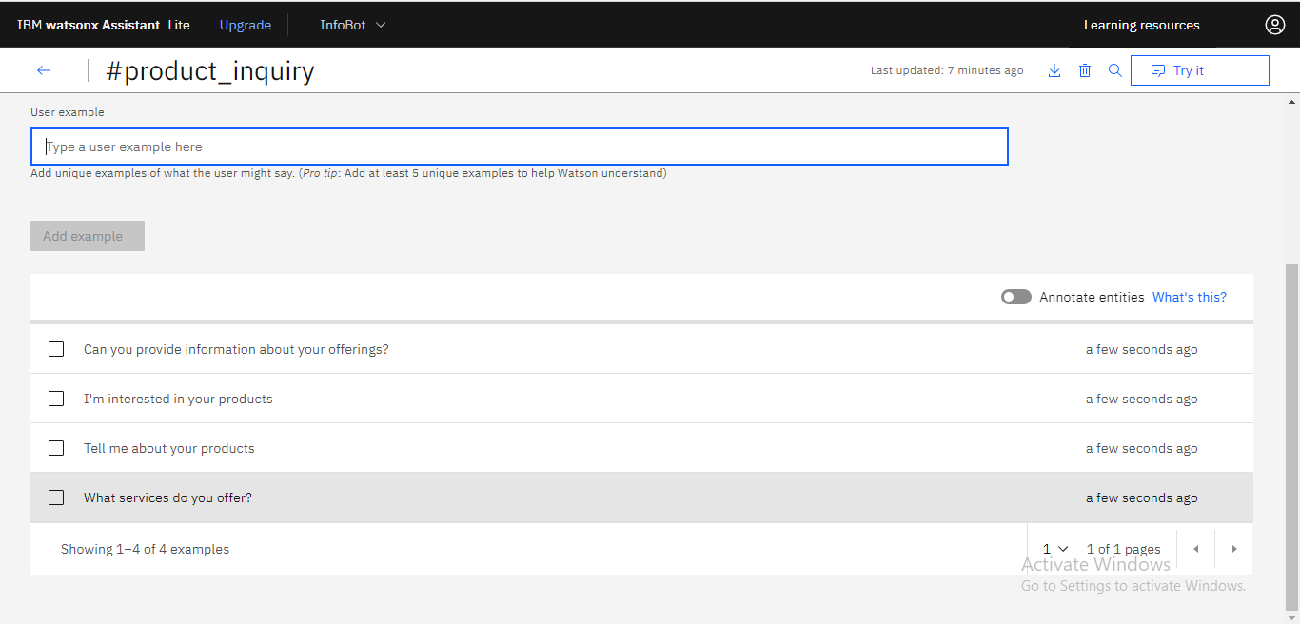

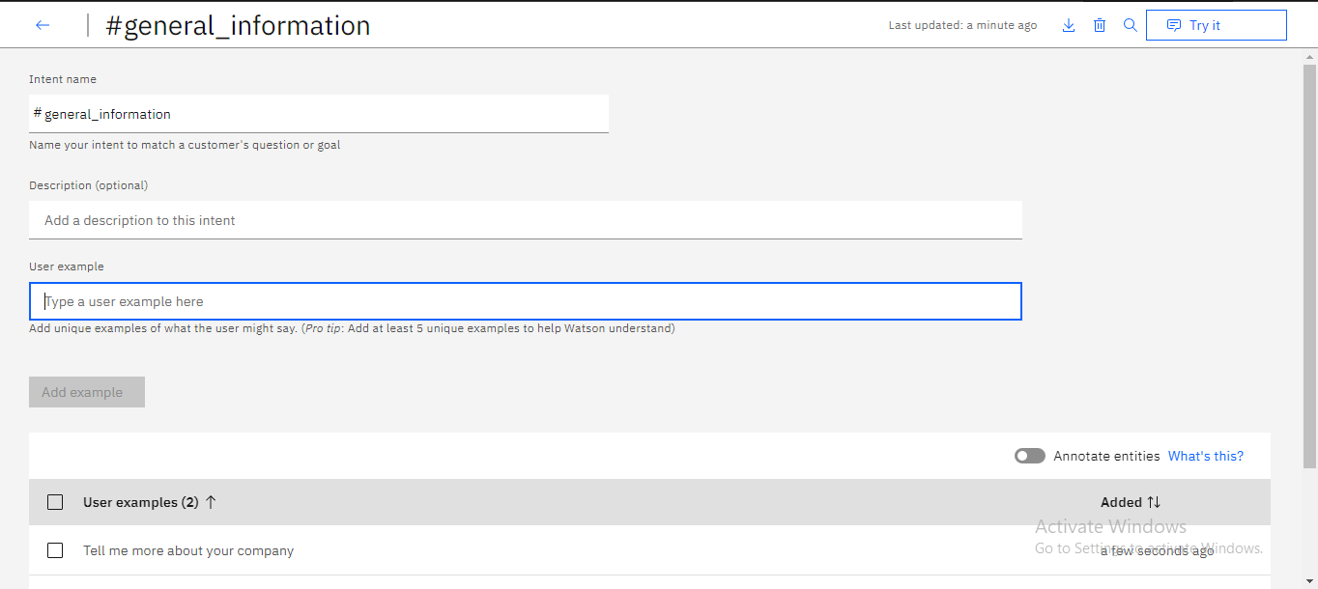

1. **Entity Configuration:**
   * Define entities to capture specific details that users might mention in their queries, such as products, services, or common issues. Entities can be named things like "@product," "@service," and "@issue."

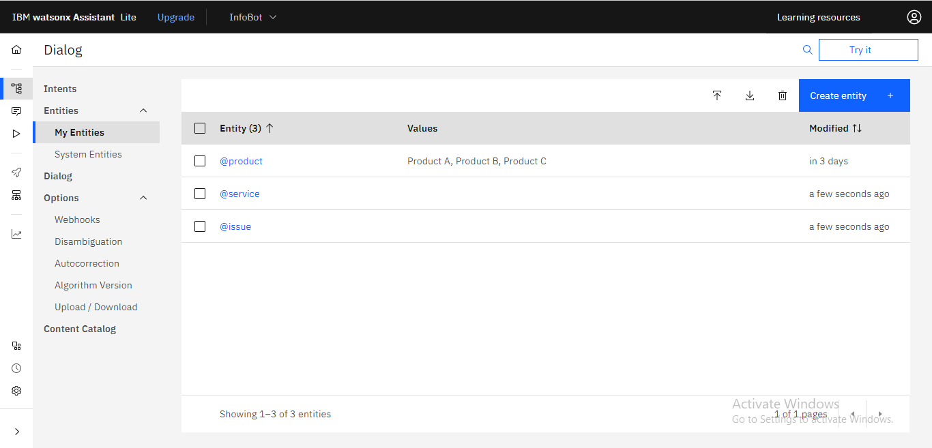

* + Populate the entity values with specific items, allowing Watson Assistant to recognize them in user queries. For instance, under "@product," you might list the different product names.

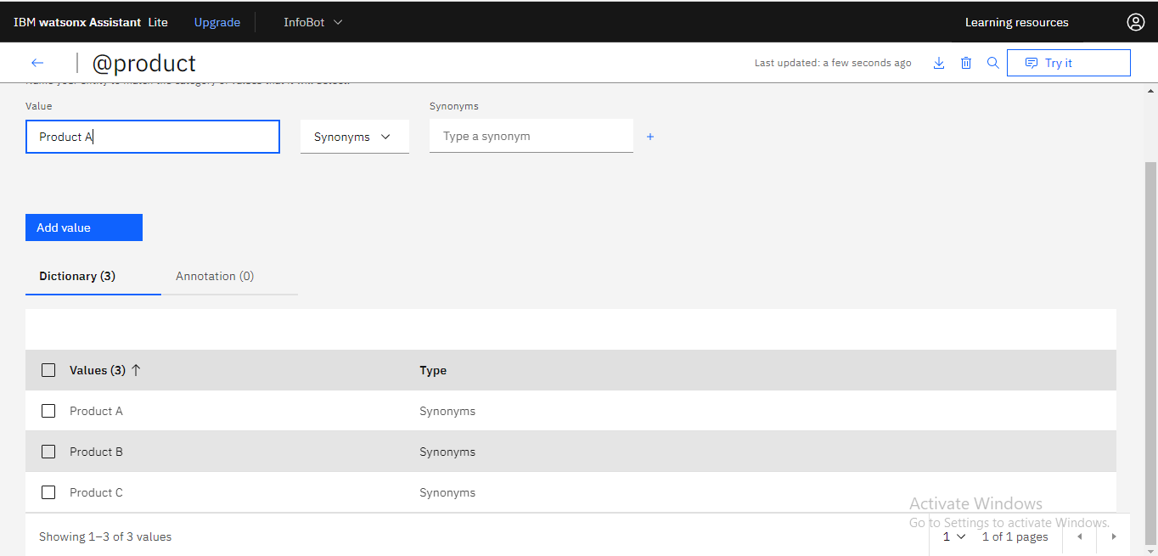

1. **Dialog Nodes:**
   * Create dialog nodes for each intent and entity combination to guide the chatbot's responses. When defining a dialog node, consider the following elements:
     + Condition: Specify a condition that checks if the recognized intent matches the intent of the dialog node. For example, for a "product_inquiry" dialog node, the condition should check if the intent is "product_inquiry."
     + Response: In the response section, you can customize what InfoBot says when the condition is met. For example, for a "product_inquiry" intent, you can provide responses that offer details about the products or services.

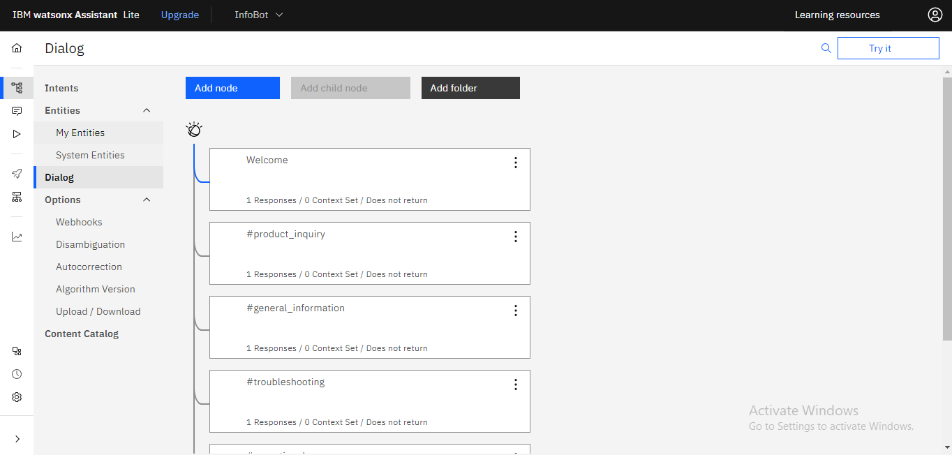

**Enhancements with NLU:**

1. **NLU Integration:**
   * First, you need to set up and configure your NLU service. In this example, we'll use IBM Watson NLU.
   * Create an instance of IBM Watson NLU and obtain the necessary API keys and credentials.
   * In the Watson Assistant configuration, navigate to "Skills" and select your skill.
   * Under "Add integrations," select "Natural Language Understanding" and enter the API key and URL for your NLU service.
2. **Dynamic Intent Recognition:**
   * Modify your dialog nodes to make use of dynamic intent recognition provided by the integrated NLU service.
   * Remove or reduce reliance on predefined intents and use NLU to understand a wide range of user inputs.
   * In each dialog node, you can set the condition to check for NLU-integrated intents. For example:
     + Condition: #nlu-intent(product_inquiry)
   * This condition will check for a specific NLU-integrated intent called product_inquiry provided by your NLU service.
3. **Dynamic Entity Recognition:**
   * Similar to dynamic intent recognition, dynamic entity recognition allows your chatbot to accurately recognize entities mentioned in user queries that weren't explicitly predefined.
   * Modify your dialog nodes to utilize dynamic entity recognition provided by NLU.
   * In each dialog node, you can set conditions to check for specific NLU-integrated entities. For example:
     + Condition: #nlu-entity(@product:Product)
     + This condition will check for a specific NLU-integrated entity @product with the value of Product.
   * This dynamic entity recognition enables your chatbot to handle a broader spectrum of user queries effectively, as it doesn't rely solely on predefined entities.

The combination of persona design, conversation flow, intent, entity configuration, and the integration of NLU ensures that InfoBot can engage users, understand their queries, and respond with accuracy and relevance. The integration of NLU takes the chatbot's capabilities to the next level, making it more adaptable and context-aware, which ultimately leads to a more valuable and user-friendly experience on messaging platforms like Facebook Messenger and Slack.