Wergonic
Device Manager
Quick Start Guide
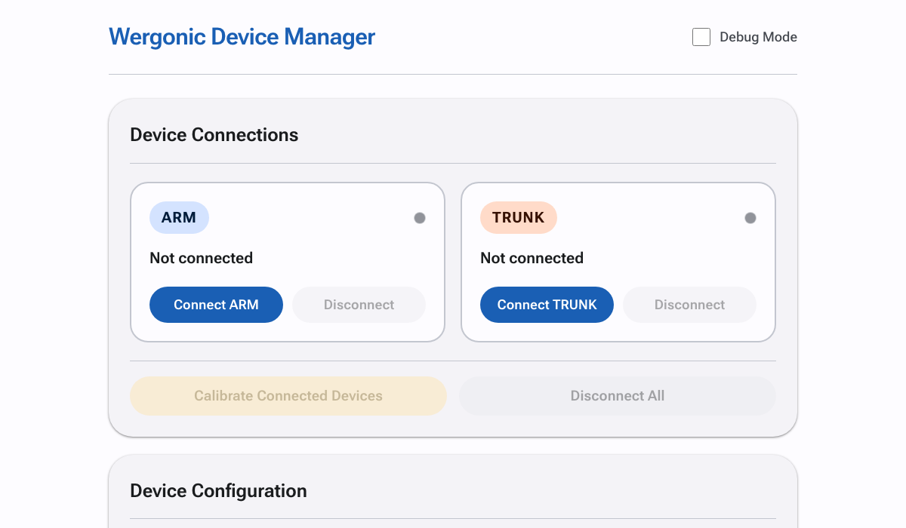
A simple guide to set up and use your Wergonic posture feedback device

What is Wergonic?
Wergonic is a wearable device that helps you maintain good posture. It monitors your arm or trunk position and gently vibrates when you exceed safe angles.
The device provides:
- Real-time angle monitoring
- Vibration alerts when posture thresholds are exceeded
- Session data logging for review

Getting Started

What You Need
- A Wergonic device (charged and turned on)
- A computer or phone with Bluetooth
- Google Chrome or Microsoft Edge browser

Step 1: Connect Your Device

- Turn on your Wergonic device
- Open the Wergonic Device Manager in your browser
- Click "Connect ARM" or "Connect TRUNK" depending on where you'll wear the device
- Select your device (named "Wergonic-XX") from the popup list
- Wait for the green dot to appear - you're connected!
Tip: You can connect two devices at once - one for ARM and one for TRUNK.

Step 2: Adjust Settings (Optional)
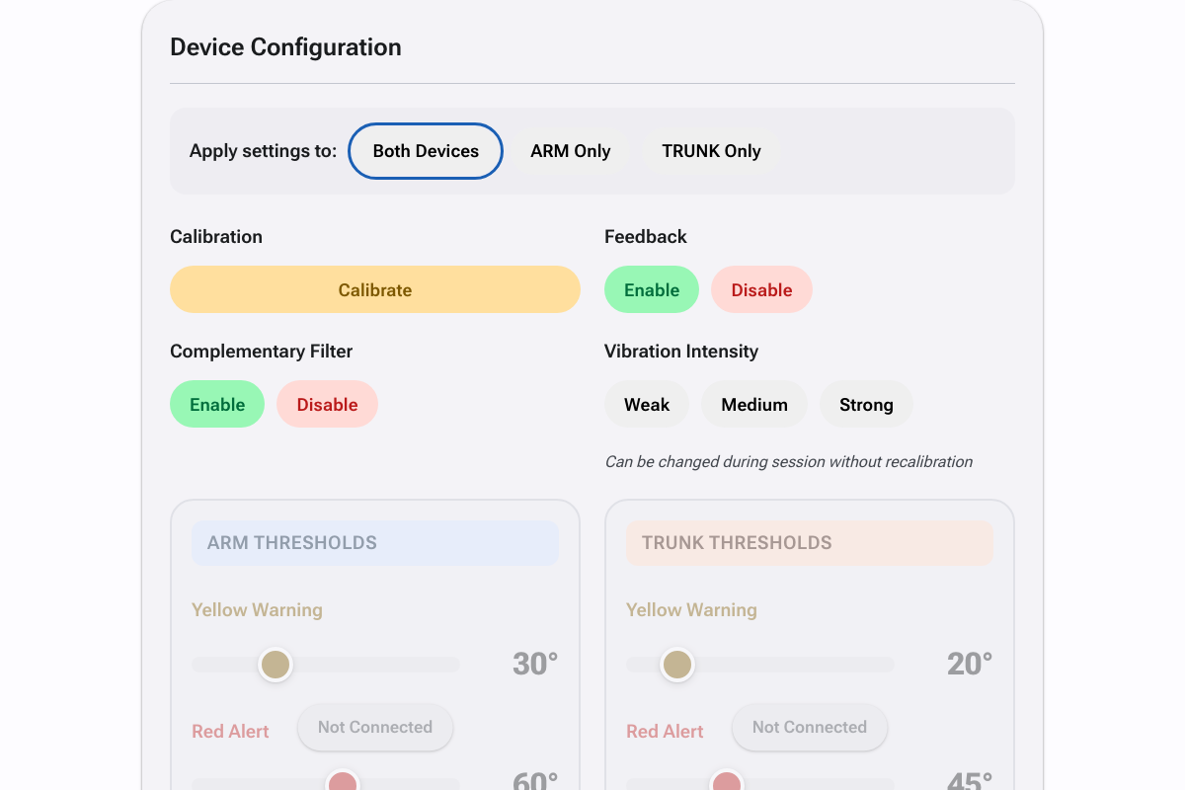
Before calibrating, you can adjust these settings:

Vibration Intensity
Choose how strong the vibration alerts feel: Weak, Medium, or Strong. You can change this anytime, even during a session.

Angle Thresholds
Set the angles that trigger alerts:
Zone | Default (ARM) | Default (TRUNK)
Yellow (Warning) | 30° | 20°
Red (Alert) | 60° | 45°
Use the sliders to adjust thresholds, then click "Apply".

Step 3: Calibrate
This is the most important step!
Calibration tells the device what your "neutral" or correct posture looks like. All angle measurements are relative to this position.
- Put on the device and assume your correct/neutral posture
- Stay still in this position
- Click "Calibrate Connected Devices"
- You'll see a confirmation message when done

Step 4: Start Your Session
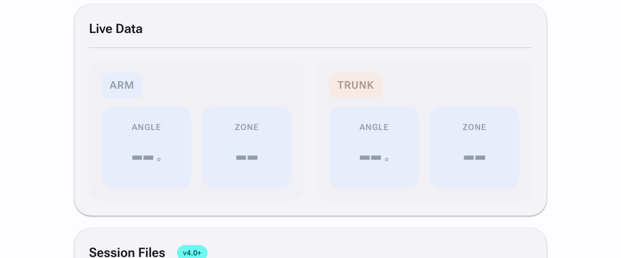
After calibration, the device is ready! The Live Data panel shows:
- Angle: Your current angle from the calibrated position
- Zone: GREEN (good), YELLOW (warning), or RED (alert)
You can now disconnect!
Once calibrated, the device works independently. You can close the browser or walk away - the device will continue monitoring your posture and providing vibration feedback on its own.

Understanding the Feedback
Zone | What It Means | Vibration
GREEN | Good posture - keep it up! | None
YELLOW | Approaching limit - adjust soon | Two short pulses
RED | Over limit - correct posture now | Continuous vibration

Ending Your Session
When you're done:
- Reconnect to the device (if disconnected)
- Click "Stop & Save Session" to save your data
- Turn off the device
- (Optional) Download session files from the Session Files panel

Tips for Best Results
- Calibrate at the start of each session while in your ideal posture
- Start with lower thresholds and adjust as needed
- Use medium intensity first, then adjust based on preference
- Make sure the device is securely attached before calibrating

Need Help?
Problem | Solution
Device not showing up | Make sure Bluetooth is on and device is turned on
Can't connect | Try refreshing the page and reconnecting
No vibration feedback | Check that feedback is enabled and device is calibrated
Wrong angle readings | Recalibrate while in your correct posture
— Enjoy using your Wergonic device! —

